1. 

2. 

3. 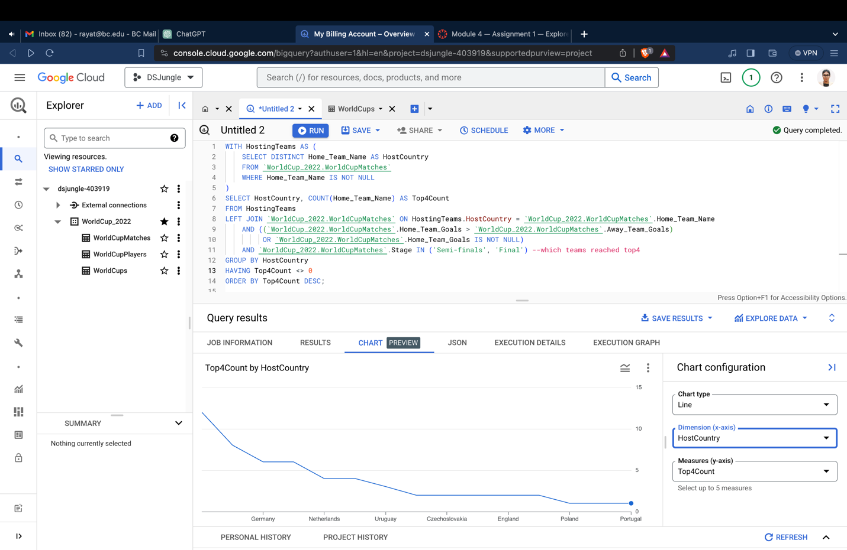

The analysis suggests that certain host countries, like Germany FR, Netherlands, Argentina, and others, have seen their teams reach the top 4 (semi-finals or finals) multiple times. This might imply a positive influence of hosting the World Cup on a team's performance.

However, it's important to note that correlation does not imply causation. While the data shows a pattern, it doesn't necessarily mean that hosting the World Cup directly causes a team to perform well. Various factors, including team skill, strategy, and other circumstances, contribute to a team's success in the tournament.

4. St. Jakob

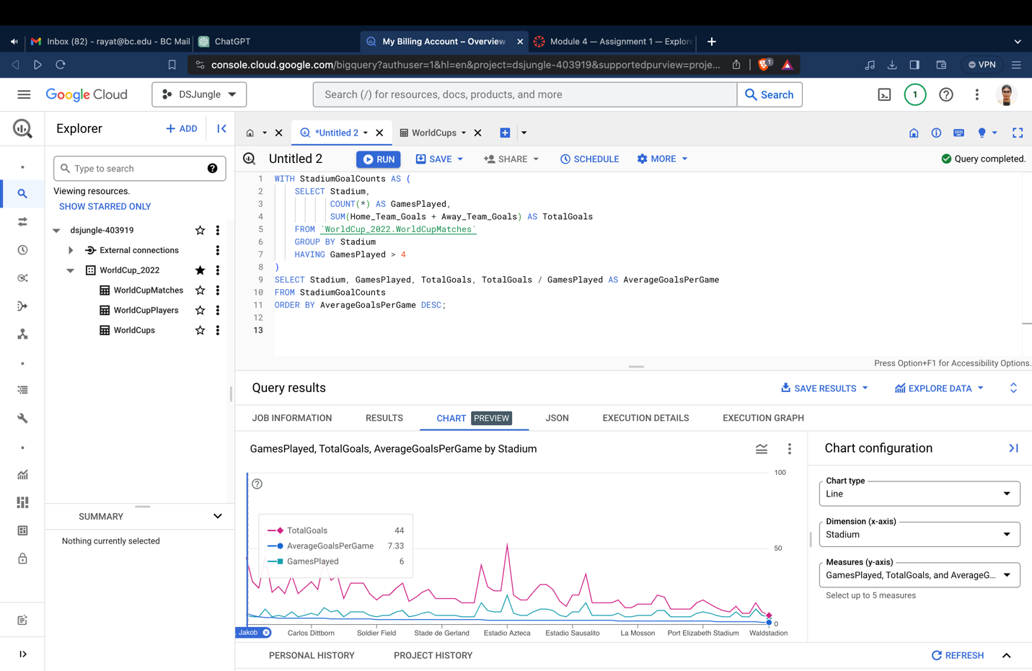

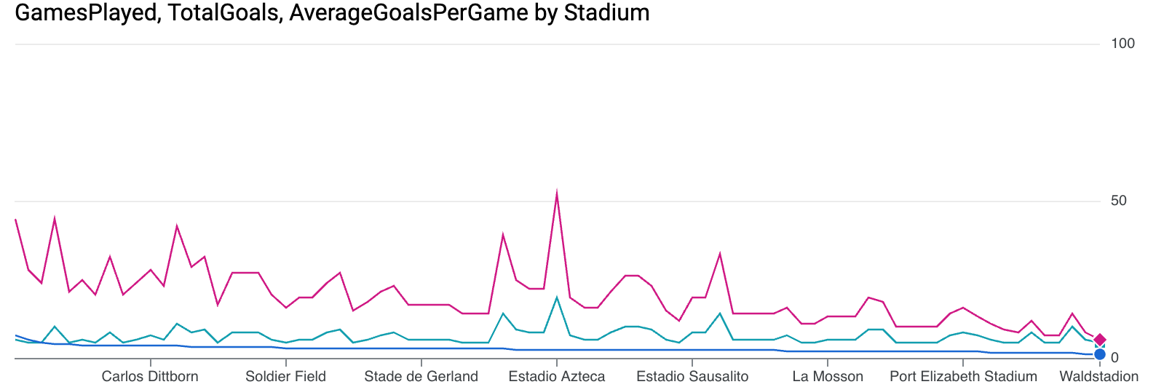

5. 