Document with Mermaid Diagrams

The following diagram was generated using Mermaid:

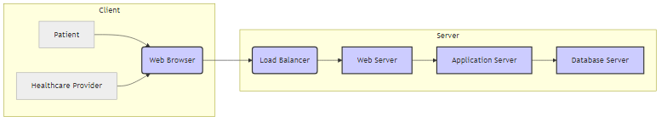

The following diagram was generated using Mermaid:

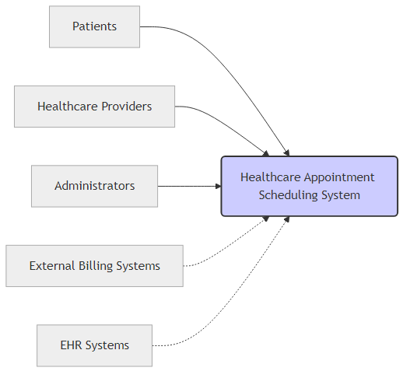

The following diagram was generated using Mermaid:

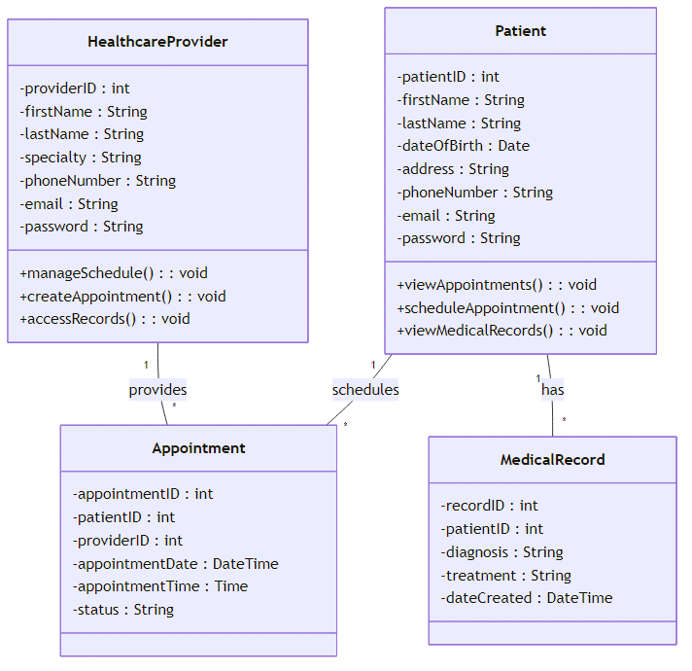

The following diagram was generated using Mermaid:

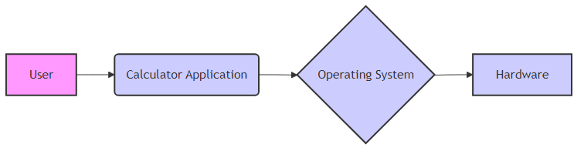

The following diagram was generated using Mermaid:

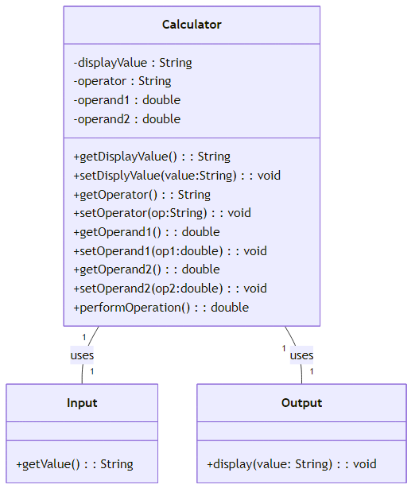

The following diagram was generated using Mermaid:

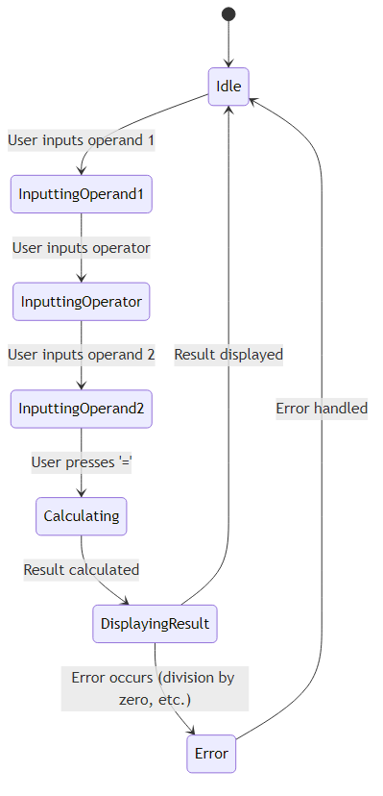

The following diagram was generated using Mermaid:

