Answers to the research questions
Paper-style answers to the eight research questions. Each section states the question, the answer in one or two sentences, the evidence, the implication for system design, and the scope of the evidence. The internal record (all runs, case studies, corrections) is FINDINGS.md; the digest with every number is SUMMARY.md. Figures are generated from the result files by systems/WDIRS/quwarts/scripts/plot_results_paper.py into figures/. A self-contained Word version with the figures embedded is RESULTS_PAPER.docx (rebuild: module load pandoc/2.19.2, then from this folder sed -E 's#\]\(figures/([a-z0-9_]+\.png)\)#](figures/\1){width=6.5in}#' RESULTS_PAPER.md | pandoc -f markdown+pipe_tables+link_attributes-implicit_figures -t docx --resource-path=. -o RESULTS_PAPER.docx).

Setting and terms
System. An LLM-based extraction system turns a document collection into relational tables so that SQL queries can be answered. It builds an initial database by reading each document once for the columns its known workload uses (the build). When a later query needs a column the build did not extract, it extracts that column on demand (a patch), reading only the documents the query’s filters can still select.
Workload drift. Each corpus has a known workload and a test set of later queries. A drift level of p% means p% of the new columns the test queries need were left out of the build. At 0% the build anticipated every column; at 100% it anticipated none.
Data. Five document corpora: research papers (cspaper, 200 documents), basketball players with teams, owners and cities (player, 4 tables, 216 documents), artists (art, 1,000), medical diseases, drugs and institutions (med, 3 tables, about 300), and court cases (legal, 570). The results below cover cspaper, player and art (220 drift test queries); med and legal have not been run yet.
Metric. Per query, structure F2 (are the right rows and groups returned) × cell F1 with 20% numeric tolerance (are the values right), averaged over queries. 1.0 is a perfect answer.
Model. Qwen 2.5 7B Instruct, 4-bit, served locally with Ollama, unless stated. Token counts are input + output.
Statistics. Differences between two systems on the same queries are paired; 95% confidence intervals come from a bootstrap over queries. Most results are single runs. Run-to-run noise was measured: re-running a whole drift stream, with every extraction repeated, moved its score by at most 0.002; three repeats of one extraction pass varied by up to 0.012 on a 20-query test set. Differences of a few thousandths are within noise and are reported as such.

RQ1. When should a system extract a column up front, and when on demand?
Answer. Extract generously up front and patch on demand only what could not be foreseen. On-demand patching is essential: without it, accuracy collapses as the workload drifts. But anticipating a column is far cheaper than patching it later, because it adds one field to prompts that are read anyway, while a patch re-reads every document in scope.
Evidence.
Patching keeps accuracy under drift; a static build does not. At 100% drift (no new column anticipated):
Corpus | Static build | With on-demand patching | Paired difference (95% CI)
player | 0.040 | 0.387 | +0.347 (0.287 – 0.411)
art | 0.031 | 0.256 | +0.225 (0.152 – 0.304)
cspaper | 0.008 | 0.153 | +0.146 (0.092 – 0.204)
legal | not yet run
med | not yet run
With patching, the score at 100% drift is never more than 0.014 below the fully anticipated build (0% drift). On player and cspaper it is slightly higher (+0.008, +0.019), but neither rise is significant (paired 95% CIs −0.007 to +0.028 and −0.011 to +0.052; query-level gains and losses cancel), so the patched curve is flat under drift. The rise is not extraction noise either: patching changes 2.5–3.7× as many cells of the drifted columns as re-running the same stream does. It is a prompt effect, and we isolated it (see Ablations): giving patches exactly the build’s prompt moves every corpus’s 100%-drift score to its 0%-drift score, and almost all of that is grouping. A patch asks for 1–3 columns, the build for all of a table’s new columns at once; fewer columns per prompt give better values on cspaper and player and worse on art (RQ2). Which documents a patch reads contributes nothing. With the 32B model the same effect is significant on cspaper (+0.062, 95% CI +0.019 to +0.113) and player (+0.020, +0.009 to +0.034) and absent on art (RQ7): a corpus-specific gain from narrow prompts, not a benefit of drift.
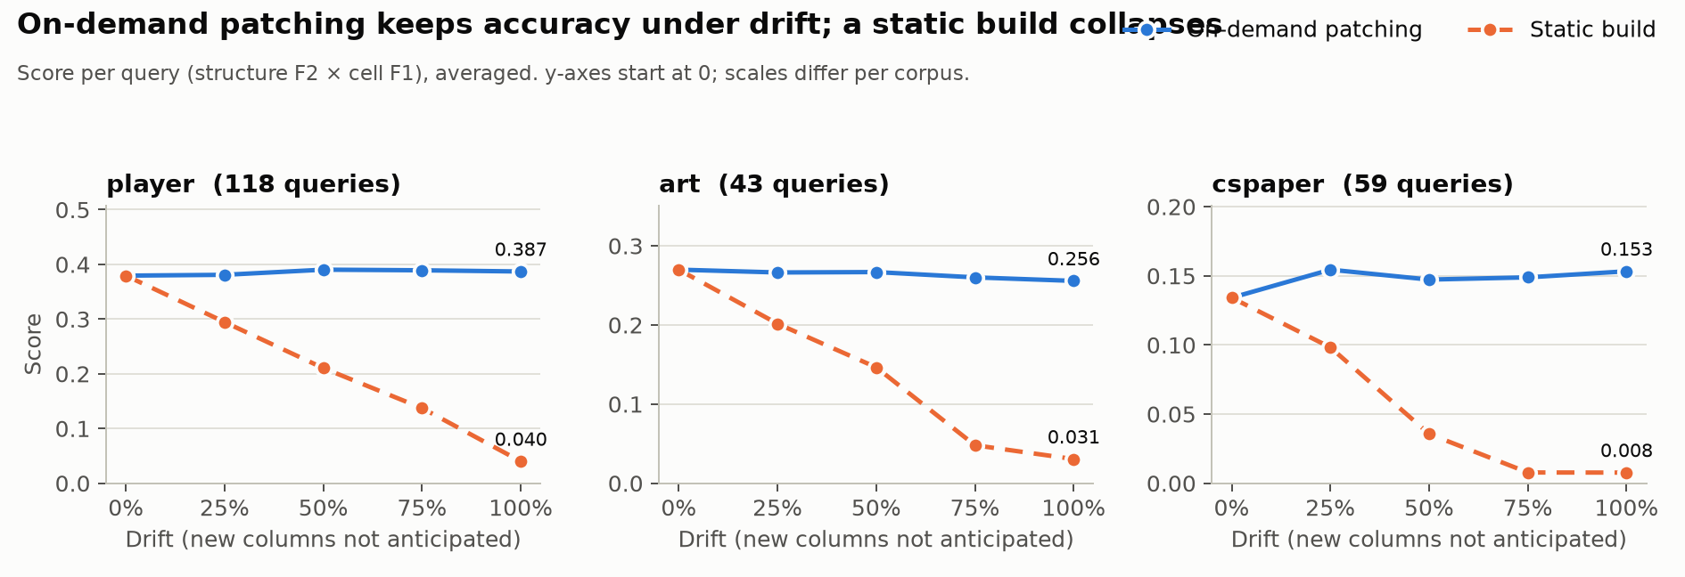 Figure 1. Score as drift grows, static build vs on-demand patching, per corpus.
The result does not depend on which columns were withheld. Re-drawing the withheld columns three more times at the same drift levels (cspaper and player), static collapses on every draw (to 0.008 and 0.040 at 100% drift), the patched curve stays within 0.035 of its 0% score at every level, and no draw’s 100% − 0% difference is significant (cspaper +0.007 to +0.020; player −0.010 to +0.008).
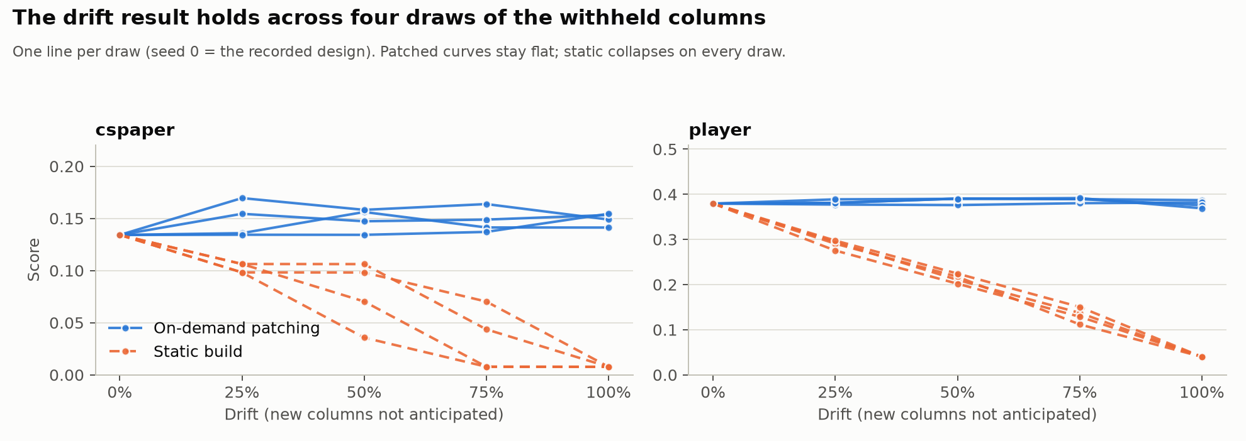 Figure 2. The drift result across four draws of the withheld columns (cspaper, player).
It does not depend on how much of the workload the build anticipates either. Cutting the build workload to 10%, 25% or 50% of its queries (same test queries; 7 runs over cspaper, player and art) leaves more columns to the patches (art at 10%: 14 new columns instead of 9). Static still collapses at 100% drift (0.000–0.043), the patched curve stays within 0.025 of its 0% score, and no 100% − 0% difference is significant (−0.015 to +0.014). The cost moves from the build to the patches and grows: art at 10% saves 1.0M build tokens but adds 2.6M patch tokens (+19% total); cspaper +23%, player +7%. The 0% score itself shifts with the share (cspaper 0.134 → 0.149–0.162, player 0.379 → 0.353), because the build groups columns into prompts by workload, and a column’s values depend on the prompt it is read in (see RQ2).
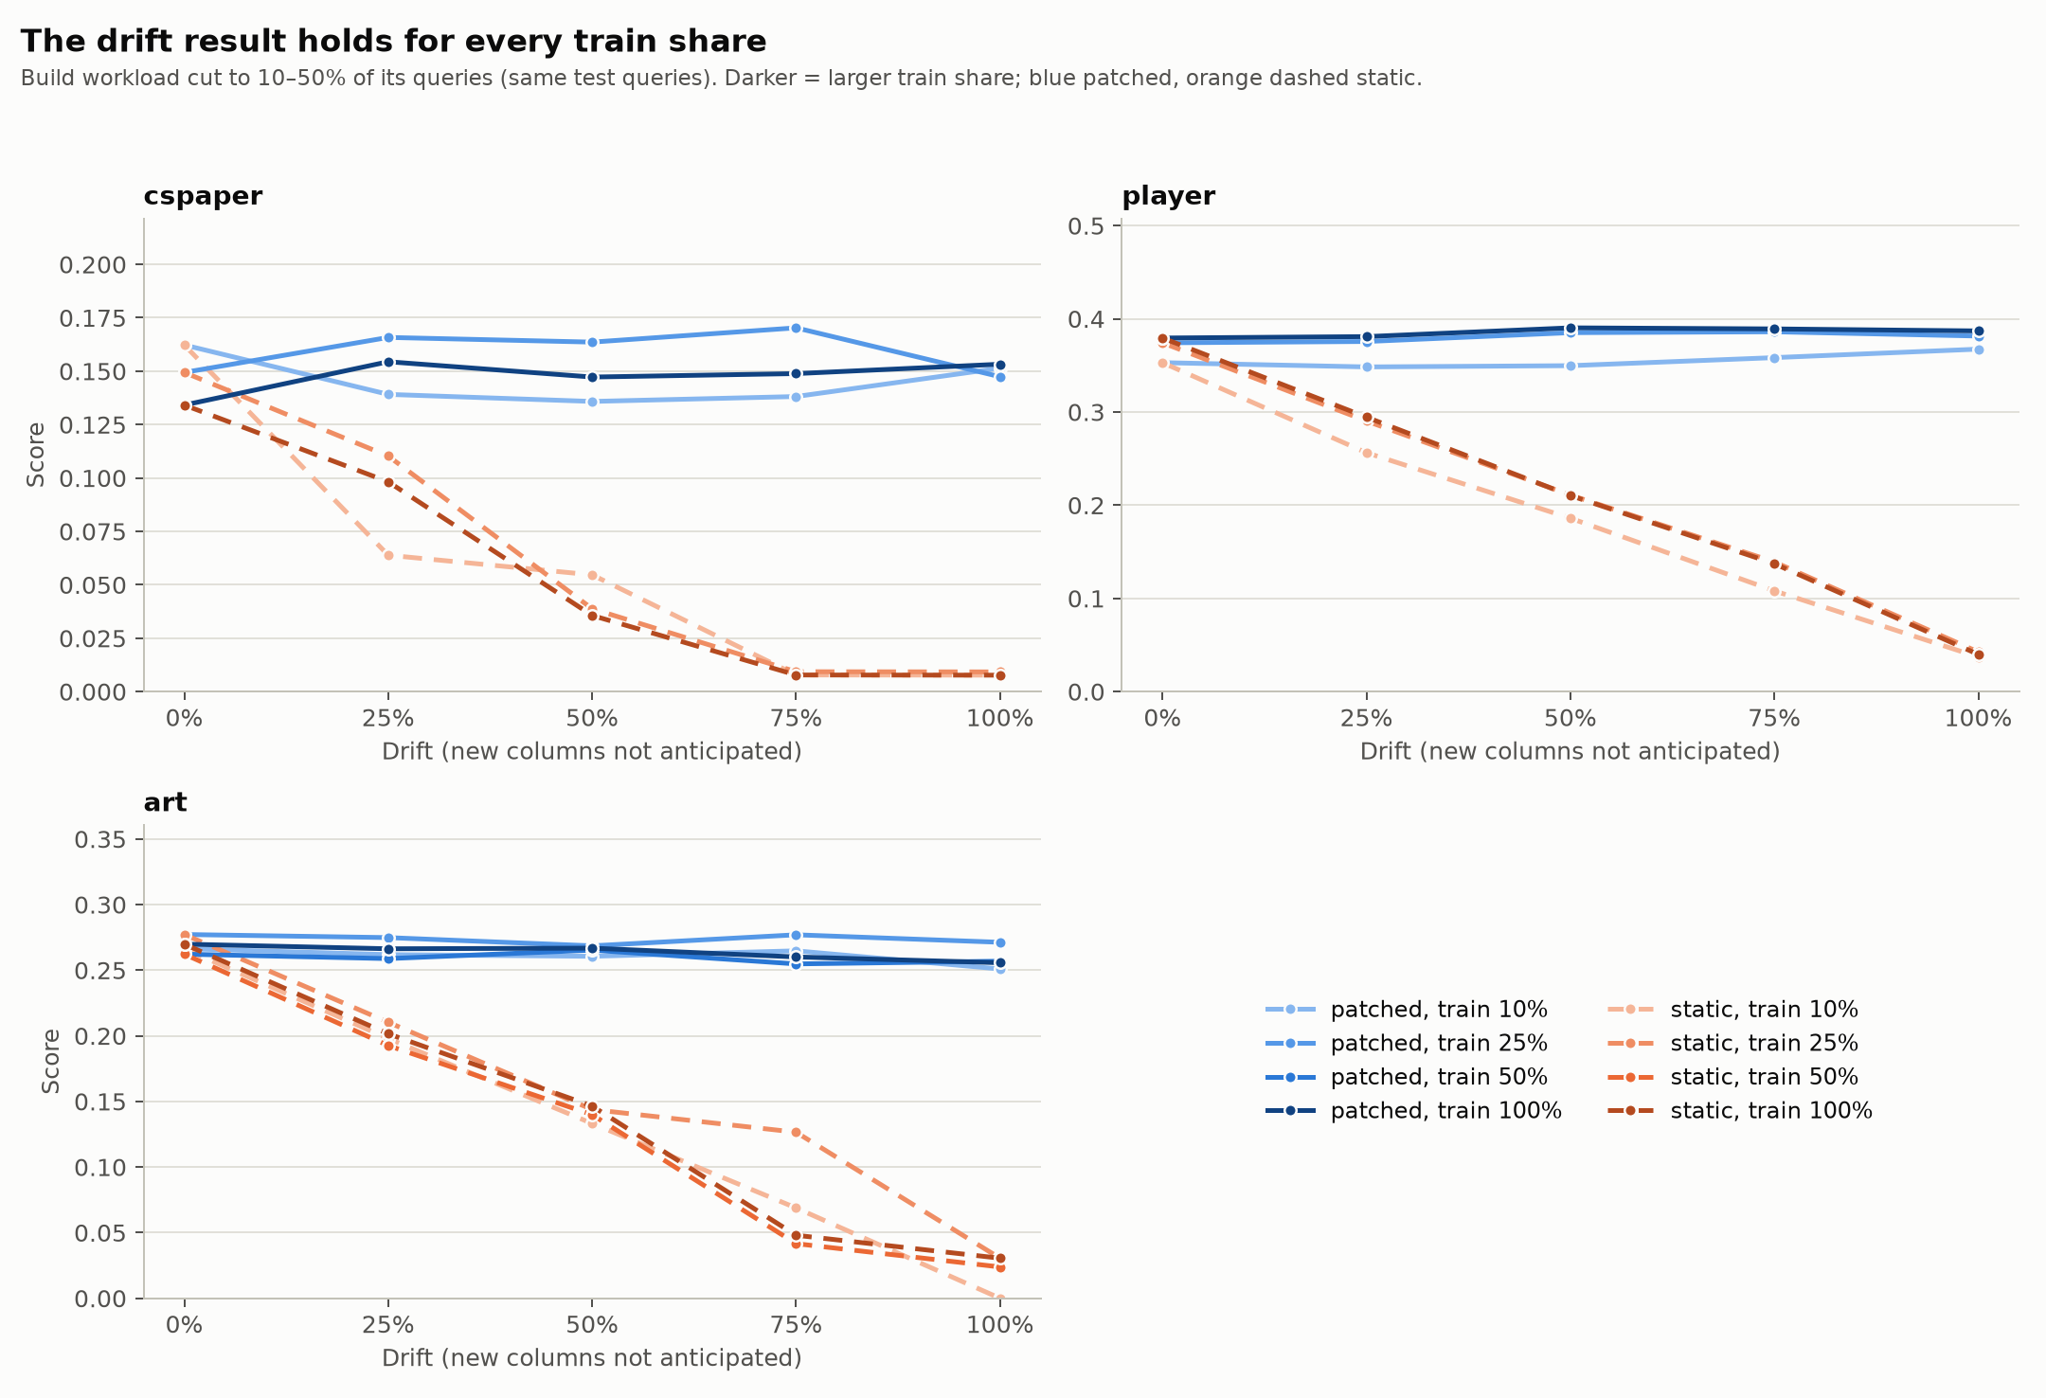 Figure 3. The drift result for build workloads cut to 10–50% of their queries (cspaper, player, art).
Anticipating is cheaper than patching. Total tokens (build + patches) and score, from fully anticipated to fully on demand:
Corpus | All anticipated | None anticipated | On-demand ÷ anticipated tokens | Break-even probability
player | 2.12M, 0.379 | 7.71M, 0.387 | 3.6× | 1.3%
med | not yet run
legal | not yet run
art | 3.18M, 0.270 | 8.52M, 0.256 | 2.7× | 12%
cspaper | 0.55M, 0.134 | 1.56M, 0.153 | 2.8× | 13%
The break-even probability is the cost of anticipating a column divided by the cost of patching it: a column is worth extracting up front if the chance a future query needs it exceeds this value. The build costs are exact up to the answer tokens of the anticipated fields (estimated at 12 per field; measured 9.5–15), an error of at most about 2%.
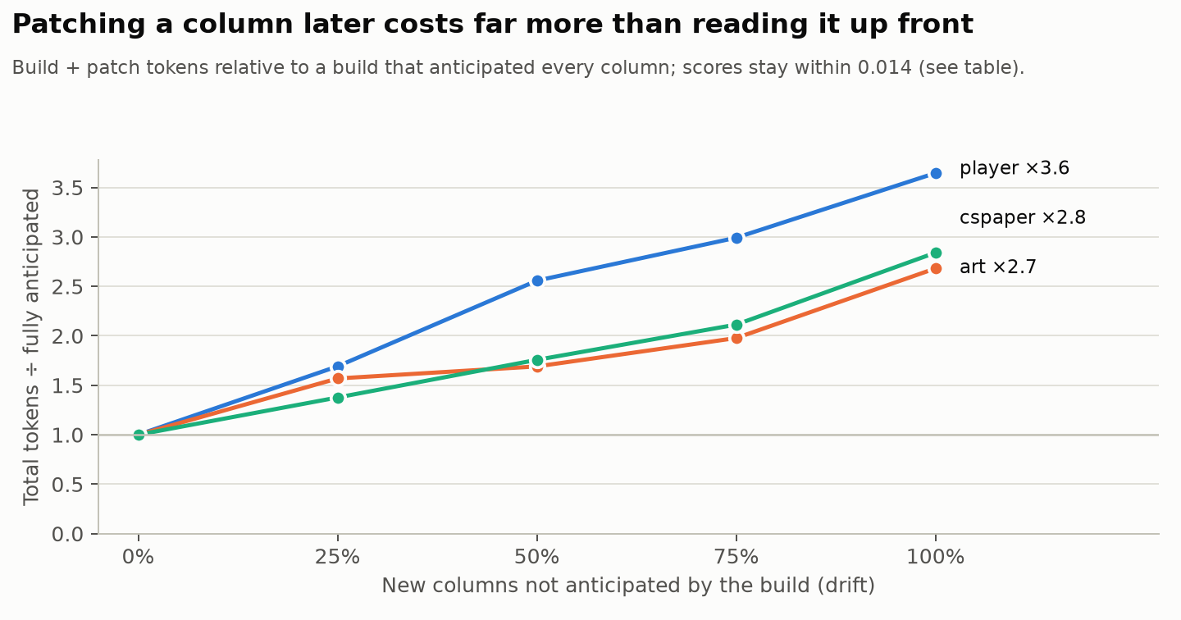 Figure 4. Total extraction tokens relative to a build that anticipated every column.
Implication. Treat anticipation as cheap insurance: extract every plausibly useful column during the build, and keep on-demand patching as the safety net for columns no one foresaw.
Scope. Three corpora (cspaper, player, art; med and legal not yet run), all drift levels, one model; four draws of the withheld columns on cspaper and player; three smaller build workloads; replicated with two other models (RQ7).

RQ2. Is a column extracted more accurately when a prompt asks for fewer columns?
Answer. No, not in general. Narrow prompts (one column) help on some corpora and hurt on others, and always cost several times the tokens. Prompt width is not a lever worth building into the system.
Evidence. The same 12 columns extracted from a fixed document sample, 1, 3, 6 or 12 columns per prompt; agreement with gold where both have a value:
Corpus | 1 column per prompt | 12 columns per prompt | Difference | Token ratio
legal | 0.547 | 0.479 | +0.068 | 10×
player | 0.806 | 0.780 | +0.026 | 10×
cspaper | 0.572 | 0.580 | −0.008 | 6×
med | 0.040 | 0.062 | −0.022 | 10×
art | 0.449 | 0.483 | −0.034 | 6×
The mechanism differs by corpus: a one-column prompt pushes the model to produce some value, so it fills cells that gold leaves empty far more often (art: 98% of gold-empty cells at one column, 60% at twelve). That helps where gold is mostly filled (legal, player) and hurts where it is often empty (art, med).
The direction is not even fixed per column. In the smaller-workload builds of RQ1, art’s birth_country read with 6 columns instead of 15 is right on 0.02 of documents instead of 0.53, while other columns gain. What a prompt’s other columns do to a column is unpredictable in sign, which is a further reason not to tune width.
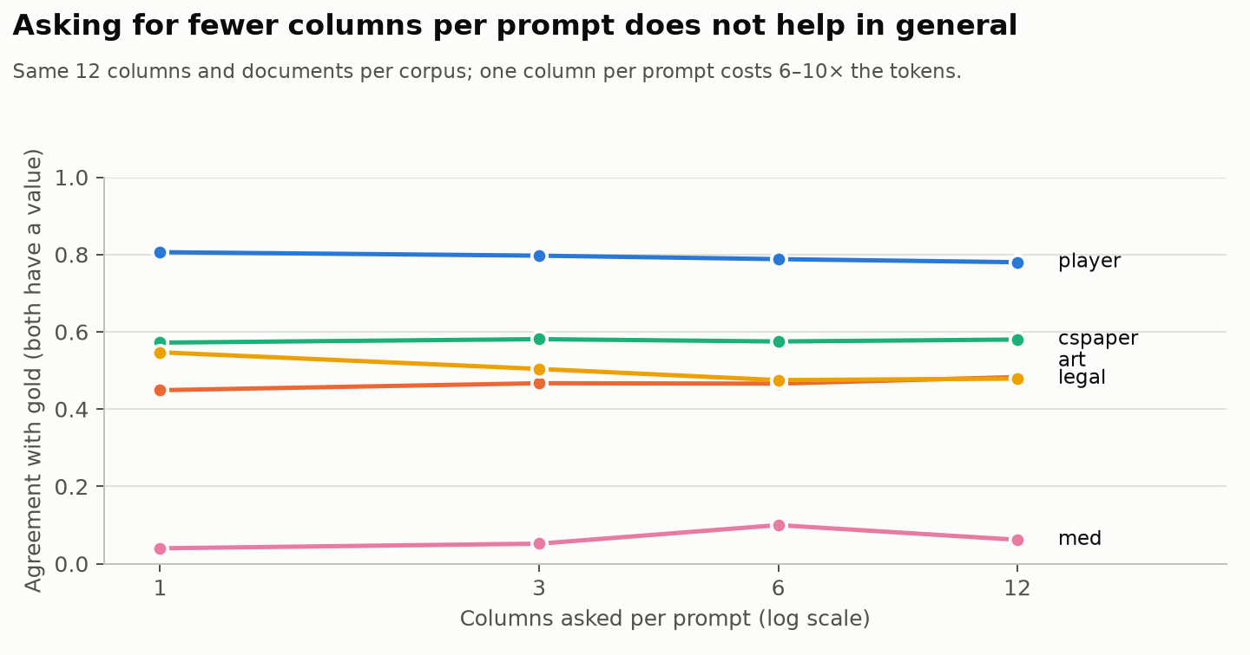 Figure 5. Agreement with gold by number of columns asked per prompt.
Implication. Extract many columns per prompt for cost; do not narrow prompts in the hope of accuracy.
Scope. Five corpora, 40–141 documents each, one model (extraction on fixed document samples; it does not use the drift test queries).

RQ3. How should an adaptive system spend a limited extraction budget?
Answer. On the corpora run so far, no policy is reliably better than spending first-come-first-served (patch every query that fits). Pacing the budget helps where early patches over-read and hurts where early patches are the valuable ones; capping any single patch hurts everywhere; skipping patches that bought nothing changes little, because few did. Even an offline plan that knows the whole stream is not better, because a patch’s cost and value depend on the patches before it.
Evidence. Mean score over 25 budget × drift settings per corpus:
Policy | cspaper | player | art | legal | med
First-come-first-served | 0.1453 | 0.3363 | 0.2356 | not yet run | not yet run
Hindsight oracle (skip patches that bought nothing) | 0.1453 | 0.3363 | 0.2356
Cap any single patch at 25% of the budget | 0.1398 | 0.3076 | 0.2263
Pacing (spend in step with the stream) | 0.1466 | 0.3260 | 0.2405
Offline knapsack over patches (whole stream known) | 0.1369 | 0.3389 | 0.2306
Pacing helps where early patches over-read (cspaper, art) and hurts where early patches are the valuable ones (player). The hindsight oracle equals first-come-first-served on all three corpora: at 100% drift no player patch and few cspaper and art patches bought nothing (RQ4).
Even hindsight does not give a better fixed plan. An offline 0/1 knapsack that knows the whole stream and picks the patches with the most measured value per budget is not better overall (−0.008 to +0.003 against first-come-first-served). A patch’s cost and value both depend on the patches before it: without the earlier patches that narrowed its scope, a chosen player patch reads 29 documents instead of 1 (0.55M estimated tokens instead of 0.02M) and no longer fits; and gains measured with every other patch present are not additive. At the full budget the knapsack leaves 39% of cspaper’s budget unspent (0.71M of 1.16M tokens) at the same score.
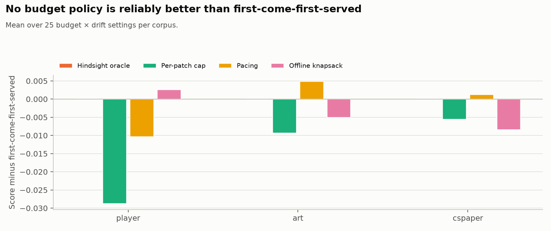 Figure 6. Each policy’s mean score minus first-come-first-served, per corpus.
Implication. Budget pacing and per-patch caps are not safe defaults; and because patch costs and values depend on order, an offline plan over patches is no substitute for deciding online.
Scope. Three corpora (med and legal not yet run) × five budgets × five drift levels.

RQ4. Can the cost and the value of an extraction be predicted before it is run?
Answer. Cost, yes, almost exactly. On the corpora run so far few extraction tokens buy nothing, and most of those are spent by patches that read the whole corpus.
Evidence.
Cost. The median ratio of estimated to actual patch tokens is between 0.997 and 1.005 on every corpus.
Value. Share of patch tokens that improved neither the triggering query nor any later query using the same columns, at 100% drift: player 0%, art 16%, cspaper 39% (med and legal not yet run). Over all 67 patches of the unlimited streams at every drift level (31.5M tokens, 5% wasted):
Signal visible in the SQL | Share of its tokens wasted | Share of all waste it covers
No filter (the patch reads the whole corpus) | 7% | 86%
A filter scopes the patch | 2% | 14%
AVG/SUM aggregate | 2% | 14%
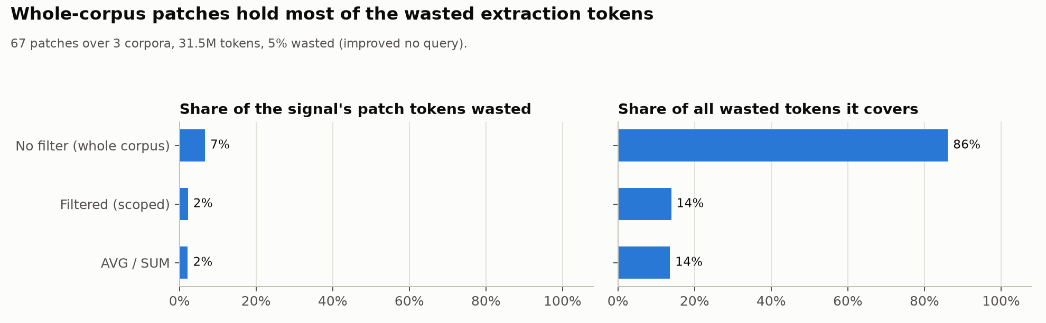 Figure 7. Wasted extraction tokens by SQL-visible signal.
Implication. A planner can trust its cost model; where value is uncertain, whole-corpus reads are the extractions to scrutinize.
Scope. Three corpora (med and legal not yet run), the unlimited streams.

RQ5. Does a cost-based extraction planner beat a single shared extraction pass?
Answer. Given the same information, the planner beats a single pass at higher budgets, but it never reaches a single pass that has better field descriptions, and it leaves much of its budget unspent. Both failures have one cause: the planner measures loss as disagreement with each query’s own extraction, so it treats that extraction as the truth and cannot recognise a more accurate shared one.
Evidence. Player, 20 held-out queries:
System | Score | Tokens
One shared pass, field names and types only | 0.234 | 1.25M
Planner, names and types, 25% / 75% budget | 0.232 / 0.340 | 2.6M / 5.6M
Planner with the benchmark’s field descriptions, 25% / 75% | 0.247 / 0.381 | 2.4M / 3.9M
Same, with join keys weighted as the whole query, 75% | 0.422 | 3.4M
One shared pass with the field descriptions | 0.560 | 1.30M
Planner building on that pass (fills only its gaps), 75% target | 0.566 | 4.93M
The field descriptions are worth +0.33 on a single pass (structure F2 0.42 → 0.87), the largest single effect we measured. At small budgets the planner loses mainly by leaving join keys unread (it values each column separately, while a missing join key zeroes the whole query). At a 100% budget it plans 4.9M of 10.6M available tokens, because its estimated loss is already 0.027 per query.
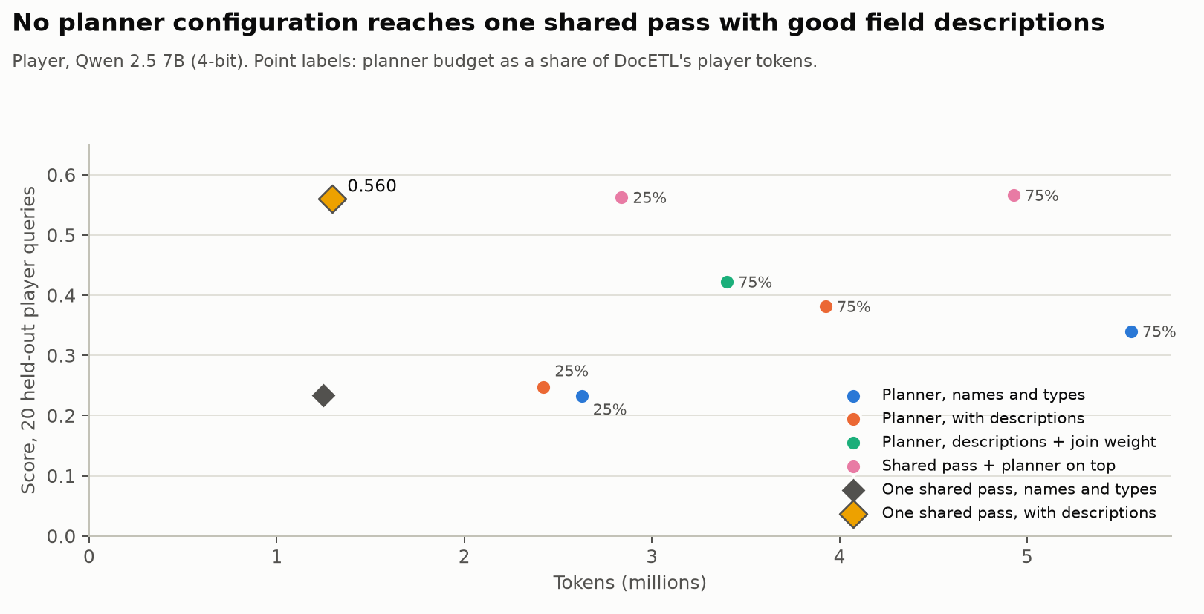 Figure 8. Score vs tokens for planner configurations and single shared passes (player).
Implication. An extraction planner’s objective must estimate accuracy, not agreement with its own reads (for example from a small labelled sample or agreement across independent contexts), and must account for join keys at query level. More extractions with the same model and inputs buy little; better field descriptions and a stronger model buy a lot (RQ7).
Scope. One corpus (player), one model; the planner budget sweep was run on player only.

RQ6. Does the order of extractions change the answers?
Answer. Order changes which documents get extracted, not the values extracted, and extracting less sometimes helps. The system never overwrites an extracted value.
Evidence. Each (column, document) pair is extracted at most once per stream. Comparing a budgeted stream with the unlimited one at the same drift level, the cells that differ are almost all filled in one and empty in the other (cspaper: 12,241 such cells vs 455 with two different values; player: 38,028 vs 0). A budgeted stream beats the unlimited one on 8–31 queries per corpus, nearly all answered without their own patch. In the clearest case (cspaper, a column defined only for papers that use an agent framework), the unlimited stream extracted it for every paper and the model assigned a framework to 82 papers that have none; the budgeted stream extracted it only on the papers earlier queries had selected and left the rest empty, which is correct for most of them.
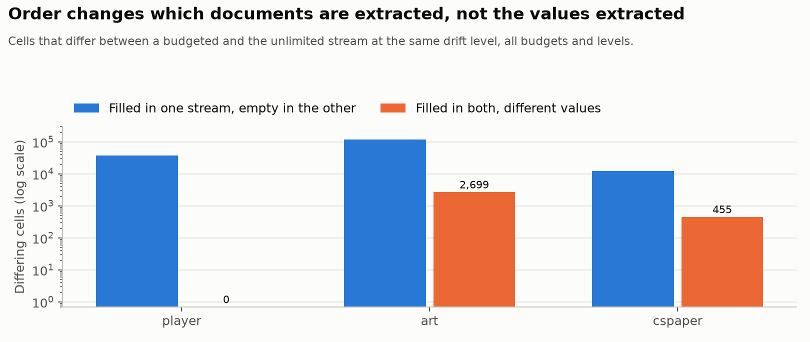 Figure 9. Cells that differ between budgeted and unlimited streams, by kind (log scale).
Implication. Extracting a column for documents where it does not apply is harmful, not merely wasteful; scoping extractions to the documents a query can select is a correctness feature as well as a cost one.
Scope. Three corpora (med and legal not yet run), all budget × drift settings.

RQ7. Do the conclusions hold across models and serving setups?
Answer. Yes. The main result (patching preserves accuracy under drift, at the same cost) holds for three models from two families, and the serving setup moves scores by much less than the effects reported here. Model capacity is the largest lever after field descriptions.
Evidence.
 | Llama 3.1 8B | Qwen 2.5 7B | Qwen 2.5 32B
Player, one shared pass (20 held-out queries) | 0.466 | 0.560 | 0.690
Player, static / patched at 100% drift | 0.040 / 0.359 | 0.040 / 0.387 | 0.052 / 0.421
cspaper, patched at 0% → 100% drift (static at 100%) | 0.149 → 0.125 (0.008) | 0.134 → 0.153 (0.008) | 0.162 → 0.224 (0.008)
player, patched at 0% → 100% drift | 0.356 → 0.359 | 0.379 → 0.387 | 0.401 → 0.421
art, patched at 0% → 100% drift (static at 100%) | 0.209 → 0.203 (0.031) | 0.270 → 0.256 (0.031) | 0.293 → 0.289 (0.031)
med, legal | not yet run
Patch costs are the same for every model (player 5.7–5.8M, cspaper 1.2–1.3M tokens). On serving: 16-bit instead of 4-bit weights adds +0.03 on a single pass and +0.004 on a whole drift stream; repeated runs vary by at most 0.012 on 20 queries and 0.002 on a stream.
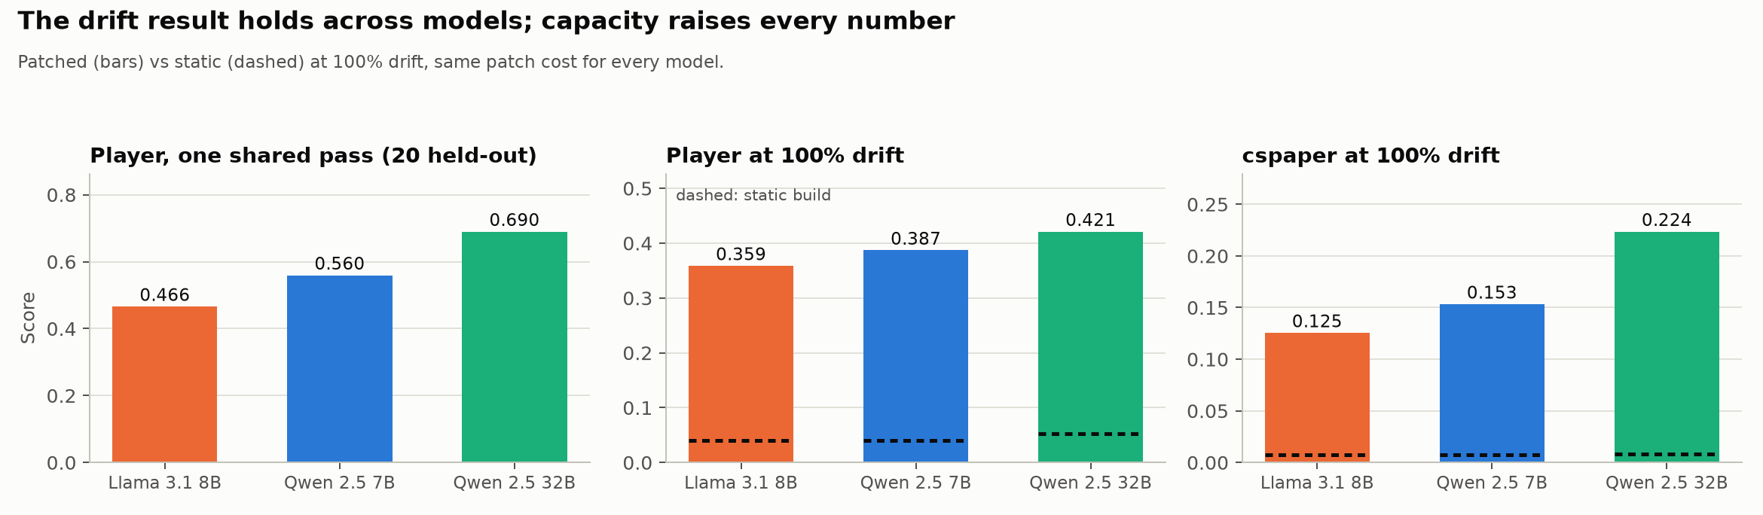 Figure 10. Three models: single pass, and patched vs static at 100% drift.
Implication. The system-level conclusions are not artefacts of one small, quantized model; a stronger model raises every number without changing what the system should do.
The 32B model raises the 0%-drift score on every corpus (cspaper +0.028, player +0.022, art +0.023). Its 100% − 0% difference is significant on cspaper and player (+0.062, +0.020) and not on art, the narrow-prompt effect of the Ablations section, larger with the stronger model.
Scope. Three corpora (med and legal not yet run); quantization on one corpus.

RQ8. Where do LLM-built databases lose accuracy?
Answer. It depends on the corpus. Where documents have simple facts and tables join cleanly (player, cspaper), the loss is in cell values; where values are free-text labels (art), it is in both values and structure (wrong or missing rows and groups). Two causes cut across corpora and bound every system: the benchmark’s metadata instructs extractors to fill fields that its own gold leaves empty, and values are often right in substance but not in the exact form a query groups by.
Evidence.
Bottleneck per corpus (patched, 100% drift):
Corpus | Structure F2 | Cell F1 | Where the loss is
player | 0.753 | 0.468 | cell values; rows and joins stay right
legal | not yet run
cspaper | 0.650 | 0.187 | cell values, e.g. results tables deep in papers
art | 0.527 | 0.340 | both
med | not yet run
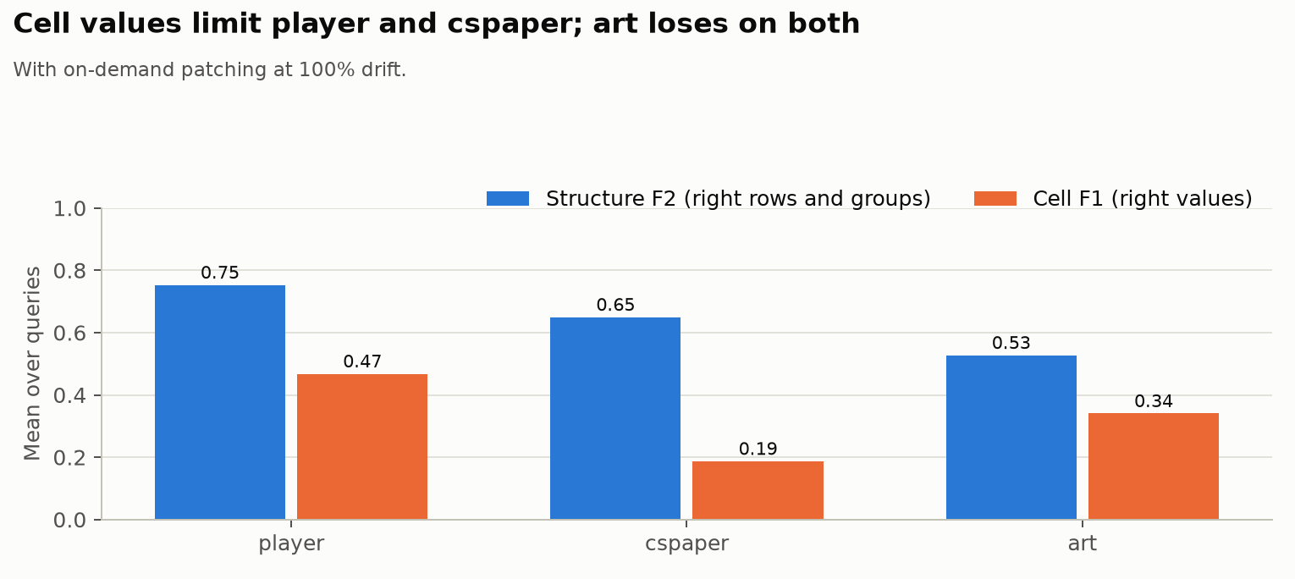 Figure 11. Structure F2 vs cell F1 per corpus, with on-demand patching at 100% drift.
Metadata contradicts gold. Of the 59 columns the benchmark’s attribute files mark “never null” in cspaper, player and art, 19 are empty in at least 5% of gold rows (e.g. cspaper performance_on_hotpotqa empty in 84%). Extractors told “never null” must invent values. Telling the model it may leave text fields empty does not help: it trades invented values for missed ones (score changes from −0.053 to +0.020).
Right in substance, wrong in form. For list-valued and free-text columns, lenient agreement with gold (any shared list item; case and punctuation ignored) far exceeds exact agreement (e.g. an art column 0.92 vs 0.13), yet the benchmark’s tolerant score is only 0.01–0.03 above the strict one, because a GROUP BY needs the exact label. Normalizing values to the constants the workload uses gains nothing: the mismatches are in labels no query names.
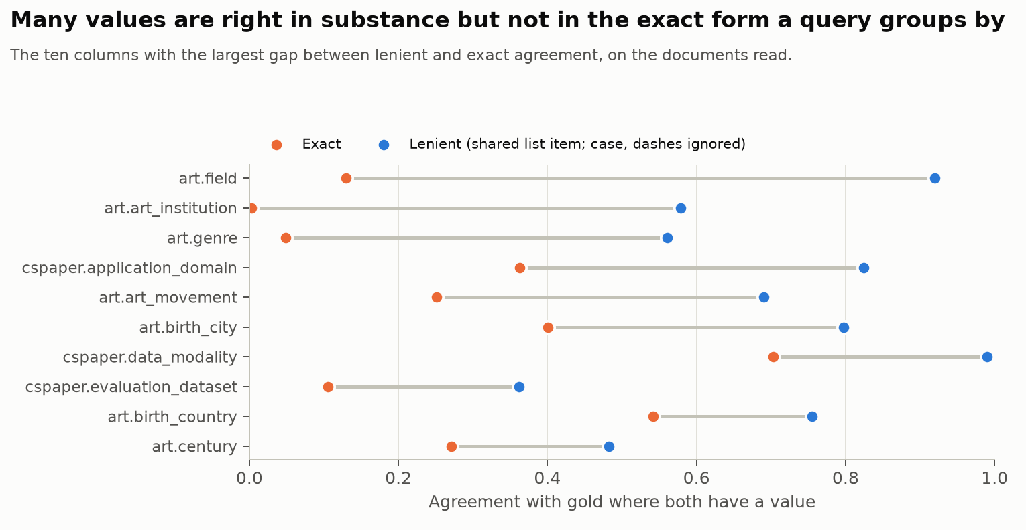 Figure 12. Exact vs lenient agreement for the ten columns with the largest gap.
By query type (patched, 100% drift): AVG 0.42, SUM 0.35, MIN over numbers 0.33, COUNT 0.28, MAX over numbers 0.18.
Implication. Benchmarks for LLM-based extraction should check their attribute metadata against their gold and score set-valued columns as sets; systems gain most from accurate field definitions.
Scope. Three corpora (med and legal not yet run); one model for the per-column analysis.

Ablations: which parts of the system matter
Answer. Three components carry accuracy: field descriptions in the extraction prompt (up to −0.136 without them), normalizing values when they are stored (up to −0.131), and mapping free-text values to the workload’s forms in the served view (−0.066 on art). Two carry cost: reusing patched columns (without it, 4.9–16.9× the tokens for the same score) and restricting a patch to the documents the query can select (up to 1.46× without it). The rest (the workload usage phrase, chained reading of long documents, batching other workload columns into a patch) change the score by at most 0.011 in either direction.
Evidence. The unlimited stream at 100% drift with one component turned off, against the full system (paired score change over each corpus’s test queries; * = 95% CI excludes 0):
Turned off | cspaper | player | art | med | legal | Patch tokens
Field descriptions | −0.034* | −0.136* | −0.101* | not yet run | not yet run | 1.0×
Value normalization at commit | −0.011* | −0.131* | −0.003 |  |  | 1.0×
Value representation in the view | 0.000 | 0.000 | −0.066* |  |  | 1.0×
Reuse of patched columns | −0.012 | −0.003* | +0.010* |  |  | 4.9–16.9×
Scope (patch every document) | 0.000 | 0.000 | +0.011* |  |  | 1.0–1.46×
Chained reading of long documents | 0.000 | −0.004 | 0.000 |  |  | 0.58–1.0×
Batching other workload columns | −0.003 | 0.000 | +0.011* |  |  | 1.0–1.46×
Workload usage phrase | −0.006 | 0.000 | +0.001 |  |  | 1.0×
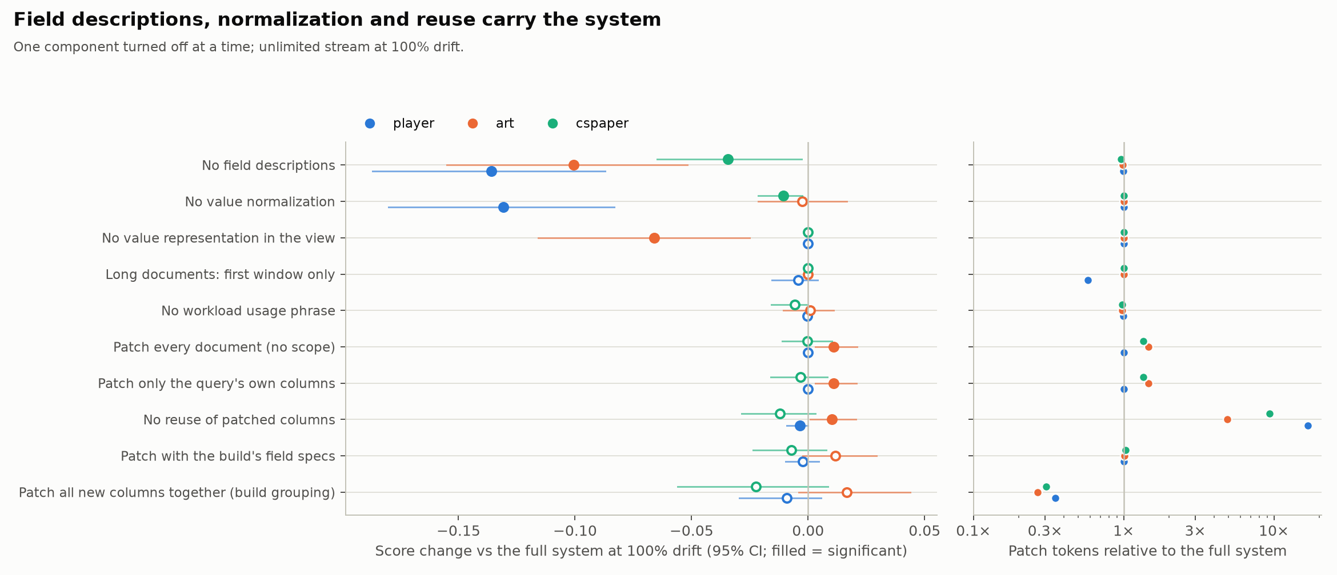 Figure 13. Each component turned off in turn: score change (95% CI) and patch tokens, at 100% drift.
Prompt factors. The same column is read differently by the build and by a patch. Giving patches the build’s exact prompt (field specs and co-read columns; no new model call was needed, so the prompts were byte-identical) moves each corpus’s 100%-drift score to its 0%-drift score; on cspaper, applied to every document, it reproduces the 0% stream query for query (58 of 59). Splitting the prompt into its two parts, the grouping alone reproduces the shift (cspaper −0.022, player −0.009, art +0.017 against the 0%-to-100% differences −0.019, −0.008, +0.014), while the build’s field specs alone move it little. Reading all new columns together costs 0.27–0.35× the patch tokens.
Implication. Invest in field definitions and in value normalization; keep reuse and scoping for cost. Prompt grouping changes values in a corpus-specific direction, so it is a cost decision, not an accuracy lever.
Scope. Three corpora (med and legal not yet run), one model (Qwen 2.5 7B), 100% drift.

Cost
Answer. Under drift, on-demand patching is most of the cost: at 100% drift patches are 71–75% of all extraction tokens, and a query that needs a patch costs 0.2–1.1M tokens, while a query answered from the database costs nothing more. At list prices for the 7B model a whole corpus costs $0.16–0.88 with patching (build plus every patch) and $0.06–0.34 if the build had anticipated every column. Reuse of patched columns is the largest saving (5–17×), and the system is 7–25× cheaper than DocETL on the same queries.
Evidence. Tokens as charged by the server; dollars at OpenRouter list rates for qwen/qwen-2.5-7b-instruct ($0.10 per million input tokens, $0.20 per million output tokens; fetched 2026-10-07). Build plus all patches for each corpus’s test queries:
Corpus | Test queries | All anticipated (0% drift) | None anticipated (100% drift) | Patches’ share | Per query that needs a patch (median) | Per test query, 0% / 100%
cspaper | 59 | 0.55M, $0.058 | 1.56M, $0.160 | 75% | 220k tokens, $0.017 | $0.0010 / $0.0027
player | 118 | 2.12M, $0.214 | 7.71M, $0.778 | 74% | 930k tokens, $0.071 | $0.0018 / $0.0066
art | 43 | 3.18M, $0.339 | 8.52M, $0.881 | 71% | 974k tokens, $0.069 | $0.0079 / $0.0205
med, legal | not yet run
Only 7–9 of each corpus’s test queries need a patch at 100% drift (the first to use each new column); every later query reuses what they read. A query answered from the database adds no extraction cost.
What changes the cost (100% drift, 7B rates):
Variant | cspaper | player | art
Recorded system (build + patches) | $0.160 | $0.778 | $0.881
Build workload cut to 10% of its queries (E12) | $0.196 (+23%) | $0.830 (+7%) | $1.036 (+18%)
No reuse of patched columns: patches only | $1.10 (vs $0.12) | $9.65 (vs $0.57) | $3.03 (vs $0.62)
Patch every document (no scope): patches only | $0.16 (vs $0.12) | $0.57 (same) | $0.91 (vs $0.62)
Long documents read to the first window: patches only | $0.12 (same) | $0.33 (vs $0.57) | $0.62 (same)
DocETL on the same test queries | $2.13 | $19.15 | $5.94
Across models (build + patches at 100% drift; patch tokens differ by at most 19% across models — Llama reads more on art — so prices differ mostly by rate):
Corpus | Llama 3.1 8B ($0.05 / $0.08) | Qwen 2.5 7B ($0.10 / $0.20) | Qwen 2.5 32B (not listed; $0.08 / $0.28 to $0.66 / $1.00)
cspaper | $0.09 (score 0.125) | $0.16 (0.153) | $0.14–1.08 (0.224)
player | $0.39 (0.359) | $0.78 (0.387) | $0.64–5.14 (0.421)
art | $0.50 (0.203) | $0.88 (0.256) | $0.73–5.58 (0.289)
Qwen 2.5 32B Instruct is not on OpenRouter; the range uses the closest listed models, qwen/qwen3-32b (low) and qwen/qwen-2.5-coder-32b-instruct (high, same generation and size).
Implication. The cost of adapting to drift is a handful of whole-corpus reads, each 0.2–1.1M tokens (cents at small model rates), paid once per new column and shared by every later query that uses it. Reuse is what keeps it small; anticipating columns during the build removes most of it.
Scope. Three corpora (med and legal not yet run); tokens measured, the fixed levels’ builds costed as one shared read (within about 2%, E1.3); prices are list rates on 2026-10-07 and exclude local serving costs.

Comparison with DocETL
Answer. On the same drift queries and model, on-demand patching is more accurate than DocETL on every corpus and uses 7–25× fewer tokens. DocETL extracts per query and does not reuse extractions; its accuracy collapses on joins.
Corpus | Queries | DocETL | Ours (patched) | Paired difference (95% CI) | DocETL tokens | Ours (build + patches) | Ratio
player | 118 | 0.081 | 0.387 | +0.306 (0.246 – 0.368) | 190.6M | 7.71M | 25×
cspaper | 59 | 0.105 | 0.153 | +0.049 (0.004 – 0.093) | 20.7M | 1.56M | 13×
art | 43 | 0.167 | 0.256 | +0.089 (0.047 – 0.135) | 57.9M | 8.51M | 7×
med | not yet run
legal | not yet run
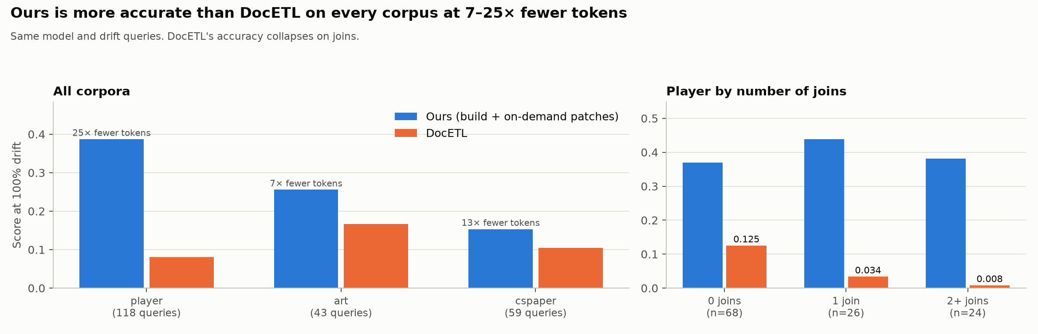 Figure 14. Ours vs DocETL per corpus (left) and on player by number of joins (right).
At 100% drift; DocETL with the same 4-bit Qwen 2.5 7B, one map operation per query and table with an equal-effort prompt. On player, DocETL scores 0.125 / 0.034 / 0.008 on queries with 0 / 1 / 2+ joins, while ours stays at 0.37–0.44; the likely cause (not yet verified value by value) is that join keys extracted by separate per-table operations do not match, whereas our build extracts every table’s keys with the same field definitions.
Scope. All 220 drift test queries on cspaper, player and art (med and legal not yet run); one model.

