- introduction
Parallel implementation of spiking neural p systems simulator using GPGPUs [ Draft ]

Francis George CABARLE¹, Henry ADORNA¹, and Juan Delacruz²

¹University of the Philippines, Department of Computer Science (Algorithms and Complexity lab), Diliman, Quezon City, Philippines
² XXXX, Quezon City, Philippines

Abstract : This paper presents a parallel simulator for a type of P system known as spiking neural P system (SNP system) using general purpose graphics processing units (GPGPUs). GPGPUs, unlike the more conventional multi-core CPUs, are used for parallelizable problems due to their architectural optimization for parallel computing. Membrane computing or P systems, are computational models which compute in a maximally parallel and non-deterministic manner. SNP systems, w/c compute via time separated spikes and whose inspiration was taken from the way neurons operate in living organisms, have been represented as matrices. The algorithms, design considerations, implementation of the simulator, as well as simulation results are discussed.
Key words : Parallel computing, Membrane computing, GPGPUs
The trend for massively parallel computation is moving from the more common multi-core CPUs towards GPGPUs for several significant reasons [CITE]. One important reason for such a trend in recent years include the low consumption in terms of power, of GPGPUs compared to setting up machines and infrastructure which will utilize multiple CPUs [CITE] in order to obtain the same level of parallelization and performance. Another more important reason is that GPGPUs are architectured for massively parallel computations since unlike the architectures of most general purpose CPUs, a large part of GPGPUs are devoted for arithmetic operations and not on control and caching [CITE]. Arithmetic operations are at the heart of many basic operations as well as scientific computations, and these are performed with larger speedups when done in parallel, by GPGPUs over CPUs.
Membrane computing or its more specific counterpart, a P system, are Turing complete computing models that perform computations nondeterministically, exhausting all possible computations at any given time. This type of unconventional model of computation was introduced by George Paun in 1998 [CITE] and takes inspiration, similar to other members of natural computing, from nature. Specifically, P systems try to mimic the constitution and dynamics of the living cell: the multitude of elements inside it, and their interactions within themselves and their environment, or outside the cell's skin membrane.
SN P systems differ from other types of P systems precisely because they are mono-membranar and only use one type of object in its computation. These characteristics, among others, are meant to capture the workings of a special type of cell known as the neuron. Neurons, such as those in the human brain, communicate or 'compute' by sending indistinct electro-chemical signals more commonly known as spikes. Information is then communicated and encoded not by the spikes themselves, since the spikes are unrecognizable from one another, by means of time duration as well as the number of spikes sent/received from one neuron to another, oftentimes under a certain time interval. [CITE]. The time duration between two spikes, or several successive spikes, transmit information from one cell to another.
It has been shown that SN P systems, given their nature, are representable by matrices [CITE]. This representation allows design and implementation of an SN P system simulator using parallel computing machines such as GPGPUs.
The design of the simulator, including the algorithms deviced, architectural considerations, are then implemented using a particular type of GPGPU, namely NVIDIA CUDA (compute unified device architecture). NVDIA CUDA extends the widely known ANSI C programming language and makes parallel computation via GPGPUs manufactured by NVIDIA more accessible.

- Spiking neural p systems

  - Computing with SNP systems
The type of SNP systems focused on by this paper are those without delays i.e. those that spike or transmit signals the moment they are able to do so. An SNP system of this type is of the form .

(2a)

(2a) represents an SNP system without delay of degree m ≥ 1, that is, with m neurons, where

1. O = { a } represents the singleton set made up of a, the spike
2.neurons of the form

where
a) n_{i} ≥ 0 are the initial number of spikes in the neuron σ_{i}
b) R_{i} are finite set of rules of the form
b-1) E/a^{c} → a^{p}, spiking rules, where E is the regular expression over a, and c ≥ 1, p ≥ 1 such that c ≥ p
b-2) a^{s} → λ are forgetting rules such that a s spikes are removed from the neuron, and that for each rule of type b-1) from R_{i} , a^{s} ∉ L(E)
  - syn are the synapses or connections between neurons such that no synapse connects a neuron to itself
  - σ_{inp},σ_{outp} are input and output neurons, respectively
Furthermore, rules of type b-1) are applied if σ_{i} contains k spikes, a^{k} ∈ L(E) and k ≥ c. Using this type of rule uses up or consumes k spikes from the neuron, producing p spikes to neurons adjacent to it. In this manner, for rules of type b-2) if σ_{i} contains s spikes, then s spikes are forgotten or removed once the rule is used. Rules of type b-1) can be simplified with the notation

b-3) a^{k} → a

where E = a^{k} , again consuming k spikes and producing a single spike.
The non-determinism of SNP systems come with the fact that more than one rule of the several types are applicable at a given time, given enough spikes. The rule to be used is chosen non-deterministically in the neuron. However, only one rule can be applied or used at a given time [CITE]. The neurons in an SN P system operate in parallel and in unison, under a global clock. For Fig. 1 no input neuron is present, but neuron 3 is the output neuron, hence the arrow pointing towards the environment, outside the SNP system [CITE]. The SNP system in Fig. 1 is a 3 neuron system.

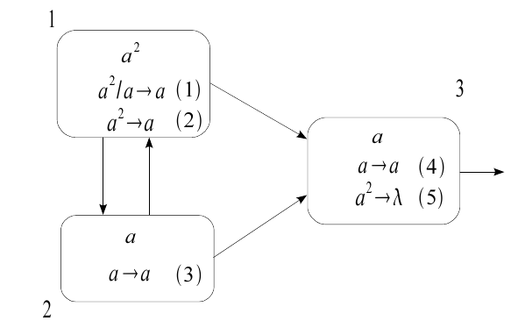Fig. 1: An SNP system, Π, generating all natural numbers except the number 1

  - Matrix representation of SNP systems
A matrix representation of an SN P system consists of the following. It is important to note that, just as in Fig. 1, a total ordering of rules (in this case rule (1) to (5) ) is in order.
Configuration vector of C_{k}, where C₀ is the initial vector containing all spikes in the system, per neuron. For Π (SNP system in Fig. 1) the initial configuration vector is (2, 1, 1) per neuron, respectively.
Spiking vector which shows, at a given configuration C_{k}, if a rule is applicable (has value 1 in the total ordering of the vector) or not (has value 0 instead). For Π we have the spiking vector at the kth configuration S_{k} = ( 1, 0, 1, 1, 0 ). Note that a 2nd spiking vector, S_{k} = ( 1, 0, 1, 1, 0 ), is possible if we use rule (2) over rule (1) instead (but not both at the same time, hence we cannot have a vector equal to ( 1, 1, 1, 1, 0) ).
Spiking transition matrix M_{Π} is a matrix comprised of a_{ij} elements such that a_{ij} is equal to
-c, if rule r_{i} is in σ_{j} and it's applied consuming c spikes
p, if rule r_{i} is in σ_{s}, s not being equal to j and that (s,j) is a synapse in Π and is applied using p spikes
0, if rule r_{i} is in σ_{s}, s not being equal to j and that (s,j) is not a synapse in Π
For Π, the M_{Π} is as follows:

In such a scheme, rows represent rules and columns represent neurons.
Finally, the following equation provides the configuration vector at the kth step, given the configuration vector and spiking vector at the (k-1)^{th} step, and the M_{Π}

(2b)

- Parallel computing and the NVIdia cuda architecture
NVIDIA, a well known manufacturer of GPUs, released in 2006 the CUDA programming model and architecture. Using extensions of the widely known C language, a programmer can write parallel code which will then execute in multiple threads within multiple thread blocks, each contained within a grid of (thread) blocks. These grids belong to a single device i.e. a single GPGPU. Each device/GPGPU has multiple cores, each capable of running its own grids. The program run in the CUDA model scales up or down, depending on the number of cores the programmer currently has in a device. This scaling is done in a manner that is abstracted from the user, and is efficiently as well. Automatic and efficient scaling is shown in Fig. 2. Parallelized code will run faster with more cores than with fewer ones [CITE].

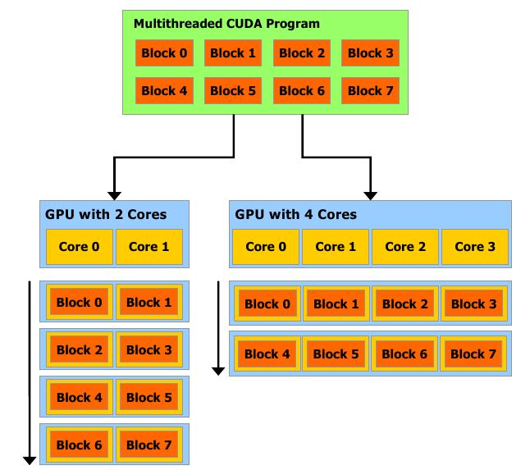Fig. 2: NVIDIA CUDA automatic scaling, hence more cores result to faster execution

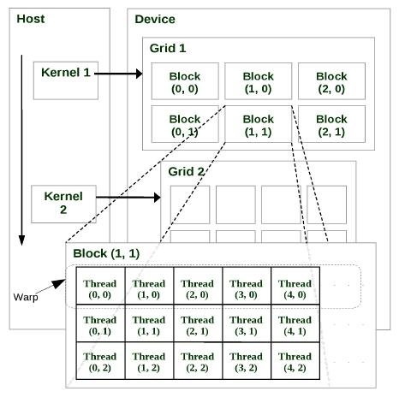Fig. 3: NVIDIA CUDA programming model
Fig. 3 shows another important feature of the CUDA model: the host and the device parts. As mentioned earlier, device pertains to the GPGPU/s of the system, while the host pertains to the CPU/s. A function known as a kernel function, is a function called from the host but executed in the device.

  - Design considerations given hardware and software setup
The kernel function i.e. code that is executed in parallel in the device, needs to have its results initially moved from the CPU/host to the device, and then back from the device to the host after computation. This movement of data back and forth should be minimized in order to obtain more efficient, in terms of time, execution.
Implementing an equation such as (2b), which involves multiplication and addition between vectors and a matrix, can be done in parallel with the previous considerations in mind. In this case, C_{k}, S_{k}, and M_{Π} are loaded within the host, before being sent to the kernel function which will perform computations on these function arguments in parallel.
In order to represent C_{k}, S_{k}, and M_{Π}, text files were created in order to house each input, whereby each element of the vector or matrix is entered in the file in order, from left to right, with a blank space in between as a delimiter. The matrix however is entered in row-major ( a linear array of all the elements, rows first, then columns) order format i.e. for the matrix M_{Π}, the row-major order version is simply

-1, 1, 1, -2, 1, 1, 1, -1, 1, 0, 0, -1, 0, 0, -2

Once all computations are done for the kth configuration, the result of equation (2b) are then collected or moved back from the device back to the host, where they can once again be operated on by the host/CPU. It is also important to note that these operations in the host/CPU provide logic and control of the data/inputs, while the device/GPU provides the arithmetic or computational 'muscle', the laborious task of working on multiple data or instructions at a given time, hence the current dichotomy of the CUDA model [CITE].

  - Matrix computations and NVIDIA CUDA
Once all 3 initial and necessary inputs are loaded, as is to be expected from equation (2b), the device is first instructed to perform multiplication between the spiking vector and the matrix. To further simplify computations at this point, the vectors are treated and automatically formatted by the host code to appear as single row matrices, since vectors can be considered as such. Multiplication is done per element (one element is in one thread of the device), and then the products are collected and summed to produce a single element of the resulting vector/single row matrix.
Once multiplication of the spiking vector and M_{Π} is done, the result is similarly added to the configuration vector, once again element per element, with each element belonging to one thread, executed all at the same time as the others.

  - XXXX Equation
Use equation editor for special high quality fonts for all mathematical equations in the text. Some equations may be placed off the text as:

(1c)

(1d)

For simple equations in the text always use superscript and subscript (select Font in the menu) instead of the equation editor. Never use the equation editor between text on same line.

  - Tables
Tables should locate close to the first reference to them in the text and number them consecutively. Explanations should be given at the foot of the table, not within the table itself. Type the caption above the table to the same width as table. See sample tables as follows:
Table 1: Caption should be centered, but if it is long, it should be indented like this
Specimen No. | Heights (cm) | Width (cm)
1 | 145.5 | 25.0
2 | 175.5 | 40.0
3 | 190.0 | 65.0

  - Figure
Place the caption underneath the figure. Type as below for the caption. Leave about two lines of space between the figure caption and the text of the paper

Fig. 4: Place caption below the drawing

  - Photographs
Figures, Table 1.

  - Conclusion
Conclusions should state concisely the most important propositions of the paper as well as the author’s view of the practical implications of the results.

- Design and implementation of an SNP system simulator using NVIdia cuda
Blah blah blah

  - Design and architectural considerations of the simulator
sdfsdfsdff

  - Algorithms for the SNP system simulator on NVIDIA CUDA
sdfsfff

- Computation simulation results, observations, and analysis

Acknowledgment
Acknowledgment should follow conclusions and its text should be preceded by bold face heading directly. Thank you UP. Thank you ERDT. Thank you President Arroyo.

Appendix
Appendix should be placed between acknowledgment and References.

References
[1] Ionescu, M., Paun, G., and Yokomori, T. (February 2006). Spiking Neural P Systems. Journal Fundamenta Informaticae, Vol. 71, issue 2,3 pp. 279-308
[2] Zeng, X., Adorna, H., Martinez-del-Amor, M., Pan, L., and Perez-Jimenez, M.J. (August 2010). Matrix Representation of Spiking Neural P Systems. 11th International Conference on Membrane Computing, Jena, Germany
[3] Cecilia, J., Garcia, J., Guerrero, G., Martinez-del-Amor, M., Perez-Jurtado, I., and Perez-Jimenez, M.J. (April 2010). Simulating a P system based efficient solution to SAT by using GPUs Journal of Logic and Algebraic Programming. Vol 79, issue 6, pp. 317-325
[4] Kirk, D., Hwu, W.. (February 2010). Programming Massively Parallel Processors: A Hands On Approach. Morgan Kaufmann 1st ed. Burlington, MA, USA
[5] NVIDIA corporation. (February 2010). Programming Massively NVIDIA CUDA C programming guide version 3.0. Santa Clara, CA, USA

