Shortest Path Restful API using Dijkstra’s Algorithm
Bera Aritra
Computer Science & Engineering
University of Nevada, Reno
abera@nevada.unr.edu

Abstract— imagine you are moving inside the University of Nevada, Reno campus and you are using your Cell phone or Laptop. Do you know how you are connected to the internet? Do you know how many routers, hub, switches your data is passed before it connects to the internet? Before the data can go from one router to another, we need to know a good route. In Network Theory, Dijkstra’s algorithm is one of the many algorithm that is used for finding the shortest path in a network. However if there is a complex network of Network Layer Devices such as Routers, it is very complicated and it takes too long to find the shortest path Algorithm. Furthermore, in reality it is not as simple as those stated in the Network Theorem. There are many available Routing algorithms [1] available today. In this project I have developed a Shortest Path Restful API using Dijkstra’s algorithm which accepts a JSON object with all the all the Network Layer Devices details and returns all the shortest path from a device. With this Restful webservice, we could find how all the devices are connected with each other and how a particular device gets connected to the internet with the shortest network path available. This restful webservice has been independently developed by me as part of the CPE600 project.

Keywords—SpringBoot, Gradle, Dijkstra’s

Introduction
One of the important computer applications in the networking is route finding. Suppose we want to connect to the internet in an area which is interconnected by a set of routers and switches, we need to know the best route that will connect a device to the internet.
In Network Theory, this route finding problem is called the shortest path problem. Dijkstra's algorithm [1,2] is normally used for solving this problem. Dijkstra's algorithm is an algorithm for finding the shortest paths between nodes in a graph, which may represent, for example, road networks. It was conceived by computer scientist Edsger W. Dijkstra in 1956 and published three years later.[3][4][5]
The algorithm exists in many variants; Dijkstra's original variant found the shortest path between two nodes [5] but a more common variant fixes a single node as the "source" node and finds shortest paths from the source to all other nodes in the graph, producing a shortest-path tree.
For a given source node in the graph, the algorithm finds the shortest path between that node and every other. It can also be used for finding the shortest paths from a single node to a single destination node by stopping the algorithm once the shortest path to the destination node has been determined. For example, if the nodes of the graph represent cities and edge path costs represent driving distances between pairs of cities connected by a direct road, Dijkstra's algorithm can be used to find the shortest route between one city and all other cities. As a result, the shortest path algorithm is widely used in network routing protocols, most notably IS-IS (Intermediate System to Intermediate System) and Open Shortest Path First (OSPF). It is also employed as a subroutine in other algorithms such as Johnson's.
Dijkstra's original algorithm does not use a min-priority queue and runs in time O (|V|^2) where |V| is the number of nodes). The idea of this algorithm is also given in Leyzorek et al. 1957. The implementation based on a min-priority queue implemented by a Fibonacci heap and running in O(|E|+|V|log |V|) (where |E| is the number of edges) is due to Fredman & Tarjan 1984. This is asymptotically the fastest known single-source shortest-path algorithm for arbitrary directed graphs with unbounded non-negative weights. However, specialized cases (such as bounded/integer weights, directed acyclic graphs etc.) can indeed be improved further. In some fields, artificial intelligence in particular, Dijkstra's algorithm or a variant of it is known as uniform cost search and formulated as an instance of the more general idea of best-first search.

AlGORITHM

The Dijkstra algorithm goes through the following steps:
- The router builds a graph of the network. Then it identifies source and destination nodes, for example R1 and R2. The router builds then a matrix, called the "adjacency matrix." In the adjacent matrix, a coordinate indicates weight. [i, j], for example, is the weight of a link between nodes Ri and Rj. If there is no direct link between Ri and Rj, this weight is identified as "infinity."
- The router then builds a status record for each node on the network. The record contains the following fields:
  - Predecessor field - shows the previous node.
  - Length field - shows the sum of the weights from the source to that node.
  - Label field - shows the status of node; each node have one status mode: "permanent" or "tentative."
- In the next step, the router initializes the parameters of the status record (for all nodes) and sets their label to "tentative" and their length to "infinity".
- During this step, the router sets a T-node. If R1 is to be the source T-node, for example, the router changes R1's label to "permanent." Once a label is changed to "permanent," it never changes again.
- The router updates the status record for all tentative nodes that are directly linked to the source T-node.
- The router goes over all of the tentative nodes and chooses the one whose weight to R1 is lowest. That node is then the destination T-node.
- If the new T-node is not R2 (the intended destination), the router goes back to step 5.
- If this node is R2, the router extracts its previous node from the status record and does this until it arrives at R1. This list of nodes shows the best route from R1 to R2.
Fig1 explains the flow diagram of Dijkstra’s Algorithmm.
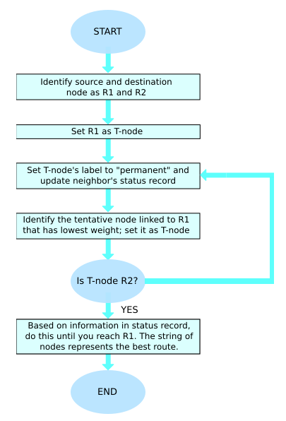
Figure 1.0: Flow Chart of Dijkstra’s Algoritm

Code Snippet

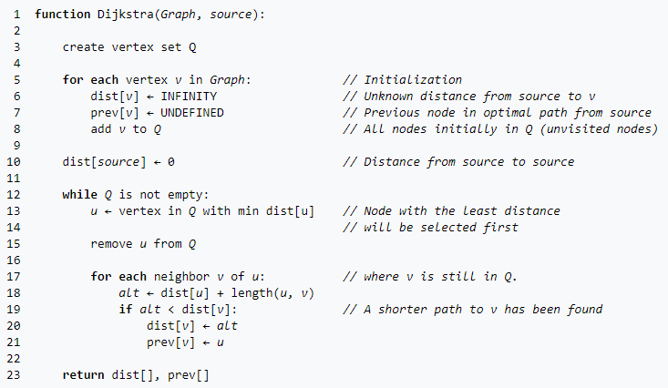

Figure-2.0 Code Snippet
In the above Fifure-2.0, the code u ← vertex in Q with min dist[u], searches for the vertex u in the vertex set Q that has the least dist[u] value. Length (u,v) returns the length of the edge joining (i.e. the distance between) the two neighbor-nodes u and v. The variable alt on line 18 is the length of the path from the root node to the neighbor node v if it were to go through u. If this path is shorter than the current shortest path recorded for v, that current path is replaced with this altpath. The prev array is populated with a pointer to the "next-hop" node on the source graph to get the shortest route to the source.

Architecture and Data Structure
The application is developed as a SpringBoot restful webservice that accepts JSON and returns JSON object. The request object consists of Lists of IotDevice that are present in a network. It has the attributes for its (X,Y) coordinate and the device ID. The IotDevice has list of connected device details ConnectedCordinate which has all the details of the connected device. The application parses each of the List of ConnectedCordinate to find the distance between the connected devices and stores the in map. The data from this map is used to create the adjacency matrix which is later used to find the shortest path of each devices from the Gateway Router.

Implementation
My implementation is based on the above algorithm and code snippet. I have created a Springboot restful webservice application that accepts a JSON with all the devices (Routers, Modem, Switch, and Gateway Router) with (X, Y) coordinates. The application parses n number of devices from the input JSON and creates a (n*n) matrix for the Dijkstra's algorithm. We have considered 9 devices in an X-Y plane with the below devices. The Figure-3.0 represents the devices. In our test implementation we have used the below configuration of devices
- 1 Gateway Router represented as z1
- 4 Routers represented as Y1,Y2,Y3,Y4
- 4 Laptops or any end device represented as X1,X2,X3,X4

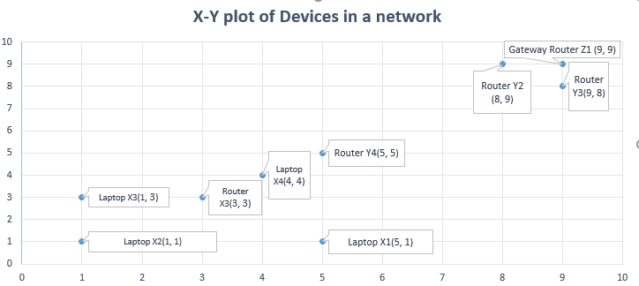

Figure-3.0 Input Devices plotted in X-Y graph
The application processes the data and creates a 9*9 adjacency matrix that represents the distances between each device. This matrix is pushed into the Java method that calculates and returns the shortest path and distance from the Gateway router to each router and end devices. It also returns the hop count of each of the paths. The data is retuned as JSON and can be read from the swagger. The below Figure-3.1 represents a part of sample JSON request and Figure-3.2 represents a sample response.

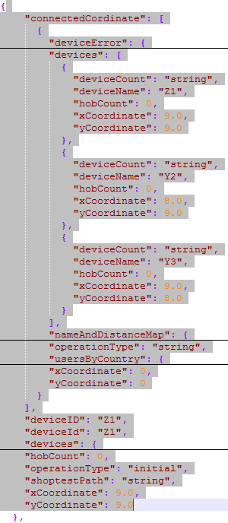

Figure-3.1 Sample JSON request

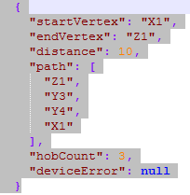

Figure-3.2 Sample JSON response

Steps to Run Spring Boot Application
Please follow the below steps to run the application in your machine or Eclipse.
- Download and Extract the zip from the below Git [7] and Google Drive [8]
- Install and setup Gradle in your Machine. [9]

Without Eclipse
- Open windows Command Prompt from the root folder location.
- Type
→gradlew clean build
→gradlew bootrun
The Springboot application will be up in your local at port number 9000
- Use the below URL to access the Swagger
- Click on “POST” call → “Try It Out”
- Use the test from the JSON file “TestJSONFile” in the example value
- Click on execute

With Eclipse
- Open Eclipse→File→Import→Existing Gradle Project
- Point to your local folder of the SpringBoot Application and click on Finish
- Click On → Window → ShowView → Terminal
- Open a new Terminal view from the Terminal bar and Launch a local terminal
- Type→ cd “your/SpringBoot/root/path”
- Type
→gradlew clean build
→gradlew bootrun
The Springboot application will be up in your local at port number 9000
- Use the below URL to access the Swagger
- Click on “POST” call → “Try It Out”
- Use the test from the JSON file “TestJSONFile_4” in the example value
- Click on execute
The Response JSON will be displayed in the response body.

Conclusion and Future work
The SpringBoot application developed gives the shortest path to traverse to a particular Device (Gateway Router) for n number of different end point devices in any given area as long the devices are mapped with (X,Y) coordinate. It generates a (n*n) matrix for all the available input devices and It returns all the path and hob count to connect to the Gateway Router. But the application does not have any User Interface where the (X, Y) coordinate can be mapped to a Google Map or any available open source Map API. The application works independently as a RESTFUL webservice. In future the application can be integrated with a User Interface and customized in such a way that any user could select n number of different end point device types, Routers, Modem in a given map and can see how the devices connected to each other and the Internet. Also, this application can be used to compare any other shortest path algorithms by just implementing the algorithm logic into class. Also, we could compute the complexity of different shortest path algorithm using this application.

References

[1] https://en.wikibooks.org/wiki/Communication_Networks/Routing
[2] LIU BING, CHOO SIEW-HWEE, LOK SHEE-LING, SING-MENG, POON FOONG-PING, 1994. “Integrating Case-Based Reasoning, Knowled e-Based Approach and Dijkstra Algorithm for Route Finding”, IEEE Conference on Artificial Intelligence for Applications available at https://ieeexplore.ieee.org/stamp/stamp.jsp?tp=&arnumber=323680&tag=1
[3] MAKARIYE NEHA, 2017. “Towards shortest path computation using Dijkstra algorithm”, International Conference on IoT and Application (ICIOT), available at https://ieeexplore.ieee.org/document/8073641

[4] FRANA PHIL, 2010. “An Interview with Edser W. Dijkstra”, ACM Library, available at https://dl.acm.org/citation.cfm?doid=1787234.1787249

[5] DIJKSTRA, E. W., 1959. "A note on two problems in connexion with graphs", Journal Google Scholor, available at https://link.springer.com/article/10.1007%2FBF01386390

[6] https://github.com/aritrabera/ShortestPathAPI
[7]https://drive.google.com/open?id=1P6r2LEC3hJHZgGQ-zPpWalWVWlQz7B2I
[8] https://www.tutorialspoint.com/gradle/gradle_installation.htm

