AVR MULTI-INTERRUPT HANDLING AND LATENCY MEASUREMENT DEMO (USING ATmega328P)
-Aritra Das

It is mainly a hardware level demo of interrupt handling in AVR architecture using ARDUINO UNO.
AVR stands for Advanced Virtual RISC (Alf-Egil Bogen and Vegard Wollan's RISC) is a 8-bit microcontroller architecture which primarily uses a Harvard style architecture for swift and single cycle instruction executions (originally developed by Atmel).
The memory structure in AVR based system (based on Harvard style architecture) has :
- Separate Program Memory (FLASH)
- Separate Data Memory
- Separate EEPROM
Inside the CPU structure, there are 32 8-bit GPR’s (R0-R31) and they can all perform arithmetic operations making the processor more fast.
Coming to Status Registers(SREG) they contain several flags, mainly –
- C → Carry
- Z → Zero
- N → Negative
- V → Overflow
- S → Sign
- H → Half carry
- T → Bit copy
- I → Global Interrupt Enable
(During an interrupt, I bit cleared automatically)

INTERRUPT HANDLING IN AVR -
AVR microcontrollers support multiple interrupt sources, such as:
- External interrupts (INT0, INT1)
- Timer interrupts (Overflow, Compare Match)
- ADC interrupt
- USART interrupt
- SPI interrupt
- Watchdog interrupt
Each interrupt has a dedicated vector address in program memory. The interrupt vector table is located at the beginning of the program memory.
AVR has a single interrupt priority level and priority is fixed by vector address order.
Now, here comes the fun part:-
In normal systems which uses ARM Cortex controllers, have an NVIC – Nested Vector Interrupt Controller. This NVIC in ARM Cortex-M processors manages interrupts, assigns programmable priority levels and supports true nested interrupt services.

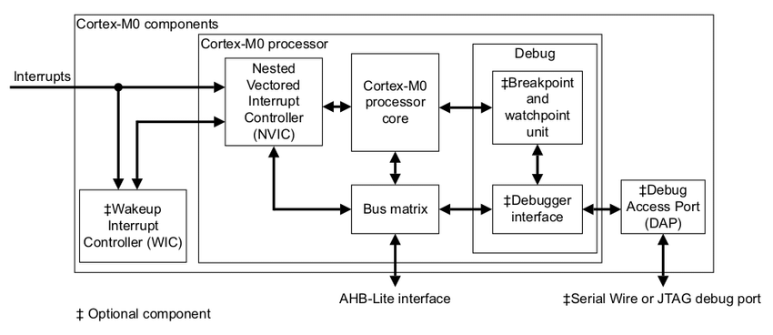

AVR doesn’t have a separate interrupt controller like NVIC.
All the interrupts in NVIC share One Global Interrupt Enable Bit ( 1-bit in SREG) and fixed priority based on vector addresses.
This project demonstrates the exactly same thing –
That is when 2 external interrupts ( here in the form of 2 wires) are given, which have been given pre-written priorities of High and Medium (along with the clock timer being a low priority function) , the Higher priority interrupt doesn’t interrupt the medium priority interrupt when the Medium priority ISR is running. The higher priority interrupts only overrides the low priority clock timer only when the medium priority ISR has finished its execution. (unlike ARM Cortex-M based controllers)
For demonstrating this I have used :-
- An Arduino UNO R3
- TM1637 display
- Piezo active buzzer
- Breadboard
- Jumper wires
The TM1637 is connected to Arduino UNO by the 4 terminals –
- GND – GND
- VCC – 5V
- DIO – D8
- CLK – D9
We take 2 interrupts from pins D2(high priority) and D3(medium priority) and produce an interrupt when we touch the wires connected to the digital pins with a grounded wire. (It can also be achieved through a push button).
The buzzer is connected to D6 pin and beeps once (low frequency) when a medium priority interrupt occurs and twice(high frequency) when a high priority interrupt occurs.
The TM1637 initiates with a clock which increments the count per second and display the latency followed by 9999 and two buzzer beeps after a high priority interrupt . For medium priority ones it displays the latency followed by 8888 and one buzzer beep.
The latency part doesn’t primarily show the interrupt latency part but shows the - system response delay under current workload (in microseconds). It includes
- Time spent inside delay()
- Display update time
- Loop execution time
- Current CPU workload
Thus, it displays the total system response time between an external interrupt request and the start of ISR execution. The value includes instruction completion delay, context saving overhead, and software-level execution delay due to blocking operations in the main loop.
The circuit diagram of my project in a rough way –

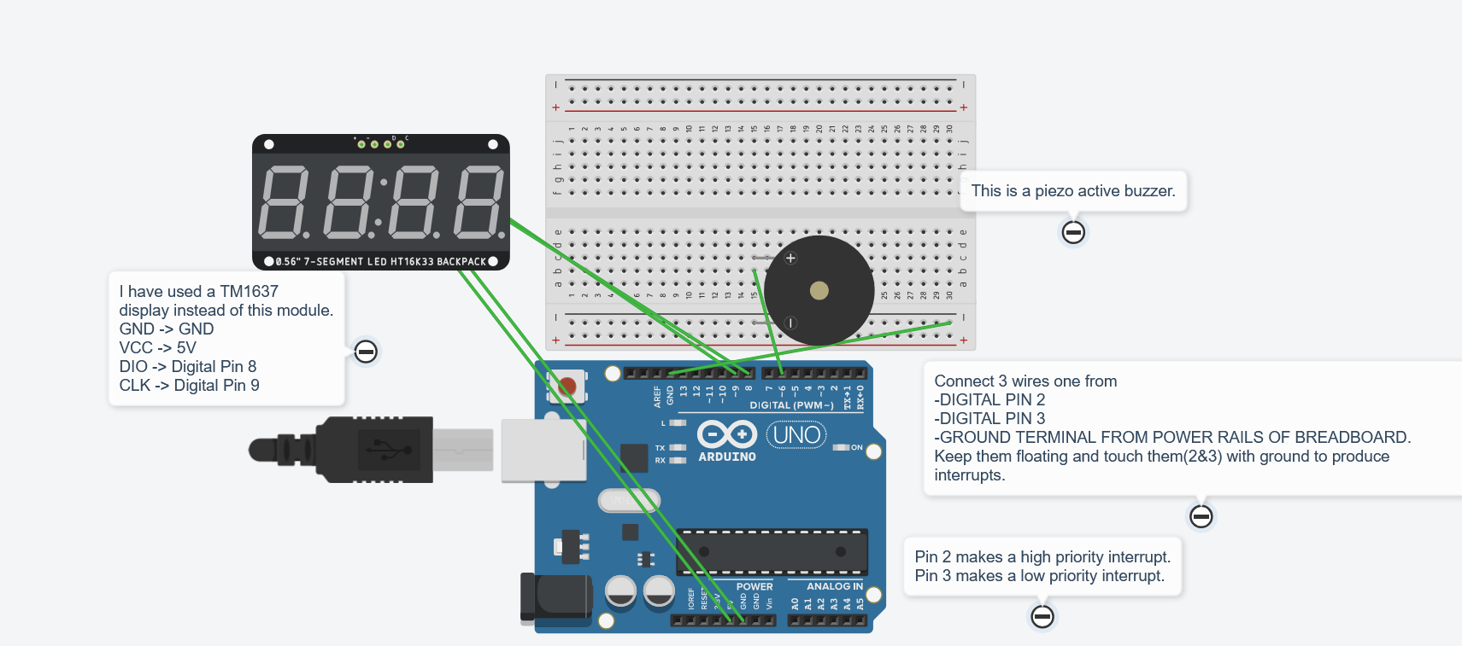
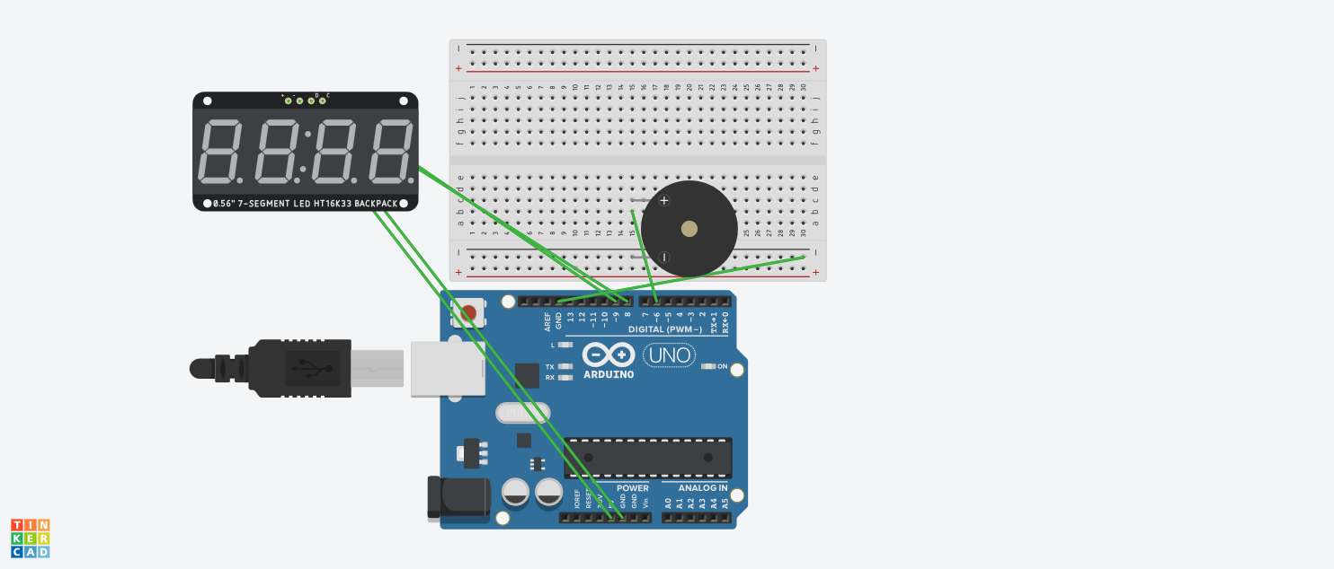

REPLACE THE LED WITH TM1637 MODULE OR DISPLAY

