Full Stack Automation project using Python Django, Ansible

Topic: Linux Inventory & Patch management WebUI Console

Prerequisites:
- The remote servers should be accessible in network
- The remote servers should have passwordless ssh configuration
- The central or control server should have python, ansible, django installaed and configured
- If the added server is not accessible using SSH, it will show SSH Failed, otherwise, it will have OS and uptime field

Setup:
- The project is running on localhost:8000
- I have NGINX configured for reverse proxy to localhost:8000

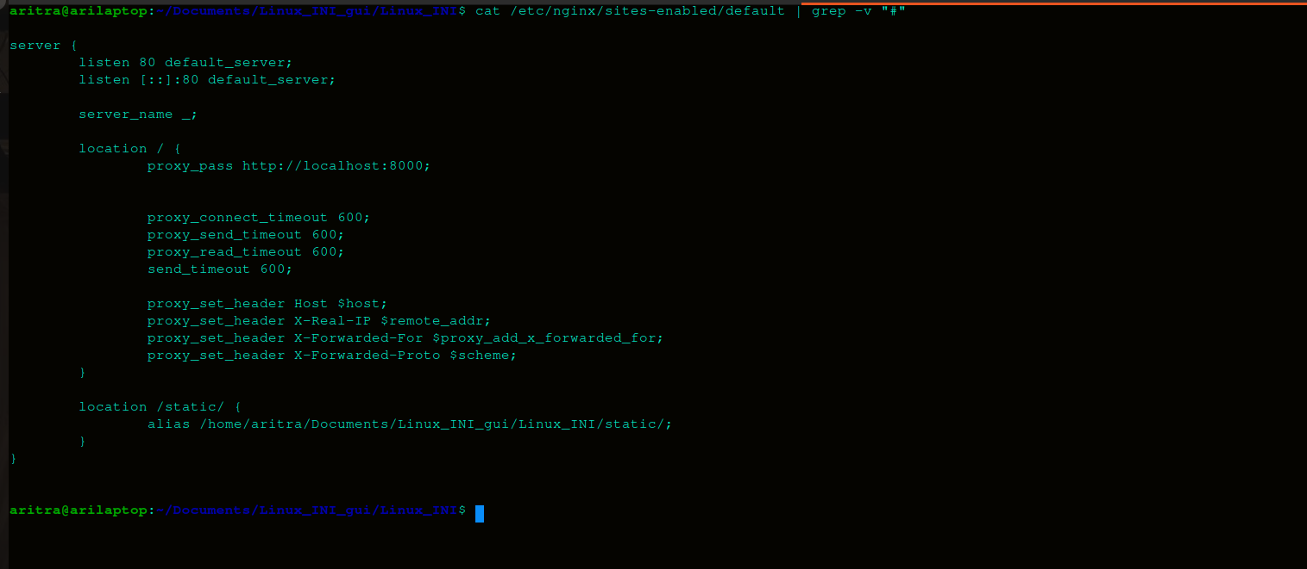
- I don not have a proper DNS entry but I had done hosts file entry for this
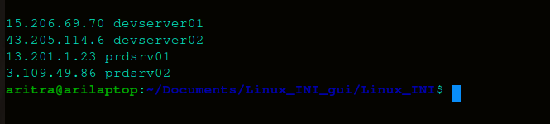

WebGUI Go THrough:

- The first look to the inventory (home page)

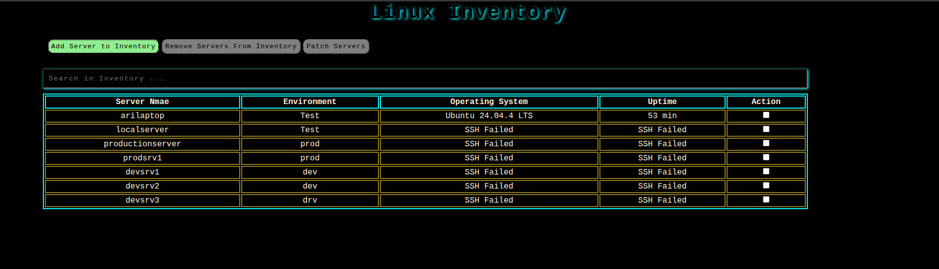
- The Delete and Patch buttons are by default disabled
- These two will get enabled once at least one of the checkboxes against servers will be selected
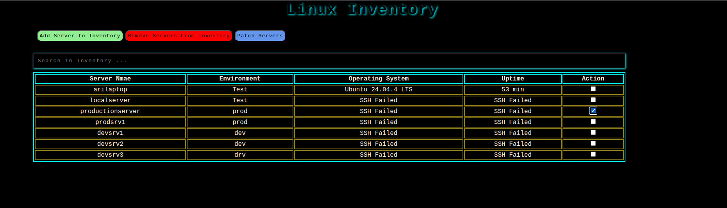
- One can also search by any keyward. The table will reflect if the keyward matches to any of the field
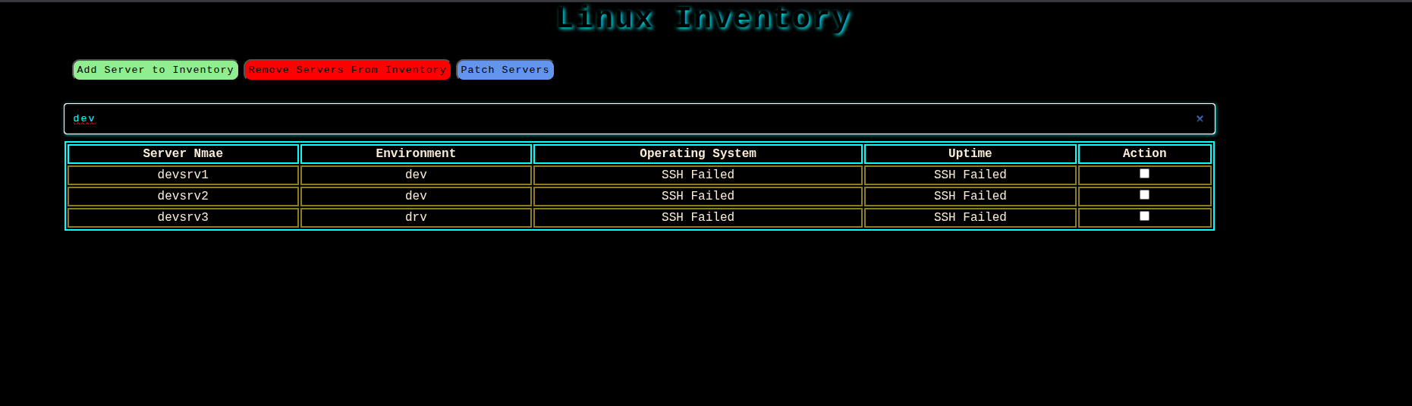
- The above were pure HTML, CSS, Java Script in play
- The table fields are from django showing data from db. Before showing the uptime & os fields will be once again fetched and saved in db and then will be provided to frontend.

- Now, click on Add server button to add new servers
- This will redirect to a form for server addition

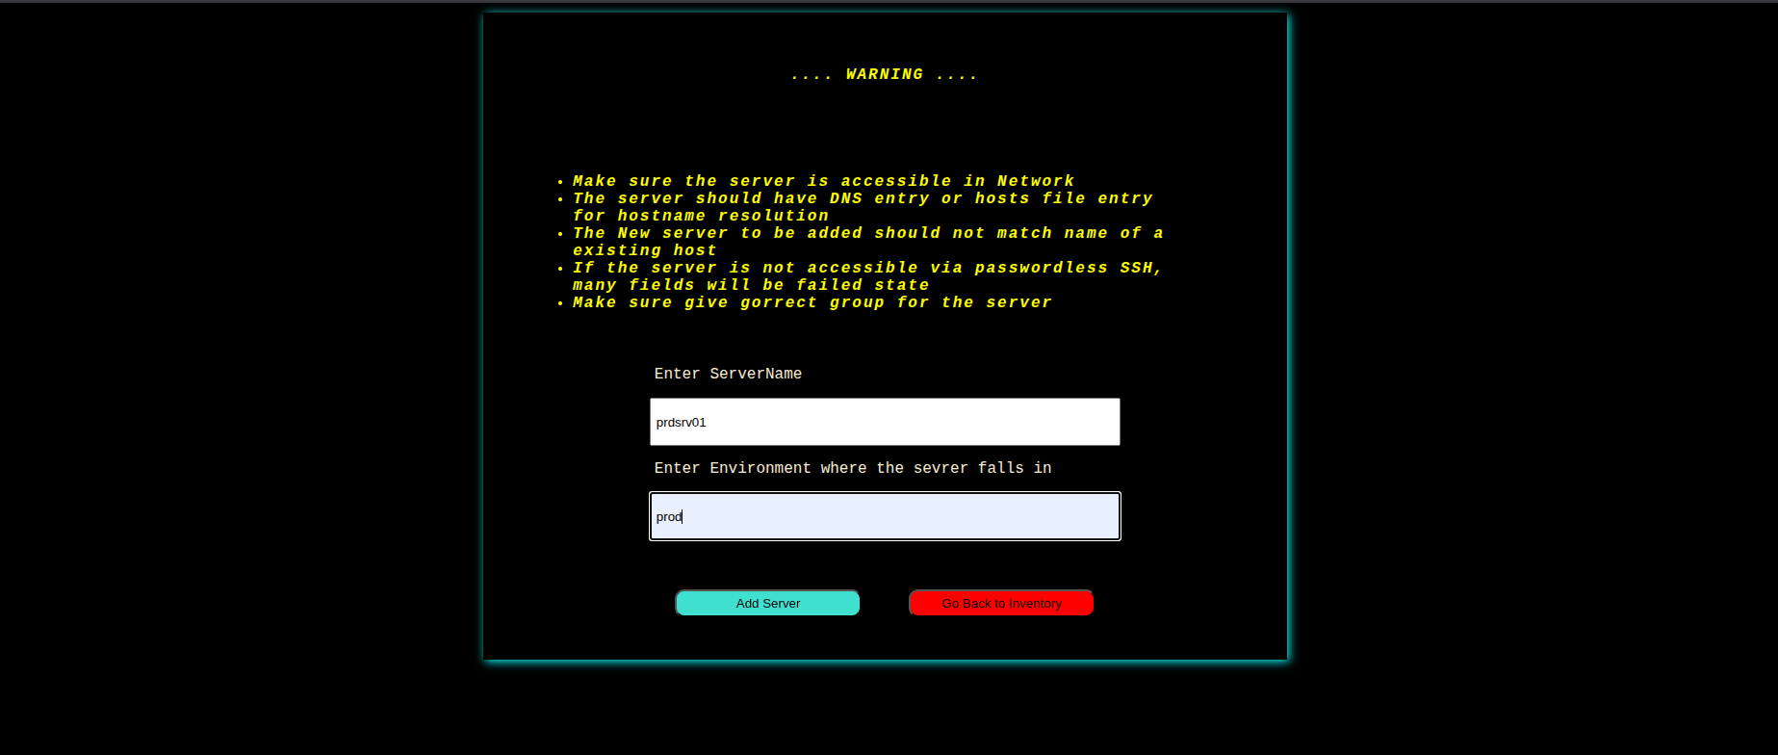

- Once submitted, it will add the server in db and show a message that the server is added

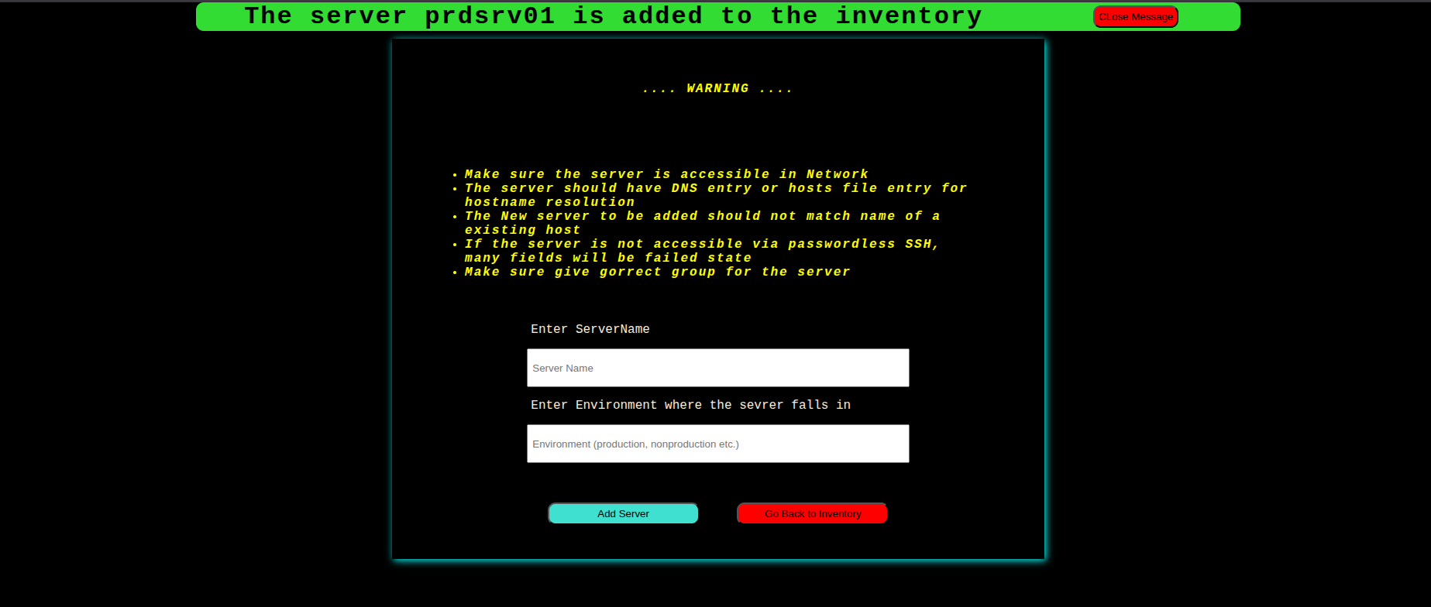
- It is not possible to add same server twice. It will throw a error
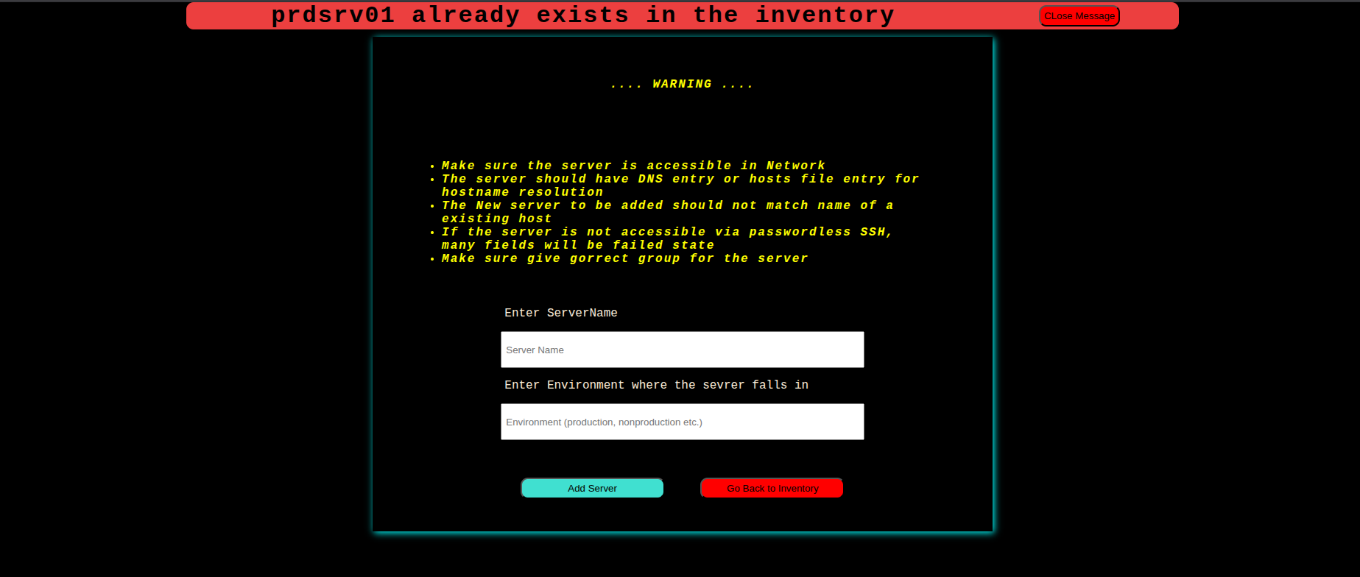
- Go back to inventory, and the new servers will be visible with uptime and OS field

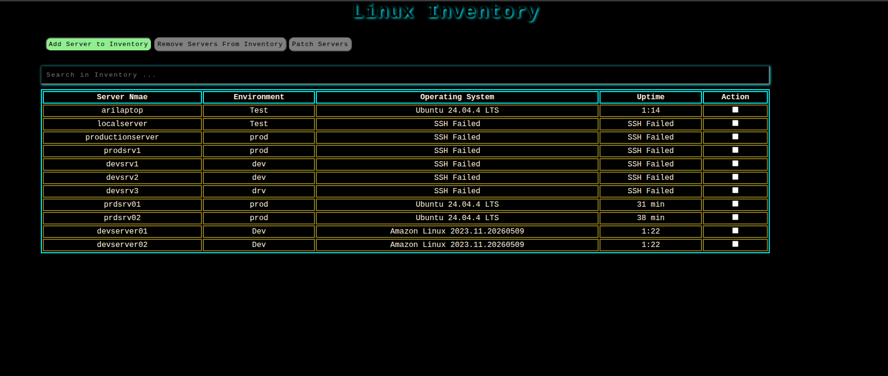

- Select the servers to be deleted and click on Remove Servers

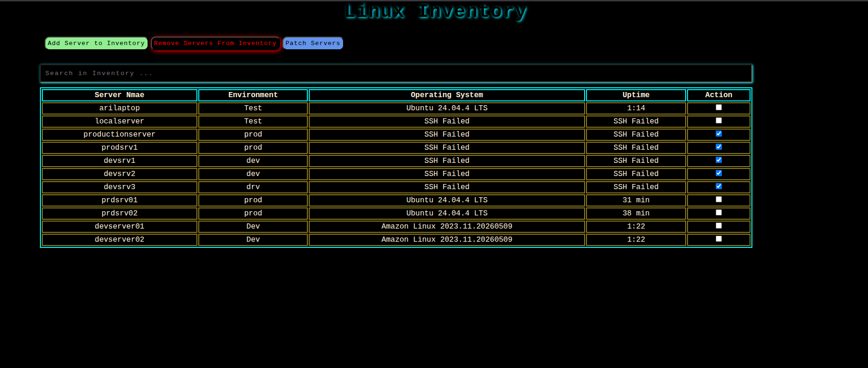
- It will ask for confirmation
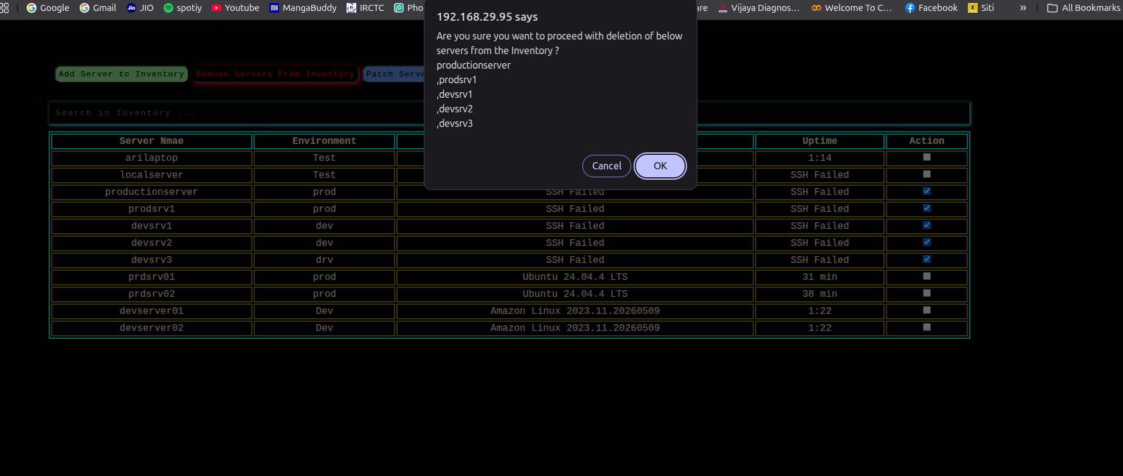
- Once confirmed it will delete the servers from db and redirect to inventory and the removed servers will be gone
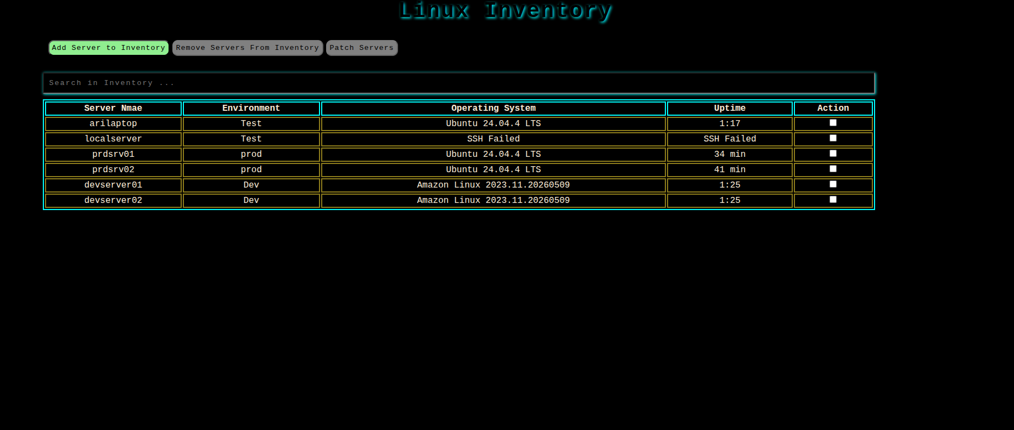

- Now Let’s move to highlight which is agentless remote patching
- Select servers and click on Patch

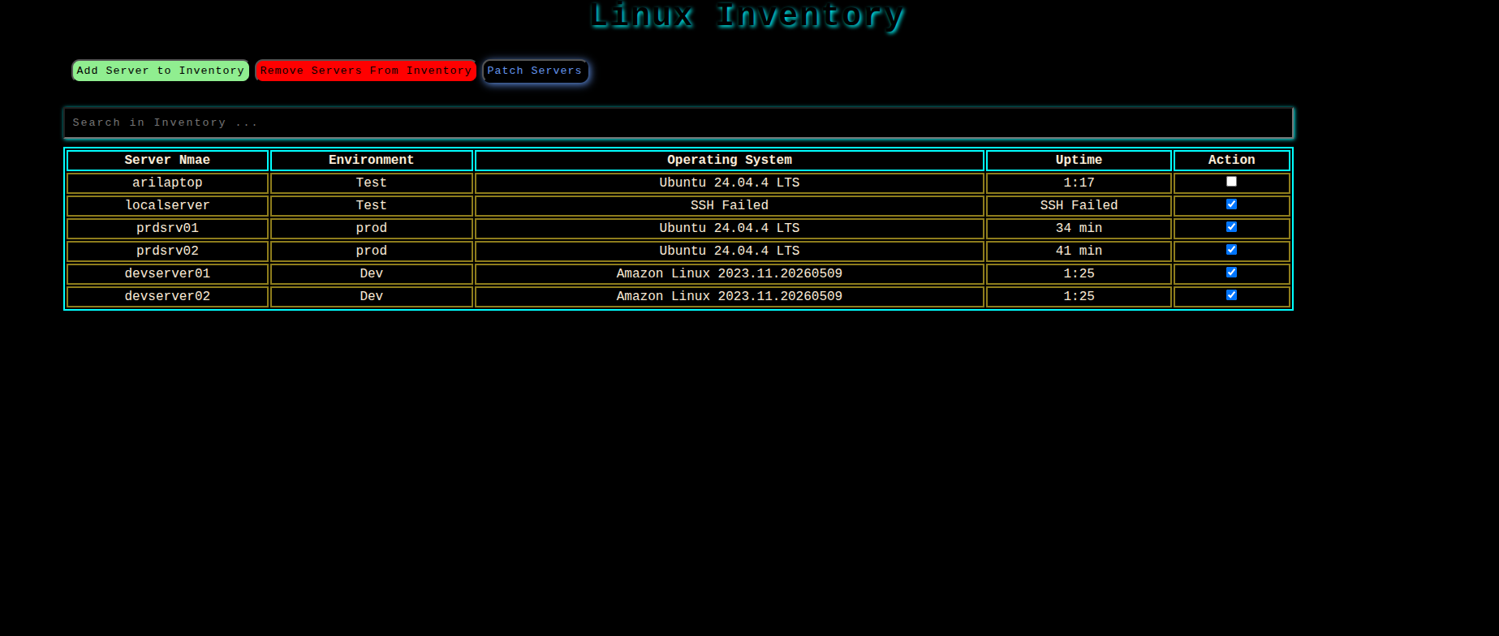
- This will ask for confirmation and once confirmed, it will redirect to a page where the selected servers will be shown and will give options to initiate patching or cancel patching
- Click on initiate patching to proceed with patching
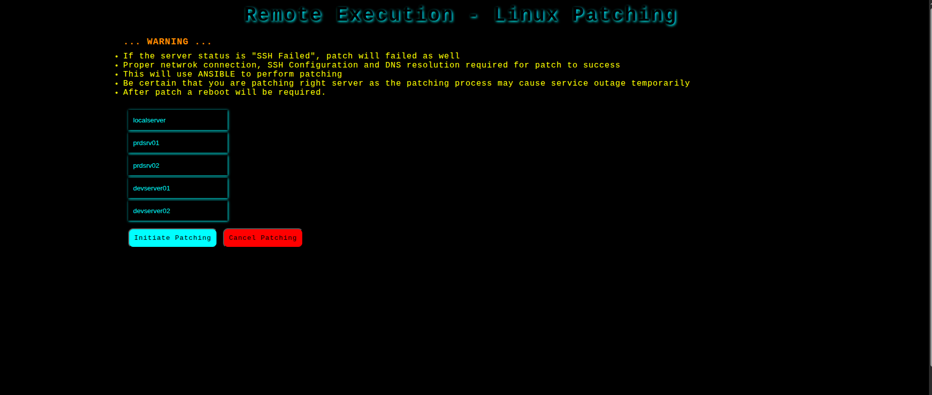

- This is totally agent less.
- The backend will use Ansible to perform this patching
- The Ansible will take prechecks → save in precheck file → initiate patching → store ansible output in a file → take postchecks → stote the postcheck in a file
- During the patch process, the webui will show a loading like “Patching in progress …”

- Once Patching is done, it will redirect to a page where the ansible output, pre/post checks and stored file patchs will be shown

