# “Opportunity Is Missed Because It Is Dressed in Overalls and Looks Like Work”

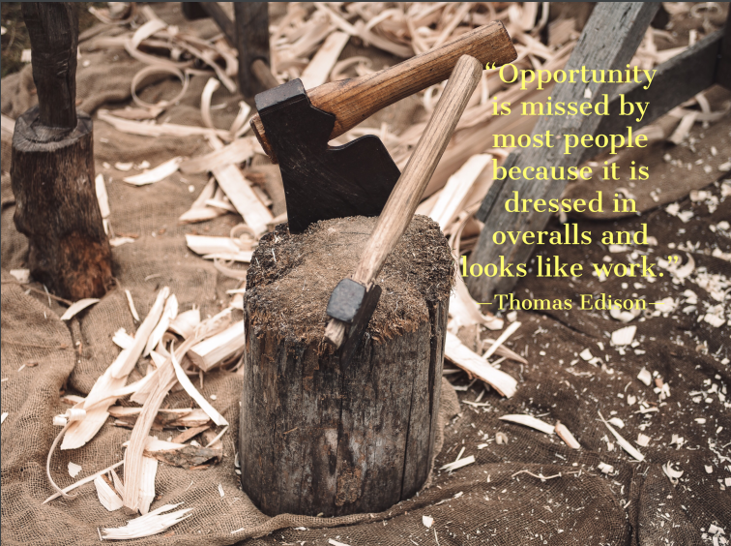

**W**hen you were a kid, did you love jumping into mud puddles? I mean the dirtier the better, right?! You just jumped right in and got messy.

**“Well, I hate to break this to you, but it’s time to do the same with your restaurant business. You can’t be afraid to roll your sleeves up and get dirty!”**

In other words, if something is worth having and growing, you have to be willing to put in the work.**There is no substitution for hard work and there is no shortcut for success.**Don’t we all wish there was – just wave a magic wand or give a little twitch of the nose and poof. But life (especially business) just doesn’t work that way.That being said, while you are putting in the hard work, you also have to be on the lookout for the opportunities. Because if you are truly doing the work, the opportunities will find you. And that’s where the sweet spot lives.

While I was working on my taxes, a quote popped up on a loading screen. The quote that appears is “Opportunity Is Missed Because It Is Dressed in Overalls and Looks Like Work” and credit goes to Thomas Edison. This quote intrigued me, because its fundamental premise struck a chord.Doing a little investigation, I discovered that the earliest rendition of this saying happened in the early 1900s and didn’t have an individual associated to it. People speak the phrase, adjust the phrase and is re-quoted by the likes of Henry Dodd, Paul Larmer and Lila Kroppmann. To my amazement, evidence tie’s Thomas Edison to the quote, though being heard during his time.

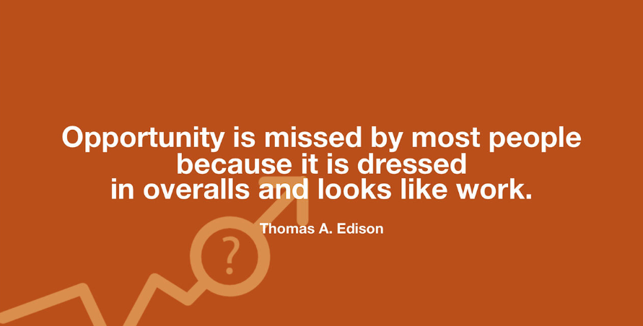What moves me most is its core notion of not recognizing opportunity based on certain stigmas. The metaphor here is of being done up in overalls and opportunities have effort behind them. During the time this quote is being thrown around, the common view of individuals who wore overalls where people of limited means. Even now when the word overalls comes to mind, the initial picture that reaches our mind might be one of a farmer.I bet that you didn’t see many overall wearing people at a high class party or a business meeting. That, my friend, is its substance. Opportunity doesn’t appear how we envision and we may look down upon it, losing the opportunity.

This concept reminds me of the Parable of the Flood, the one in which a flood traps the elderly man and he receives several opportunities for rescue. The man turns them down because the rescue is not how he interpreted his rescue happening.

* **How many times are we operating like this guy and how many opportunities pass us by?**

I am certain this life is a precious and precarious thing. We don’t understand all of life and we are discovering more about life each day. I also suspect that life has ways of showing us opportunities and it’s our responsibility to recognize them. Opportunities, as represented in this quote, don’t always show up to us how we prefer.Opportunities may also have work connected to them. You may notice an opportunity but let it leave you by because you don’t trust you have the experience or abilities. Sometimes in life, the journey is more powerful than the destination and we need to take advantage of those challenges so we can grow from them.Start your day out by informing yourself to not be frightened of the opportunities that come your way, and to recognize them as they are. If you adhere to a Religious Tradition, perhaps you can turn this into a prayer each morning.As the infamous Wayne Gretzky said, “You Miss 100% of the Shots You Never Take.” The initial step to taking those shots is to recognize them and then be willing to follow through.