FORENSITRUST: A UNIFIED FRAMEWORK FOR INSIDER THREAT & TIMESTAMP TAMPERING DETECTION
ABSTRACT:
This project presents an intelligent system that combines facial emotion detection and user activity monitoring to regulate access and usage of a computer system. The system is designed to ensure that only authorized and emotionally suitable users can access the system and that their subsequent actions are continuously monitored for security compliance. Upon entry, the user’s face is captured through the laptop’s webcam. Using face recognition, the system verifies the identity of the user against a stored dataset. Once the face is authenticated, an emotion detection model analyzes the user’s facial expression. If the detected emotion is happy, the system grants access; otherwise, access is denied.After access is granted, the system continues to monitor user behavior in real time. It tracks keyboard activity to estimate typing speed and detects abnormal or rapid typing that may indicate misuse, triggering an automatic system lock or shutdown. Additionally, the system monitors file operations, such as copying or transferring data, to prevent unauthorized data sharing. The proposed system is implemented entirely in Python, using libraries such as OpenCV, DeepFace, and pynput, making it suitable for normal laptop environments without requiring additional hardware.This project demonstrates a novel approach to workplace access control and system monitoring by integrating computer vision and user behavior analytics, offering enhanced security and accountability through emotion-based access and real-time user activity supervision.
Keywords:
Facial Emotion Detection, Face Recognition, Emotion-Based Access Control, User Activity Monitoring, Computer Vision, Behavioral Analytics, Keyboard Activity Analysis, File Access Monitoring, Real-Time Security, Human–Computer Interaction, Python-Based Security System, Workplace System Protection

INTRODUCTION:
In today’s digital era, computer systems play a vital role in organizational workflows, personal data management, and secure communication. As dependency on computer-based systems continues to increase, ensuring system security and responsible usage has become a major concern. Traditional security mechanisms such as passwords, PINs, and access cards provide a basic level of protection; however, they are often vulnerable to theft, sharing, or misuse. This has created a growing need for intelligent and adaptive security systems that go beyond conventional authentication methods.Biometric-based security systems have emerged as a promising solution to overcome the limitations of traditional access control techniques. Among various biometric traits, facial recognition stands out due to its non-intrusive nature, ease of implementation, and compatibility with commonly available hardware such as webcams. Facial recognition enables reliable user authentication by verifying an individual’s identity based on unique facial features, thereby enhancing system security and reducing unauthorized access.While identity verification is essential, it alone may not be sufficient in sensitive environments such as workplaces, laboratories, or examination systems. A user’s emotional state can significantly influence behavior, decision-making, and system usage patterns. Emotion detection using facial expressions provides an additional layer of intelligence by analyzing whether the user is in a suitable emotional condition to access the system. For instance, granting access only when a user is emotionally stable or positive can help prevent impulsive actions, misuse, or security breaches.Beyond access control, continuous monitoring of user activities is equally important to ensure compliance with security policies after login. User behavior analytics, such as keyboard activity monitoring and file operation tracking, can help identify abnormal patterns that may indicate malicious intent, stress, or unauthorized data handling. Rapid or unusual typing behavior, as well as suspicious file transfers, can serve as early indicators of potential system misuse.Advancements in computer vision, machine learning, and real-time monitoring tools have made it feasible to integrate multiple intelligent components into a single security framework. Python, with its rich ecosystem of libraries such as OpenCV for image processing, DeepFace for facial emotion analysis, and pynput for activity monitoring, provides an efficient platform for developing such systems without the need for specialized hardware.This project proposes an intelligent access control and monitoring system that integrates facial recognition, emotion detection, and user activity supervision into a unified framework. The system authenticates users based on facial identity, evaluates emotional suitability before granting access, and continuously monitors keyboard and file activities during system usage. By combining biometric authentication with emotion-based decision-making and real-time behavior analysis, the proposed approach enhances system security, accountability, and user awareness.Overall, the proposed system represents a novel and practical solution for modern workplace security, offering a proactive approach to access control and continuous system protection through intelligent human–computer interaction.

OBJECTIVE:
To design and develop an intelligent computer access control system using facial recognition technology for secure user authentication. To implement facial emotion detection to evaluate the emotional suitability of a user before granting system access. To ensure that only authorized users with acceptable emotional states are allowed to access the computer system. To monitor user behavior continuously after login for enhanced security and compliance .To analyze keyboard activity in real time to detect abnormal typing speed or suspicious usage patterns .To identify and prevent unauthorized or unsafe system usage by triggering automatic system lock or shutdown mechanisms. To monitor file operations such as copying or data transfer to prevent unauthorized data sharing or leakage .To integrate computer vision and user behavior analytics into a unified security framework .To implement the complete system using Python and open-source libraries suitable for standard laptop environments .To enhance workplace security, accountability, and responsible system usage through emotion-based access control and real-time monitoring.

PROBLEM STATEMENT:
- Existing access control systems rely solely on identity verification without assessing the emotional suitability of users.
- There is no integrated mechanism to monitor user behavior and detect abnormal activities after successful login.
- Current emotion detection systems operate independently and are not linked to system-level security responses.
- Many available models are resource-intensive, making them impractical for real-time use on standard laptops.
- The absence of emotion-driven access decisions leads to potential misuse or unauthorized system operation by emotionally unstable users.

DOMAIN OVERVIEW:

DOMAIN OVERVIEW:
Artificial intelligence vs Machine Learning vs Deep Learning
We often confuse the terms Artificial Intelligence (AI), Machine Learning (ML) and Deep Learning (DL), assuming they all mean the same thing. But in reality, they represent different levels of intelligent computing. AI is the broadest field, ML is a subset of AI and DL is a further subset of ML. Let’s define each one, highlight its features and compare them.
1. Artificial Intelligence (AI)
Artificial intelligence is the field of computer science focused on creating systems that can perform tasks requiring human-like intelligence such as reasoning, problem-solving, planning and understanding natural language. It includes rule-based systems as well as data-driven approaches like ML and DL.
- The broadest field covering ML, DL, robotics and NLP.
- Mimics human cognitive abilities like learning and decision-making.
- Divided into Narrow AI (task-specific) and General AI (human-level, not yet achieved).
- Still evolving but already powerful in real-world use cases.
- Examples: Sophia robot, AI chatbots, fraud detection, medical diagnosis.

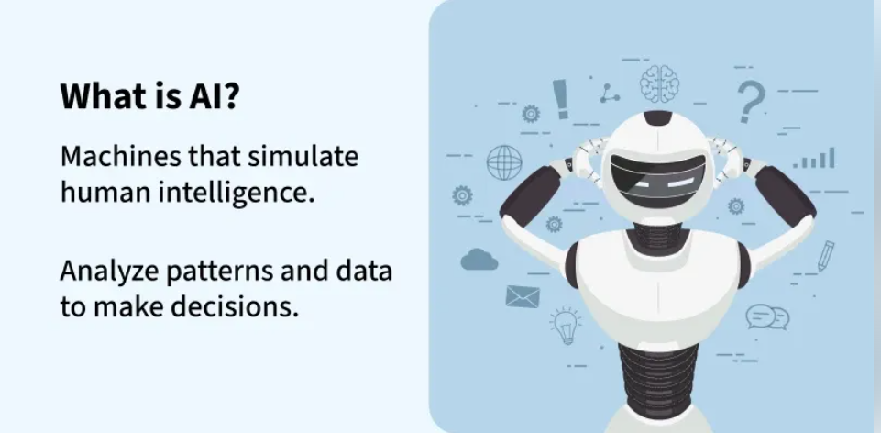

2. Machine Learning (ML)
Machine Learning is a branch of AI that enables systems to learn from data and improve their performance without being explicitly programmed. Instead of following fixed rules, ML algorithms analyze past data, detect patterns and use them to make predictions or decisions in new situations.
- Learns from structured and labeled datasets.
- Requires human input for training and corrections.
- Uses algorithms such as regression, clustering and decision trees.
- Improves accuracy with more data.
- Examples: Amazon recommendations, Netflix suggestions, spam detection.
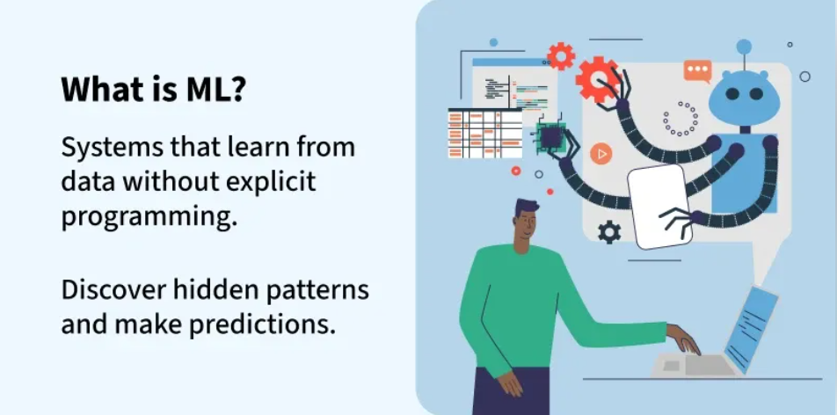
3. Deep Learning (DL)
Deep Learning is a subset of machine learning that uses artificial neural networks with many layers to automatically learn complex patterns from large datasets. Unlike traditional ML, it can extract features on its own making it useful for handling unstructured data such as images, speech and text.
- Built on neural networks inspired by the human brain.
- Learns automatically with minimal human guidance.
- Needs massive datasets and high computational power.
- Excels in tasks like vision, speech and natural language.
- Examples: Self-driving cars, facial recognition, voice assistants.

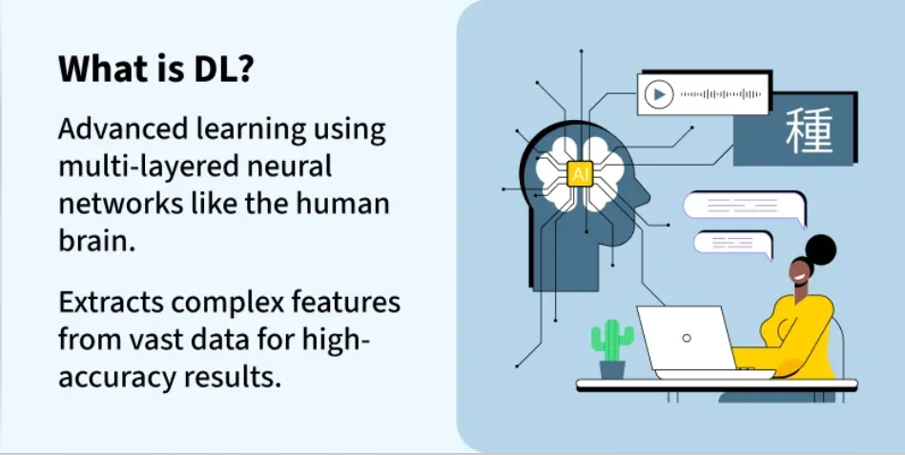

Deep Learning is transforming the way machines understand, learn and interact with complex data. Deep learning mimics neural networks of the human brain, it enables computers to autonomously uncover patterns and make informed decisions from vast amounts of unstructured data.
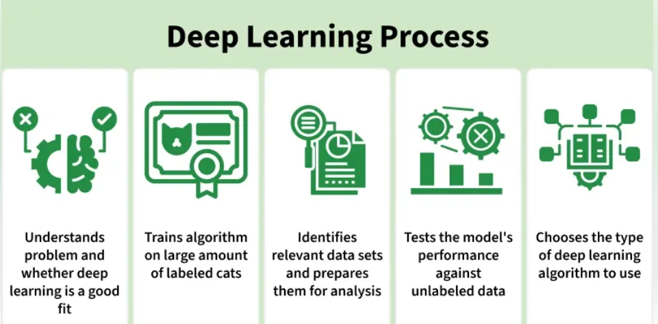

How Deep Learning Works?
Neural network consists of layers of interconnected nodes or neurons that collaborate to process input data. In a fully connected deep neural network data flows through multiple layers where each neuron performs nonlinear transformations, allowing the model to learn intricate representations of the data.
In a deep neural network the input layer receives data which passes through hidden layers that transform the data using nonlinear functions. The final output layer generates the model’s prediction.

What is a Neural Network?
Neural networks are machine learning models that mimic the complex functions of the human brain. These models consist of interconnected nodes or neurons that process data, learn patterns and enable tasks such as pattern recognition and decision-making.
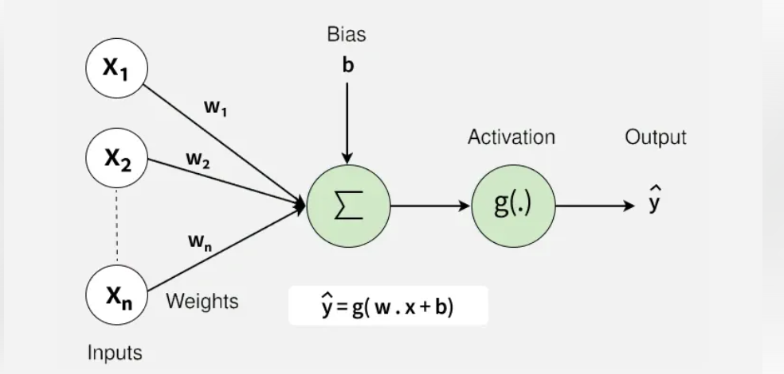

Neural networks are capable of learning and identifying patterns directly from data without pre-defined rules. These networks are built from several key components:
- Neurons: The basic units that receive inputs, each neuron is governed by a threshold and an activation function.
- Connections: Links between neurons that carry information, regulated by weights and biases.
- Weights and Biases: These parameters determine the strength and influence of connections.
- Propagation Functions: Mechanisms that help process and transfer data across layers of neurons.
- Learning Rule: The method that adjusts weights and biases over time to improve accuracy.

Learning in neural networks follows a structured, three-stage process:
- Input Computation: Data is fed into the network.
- Output Generation: Based on the current parameters, the network generates an output.
- Iterative Refinement: The network refines its output by adjusting weights and biases, gradually improving its performance on diverse tasks.

In an adaptive learning environment:
- The neural network is exposed to a simulated scenario or dataset.
- Parameters such as weights and biases are updated in response to new data or conditions.
- With each adjustment, the network’s response evolves allowing it to adapt effectively to different tasks or environments.

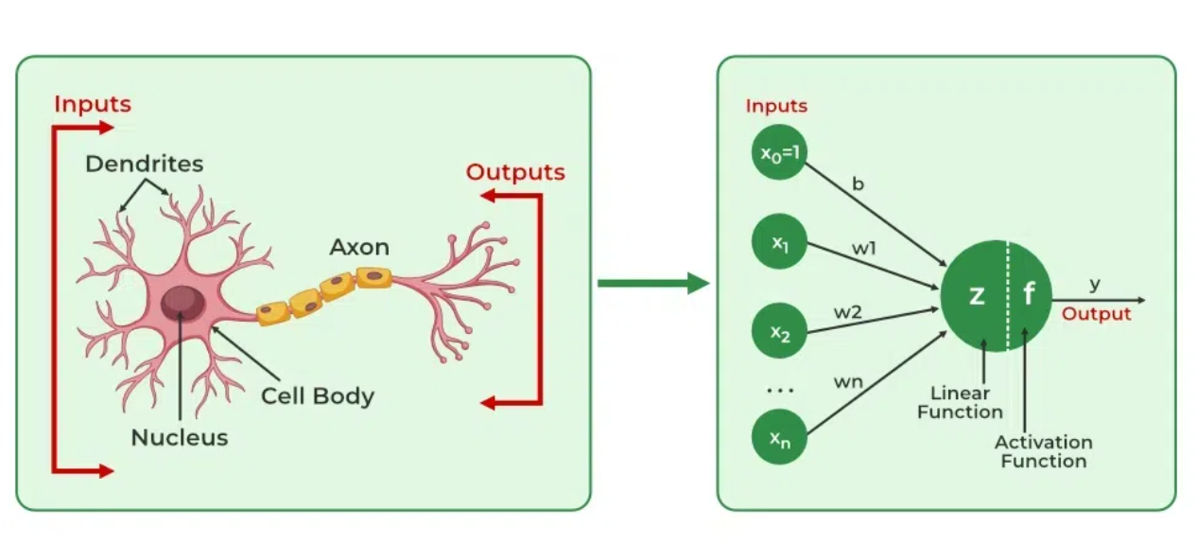

Importance of Neural Networks
- Identify Complex Patterns: Recognize intricate structures and relationships in data; adapt to dynamic and changing environments.
- Learn from Data: Handle vast datasets efficiently; improve performance with experience and retraining.
- Drive Key Technologies: Power natural language processing (NLP); enable self-driving vehicles; support automated decision-making systems.
- Boost Efficiency: Streamline workflows and processes; enhance productivity across industries.
- Backbone of AI: Serve as the core driver of artificial intelligence progress; continue shaping the future of technology and innovation.
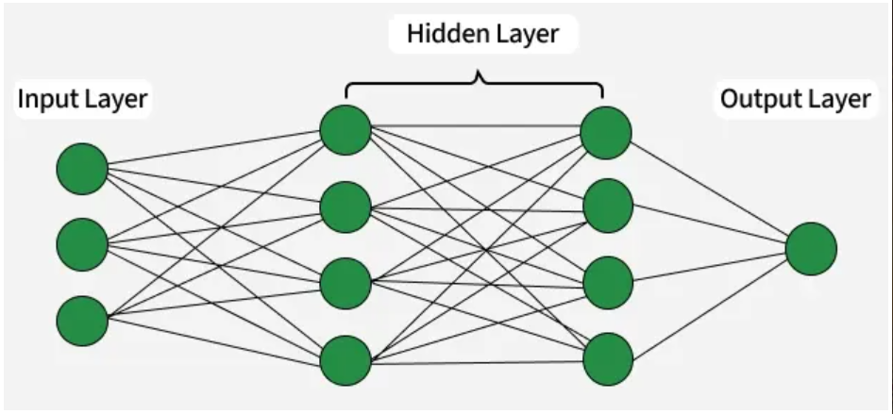
- Input Layer: This is where the network receives its input data. Each input neuron in the layer corresponds to a feature in the input data.
- Hidden Layers: These layers perform most of the computational heavy lifting. A neural network can have one or multiple hidden layers. Each layer consists of units (neurons) that transform the inputs into something that the output layer can use.
- Output Layer: The final layer produces the output of the model. The format of these outputs varies depending on the specific task like classification, regression.

Difference between Machine Learning and Deep Learning
Machine learning and Deep Learning both are subsets of artificial intelligence but there are many similarities and differences between them.
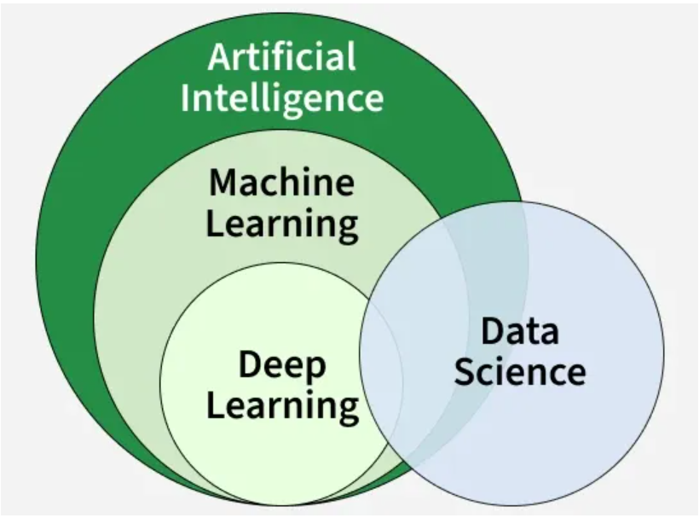

Aspect | Machine Learning | Deep Learning
Basic Idea | Applies statistical algorithms to learn patterns from data | Uses artificial neural networks to learn patterns from data
Data Requirement | Works well with small to medium datasets | Requires a large amount of data
Task Complexity | Better for simple and low-label tasks | Better for complex tasks like image and text processing
Training Time | Takes less time to train | Takes more time to train
Feature Extraction | Features are manually selected and extracted | Features are automatically extracted
Learning Process | Not end-to-end | End-to-end learning
Model Complexity | Less complex | Highly complex
Interpretability | Easy to understand and explain | Hard to interpret (black box)
Hardware Requirement | Can run on CPU, needs less computing power | Needs GPU and high-performance systems
Use Cases | Spam detection, recommendation systems | Image recognition, NLP, speech recognition

Evolution of Neural Architectures
Perceptron (1950s)
- First simple neural network with a single layer
- Could only solve linearly separable problems
- Failed on complex tasks like the XOR problem
Multi-Layer Perceptrons (MLPs)
- Introduced hidden layers and non-linear activation functions
- Enabled modeling of non-linear relationships
- Trained effectively using backpropagation
- Marked a major leap in neural network capabilities

Types of neural networks
- Feedforward neural networks (FNNs): They are the simplest type of ANN, where data flows in one direction from input to output. It is used for basic tasks like classification.
- Convolutional Neural Networks (CNNs): They are specialized for processing grid-like data, such as images. CNNs use convolutional layers to detect spatial hierarchies, making them ideal for computer vision tasks.
- Recurrent Neural Networks (RNNs): Theyare able to process sequential data, such as time series and natural language. RNNs have loops to retain information over time, enabling applications like language modeling and speech recognition. Variants like LSTMs and GRUs address vanishing gradient issues.
- Generative Adversarial Networks (GANs): This consist of two networks—a generator and a discriminator—that compete to create realistic data. GANs are widely used for image generation, style transfer and data augmentation.
- Autoencoders: They are unsupervised networks that learn efficient data encodings. They compress input data into a latent representation and reconstruct it, useful for dimensionality reduction and anomaly detection.
- Transformer Networks: It has revolutionized NLP with self-attention mechanisms. Transformers excel at tasks like translation, text generation and sentiment analysis, powering models like GPT and BERT.

Applications
1. Computer vision
In computer vision, deep learning models enable machines to identify and understand visual data. Some of the main applications of deep learning in computer vision include:
- Object detection and recognition: Deep learning models are used to identify and locate objects within images and videos, making it possible for machines to perform tasks such as self-driving cars, surveillance and robotics.
- Image classification: Deep learning models can be used to classify images into categories such as animals, plants and buildings. This is used in applications such as medical imaging, quality control and image retrieval.
- Image segmentation: Deep learning models can be used for image segmentation into different regions, making it possible to identify specific features within images.
2. Natural language processing (NLP)
In NLP, deep learning model enable machines to understand and generate human language. Some of the main applications of deep learning in NLP include:
- Automatic Text Generation: Deep learning model can learn the corpus of text and new text like summaries, essays can be automatically generated using these trained models.
- Language translation: Deep learning models can translate text from one language to another, making it possible to communicate with people from different linguistic backgrounds.
- Sentiment analysis: Deep learning models can analyze the sentiment of a piece of text, making it possible to determine whether the text is positive, negative or neutral.
- Speech recognition: Deep learning models can recognize and transcribe spoken words, making it possible to perform tasks such as speech-to-text conversion, voice search and voice-controlled devices.
3. Reinforcement learning
In reinforcement learning, deep learning works as training agents to take action in an environment to maximize a reward. Some of the main applications of deep learning in reinforcement learning include:
- Game playing: Deep reinforcement learning models have been able to beat human experts at games such as Go, Chess and Atari.
- Robotics: Deep reinforcement learning models can be used to train robots to perform complex tasks such as grasping objects, navigation and manipulation.
- Control systems: Deep reinforcement learning models can be used to control complex systems such as power grids, traffic management and supply chain optimization.
Advantages
- High accuracy: Deep Learning algorithms can achieve state-of-the-art performance in various tasks such as image recognition and natural language processing.
- Automated feature engineering: Deep Learning algorithms can automatically discover and learn relevant features from data without the need for manual feature engineering.
- Scalability: Deep Learning models can scale to handle large and complex datasets and can learn from massive amounts of data.
- Flexibility: Deep Learning models can be applied to a wide range of tasks and can handle various types of data such as images, text and speech.
Disadvantages
Here are some of the main challenges in deep learning:
- Data availability: It requires large amounts of data to learn from. For using deep learning it's a big concern to gather as much data for training.
- Computational Resources: For training the deep learning model, it is computationally expensive because it requires specialized hardware like GPUs and TPUs.
- Interpretability: Deep learning models are complex, it works like a black box. It is very difficult to interpret the result.
- Overfitting: when the model is trained again and again it becomes too specialized for the training data leading to overfitting and poor performance on new data.

What is Image Processing?
Image processing is a method used to perform operations on an image to enhance it or to extract useful information from it. It involves various techniques and algorithms that process images in a digital format. This can include a range of tasks such as improving the visual quality of images, detecting patterns, segmenting objects, and transforming images into different formats. Image processing can be used for both photos and video frames. The process usually involves steps such as inputting the image, processing the image through various algorithms, and then outputting the results in a format that is usable or can be further analyzed.
Types of Image Processing
1. Analog Image Processing
Analog image processing refers to techniques used to process images in their analog form, such as photographs, printed pictures, or images captured on film. This type of processing involves modifying images through physical or chemical means. Before the advent of digital technology, all image processing was done using analog methods. These methods are generally less flexible and more time-consuming compared to digital techniques, but they have historical significance and specific applications.
2. Digital Image Processing
Digital image processing involves the use of computer algorithms to perform operations on digital images. Unlike analog processing, digital techniques offer more flexibility, precision, and automation. Digital images are composed of pixels, and processing these images involves manipulating pixel values to achieve the desired effect. The use of digital processing is widespread due to its efficiency and the vast array of tools and techniques available.
Image Processing Techniques
- Image Enhancement
- Image Restoration
- Image Segmentation
- Image Compression
- Image Synthesis
- Feature Extraction
- Morphological Processing
Applications of Image Processing
1. Medical Imaging
- MRI and CT Scans: Enhancing the clarity of MRI and CT scans for better diagnosis and treatment planning.
- X-Ray Imaging: Improving the quality and detail of X-ray images to detect fractures, tumors, and other anomalies.
- Ultrasound Imaging: Enhancing ultrasound images for more accurate visualization of internal organs and fetal development.
2. Remote Sensing
- Satellite Imaging: Analyzing satellite images for applications like land use mapping and resource monitoring.
- Aerial Photography: Using drones and aircraft to capture high-resolution images for mapping and surveying.
- Environmental Monitoring: Monitoring environmental changes and natural disasters using image analysis.
3. Industrial Inspection
- Quality Control: Automating the inspection process to ensure product quality and consistency.
- Defect Detection: Detecting defects in manufacturing processes to maintain high standards.
- Robotics Vision: Enabling robots to interpret and navigate their environment using image processing techniques.
4. Security and Surveillance
- Facial Recognition: Identifying individuals by analyzing facial features for security purposes.
- Object Detection: Detecting and identifying objects in surveillance footage to enhance security measures.
- Motion Detection: Monitoring and detecting movement in video feeds for security and surveillance.
5. Automotive Industry
- Autonomous Vehicles: Processing images from sensors to enable autonomous driving.
- Traffic Sign Recognition: Identifying and interpreting traffic signs to assist drivers and autonomous systems.
- Driver Assistance Systems: Enhancing driver safety with features like lane departure warnings and collision avoidance.
6. Entertainment and Multimedia
- Photo and Video Editing: Enhancing and manipulating images and videos for artistic and practical purposes.
- Virtual Reality and Augmented Reality: Creating immersive experiences by integrating real-world images with virtual elements.
- Gaming: Enhancing graphics and creating realistic environments in video games.
7. Document Processing
- OCR (Optical Character Recognition): Converting printed text into digital text for easy editing and searching.
- Barcode and QR Code Scanning: Reading and interpreting barcodes and QR codes for quick information retrieval.
- Document Enhancement and Restoration: Improving the quality of scanned documents and restoring old or damaged documents.

SOFTWARE REQUIREMENTS:
PYTHON:
Python is one of the most popular programming languages. It’s simple to use, packed with features and supported by a wide range of libraries and frameworks. Its clean syntax makes it beginner-friendly.
- A high-level language, used in data science, automation, AI, web development and more.
- Known for its readability, which means code is easier to write, understand and maintain.
- Backed by strong library support, we don’t have to build everything from scratch.

Basic Code Example
- The following is a simple program that displays the message “Hello, World!” on the screen
# Python Program to Print Hello World!

print("Hello World!")
Why Learn Python?
- Requires fewer lines of code compared to other programming languages like Java.
- Provides Libraries / Frameworks like Django, Flask and many more for Web Development, and Pandas, Tensorflow, Scikit-learn and many more for, AI/ML, Data Science and Data Analysis
- Cross-platform, works on Windows, Mac and Linux without major changes.
- Used by top tech companies like Google, Netflix and NASA.
- Many Python coding job opportunities in Software Development, Data Science and AI/ML.
Python: Python Is An Object-Oriented, High Level Language, Interpreted, Dynamic And Multipurpose Programming Language.
Python Is Easy To Learn Yet Powerful And Versatile Scripting Language Which Makes It Attractive For Application Development.
Python's Syntax And Dynamic Typing With Its Interpreted Nature, Make It An Ideal Language For Scripting And Rapid Application Development In Many Areas.
Python Supports Multiple Programming Pattern, Including Object Oriented Programming, Imperative And Functional Programming Or Procedural Styles.
Python Is Not Intended To Work On Special Area Such As Web Programming. That Is Why It Is Known As Multipurpose Because It Can Be Used With Web, Enterprise, 3d Cad Etc.
We Don't Need To Use Data Types To Declare Variable Because It Is Dynamically Typed So We Can Write A=10 To Declare An Integer Value In A Variable.
Python Makes The Development And Debugging Fast Because There Is No Compilation Step Included In Python Development And Edit-Test-Debug Cycle Is Very Fast.
2. Python Features

1) Easy To Use:
Python Is Easy To Very Easy To Use And High Level Language. Thus It Is Programmer-Friendly Language.

2) Expressive Language:
Python Language Is More Expressive. The Sense Of Expressive Is The Code Is Easily Understandable.

3) Interpreted Language:
Python Is An Interpreted Language I.E. Interpreter Executes The Code Line By Line At A Time. This Makes Debugging Easy And Thus Suitable For Beginners.

4) Cross-Platform Language:
Python Can Run Equally On Different Platforms Such As Windows, Linux, Unix , Macintosh Etc. Thus, Python Is A Portable Language.

5) Free And Open Source:
Python Language Is Freely Available(Www.Python.Org).The Source-Code Is Also Available. Therefore It Is Open Source.

6) Object-Oriented Language:
Python Supports Object Oriented Language. Concept Of Classes And Objects Comes Into Existence.

7) Extensible:
It Implies That Other Languages Such As C/C++ Can Be Used To Compile The Code And Thus It Can Be Used Further In Your Python Code.

8) Large Standard Library:
Python Has A Large And Broad Library.

9) Gui Programming:
Graphical User Interfaces Can Be Developed Using Python.

10) Integrated:
It Can Be Easily Integrated With Languages Like C, C++, Java Etc.

3. Python History
- Python Laid Its Foundation In The Late 1980s.
- The Implementation Of Python Was Started In The December 1989 By Guido Van Rossum At Cwi In Netherland.
- Abc Programming Language Is Said To Be The Predecessor Of Python Language Which Was Capable Of Exception Handling And Interfacing With Amoeba Operating System.
- Python Is Influenced By Programming Languages Like:
  - Abc Language.
  - Modula-3

5. Python Applications
Python As A Whole Can Be Used In Any Sphere Of Development.
Let Us See What Are The Major Regions Where Python Proves To Be Handy.

1) Console Based Application
Python Can Be Used To Develop Console Based Applications. For Example: Ipython.

2) Audio Or Video Based Applications
Python Proves Handy In Multimedia Section. Some Of Real Applications Are: Timplayer, Cplay Etc.

3) 3d Cad Applications
Fandango Is A Real Application Which Provides Full Features Of Cad.

4) Web Applications
Python Can Also Be Used To Develop Web Based Application. Some Important Developments Are: Pythonwikiengines, Pocoo, Pythonblogsoftware Etc.

5) Enterprise Applications
Python Can Be Used To Create Applications Which Can Be Used Within An Enterprise Or An Organization. Some Real Time Applications Are: Openerp, Tryton, Picalo Etc.

6) Applications For Images
Using Python Several Application Can Be Developed For Image. Applications Developed Are: Vpython, Gogh, Imgseek Etc.
There Are Several Such Applications Which Can Be Developed Using Python

6. Python Example
Python Code Is Simple And Easy To Run. Here Is A Simple Python Code That Will Print "Welcome To Python".
A Simple Python Example Is Given Below.
- >>> A="Welcome To Python"
- >>> Print A
- Welcome To Python
- >>>
Explanation:
- Here We Are Using Idle To Write The Python Code. Detail Explanation To Run Code Is Given In Execute Python Section.
- A Variable Is Defined Named "A" Which Holds "Welcome To Python".
- "Print" Statement Is Used To Print The Content. Therefore "Print A" Statement Will Print The Content Of The Variable. Therefore, The Output "Welcome To Python" Is Produced.

- Python idle
- Anaconda navigator
- opencv
- HARDWARE REQUIREMENTS
- The most common set of requirements defined by any operating system or software application is the physical computer resources, also known as hardware, A hardware requirements list is often accompanied by a hardware compatibility list (HCL), especially in case of operating systems. An HCL lists tested, compatible, and sometimes incompatible hardware devices for a particular operating system or application. The following sub-sections discuss the various aspects of hardware requirements.
- Architecture – All computer operating systems are designed for a particular computer architecture. Most software applications are limited to particular operating systems running on particular architectures. Although architecture-independent operating systems and applications exist, most need to be recompiled to run on a new architecture. See also a list of common operating systems and their supporting architectures.
- Processing power – The power of the central processing unit (CPU) is a fundamental system requirement for any software. Most software running on x86 architecture define processing power as the model and the clock speed of the CPU. Many other features of a CPU that influence its speed and power, like bus speed, cache, and MIPS are often ignored. This definition of power is often erroneous, as AMD Athlon and Intel Pentium CPUs at similar clock speed often have different throughput speeds. Intel Pentium CPUs have enjoyed a considerable degree of popularity, and are often mentioned in this category.
- Memory – All software, when run, resides in the random access memory (RAM) of a computer. Memory requirements are defined after considering demands of the application, operating system, supporting software and files, and other running processes. Optimal performance of other unrelated software running on a multi-tasking computer system is also considered when defining this requirement.
- Secondary storage – Hard-disk requirements vary, depending on the size of software installation, temporary files created and maintained while installing or running the software, and possible use of swap space (if RAM is insufficient).
- Display adapter – Software requiring a better than average computer graphics display, like graphics editors and high-end games, often define high-end display adapters in the system requirements.
- Peripherals – Some software applications need to make extensive and/or special use of some peripherals, demanding the higher performance or functionality of such peripherals. Such peripherals include CD-ROM drives, keyboards, pointing devices, network devices, etc.
1)Operating System : Windows Only
2)Processor : i5 and above
3)Ram : 4gb and above
4)Hard Disk : 50 GB

LITERATURE REVIEW:

No. | Research Paper Title | Authors | Model / Technique Used | Advantages | Research Gaps
1 | Emotion Recognition from Facial Expressions using Deep Learning | Ekman et al. | CNN, Deep Neural Networks | High accuracy in emotion classification; real-time capability | Does not integrate access control or security systems
2 | Face Recognition-Based Authentication System | Turk & Pentland | Eigenfaces, PCA | Efficient face authentication; low computational cost | No emotion analysis or post-login monitoring
3 | Real-Time Facial Emotion Detection Using CNN | Mollahosseini et al. | CNN | Robust emotion detection under controlled environments | Performance degrades in real-world lighting conditions
4 | Biometric Access Control Using Face Recognition | Jain et al. | Haar Cascade + LBPH | Non-intrusive and easy to deploy | Limited to identity verification only
5 | Emotion-Aware Human–Computer Interaction Systems | Picard | Affective Computing Models | Improves user interaction and system intelligence | Not designed for security or access restriction
6 | Keyboard Dynamics for User Authentication | Monrose & Rubin | Keystroke Dynamics, Statistical Models | Continuous user authentication; low hardware cost | Does not consider emotional or facial features
7 | Behavior-Based Intrusion Detection System | Denning | Rule-Based IDS | Detects abnormal user activities | Lacks biometric or emotion-based validation
8 | Facial Expression Recognition Using DeepFace | Taigman et al. | DeepFace CNN Model | High facial feature extraction accuracy | Requires large datasets and high computation
9 | User Activity Monitoring for Insider Threat Detection | Bishop et al. | Machine Learning Classifiers | Detects malicious insider behavior | No real-time facial or emotion-based verification
10 | Emotion Detection Using OpenCV and Machine Learning | Happy & Routray | SVM, Haar Cascade | Simple and fast implementation | Limited emotion classes and lower accuracy
11 | Secure System Access Using Multimodal Biometrics | Ross & Jain | Face + Voice Biometrics | Improved authentication accuracy | Complex system design; no emotion filtering
12 | Continuous Authentication Using Behavioral Biometrics | Eberz et al. | Keystroke & Mouse Dynamics | Enhances security after login | Does not include facial emotion or vision-based monitoring

SYSTEM ANALYSIS:
EXISTING METHOD:
- Existing systems primarily rely on passwords, PINs, or biometric authentication such as fingerprints or facial recognition for granting access.
- These systems focus only on identity verification and do not consider the emotional state or behavioral suitability of the user.
- There is no continuous monitoring of user activity after login, leaving systems vulnerable to misuse once access is granted.
- Current emotion detection models operate independently and are not connected to security or access control mechanisms.
- Overall, existing systems provide limited adaptability and intelligence, failing to respond dynamically to real-time user behavior or emotions.

DISADVANTAGES:
- Existing systems rely heavily on static authentication methods such as passwords and PINs, which are vulnerable to theft, guessing, and sharing.
- Biometric authentication methods like fingerprint or facial recognition are limited to identity verification and do not assess the user’s emotional or mental state.
- Once access is granted, there is no continuous monitoring of user behavior, increasing the risk of insider threats and misuse.
- Current systems fail to detect abnormal activities such as unusually rapid typing or suspicious behavioral patterns during system usage.

PROPOSED SYSTEM:
- The proposed system integrates facial recognition and emotion detection to allow access only to authorized and emotionally suitable users.
- A webcam-based facial authentication module verifies the user’s identity against a pre-stored dataset in real time.
- After successful authentication, an emotion analysis model using DeepFace determines if the user’s emotion (e.g., happy) is appropriate for system access.
- Once access is granted, the system performs continuous user activity monitoring, including typing speed and file operations, to detect abnormal behavior.
- If any suspicious activity is detected, the system automatically locks or shuts down the computer to prevent misuse, ensuring enhanced security and accountability.

- Face_module: face_recognition
- Emotion module: deepface
- File monitoring : watchdog
- Keyboard monitoring: pynput

ADVANTAGES:

- Provides enhanced security by combining facial recognition with emotion-based access control instead of relying on a single authentication factor.
- Ensures that only authorized users in an emotionally suitable state are granted access to the system.
- Eliminates risks associated with password sharing, theft, or brute-force attacks.
- Enables real-time facial authentication using a standard webcam without the need for additional hardware.
- Integrates emotion detection directly into the access control mechanism, increasing system intelligence and adaptability.

FUNCTIONAL REQUIREMENTS
1.Data Collection
2.Data Preprocessing
3.Training And Testing
4.Modeling
5.Predicting

NON FUNCTIONAL REQUIREMENTS
NON-FUNCTIONAL REQUIREMENT (NFR) specifies the quality attribute of a software system. They judge the software system based on Responsiveness, Usability, Security, Portability and other non-functional standards that are critical to the success of the software system. Example of nonfunctional requirement, “how fast does the website load?” Failing to meet non-functional requirements can result in systems that fail to satisfy user needs. Non- functional Requirements allows you to impose constraints or restrictions on the design of the system across the various agile backlogs. Example, the site should load in 3 seconds when the number of simultaneous users are > 10000. Description of non-functional requirements is just as critical as a functional requirement.
- Usability requirement
- Serviceability requirement
- Manageability requirement
- Recoverability requirement
- Security requirement
- Data Integrity requirement
- Capacity requirement
- Availability requirement
- Scalability requirement
- Interoperability requirement
- Reliability requirement
- Maintainability requirement
- Regulatory requirement
- Environmental requirement
APPLICATIONS:
- Workplace Security Systems
- Research Laboratories
- Government and Defense Offices

SYSTEM ARCHITECTURE:
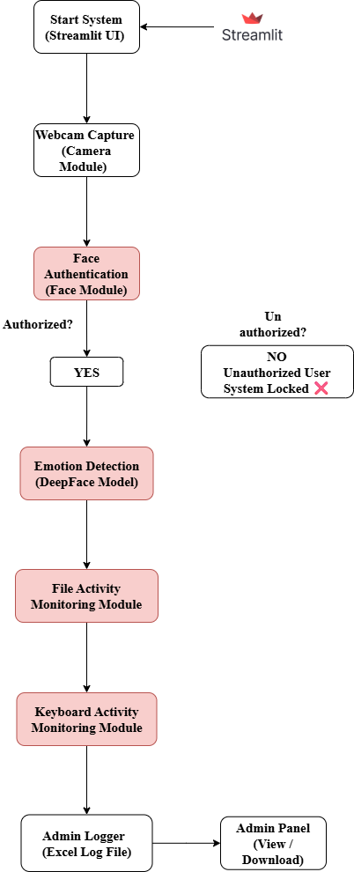
IMPLEMENTATION MODULE:
User Interface Module (Streamlit)
The User Interface module serves as the front-end of the AI Multi-Level Security System. It is developed using the Streamlit framework, which provides an interactive and user-friendly web interface. This module allows users to start the security system and enables administrators to access security logs. The interface displays real-time system status messages such as face authentication progress, emotion detection results, and activity monitoring updates. Additionally, the admin panel allows viewing and downloading logged security data in Excel or CSV format for audit and analysis purposes.

Camera Module
The Camera module is responsible for capturing live video input from the laptop’s webcam. It continuously acquires frames and supplies them to the facial authentication and emotion detection modules. This module acts as the primary input source for all vision-based analysis. Since it relies only on a standard webcam, the system does not require any additional hardware, making it cost-effective and easily deployable in normal laptop environments.

Face Authentication Module
The Face Authentication module verifies the identity of the user by comparing live facial images with a pre-stored facial dataset. It extracts distinctive facial features and performs real-time face matching to identify authorized users. If the detected face matches an entry in the authorized database, the user’s identity is confirmed and access is granted to the next stage. If no match is found, the system immediately denies access and locks further operations. This module ensures that only legitimate users can initiate system usage.

Recognize and manipulate faces from Python or from the command line with the world’s simplest face recognition library.
Built using dlib’s state-of-the-art face recognition built with deep learning. The model has an accuracy of 99.38% on the Labeled Faces in the Wild benchmark.
This also provides a simple face_recognition command line tool that lets you do face recognition on a folder of images from the command line!
Features
Find faces in pictures
Find all the faces that appear in a picture:
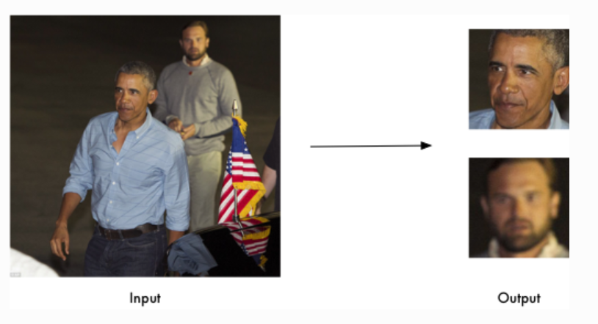
Facial recognition is a biometric technology using AI to identify or verify a person from a digital image or video by analyzing unique facial features, creating a digital "faceprint" that's compared to a database. It works by capturing an image, detecting the face, extracting key landmarks (eyes, nose, jawline), converting these into a template, and matching it to stored data, often used for security, unlocking phones (FaceID), and law enforcement
How does facial recognition work?
Face recognition is a form of artificial intelligence (AI) that mimics a human capability to recognize human faces. Just like when a human recognizes a face, facial recognition software captures facial features and creates a pattern of facial features which it uses to identify or group a face.

Facial recognition process:


An image is captured.


AI image recognition software reads the geometry of the face in the image by looking at the distance between key facial features, creating a unique facial template.


The facial template is compared to a database of known, stored, or available faces.


A determination is made if a match is found in the existing database.

Emotion Detection Module
After successful facial authentication, the Emotion Detection module evaluates the emotional state of the authenticated user. Using the DeepFace model, the system analyzes facial expressions and classifies emotions such as happy, neutral, sad, angry, or fearful. The detected emotion is used as an additional decision-making factor for system access. This module introduces emotional intelligence into the security framework by ensuring that access is granted only when the user is emotionally suitable, thereby reducing impulsive or risky system usage.

DeepFace is used for emotion detection to build smart, responsive applications by analyzing facial expressions in real-time (happy, sad, angry, surprise, etc.) for enhanced human-computer interaction, customer analytics, healthcare monitoring (mental health), driver safety, and personalized content, leveraging deep learning models for high accuracy in identifying human emotional states from images or video

File Activity Monitoring Module
The File Activity Monitoring module tracks file-related operations performed by the user after login. It monitors actions such as file access, copying, modification, or transfer. Any suspicious or unauthorized file operation is recorded for security analysis. This module plays a crucial role in preventing data leakage and unauthorized data sharing, especially in environments where sensitive information is handled. The monitored activity details are stored for administrative review.


Python’s watchdog library makes it easy to monitor your file system and respond to these changes automatically. Watchdog is a cross-platform API that allows you to run commands in response to any changes in the file system being monitored. We can set triggers on multiple events such as file creation, modification, deletion, and movement, and then respond to these changes with our custom scripts.

Basic Usage

Let's create a simple script ‘main.py’ that monitors a directory and prints a message whenever a file is created, modified, or deleted.
Some useful methods of FileSystemEventHandler are explained below.
- on_any_event: Executed for any event.
- on_created: Executed upon creation of a new file or directory.
- on_modified: Executed upon modification of a file or when a directory is renamed.
- on_deleted: Triggered upon the deletion of a file or directory.
- on_moved: Triggered when a file or directory is relocated.

Keyboard Activity Monitoring Module
The Keyboard Activity Monitoring module continuously observes user typing behavior. It calculates typing speed and detects irregular or unusually rapid keystroke patterns that may indicate stress, automated scripts, or malicious activity. By analyzing keyboard dynamics, this module provides behavioral authentication even after login. Abnormal activity can trigger alerts or automatic system lock actions, enhancing real-time protection.

For keyboard activity monitoring in Python, the most widely recommended and cross-platform modules are pynput and keyboard. These libraries can hook global events (capturing keys regardless of application focus) and allow you to define callback functions for key presses and releases.
Key Python Modules for Keyboard Monitoring
- pynput: A robust library that allows you to control and monitor both keyboard and mouse inputs. It works on Windows, macOS (experimental), and Linux.
- keyboard: A simple, pure-Python library focused specifically on the keyboard. It works on Windows and Linux (requires sudo) and offers features like hotkey registration and recording/replaying key events. It does not work well over SSH connections.

Admin Logger Module
The Admin Logger module is responsible for securely storing all security-related information. It logs details such as the authenticated user’s name, detected emotion, file activity status, and keyboard speed into an Excel file. This structured logging enables transparency, accountability, and traceability of system usage. The stored logs serve as valuable evidence for auditing, investigation, and compliance purposes.

Admin Panel Module
The Admin Panel module provides administrators with complete visibility into system activities. Using the Streamlit interface, administrators can view security logs in a tabular format and download them for offline analysis. This module supports system supervision, policy enforcement, and security audits by offering a centralized monitoring dashboard.

UML DIAGRAMS
The Unified Modeling Language (UML) is used to specify, visualize, modify, construct and document the artifacts of an object-oriented software intensive system under development. UML offers a standard way to visualize a system's architectural blueprints, including elements such as:
- actors
- business processes
- (logical) components
- activities
- programming language statements
- database schemas, and
- Reusable software components.

UML combines best techniques from data modeling (entity relationship diagrams), business modeling (work flows), object modeling, and component modeling. It can be used with all processes, throughout the software development life cycle, and across different implementation technologies. UML has synthesized the notations of the Booch method, the Object-modeling technique (OMT) and Object-oriented software engineering (OOSE) by fusing them into a single, common and widely usable modeling language. UML aims to be a standard modeling language which can model concurrent and distributed systems.
Sequence Diagram:
Sequence Diagrams Represent the objects participating the interaction horizontally and time vertically. A Use Case is a kind of behavioral classifier that represents a declaration of an offered behavior. Each use case specifies some behavior, possibly including variants that the subject can perform in collaboration with one or more actors. Use cases define the offered behavior of the subject without reference to its internal structure. These behaviors, involving interactions between the actor and the subject, may result in changes to the state of the subject and communications with its environment. A use case can include possible variations of its basic behavior, including exceptional behavior and error handling.
Activity Diagrams-:
- Activity diagrams are graphical representations of Workflows of stepwise activities and actions with support for choice, iteration and concurrency.In the Unified Modeling Language, activity diagrams can be used to describe the business and operational step-by-step workflows of components in a system. An activity diagram shows the overall flow of control.
Usecase diagram:
- UML is a standard language for specifying, visualizing, constructing, and documenting the artifacts of software systems.
- UML was created by Object Management Group (OMG) and UML 1.0 specification draft was proposed to the OMG in January 1997.
- OMG is continuously putting effort to make a truly industry standard.
- UML stands for Unified Modeling Language.
- UML is a pictorial language used to make software blue prints
Collaboration
A collaboration diagram resembles a flowchart that portrays the roles, functionality and behavior of individual objects as well as the overall operation of the system in real time. Objects are shown as rectangles with naming labels inside. These labels are preceded by colons and may be underlined. The relationships between the objects are shown as lines connecting the rectangles. The messages between objects are shown as arrows connecting the relevant rectangles along with labels that define the message sequencing
Class diagram
The class diagram is the main building block of object-oriented modeling. It is used for general conceptual modeling of the systematic of the application, and for detailed modeling translating the models into programming code. Class diagrams can also be used for data modeling.[1] The classes in a class diagram represent both the main elements, interactions in the application, and the classes to be programmed.

In the diagram, classes are represented with boxes that contain three compartments:

The top compartment contains the name of the class. It is printed in bold and centered, and the first letter is capitalized.
The middle compartment contains the attributes of the class. They are left-aligned and the first letter is lowercase.
The bottom compartment contains the operations the class can execute. They are also left-aligned and the first letter is lowercase.
Component diagram
Component diagram is a special kind of diagram in UML. The purpose is also different from all other diagrams discussed so far. It does not describe the functionality of the system but it describes the components used to make those functionalities.

Thus from that point of view, component diagrams are used to visualize the physical components in a system. These components are libraries, packages, files, etc.

Component diagrams can also be described as a static implementation view of a system. Static implementation represents the organization of the components at a particular moment.

A single component diagram cannot represent the entire system but a collection of diagrams is used to represent the whole.

The purpose of the component diagram can be summarized as −

- Visualize the components of a system.

- Construct executables by using forward and reverse engineering.

- Describe the organization and relationships of the components.

ER Diagram
An entity relationship diagram (ERD) shows the relationships of entity sets stored in a database. An entity in this context is an object, a component of data. An entity set is a collection of similar entities. These entities can have attributes that define its properties.
By defining the entities, their attributes, and showing the relationships between them, an ER diagram illustrates the logical structure of databases.
ER diagrams are used to sketch out the design of a database.
Data flow diagram
Also known as DFD, Data flow diagrams are used to graphically represent the flow of data in a business information system. DFD describes the processes that are involved in a system to transfer data from the input to the file storage and reports generation.
Data flow diagrams can be divided into logical and physical. The logical data flow diagram describes flow of data through a system to perform certain functionality of a business. The physical data flow diagram describes the implementation of the logical data flow

USE CASE DIAGRAM:

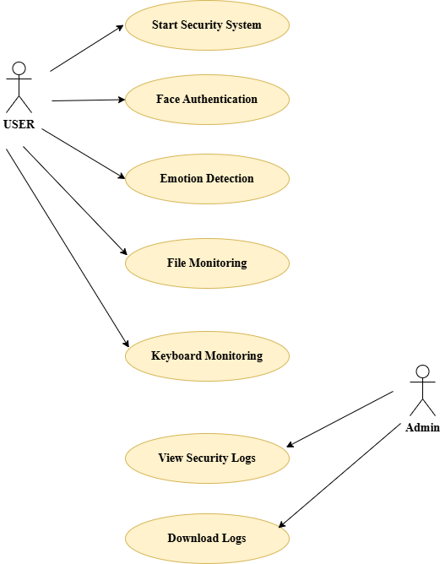
CLASS DIAGRMAE:
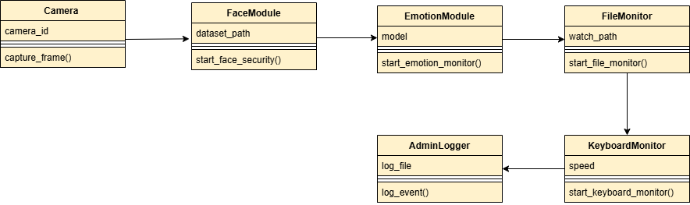

SEQUENCE DIAGRAM:
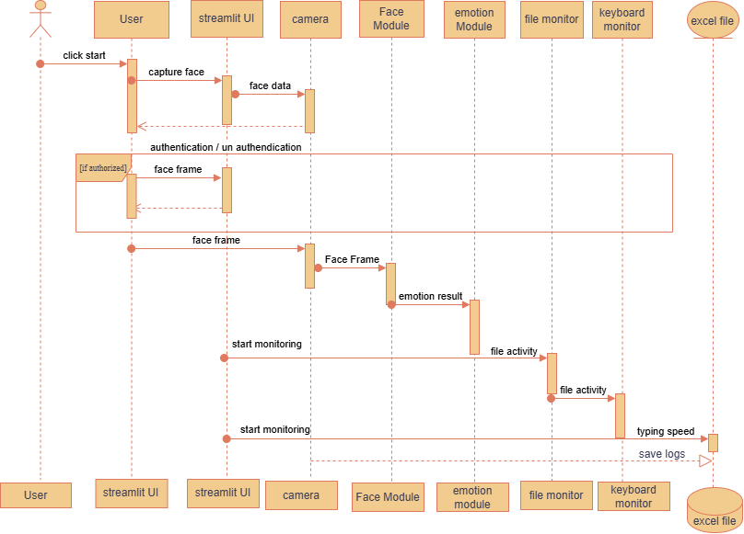

Collaboration Diagram:
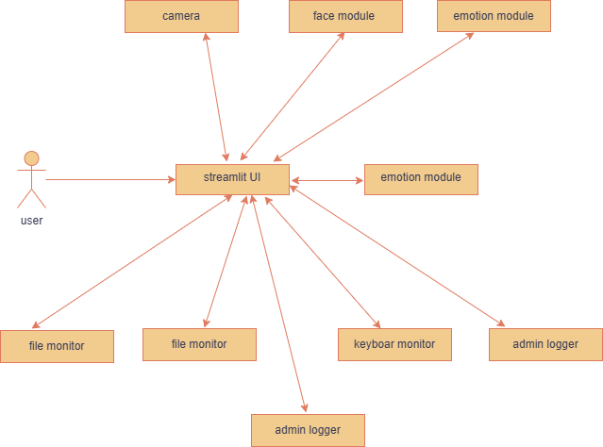

Activity Diagram:

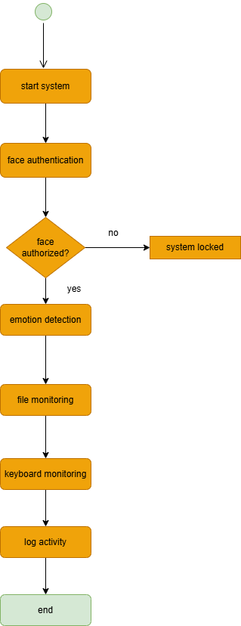

Component Diagram:

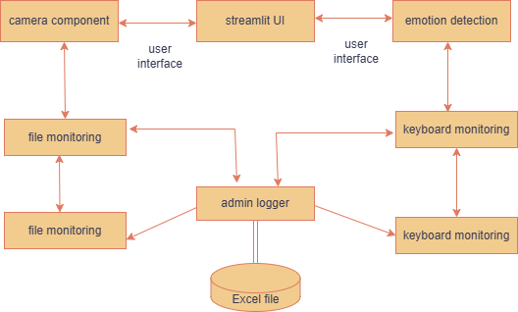

Deployment Diagram:
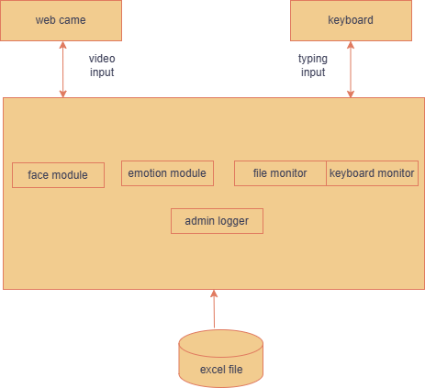
DFD-0:

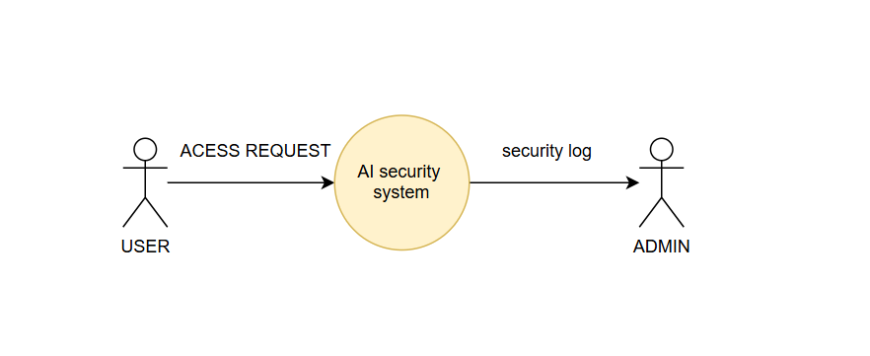
DFD-1:
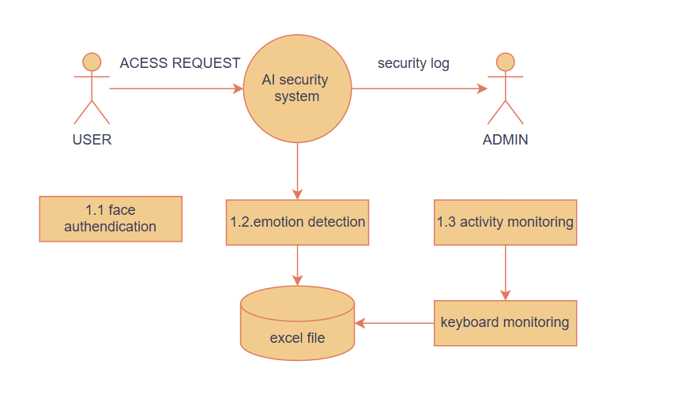

CONCLUSION:
This project successfully demonstrates the design and implementation of an AI-based Multi-Level Security System that integrates facial recognition, emotion detection, and real-time user activity monitoring to enhance system security. Unlike traditional authentication mechanisms that rely solely on passwords or single biometric checks, the proposed system introduces an intelligent and adaptive approach by verifying not only the user’s identity but also their emotional state before granting access. By leveraging computer vision techniques and deep learning models, the system ensures that only authorized and emotionally suitable users can access the computer system.
Furthermore, the continuous monitoring of user activities such as keyboard typing behavior and file operations adds an additional layer of protection after login. This helps in detecting abnormal behavior, potential insider threats, or misuse of the system in real time. The integration of logging mechanisms enables accountability and allows administrators to review security events effectively. The use of Python and lightweight libraries such as OpenCV, DeepFace, pynput, and Streamlit makes the system cost-effective, scalable, and deployable on standard laptop environments without additional hardware requirements. Overall, the project proves that combining emotion-aware access control with behavioral analytics can significantly improve system security and reliability.

FUTURE SCOPE:
- Multi-Emotion Access Policies
Instead of allowing access based on a single emotion (e.g., happy), future versions can define flexible access rules for multiple emotions with confidence thresholds.
- Advanced Behavioral Analytics
Incorporating mouse movement patterns, application usage, and screen activity analysis can further strengthen user behavior monitoring.
- Cloud-Based Logging and Analytics
Replacing local Excel logs with cloud databases and dashboards would enable real-time monitoring, analytics, and remote administration.
- Mobile and IoT Integration
The system can be extended to secure mobile devices, smart workstations, and IoT-enabled environments.

