Code Battle - Admin and Participant Guide

Admin login
Open https://code-battle-one-livid.vercel.app/admin and enter the ADMIN_PASSWORD configured in .env.
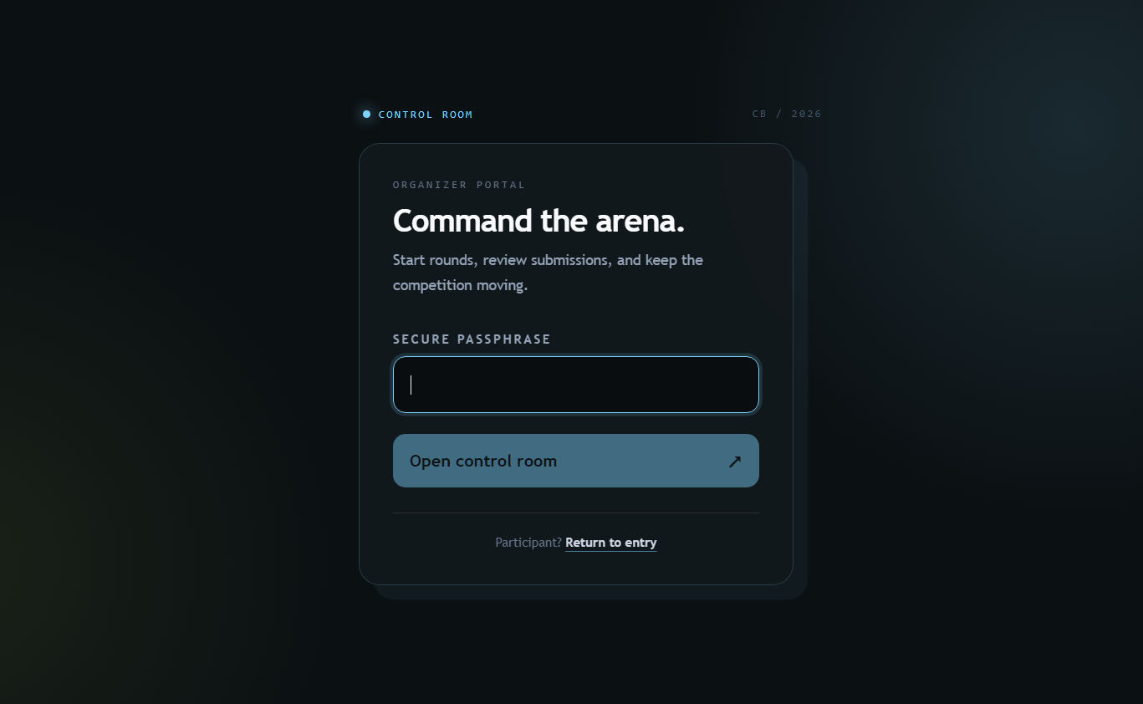
Figure 1. Admin portal login.

Admin dashboard and participants
The dashboard provides round controls, the leaderboard, the Participants section, and per-participant Audit, Disqualify/Reinstate, and Remove actions.
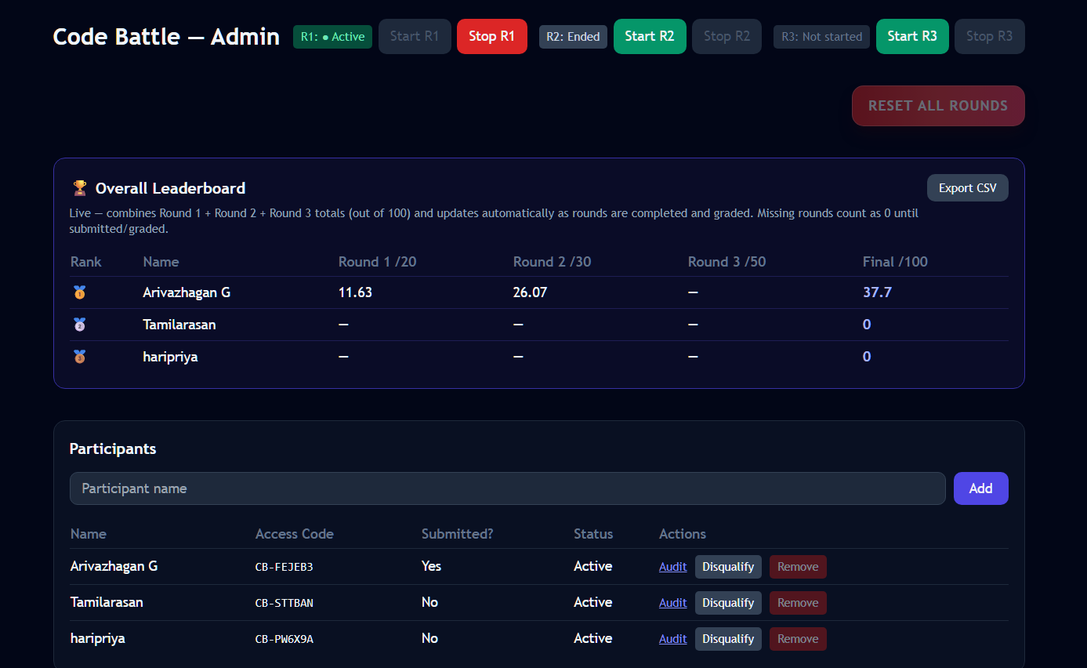
Figure 2. Dashboard overview and participant controls.

Participant entry
Participants enter their access code, review the contest rules, and acknowledge fair-competition requirements.
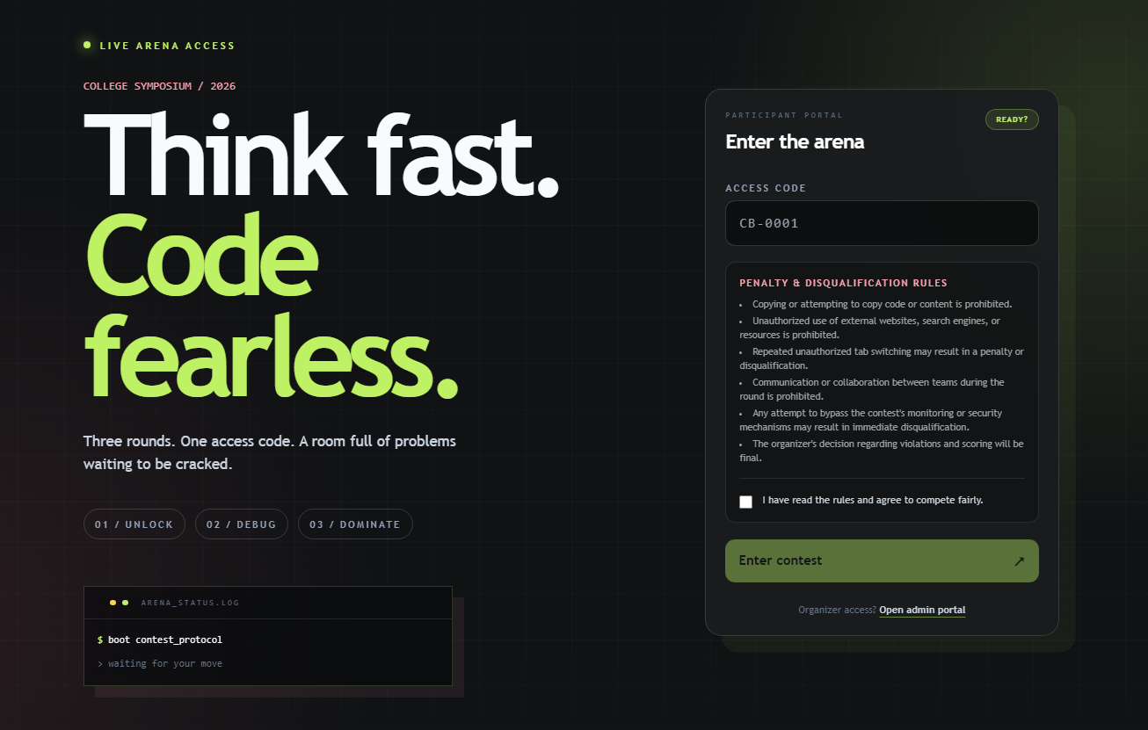
Figure 3. Participant login and rules acknowledgement.

Round 2 grading
The table uses Bug Identify /10 so the label fits cleanly. The internal field remains bugIdentification and CSV export remains Bug Identification/10.
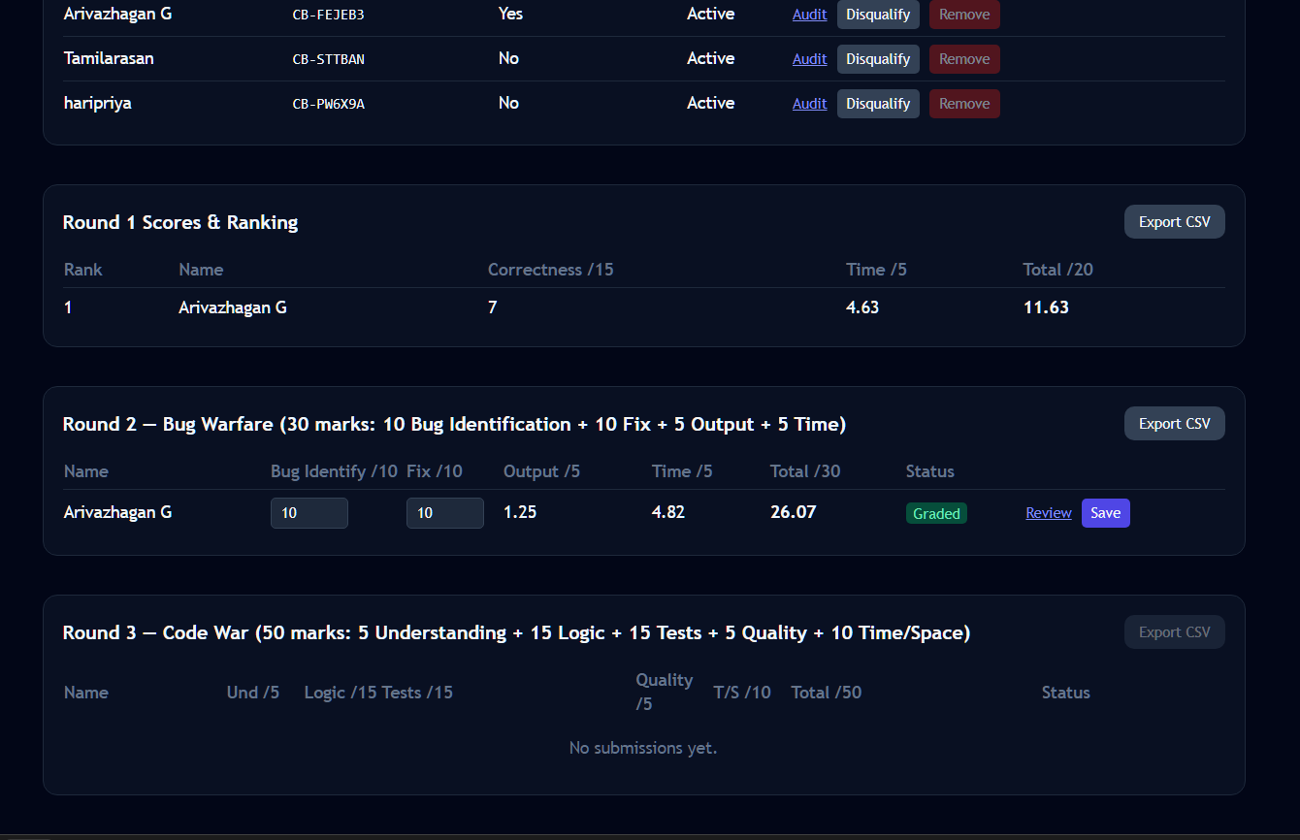
Figure 4. Round 2 grading, review, and save controls.

Participant management
Add a participant by entering a name and selecting Add. Use Audit to view events. Use Disqualify with a reason, or Reinstate when appropriate.

Remove one participant
Select Remove beside the participant. Confirm: Remove <participant name> permanently? This deletes their submissions, scores, answers, and audit history. Removal affects only that participant and is disabled while any round is active.

Replacement workflow
Stop active rounds, remove the old participant, confirm the deletion, add the replacement, share the new access code securely, and start the appropriate round.

Safety notes
Removal is permanent. Keep access codes, admin passwords, cookies, database URLs, and environment variables private. Blur access codes before sharing screenshots.

