NAME: NUR ARISSA SOFIA BINTI MUHAMMAD TAUFIK

CLASS: 1K4

TITLE: SQL-TASK-3

DUE DATE: 18 DECEMBER 2024

CREATING DATABASE

Command:

*-- Create the database*

**CREATE** **DATABASE** **IF** **NOT** **EXISTS** db_library;

*-- Select the database*

**USE** db_library;

Screenshot:

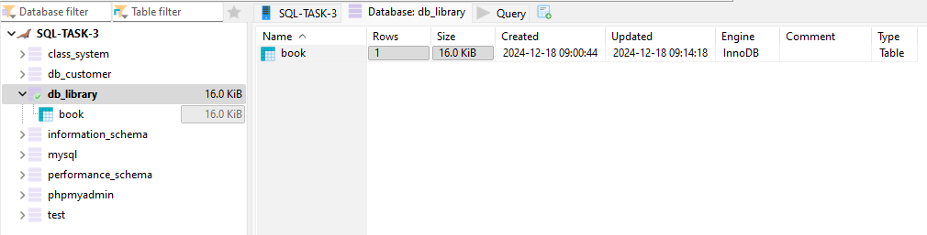

TABLE STRUCTURE

Command:

*-- Create the database*

**CREATE** **DATABASE** **IF** **NOT** **EXISTS** db_library;

*-- Select the database*

**USE** db_library;

*-- Create the table*

**DROP** **TABLE** **IF** **EXISTS** book;

**CREATE** **TABLE** book (

book_id **INT** **PRIMARY** **KEY** **AUTO_INCREMENT**,

title **VARCHAR**(100) **NOT** **NULL**,

author **VARCHAR**(100) **NOT** **NULL**,

borrowed_date **DATE** **NOT** **NULL**

);

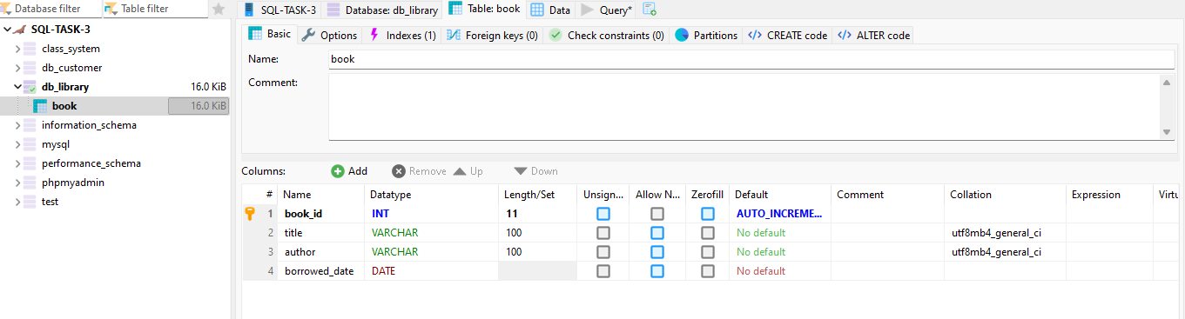

REQUIRED OPERATIONS – DATA ENTRY:

Command:

*-- Create the database*

**CREATE** **DATABASE** **IF** **NOT** **EXISTS** db_library;

*-- Select the database*

**USE** db_library;

*-- Create the table*

**DROP** **TABLE** **IF** **EXISTS** book;

**CREATE** **TABLE** book (

book_id **INT** **PRIMARY** **KEY** **AUTO_INCREMENT**,

title **VARCHAR**(100) **NOT** **NULL**,

author **VARCHAR**(100) **NOT** **NULL**,

borrowed_date **DATE** **NOT** **NULL**

);

*-- Insert data*

**INSERT** **INTO** book (title, author, borrowed_date)

**VALUES**

('To Kill A Mockingbird', 'Harper Lee', '2024-03-10'),

('1984', 'George Orwell', '2024-04-13'),

('Pride and Prejudice', 'Jane Austen', '2024-04-21'),

('The Great Gatsby', 'F. Scott Fitzgerald', '2024-05-06'),

('The Catcher in the Rye', 'J.D. Salinger', '2024-07-02');

*-- Verify the data*

**SELECT** * **FROM** book;

Screenshot:

