NAME: NUR ARISSA SOFIA BINTI MUHAMMAD TAUFIK

CLASS: 1K4

TITLE: SQL-CS-TASKS

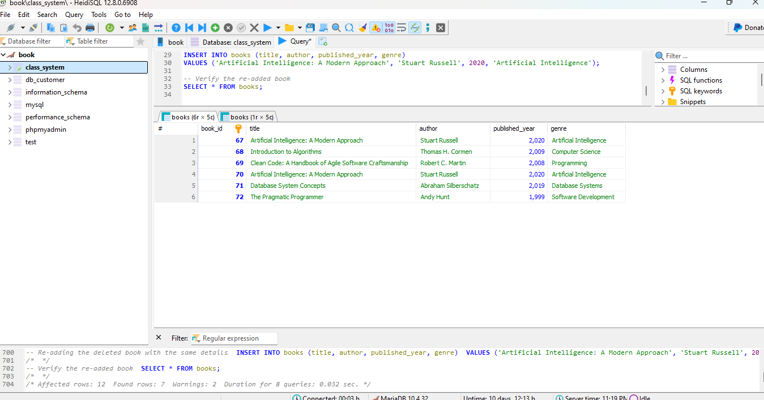

Coding:

**CREATE** **DATABASE** **IF** **NOT** **EXISTS** class_system;

**USE** class_system;

*-- Create the books table*

**CREATE** **TABLE** **IF** **NOT** **EXISTS** books (

book_id **INT** **PRIMARY** **KEY** **AUTO_INCREMENT**,

title **VARCHAR**(150) **NOT** **NULL**,

author **VARCHAR**(100) **NOT** **NULL**,

published_year **INT** **NOT** **NULL**,

genre **VARCHAR**(50) **NOT** **NULL**

);

*-- Insert some initial books*

**INSERT** **INTO** books (title, author, published_year, genre)

**VALUES**

('Introduction to Algorithms', 'Thomas H. Cormen', 2009, 'Computer Science'),

('Clean Code: A Handbook of Agile Software Craftsmanship', 'Robert C. Martin', 2008, 'Programming'),

('Artificial Intelligence: A Modern Approach', 'Stuart Russell', 2020, 'Artificial Intelligence'),

('Database System Concepts', 'Abraham Silberschatz', 2019, 'Database Systems'),

('The Pragmatic Programmer', 'Andy Hunt', 1999, 'Software Development');

*-- Query to verify initial books*

**SELECT** * **FROM** books;

*-- Deleting a book from the books table*

**DELETE** **FROM** books;

*-- Re-adding the deleted book*

**INSERT** **INTO** books (title, author, published_year, genre)

**VALUES** ('Artificial Intelligence: A Modern Approach', 'Stuart Russell', 2020, 'Artificial Intelligence');

*-- Verify the re-added book*

**SELECT** * **FROM** books;

(THE LAST SECOND ROW IS AN EXAMPLE FOR THE DELETED BOOK AND READDING THE DELETED BOOK)