**ECE2310 Final Exam**

Name: ___________________________

**Instructions: PLEASE READ BEFORE STARTING**

Time Allowed: 110 minutes

Submit your zipped solution ( project folder and a word document that contains the code and the screen shot) to Blackboard/Assignment/Final *.*

Please note that all submissions are time-stamped. 10 points of your score will be deducted for every 5 minutes your submission is late.

Please note that all work of this exam is individual. Plagiarism will NOT be tolerated.

1. (50 Points) Develop a C# project that implements the following class hierarchy. Add methods when needed.

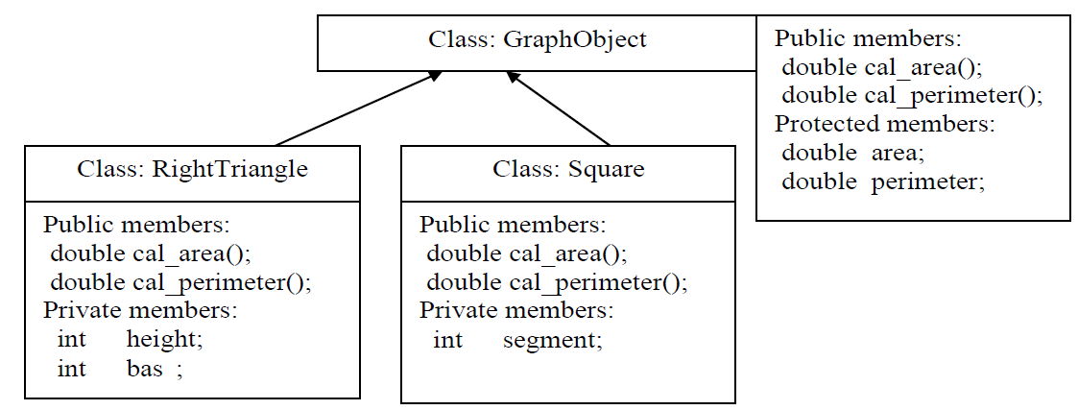

* All classes shall have a constructor that sets the values for the data members.
*  All classes shall have the public method ***cal_area( )*** and ***cal_perimeter()*** .
*  The results of the two functions ***cal_area( )*** and ***cal_perimeter( )*** shall be stored as the protected members of GraphObject.

est the above class hierarchy by writing a user-defined function ***FindLargest*** and a driver program of which,

***FindLargest*** shall be a member method of class ***Utilities***. It shall have a return type of ***void***. It shall use pass-by-reference to “return” the index of the largest element in an array and also the value of the largest element.

The driver program shall be a member method of class ***Program***. It shall instantiate an array of 4 objects of class ***GraphObject*** as such:

#1 object: A triangle with height of 6 and base of 8

#2 object: A square with segment of 8

#3 object: A triangle with height of 5 and base of 15

#4 object: A square with segment of 7

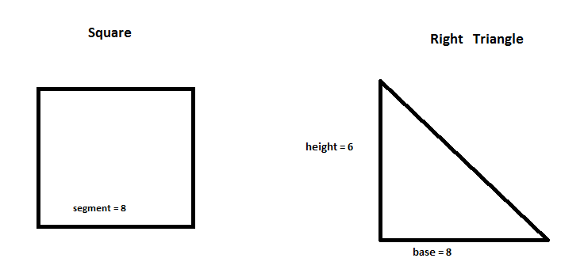

* The driver shall print out the information of the 4 objects: height, base, segment, areas and perimeters. The output looks like this:

#1 object : A triangle, height = 6 , base = 8, area =24, perimeter = 24

#2 object : A square, segment = …… ……..

#3 object : …….. …….

#4 object : …….. … …

* The driver shall call the function ***FindLargest*** and display which object has the largest area and the value of the largest area. The output looks like this:

#...... object has the largest area of ……

* The driver shall call the function ***FindLargest*** and display which object has the largest perimeter and the value of the largest perimeter. The output looks like this:

#...... object has the largest perimeter of ……

**Notes: Use “bas” , instead of “base”, as the variable name for the base of the triangle.**