**Homework04 ECE 2310**

1. Write a C# console application that finds the first 30 numbers of Fibonacci series and displays all of them in 6 rows, with 5 numbers in each row. Use a formated string to make the output numbers aligned neatly, such as:

**1 1 2 3 5**

**8 13 21 34 55**

**89 144 233 … …**

**… … …**

**… … …**

**… … …**

2. *(Investing vs. saving)* John and Linda are both of age 20. Linda invests her $1000.00 in a mutual fund that has an average yearly return of 6%. John, on the other hand, saves his money of $1000.00 in a CD with a yearly interest of 1.5%. Write a program to calculate and display how much money each of them will have when they turn 30, 40, 50, and 60.

The output should look like this:

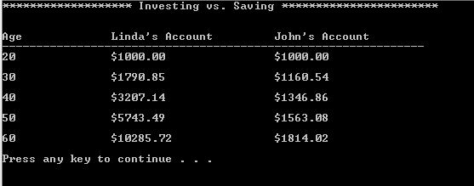

3. The factorial of a nonnegative integer *n* is written *n*! (pronounced “*n* factorial”)

and is defined as follows:

*n!* = *n* · (*n* – 1) · (*n* – 2) · … · 1 (for values of *n* greater than 1)

and

*n!* = 1 (for *n* = 0 or *n* = 1).

For example, 5! = 5 · 4 · 3 · 2 · 1, which is 120. Use while statements in each of the following:

Write a C# Windows Forms Application that reads n from a textbox and display *1!* through *n!* in a list box. Also, estimates the value of the mathematical constant *e* by using the following formula (with accuracy of 6 decimal places) :

*e = 1 + 1/1! + 1/2! + 1/3! + ...*