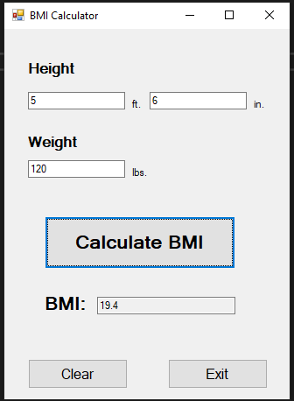

private void btnCalc_Click(object sender, EventArgs e)

{

double weight = Convert.ToDouble(txtPounds.Text);

double feet = Convert.ToDouble(txtFeet.Text);

double inches = Convert.ToDouble(txtInches.Text);

double height = feet * 12 + inches;

double bmi = (weight * 703) / (height * height);

textBox4.Text = Convert.ToString(Math.Round(bmi, 1));

}

private void btnExit_Click(object sender, EventArgs e)

{

Close();

}

private void btnClear_Click(object sender, EventArgs e)

{

txtFeet.Clear();

txtInches.Clear();

txtPounds.Clear();

textBox4.Clear();

}