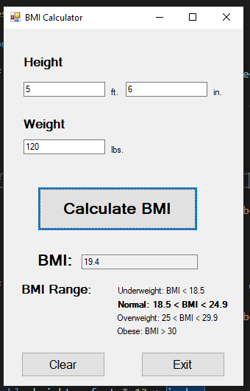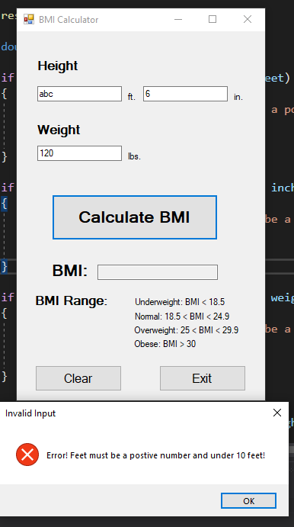

private void btnCalc_Click(object sender, EventArgs e)

{

restoreText();

double feet, inches, weight;

if (!double.TryParse(txtFeet.Text, out feet) || feet > 10 || feet < 0)

{

MessageBox.Show("Error! Feet must be a postive number and under 10 feet!", "Invalid Input", MessageBoxButtons.OK, MessageBoxIcon.Error);

clearForm();

return;

}

if (!double.TryParse(txtInches.Text, out inches) || inches > 12 || inches < 0)

{

MessageBox.Show("Error! Inches must be a postive number and under 12 inches!", "Invalid Input", MessageBoxButtons.OK, MessageBoxIcon.Error);

clearForm();

return;

}

if (!double.TryParse(txtPounds.Text, out weight) || weight < 0)

{

MessageBox.Show("Error! Weight must be a positive number!", "Invalid Input", MessageBoxButtons.OK, MessageBoxIcon.Error);

clearForm();

return;

}

double height = feet * 12 + inches;

double bmi = (weight * 703) / (height * height);

textBox4.Text = Convert.ToString(Math.Round(bmi, 1));

rangeCheck(bmi);

}

private void btnExit_Click(object sender, EventArgs e)

{

Close();

}

private void btnClear_Click(object sender, EventArgs e)

{

txtFeet.Clear();

txtInches.Clear();

txtPounds.Clear();

textBox4.Clear();

restoreText();

}

private void rangeCheck(double bmi)

{

if (bmi < 18.5)

{

underweight.Font = new Font(underweight.Font, FontStyle.Bold);

}

else if (bmi >= 18.5 && bmi < 24.9)

{

normal.Font = new Font(normal.Font, FontStyle.Bold);

}

else if (bmi >= 18.5 && bmi < 24.9)

{

overweight.Font = new Font(overweight.Font, FontStyle.Bold);

}

else

{

obese.Font = new Font(obese.Font, FontStyle.Bold);

}

}

private void restoreText()

{

underweight.Font = new Font(underweight.Font, FontStyle.Regular);

normal.Font = new Font(normal.Font, FontStyle.Regular);

overweight.Font = new Font(overweight.Font, FontStyle.Regular);

obese.Font = new Font(obese.Font, FontStyle.Regular);

}

private void clearForm()

{

txtFeet.Clear();

txtInches.Clear();

txtPounds.Clear();

textBox4.Clear();

restoreText();

}