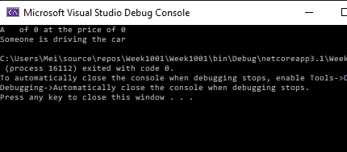

// Object-oriented programming/designing

// class object

// procedural vs object-oriented

// member access operator .

//attributes : variables behaviors : functions/methods

//1. define the class

// 2. instantiate object(s) from the class

// 3. use the object to operate

using System;

namespace Week1001

{

class Program

{

static void Main(string[] args)

{

Car myCar = new Car();

Car yourCar = new Car();

myCar.DisplayInfo();

yourCar.Drive();

}

}

}

using System;

using System.Collections.Generic;

using System.Text;

namespace Week1001

{

class Car

{

//data members :attributes

string color;

double price;

int numOfSeats;

string make;

//member methods: behaviors

// public double PriceDepreciation(rate r)

// { }

public void Drive()

{ Console.WriteLine("Someone is driving the car"); }

public void DisplayInfo()

{

Console.WriteLine($"A {color} {make} of {numOfSeats} at the price of {price}");

}

}

}