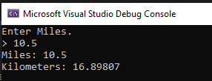

using System;

namespace ECE2310_HW01_1

{

class Program

{

static void Main(string[] args)

{

string userInput;

double miles, kilometers;

Console.WriteLine("Enter Miles.");

Console.Write("> ");

userInput = Console.ReadLine();

miles = Convert.ToDouble(userInput);

kilometers = miles * 1.60934;

Console.WriteLine("Miles: " + miles);

Console.WriteLine("Kilometers: " + kilometers);

}

}

}