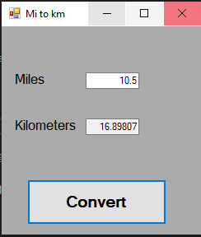

using System;

using System.Collections.Generic;

using System.ComponentModel;

using System.Data;

using System.Drawing;

using System.Linq;

using System.Text;

using System.Threading.Tasks;

using System.Windows.Forms;

namespace ECE2310_HW01_02

{

public partial class Form1 : Form

{

public Form1()

{

InitializeComponent();

}

private void Form1_Load(object sender, EventArgs e)

{

}

private void button1_Click(object sender, EventArgs e)

{

double miles = Convert.ToDouble(textBox1.Text);

double kilometers = miles * 1.60934;

textBox2.Text = Convert.ToString(kilometers);

}

private void label1_Click(object sender, EventArgs e)

{

}

private void label2_Click(object sender, EventArgs e)

{

}

}

}