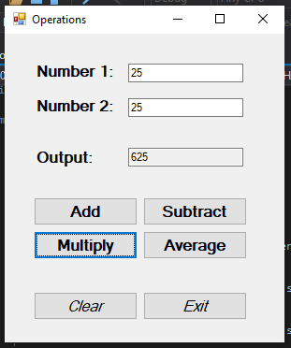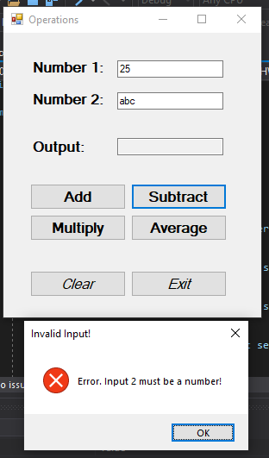

private void btnAdd_Click(object sender, EventArgs e)

{

double num1, num2;

if (!double.TryParse(txtNum1.Text, out num1))

{

MessageBox.Show("Error. Input 1 must be a number!", "Invalid Input!", MessageBoxButtons.OK, MessageBoxIcon.Error);

clearForm();

return;

}

if (!double.TryParse(txtNum2.Text, out num2))

{

MessageBox.Show("Error. Input 2 must be a number!", "Invalid Input!", MessageBoxButtons.OK, MessageBoxIcon.Error);

clearForm();

return;

}

txtOut.Text = Convert.ToString(num1 + num2);

}

private void btnSubtract_Click(object sender, EventArgs e)

{

double num1, num2;

if (!double.TryParse(txtNum1.Text, out num1))

{

MessageBox.Show("Error. Input 1 must be a number!", "Invalid Input!", MessageBoxButtons.OK, MessageBoxIcon.Error);

clearForm();

return;

}

if (!double.TryParse(txtNum2.Text, out num2))

{

MessageBox.Show("Error. Input 2 must be a number!", "Invalid Input!", MessageBoxButtons.OK, MessageBoxIcon.Error);

clearForm();

return;

}

txtOut.Text = Convert.ToString(num1 - num2);

}

private void btnMultiply_Click(object sender, EventArgs e)

{

double num1, num2;

if (!double.TryParse(txtNum1.Text, out num1))

{

MessageBox.Show("Error. Input 1 must be a number!", "Invalid Input!", MessageBoxButtons.OK, MessageBoxIcon.Error);

clearForm();

return;

}

if (!double.TryParse(txtNum2.Text, out num2))

{

MessageBox.Show("Error. Input 2 must be a number!", "Invalid Input!", MessageBoxButtons.OK, MessageBoxIcon.Error);

clearForm();

return;

}

txtOut.Text = Convert.ToString(num1 * num2);

}

private void btnAverage_Click(object sender, EventArgs e)

{

double num1, num2;

if (!double.TryParse(txtNum1.Text, out num1))

{

MessageBox.Show("Error. Input 1 must be a number!", "Invalid Input!", MessageBoxButtons.OK, MessageBoxIcon.Error);

clearForm();

return;

}

if (!double.TryParse(txtNum2.Text, out num2))

{

MessageBox.Show("Error. Input 2 must be a number!", "Invalid Input!", MessageBoxButtons.OK, MessageBoxIcon.Error);

clearForm();

return;

}

txtOut.Text = Convert.ToString((num1 + num2) / 2);

}

private void btnClear_Click(object sender, EventArgs e)

{

clearForm();

}

private void btnExit_Click(object sender, EventArgs e)

{

Close();

}

private void clearForm()

{

txtNum1.Clear();

txtNum2.Clear();

txtOut.Clear();

}