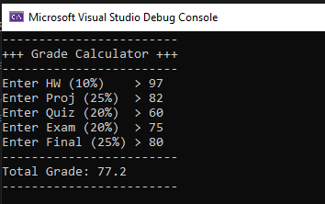

/*

Ari Yonaty

1.21.2020

ECE2310

HW 1, Problem 3

*/

using System;

namespace ECE2310_HW01_1

{

class Program

{

static void Main(string[] args)

{

string userInput;

double homework, projects, quizzes, exams, final;

double percentHW = 0.1, percentProj = 0.25, percentQuiz = 0.2, percentExam = 0.2, percentFinal = 0.25;

double overallGrade;

Console.WriteLine("------------------------");

Console.WriteLine("+++ Grade Calculator +++");

Console.WriteLine("------------------------");

// Get homework

Console.Write("Enter HW (10%) > ");

userInput = Console.ReadLine();

homework = Convert.ToDouble(userInput);

// Get projects

Console.Write("Enter Proj (25%) > ");

userInput = Console.ReadLine();

projects = Convert.ToDouble(userInput);

// Get quizzes

Console.Write("Enter Quiz (20%) > ");

userInput = Console.ReadLine();

quizzes = Convert.ToDouble(userInput);

// Get exams

Console.Write("Enter Exam (20%) > ");

userInput = Console.ReadLine();

exams = Convert.ToDouble(userInput);

// Get final

Console.Write("Enter Final (25%) > ");

userInput = Console.ReadLine();

final = Convert.ToDouble(userInput);

// Calculate overall grade

overallGrade = (((homework * percentHW) + (projects * percentProj) + (quizzes * percentQuiz) + (exams * percentExam) + (final * percentFinal)) / (percentHW + percentProj + percentQuiz + percentExam + percentFinal));

Console.WriteLine("------------------------");

Console.WriteLine("Total Grade: " + string.Format("{0:0.0}", overallGrade));

Console.WriteLine("------------------------");

}

}

}