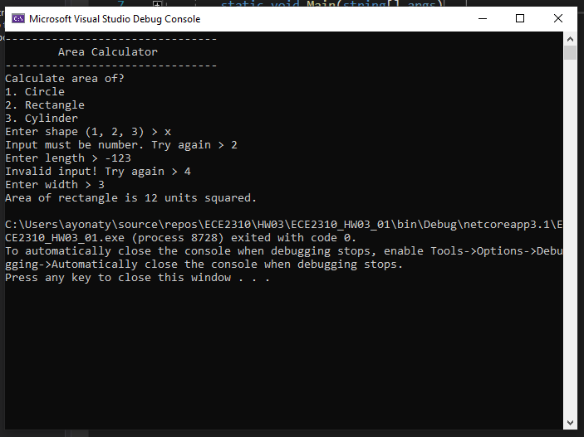

class Program

{

static void Main(string[] args)

{

menu();

int selection;

while (!Int32.TryParse(Console.ReadLine(), out selection) || selection <= 0 || selection > 3)

{

Console.Write("Input must be number. Try again > ");

}

switch (selection)

{

case 1:

areaCircle();

break;

case 2:

areaRectangle();

break;

case 3:

areaCylinder();

break;

}

}

private static void menu()

{

Console.WriteLine("--------------------------------");

Console.WriteLine("\tArea Calculator");

Console.WriteLine("--------------------------------");

Console.WriteLine("Calculate area of?");

Console.WriteLine("1. Circle");

Console.WriteLine("2. Rectangle");

Console.WriteLine("3. Cylinder");

Console.Write("Enter shape (1, 2, 3) > ");

}

private static void areaCircle()

{

double radius = 0;

Console.Write("Enter circle radius > ");

getValue(ref radius);

double area = Math.Round(Math.PI \* radius \* radius, 3);

Console.WriteLine($"Area of circle is {area} units squared.");

}

private static void areaRectangle()

{

double length = 0;

double width = 0;

Console.Write("Enter length > ");

getValue(ref length);

Console.Write("Enter width > ");

getValue(ref width);

double area = Math.Round(length \* width, 3);

Console.WriteLine($"Area of rectangle is {area} units squared.");

}

private static void areaCylinder()

{

double radius = 0;

double height = 0;

Console.Write("Enter radius > ");

getValue(ref radius);

Console.Write("Enter height > ");

getValue(ref height);

double area = Math.Round((2 \* Math.PI \* radius \* height) + (2 \* Math.PI \* radius \* radius), 3);

Console.WriteLine($"Area of cylinder is {area} units squared.");

}

private static void getValue(ref double value)

{

while(!Double.TryParse(Console.ReadLine(), out value) || value <= 0)

{

Console.Write("Invalid input! Try again > ");

}

}

}

}