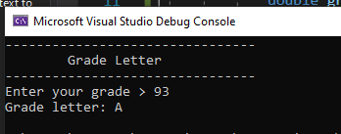

class Program

{

static void Main(string[] args)

{

menu();

double grade;

while(!Double.TryParse(Console.ReadLine(), out grade) || grade < 0 || grade > 100)

{

Console.WriteLine("Invalid input. Quitting...");

return;

}

switch (grade)

{

case double n when (n >= 90):

Console.WriteLine("Grade letter: A");

break;

case double n when (n < 90 && n >= 80):

Console.WriteLine("Grade letter: B");

break;

case double n when (n < 80 && n >= 70):

Console.WriteLine("Grade letter: C");

break;

case double n when (n < 70 && n >= 60):

Console.WriteLine("Grade letter: D");

break;

case double n when (n < 60):

Console.WriteLine("Grade letter: F");

break;

}

}

private static void menu()

{

Console.WriteLine("--------------------------------");

Console.WriteLine("\tGrade Letter");

Console.WriteLine("--------------------------------");

Console.Write("Enter your grade > ");

}

}

}