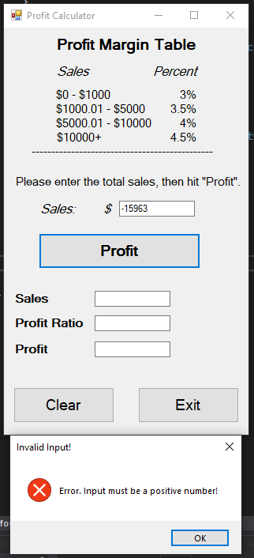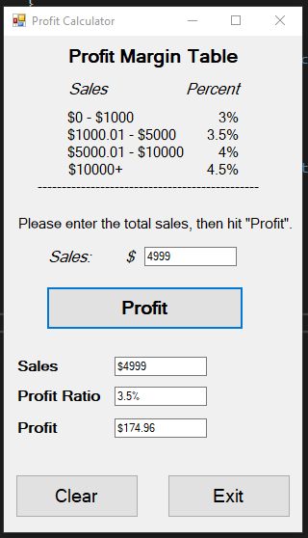

public partial class Form1 : Form

{

public Form1()

{

InitializeComponent();

}

private void Form1_Load(object sender, EventArgs e)

{

}

private void BtnProfit_Click(object sender, EventArgs e)

{

double input;

if(!Double.TryParse(txtInput.Text, out input) || input < 0)

{

MessageBox.Show("Error. Input must be a positive number!", "Invalid Input!", MessageBoxButtons.OK, MessageBoxIcon.Error);

clearForm();

return;

}

if (input >= 0 && input <= 1000)

{

txtSales.Text = Convert.ToString("$" + Math.Round(input, 2));

txtProfitRatio.Text = "3.0%";

txtProfit.Text = Convert.ToString("$" + Math.Round(0.03 * input, 2));

}

else if (input > 1000 && input <= 5000)

{

txtSales.Text = Convert.ToString("$" + Math.Round(input, 2));

txtProfitRatio.Text = "3.5%";

txtProfit.Text = Convert.ToString("$" + Math.Round(0.035 * input, 2));

}

else if (input > 5000 && input <= 10000)

{

txtSales.Text = Convert.ToString("$" + Math.Round(input, 2));

txtProfitRatio.Text = "4%";

txtProfit.Text = Convert.ToString("$" + Math.Round(0.04 * input, 2));

}

else

{

txtSales.Text = Convert.ToString("$" + Math.Round(input, 2));

txtProfitRatio.Text = "4.5%";

txtProfit.Text = Convert.ToString("$" + Math.Round(0.045 * input, 2));

}

}

private void clearForm()

{

txtInput.Clear();

txtProfit.Clear();

txtSales.Clear();

txtProfitRatio.Clear();

}

private void btnClear_Click(object sender, EventArgs e)

{

clearForm();

}

private void btnExit_Click(object sender, EventArgs e)

{

Close();

}

}