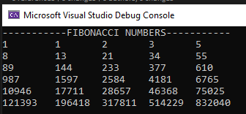

class Program

{

private static int[] fib(int n)

{

int[] fibonacci = new int[n];

fibonacci[0] = 1;

fibonacci[1] = 1;

for (int i = 2; i < n; i++)

{

fibonacci[i] = fibonacci[i - 2] + fibonacci[i - 1];

}

return fibonacci;

}

static void Main(string[] args)

{

int[] fibonacci = fib(30);

int count = 0;

Console.WriteLine("-----------FIBONACCI NUMBERS-----------");

for (int i = 1; i <= 6; i++)

{

for (int j = 0; j < 5; j++)

{

Console.Write($"{fibonacci[count]}\t ");

count++;

}

Console.WriteLine();

}

}

}