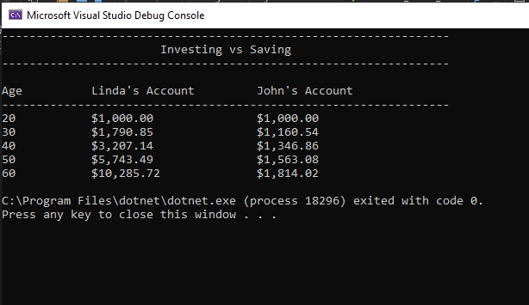

static void Main(string[] args)

{

menu();

double startMoney = 1000;

int startAge = 20;

int age = startAge;

double linda = startMoney;

double john = startMoney;

double lindaRate = 0.06;

double johnRate = 0.015;

for (int i = 20; i <= 60; i++)

{

if (i % 10 == 0)

{

Console.WriteLine($"{age, -13}{linda,-24:C2}{john,-10:C2}");

age += 10;

}

linda += linda \* lindaRate;

john += john \* johnRate;

}

}

private static void menu()

{

Console.WriteLine("-----------------------------------------------------------------");

Console.WriteLine(" Investing vs Saving ");

Console.WriteLine("-----------------------------------------------------------------");

Console.WriteLine();

Console.WriteLine("Age Linda's Account John's Account ");

Console.WriteLine("-----------------------------------------------------------------");

}