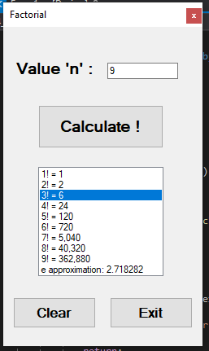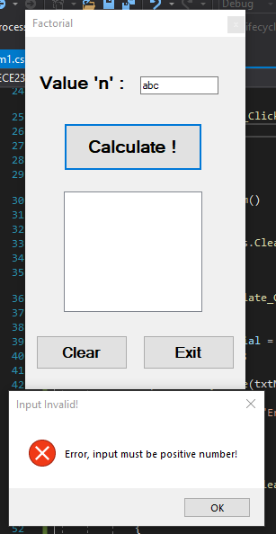

public partial class Form1 : Form

{

public Form1()

{

InitializeComponent();

}

private void BtnExit_Click(object sender, EventArgs e)

{

Close();

}

private void BtnClear_Click(object sender, EventArgs e)

{

clearForm();

}

private void BtnCalculate_Click(object sender, EventArgs e)

{

int n;

int i = 1, factorial = 1;

double eVal = 1.0;

if(!Int32.TryParse(txtN.Text, out n) || n < 0)

{

MessageBox.Show("Error, input must be positive number!", "Input Invalid!", MessageBoxButtons.OK, MessageBoxIcon.Error);

clearForm();

return;

}

lstFactorial.Items.Clear();

if (n == 0 || n == 1)

{

lstFactorial.Items.Add($"{n}! = {factorial:n0}");

return;

}

while (i <= n)

{

factorial *= i;

lstFactorial.Items.Add($"{i}! = {factorial:n0}");

eVal += (double)(1.0 / factorial);

i++;

}

lstFactorial.Items.Add($"e approximation: {Math.Round(eVal, 6)}");

}

private void clearForm()

{

txtN.Clear();

lstFactorial.Items.Clear();

}

}