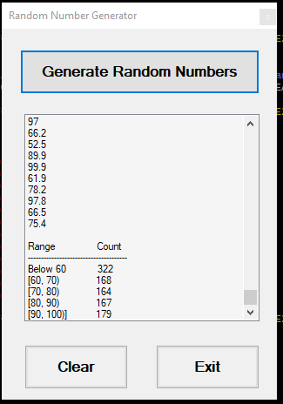

private void btnRand_Click(object sender, EventArgs e)

{

lstRand.Items.Clear();

Random rand = new Random();

int r60 = 0, r60to70 = 0, r70to80 = 0, r80to90 = 0, r90to100 = 0;

for (int i = 0; i < 1000; i++)

{

double r = rand.NextDouble() * (100 - 40) + 40;

lstRand.Items.Add(Math.Round(r, 1));

checkRange(ref r60, ref r60to70, ref r70to80, ref r80to90, ref r90to100, r);

}

lstRand.Items.Add("");

lstRand.Items.Add("Range Count");

lstRand.Items.Add("--------------------------------------");

lstRand.Items.Add($"Below 60 {r60}");

lstRand.Items.Add($"[60, 70) {r60to70}");

lstRand.Items.Add($"[70, 80) {r70to80}");

lstRand.Items.Add($"[80, 90) {r80to90}");

lstRand.Items.Add($"[90, 100)] {r90to100}");

}

private void btnClear_Click(object sender, EventArgs e)

{

lstRand.Items.Clear();

}

private void btnExit_Click(object sender, EventArgs e)

{

Close();

}

private void checkRange(ref int r60, ref int r60to70, ref int r70to80, ref int r80to90, ref int r90to100, double r)

{

if (r >= 90)

{

r90to100++;

}

else if (r >= 80)

{

r80to90++;

}

else if (r >= 70)

{

r70to80++;

}

else if (r >= 60)

{

r60to70++;

}

else

{

r60++;

}

}