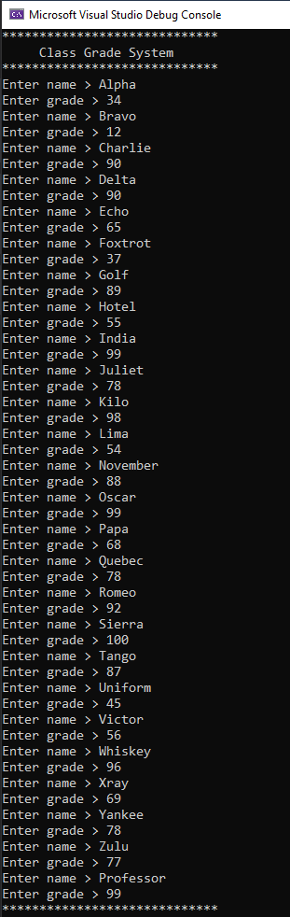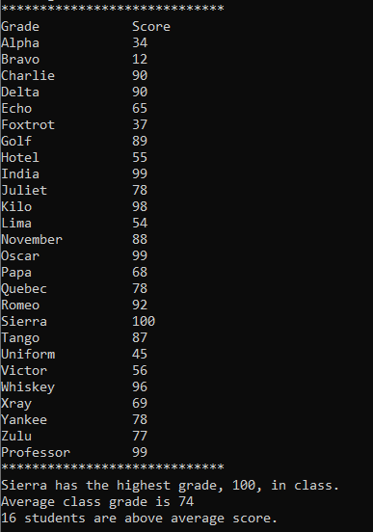

static void Main(string[] args)

{

string[] names = new string[26];

int[] grades = new int[26];

int sum = 0;

int max = 0;

int avgCount = 0;

int maxIndex = 0;

Console.WriteLine("\*\*\*\*\*\*\*\*\*\*\*\*\*\*\*\*\*\*\*\*\*\*\*\*\*\*\*\*\*");

Console.WriteLine(" Class Grade System");

Console.WriteLine("\*\*\*\*\*\*\*\*\*\*\*\*\*\*\*\*\*\*\*\*\*\*\*\*\*\*\*\*\*");

for (int i = 0; i < names.Length; i++)

{

Console.Write("Enter name > ");

names[i] = Console.ReadLine();

Console.Write("Enter grade > ");

while (!Int32.TryParse(Console.ReadLine(), out grades[i]) || grades[i] > 100 || grades[i] < 0)

{

Console.Write("Invalid input. Try again > ");

}

sum += grades[i];

if (grades[i] > max)

{

max = grades[i];

}

}

Console.WriteLine("\*\*\*\*\*\*\*\*\*\*\*\*\*\*\*\*\*\*\*\*\*\*\*\*\*\*\*\*\*");

Console.WriteLine("Grade Score");

for (int i = 0; i < names.Length; i++)

{

Console.WriteLine($"{names[i],-16} {grades[i],-13}");

}

maxIndex = Array.IndexOf(grades, max);

int avg = sum / grades.Length;

Console.WriteLine("\*\*\*\*\*\*\*\*\*\*\*\*\*\*\*\*\*\*\*\*\*\*\*\*\*\*\*\*\*");

Console.WriteLine($"{names[maxIndex]} has the highest grade, {max}, in class.");

Console.WriteLine($"Average class grade is {avg}");

for (int i = 0; i < grades.Length; i++)

{

if (grades[i] > avg)

{

avgCount++;

}

}

Console.WriteLine($"{avgCount} students are above average score.");

}