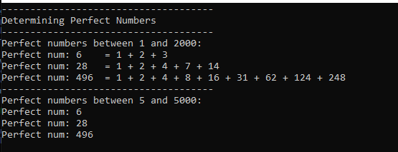

using System;

namespace ECE2310_HW06_01

{

class Program

{

static void Main(string[] args)

{

Console.WriteLine("-------------------------------------");

Console.WriteLine("Determining Perfect Numbers");

Console.WriteLine("-------------------------------------");

int endRange = 2000;

Console.WriteLine($"Perfect numbers between 1 and {endRange}:");

for (int i = 1; i < endRange; i++)

{

if (isPerfect(i) == true)

{

Console.Write($"Perfect num: {i, -4} = ");

printDivisors(i);

Console.WriteLine();

}

}

Console.WriteLine("-------------------------------------");

int startRange = 5;

endRange = 5000;

Console.WriteLine($"Perfect numbers between {startRange} and {endRange}:");

for (int i = startRange; i < endRange; i++)

{

if (isPerfect(i) == true)

{

Console.WriteLine($"Perfect num: {i,-4}");

}

}

}

private static bool isPerfect(int number)

{

for (int i = 1; i < number; i++)

{

/*

Implementation of Euclid-Euler theorem

Theorem = 2^(p-1)*[2^(p) - 1] is an even natural number when 2^(p-1) is prime

*/

long x = (long)(Math.Pow(2, i - 1) * (Math.Pow(2, i) - 1));

if (x == number && isPrime(i))

{

return true;

}

}

return false;

}

private static void printDivisors(int number)

{

Console.Write("1");

for (int i = 2; i < number; i++)

{

if (number % i == 0)

{

Console.Write($" + {i}");

}

}

}

private static bool isPrime(int number)

{

/*

Current method inefficient as it calculates the squareroot each time through loop

*/

if (number == 1) return false;

if (number == 2) return true;

if (number % 2 == 0) return false;

var limit = Math.Floor(Math.Sqrt(number));

for (int i = 3; i <= limit; i+=2)

{

if (number % i == 0) return false;

}

return true;

}

}

}