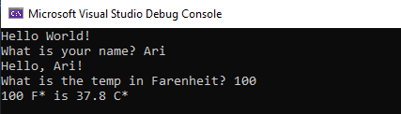

using System;

namespace Week0101

{

class Program

{

static void Main(string[] args)

{

Console.WriteLine("Hello World!");

// prompt user for name

Console.Write("What is your name? ");

// accept input from name

string name = Console.ReadLine();

// display name to console

Console.WriteLine("Hello, " + name + "!");

// Convert faren to celsius

Console.Write("What is the temp in Farenheit? ");

double tempF = Convert.ToDouble(Console.ReadLine());

double tempC = (tempF - 32) \* 5 / 9;

Console.WriteLine($"{tempF} F\* is {Math.Round(tempC, 1)} C\*");

}

}

}