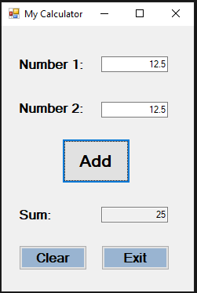

private void btnAdd_Click(object sender, EventArgs e)

{

double num1 = Convert.ToDouble(textBox1.Text);

double num2 = Convert.ToDouble(textBox2.Text);

textBox3.Text = Convert.ToString(num1 + num2);

}

private void btnClear_Click(object sender, EventArgs e)

{

textBox1.Clear();

textBox2.Clear();

textBox3.Clear();

}

private void btnExit_Click(object sender, EventArgs e)

{

Close();

}