Pace University

Homework

Git Project

Arizé Lee

Programming Languages and Implementation – CS 361

Professor Scharff

14 November 2016

**Part 3:**

Answer the following questions.

What is GitHub? When was it created? Why? By who? What similar platforms exist? Why would you use such a platform? (Answer between 5 and 10 lines)

Answer these questions in a Word file called *LastnameFirstnameGitTutorial-mm-dd-yyyy.docx*. Please respect the naming conventions!

GitHub is a web-based version-control and collaboration platform for software developers.  GitHub was started in 2008, founded on Git, and was launched in April 2008 by Tom Preston-Werner, Chris Wanstrath, and PJ Hyett. Git is used to store the source code for a project and track the complete history of all changes to that code. It helps developers to collaborate in an efficient organized fashion. GitHub additionally facilitates social coding by providing a web interface to the Git code repository and management tools for collaboration. Some similar platforms to Github include Kiln, Bitbucket and SourceForge.

**Part 4:**

Go through the Git tutorial here: <https://try.github.io>. While doing the tutorial, save your work the *LastnameFirstnameGitTutorial-mm-dd-yyyy.docx* file.

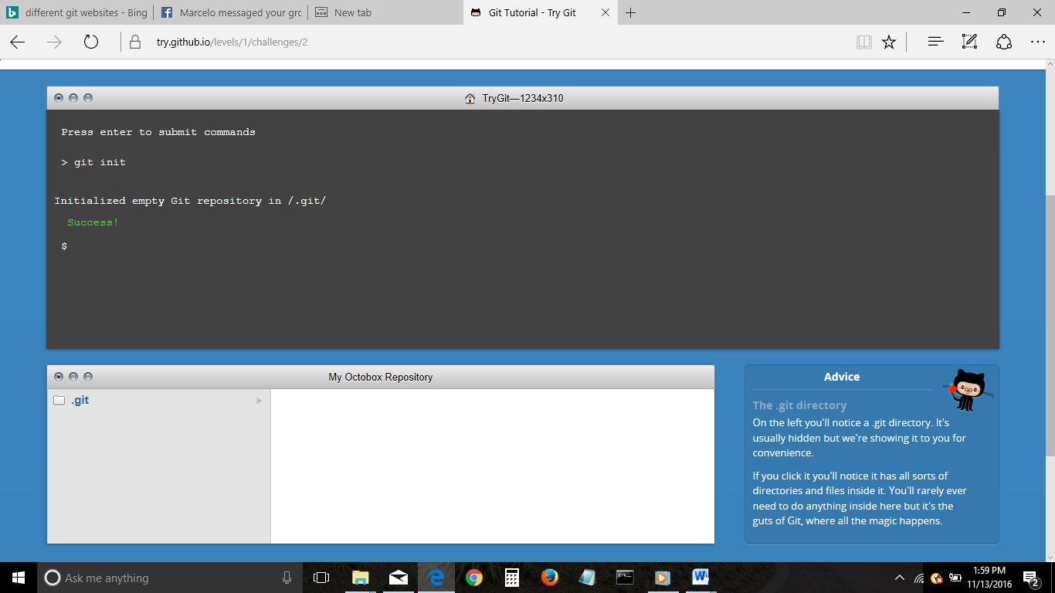

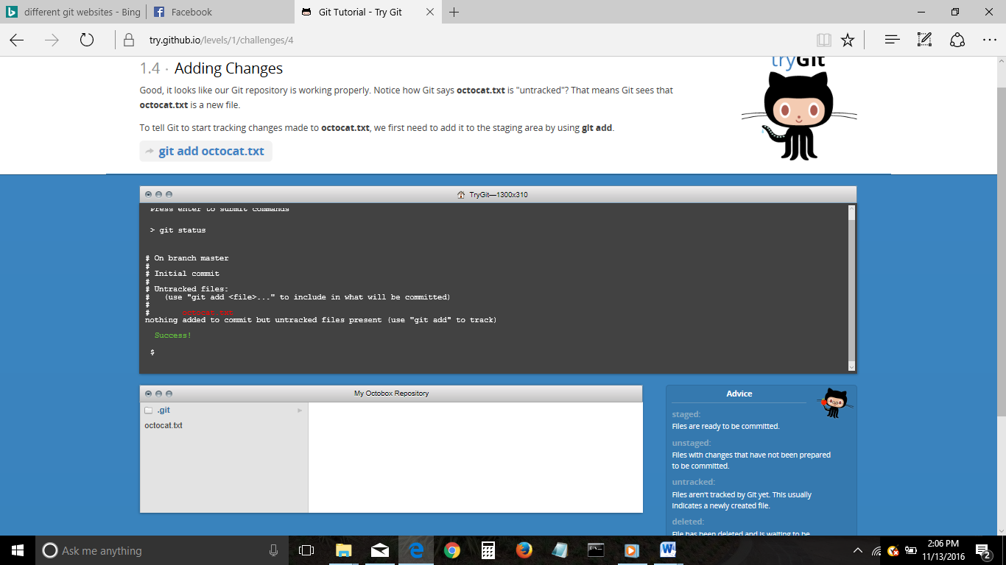

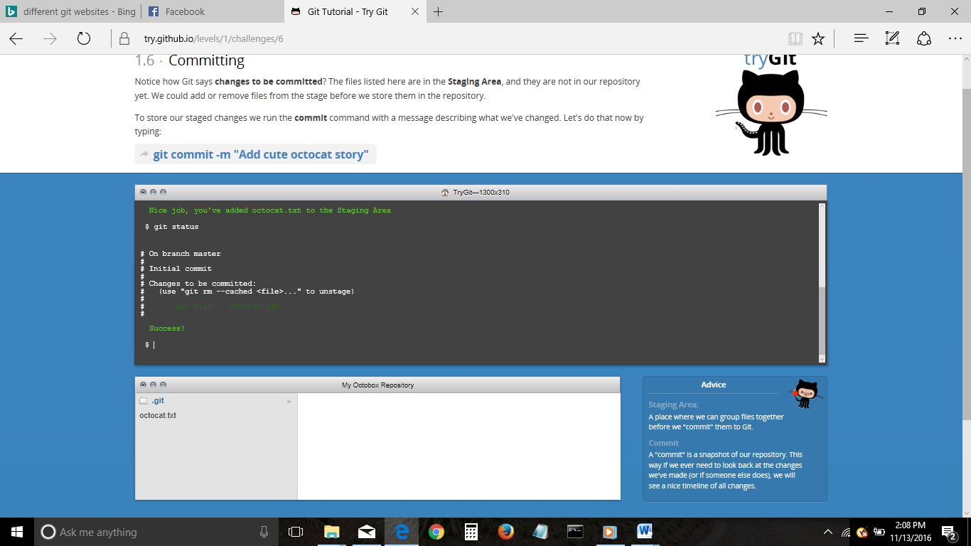

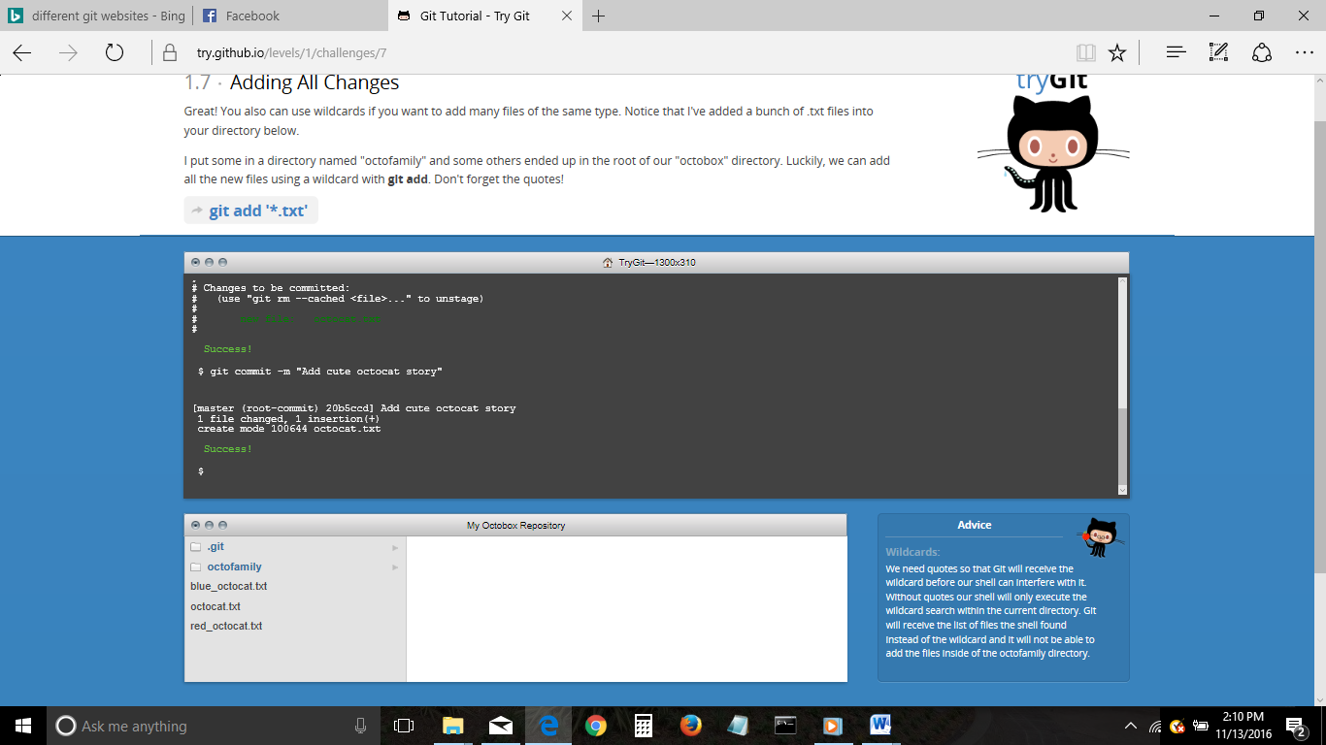

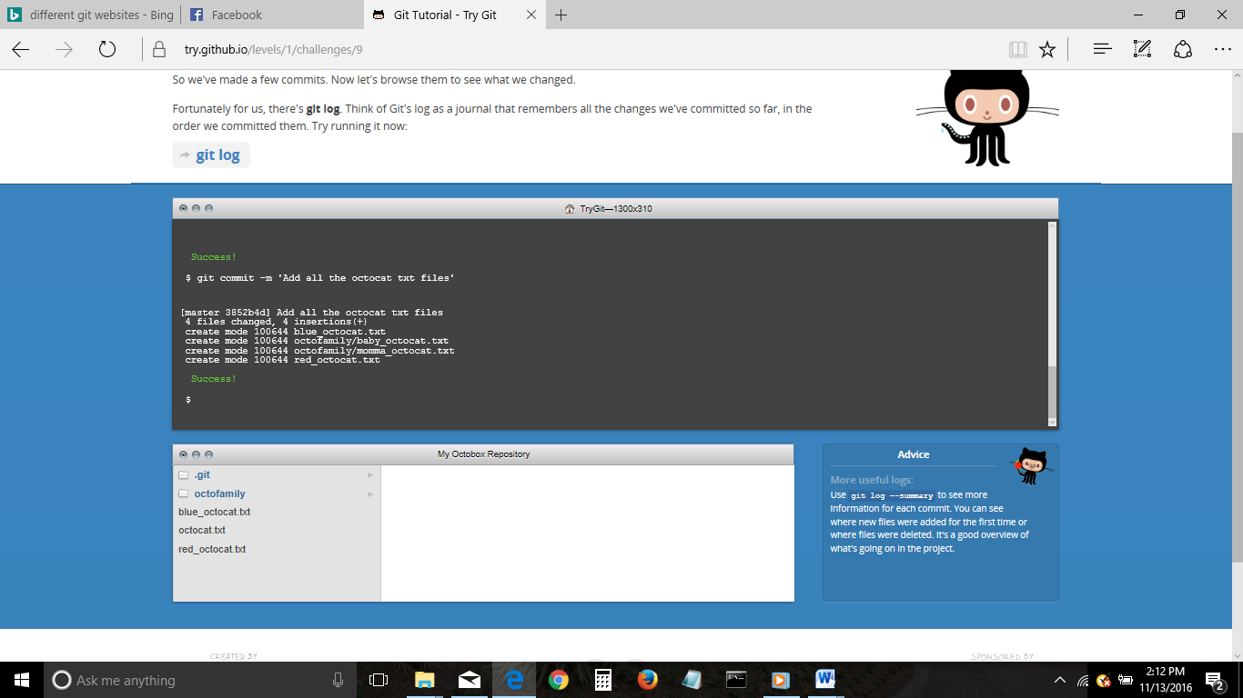

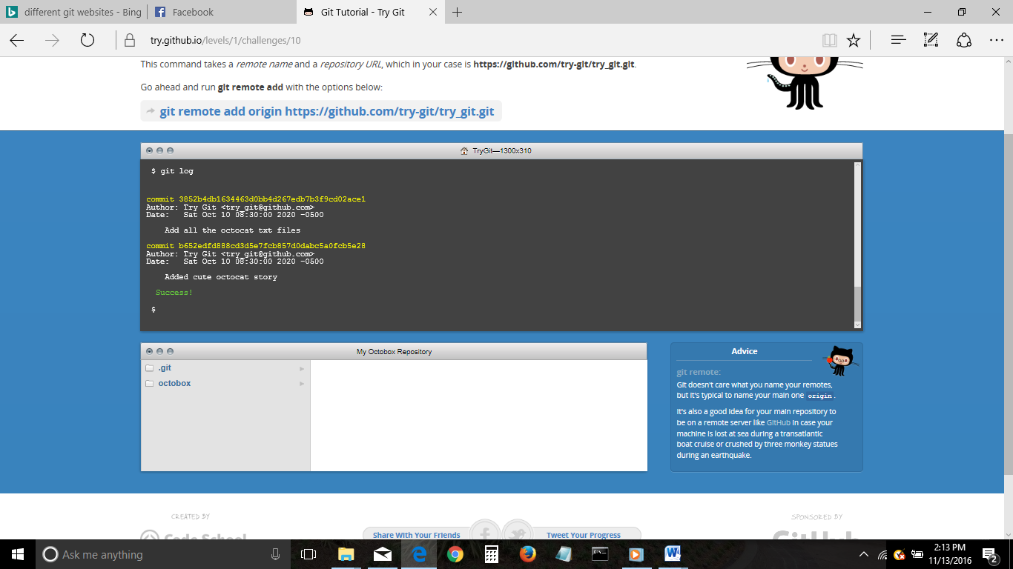

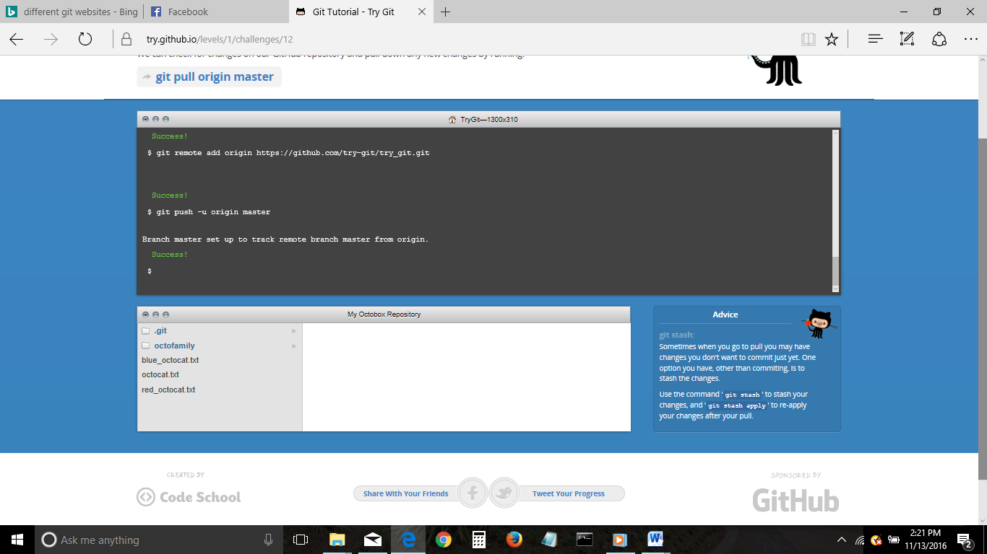

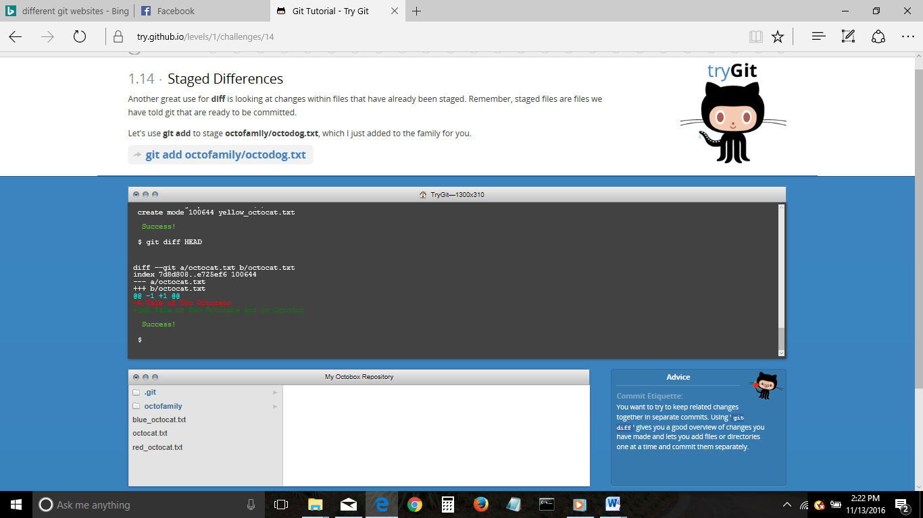

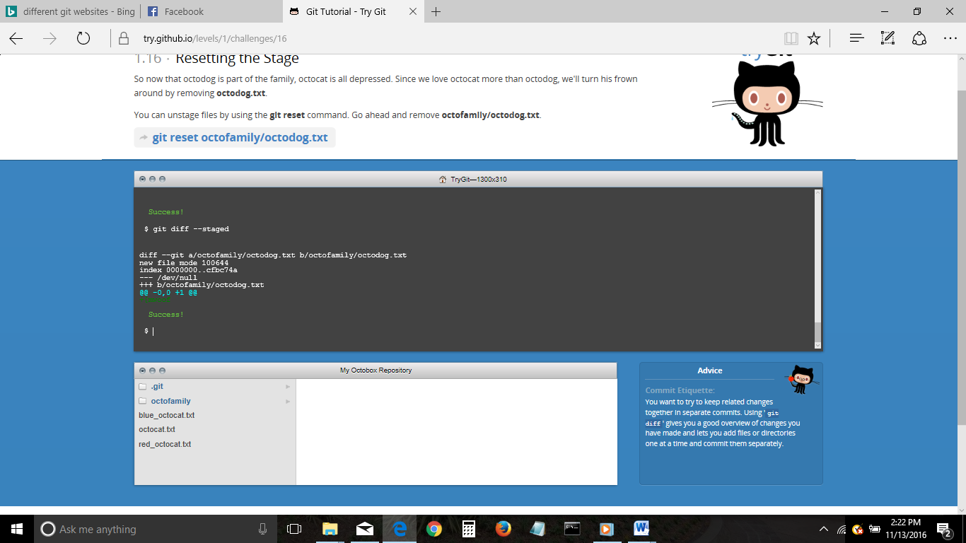

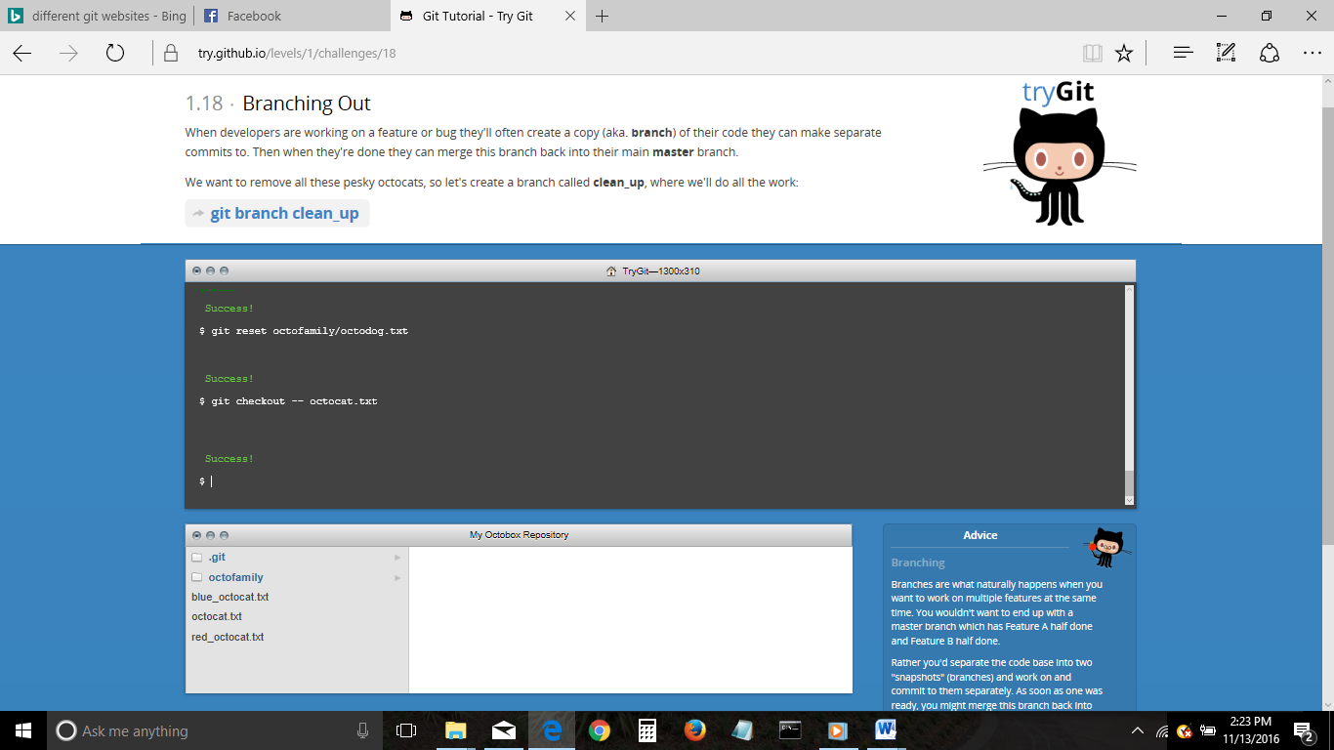

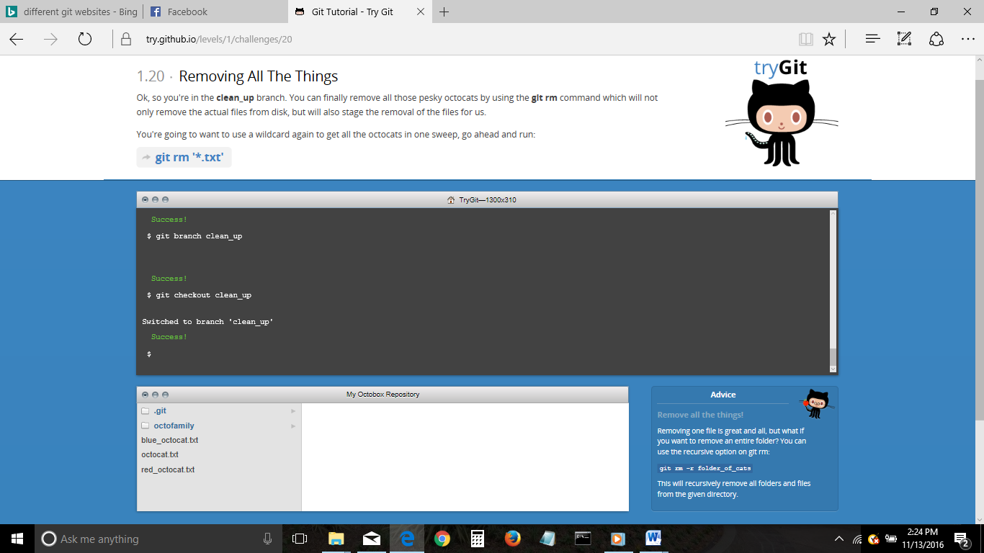

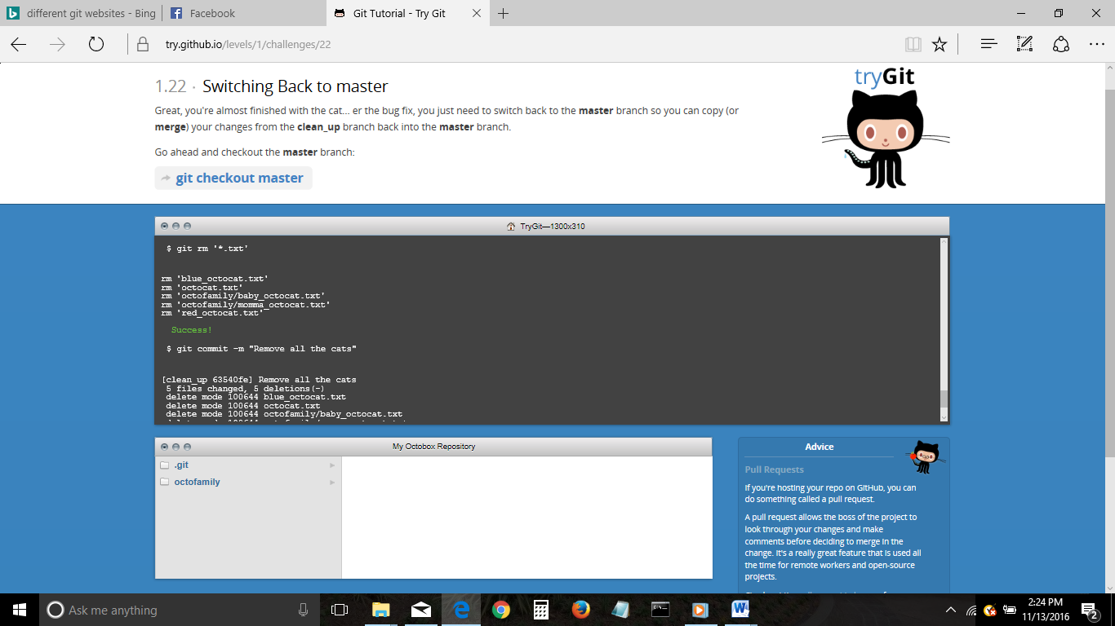

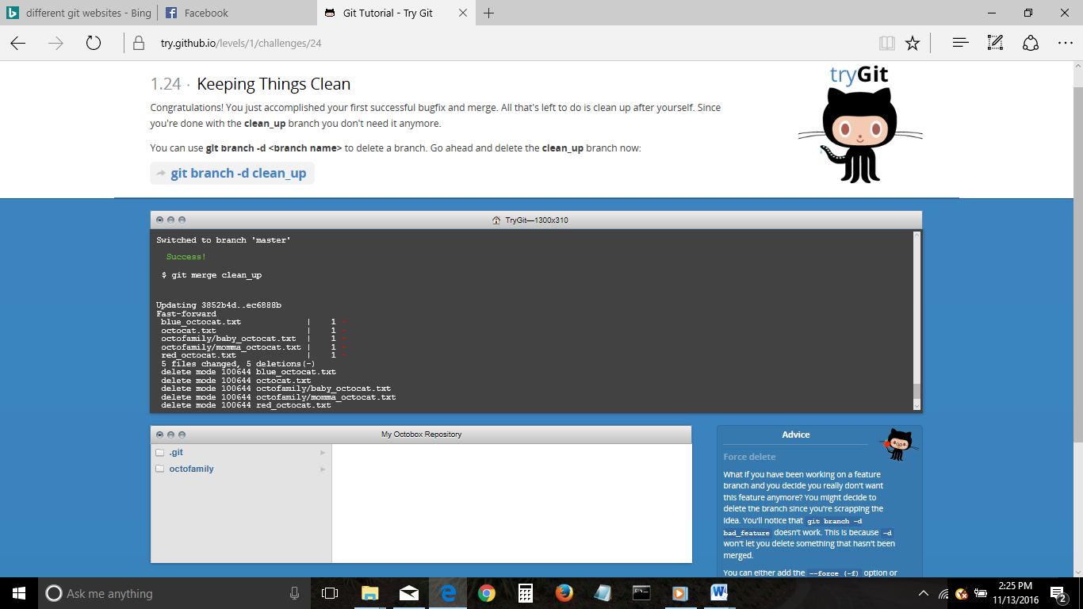

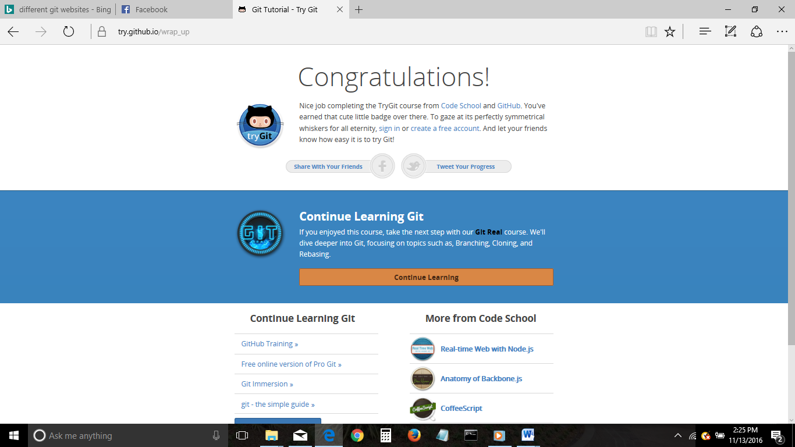

**Part 5:**

Define the following terms in the context of Git (2 lines maximum):

* Repository - A directory or storage space where your projects reside. It can be local to a folder on your computer or an external online host.
* Commit - When you commit, you manually place a checkpoint at your repository’s current state, to which you can reevaluate or restore your project to any previous state.
* Push – This ‘pushes’ the commits on your local repository onto the remote repository.
* Branch - This command will let you build a new branch, or timeline of commits, of changes and file additions, separate from the master branch and all others.
* Fork – Copy a remote repository into your own repository.
* Merge - You can merge your changes from your local repository into the master branch.
* Clone - You can clone your repository to create a local copy on your computer and sync between the two locations.
* Pull – Retrieve the most up-to-date version of the your remote repository.
* Pull request – Pull requests let you tell others about changes you've pushed to a remote repository.