Fizz Buzz

Challenge Description:
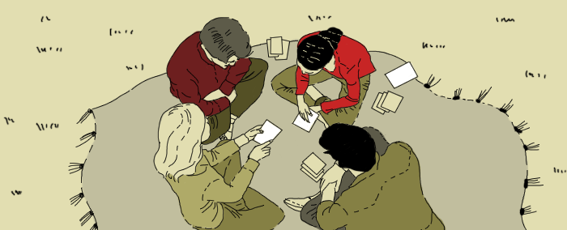
Players generally sit in a circle. The first player says the number “1”, and each player says next number in turn. However, any number divisible by X (for example, three) is replaced by the word fizz, and any divisible by Y (for example, five) by the word buzz. Numbers divisible by both become fizz buzz. A player who hesitates, or makes a mistake is eliminated from the game.
Write a program that prints out the final series of numbers where those divisible by X, Y and both are replaced by “F” for fizz, “B” for buzz and “FB” for fizz buzz.

Input sample:
Your program should accept a file as its first argument. The file contains multiple separated lines; each line contains 3 numbers that are space delimited. The first number is the first divider (X), the second number is the second divider (Y), and the third number is how far you should count (N). You may assume that the input file is formatted correctly and the numbers are valid positive integers.
For example:

Output sample:
Print out the series 1 through N replacing numbers divisible by X with “F”, numbers divisible by Y with “B” and numbers divisible by both with “FB”. Since the input file contains multiple sets of values, your output should print out one line per set. Ensure that there are no trailing empty spaces in each line you print.

Constraints:
- The number of test cases ≤ 20
- "X" is in range [1, 20]
- "Y" is in range [1, 20]
- "N" is in range [21, 100]

Prime Palindrome

Challenge Description:
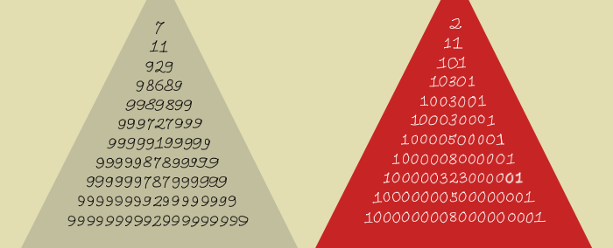
Write a program which determines the largest prime palindrome less than 1000.

Input sample:
There is no input for this program.

Output sample:
Print to stdout the largest prime palindrome less than 1000.
929

Sum of Primes

Challenge Description:
Write a program which determines the sum of the first 1000 prime numbers.

Input sample:
There is no input for this program.

Output sample:
Print to stdout the sum of the first 1000 prime numbers.
3682913

Reverse words

Challenge Description:
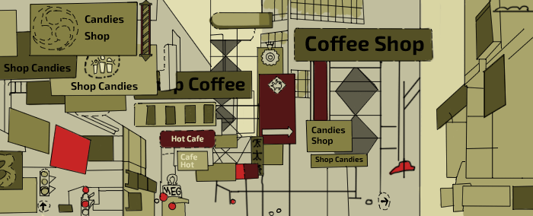
Write a program which reverses the words in an input sentence.

Input sample:
The first argument is a file that contains multiple sentences, one per line. Empty lines are also possible.
For example:

Output sample:
Print to stdout each sentence with the reversed words in it, one per line. Empty lines in the input should be ignored. Ensure that there are no trailing empty spaces in each line you print.
For example:
World Hello
CodeEval Hello
Submit Solution

Multiples of a Number

Challenge Description:
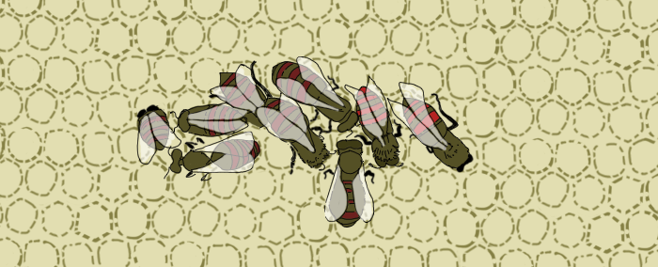
Given numbers x and n, where n is a power of 2, print out the smallest multiple of n which is greater than or equal to x. Do not use division or modulo operator.

Input sample:
The first argument will be a path to a filename containing a comma separated list of two integers, one list per line. E.g.
13,8
17,16

Output sample:
Print to stdout, the smallest multiple of n which is greater than or equal to x, one per line. E.g.
16
32
Submit Solution

Multiples of a Number

Challenge Description:
Given numbers x and n, where n is a power of 2, print out the smallest multiple of n which is greater than or equal to x. Do not use division or modulo operator.

Input sample:
The first argument will be a path to a filename containing a comma separated list of two integers, one list per line. E.g.
13,8
17,16

Output sample:
Print to stdout, the smallest multiple of n which is greater than or equal to x, one per line. E.g.
16
32

Bit Positions

Challenge Description:
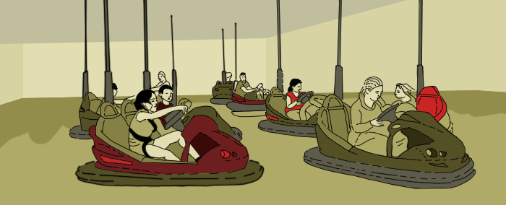
Given a number n and two integers p1,p2 determine if the bits in position p1 and p2 are the same or not. Positions p1 and p2 are 1 based.

Input sample:
The first argument will be a path to a filename containing a comma separated list of 3 integers, one list per line. E.g.

86,2,3
125,1,2

Output sample:
Print to stdout, 'true'(lowercase) if the bits are the same, else 'false'(lowercase). E.g.
true
false

Lowercase

Challenge Description:
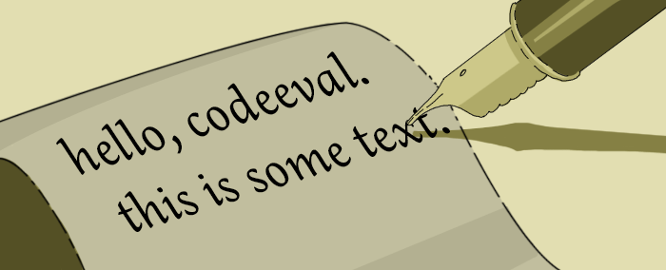
Given a string write a program to convert it into lowercase.

Input sample:
The first argument will be a path to a filename containing sentences, one per line. You can assume all characters are from the english language. E.g.
HELLO CODEEVAL
This is some text

Output sample:
Print to stdout, the lowercase version of the sentence, each on a new line. E.g.
hello codeeval
this is some text

Sum of Digits

Challenge Description:
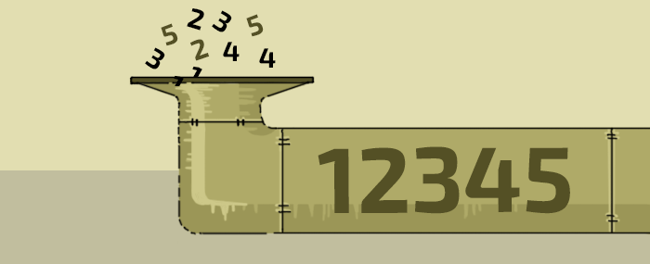
Given a positive integer, find the sum of its constituent digits.

Input sample:
The first argument will be a path to a filename containing positive integers, one per line. E.g.
23
496

Output sample:
Print to stdout, the sum of the numbers that make up the integer, one per line. E.g.
5
19

Fibonacci Series

Challenge Description:
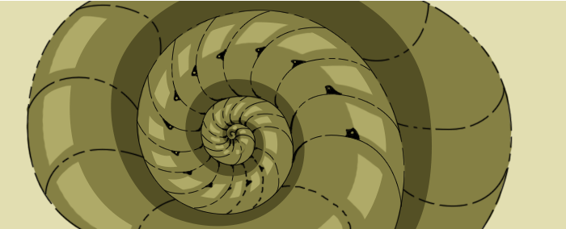
The Fibonacci series is defined as: F(0) = 0; F(1) = 1; F(n) = F(n–1) + F(n–2) when n>1. Given an integer n≥0, print out the F(n).

Input sample:
The first argument will be a path to a filename containing integer numbers, one per line. E.g.
5
12

Output sample:
Print to stdout, the fibonacci number, F(n). E.g.
5
144

Multiplication Tables

Challenge Description:

Print out the grade school multiplication table upto 12*12.

Input sample:
There is no input for this program.

Output sample:
Print out the table in a matrix like fashion, each number formatted to a width of 4 (The numbers are right-aligned and strip out leading/trailing spaces on each line). The first 3 line will look like:
1 2 3 4 5 6 7 8 9 10 11 12
2 4 6 8 10 12 14 16 18 20 22 24
3 6 9 12 15 18 21 24 27 30 33 36

Sum of Integers from File

Challenge Description:

Print out the sum of integers read from a file.

Input sample:
The first argument to the program will be a path to a filename containing a positive integer, one per line. E.g.
5
12

Output sample:
Print out the sum of all the integers read from the file. E.g.
17

Odd Numbers

Challenge Description:
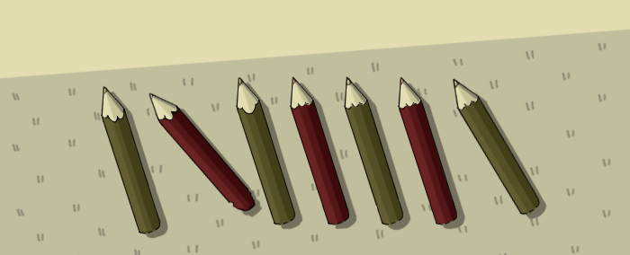
Print the odd numbers from 1 to 99.

Input sample:
There is no input for this program.

Output sample:
Print the odd numbers from 1 to 99, one number per line.

File Size

Challenge Description:
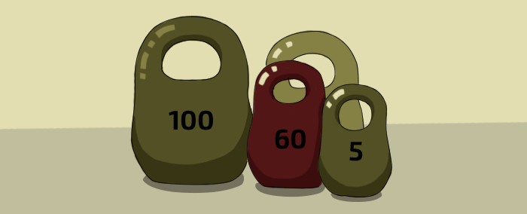
Print the size of a file in bytes.

Input:
The first argument to your program has the path to the file you need to check the size of.

Output sample:
Print the size of the file in bytes. E.g.
55

JSON menu IDs

Challenge Description:
You have JSON string which describes a menu. Calculate the SUM of IDs of all "items" in the case a "label" exists for an item.

Input sample:
Your program should accept as its first argument a path to a filename. Input example is the following
{"menu": {"header": "menu", "items": [{"id": 27}, {"id": 0, "label": "Label 0"}, null, {"id": 93}, {"id": 85}, {"id": 54}, null, {"id": 46, "label": "Label 46"}]}}

{"menu": {"header": "menu", "items": [{"id": 81}]}}

{"menu": {"header": "menu", "items": [{"id": 70, "label": "Label 70"}, {"id": 85, "label": "Label 85"}, {"id": 93, "label": "Label 93"}, {"id": 2}]}}
All IDs are integers between 0 and 100. It can be 10 items maximum for a menu.

Output sample:
Print results in the following way.
46
0
248
Moderate level

Longest Lines

Challenge Description:
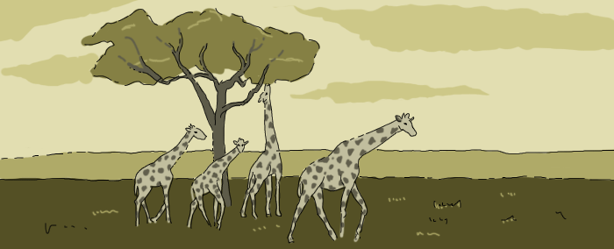
Write a program which reads a file and prints to stdout the specified number of the longest lines that are sorted based on their length in descending order.

Input sample:
Your program should accept a path to a file as its first argument. The file contains multiple lines. The first line indicates the number of lines you should output, the other lines are of different length and are presented randomly. You may assume that the input file is formatted correctly and the number in the first line is a valid positive integer.
For example:
2
Hello World
CodeEval
Quick Fox
A
San Francisco

Output sample:
Print out the longest lines limited by specified number and sorted by their length in descending order.
For example:
San Francisco
Hello World

Detecting Cycles

Sponsoring Company:


Challenge Description:

Given a sequence, write a program to detect cycles within it.

Input sample:
Your program should accept as its first argument a path to a filename containing a sequence of numbers (space delimited). The file can have multiple such lines. E.g

2 0 6 3 1 6 3 1 6 3 1
3 4 8 0 11 9 7 2 5 6 10 1 49 49 49 49
1 2 3 1 2 3 1 2 3

Output sample:
Print to stdout the first cycle you find in each sequence. Ensure that there are no trailing empty spaces on each line you print. E.g.

6 3 1
49
1 2 3
The cycle detection problem is explained more widely on wiki
Constrains:
The elements of the sequence are integers in range [0, 99]
The length of the sequence is in range [0, 50]

Stack Implementation

Challenge Description:
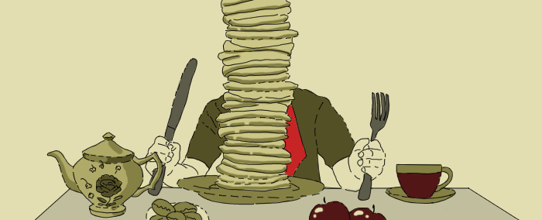
Write a program which implements a stack interface for integers. The interface should have ‘push’ and ‘pop’ functions. Your task is to ‘push’ a series of integers and then ‘pop’ and print every alternate integer.

Input sample:
Your program should accept a file as its first argument. The file contains a series of space delimited integers, one per line.
For example:
1 2 3 4
10 -2 3 4

Output sample:
Print to stdout every alternate space delimited integer, one per line.
For example:
4 2
4 -2

Mth to last element

Sponsoring Company:


Challenge Description:
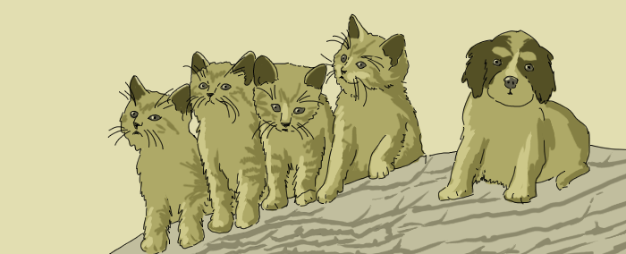
Write a program which determines the Mth to the last element in a list.

Input sample:
The first argument is a path to a file. The file contains the series of space delimited characters followed by an integer. The integer represents an index in the list (1-based), one per line.
For example:
a b c d 4
e f g h 2

Output sample:
Print to stdout the Mth element from the end of the list, one per line. If the index is larger than the number of elements in the list, ignore that input.
For example:
a
g

Lowest Common Ancestor

Challenge Description:
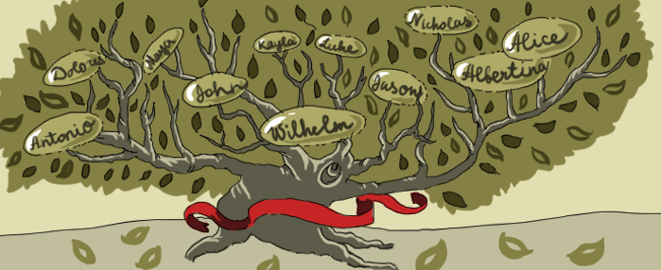
Write a program to determine the lowest common ancestor of two nodes in a binary search tree. You may hardcode the following binary search tree in your program:
30
|
____
| |
8 52
|
____
| |
3 20
|
____
| |
10 29

Input sample:
The first argument is a path to a file that contains two values. These values represent two nodes within the tree, one per line. E.g.:
8 52
3 29

Output sample:
Print to stdout the lowest common ancestor, one per line. Lowest means the lowest depth in the tree, not the lowest value. E.g.:
30
8

Remove Characters

Challenge Description:

Write a program which removes specific characters from a string.

Input sample:
The first argument is a path to a file. The file contains the source strings and the characters that need to be scrubbed. Each source string and characters you need to scrub are delimited by comma.
For example:
how are you, abc
hello world, def

Output sample:
Print to stdout the scrubbed strings, one per line. Ensure that there are no trailing empty spaces on each line you print.
For example:
how re you
hllo worl

Number of Ones

Challenge Description:

Write a program which determines the number of 1 bits in the internal representation of a given integer.

Input sample:
The first argument is a path to a file. The file contains integers, one per line.
For example:
10
22
56

Output sample:
Print to stdout the number of ones in the binary form of each number.
For example:
2
3
3

Endianness

Challenge Description:
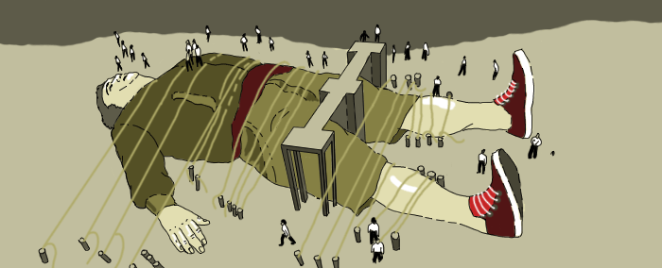
Write a program which prints the endianness of the system.

Input sample:
There is no input for this program.

Output sample:
Print to stdout the endianness, wheather it is LittleEndian or BigEndian.
For example:
BigEndian

Sum of integers

Challenge Description:
Write a program to determine the largest sum of contiguous integers in a list.

Input sample:
The first argument is a path to a filename containing a comma-separated list of integers, one per line.
For example:
-10,2,3,-2,0,5,-15
2,3,-2,-1,10

Output sample:
Print to stdout the largest sum. In other words, of all the possible contiguous subarrays for a given array, find the one with the largest sum, and print that sum.
For example:
8
12

Decimal To Binary

Challenge Description:

You are given a decimal (base 10) number, print its binary representation.

Input sample:
Your program should accept as its first argument a path to a filename containing decimal numbers greater or equal to 0, one per line.
Ignore all empty lines.
For example:
2
10
67

Output sample:
Print the binary representation, one per line.
For example:
10
1010
1000011

Reverse and Add

Sponsoring Company:


Challenge Description:
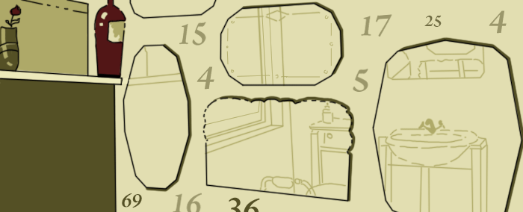 Credits: Programming Challenges by Steven S. Skiena and Miguel A. Revilla
The problem is as follows: choose a number, reverse its digits and add it to the original. If the sum is not a palindrome (which means, it is not the same number from left to right and right to left), repeat this procedure.
For example:
195 (initial number) + 591 (reverse of initial number) = 786

786 + 687 = 1473

1473 + 3741 = 5214

5214 + 4125 = 9339 (palindrome)
In this particular case the palindrome 9339 appeared after the 4th addition. This method leads to palindromes in a few step for almost all of the integers. But there are interesting exceptions. 196 is the first number for which no palindrome has been found. It is not proven though, that there is no such a palindrome.

Input sample:
Your program should accept as its first argument a path to a filename. Each line in this file is one test case. Each test case will contain an integer n < 10,000. Assume each test case will always have an answer and that it is computable with less than 100 iterations (additions).

Output sample:
For each line of input, generate a line of output which is the number of iterations (additions) to compute the palindrome and the resulting palindrome. (they should be on one line and separated by a single space character).
For example:
4 9339

Jolly Jumpers

Challenge Description:
Credits: Programming Challenges by Steven S. Skiena and Miguel A. Revilla
A sequence of n > 0 integers is called a jolly jumper if the absolute values of the differences between successive elements take on all possible values 1 through n - 1. eg.
1 4 2 3
is a jolly jumper, because the absolute differences are 3, 2, and 1, respectively. The definition implies that any sequence of a single integer is a jolly jumper. Write a program to determine whether each of a number of sequences is a jolly jumper.

Input sample:
Your program should accept as its first argument a path to a filename. Each line in this file is one test case. Each test case will contain an integer n < 3000 followed by n integers representing the sequence. The integers are space delimited.
For example:
4 1 4 2 3
3 7 7 8
9 8 9 7 10 6 12 17 24 38

Output sample:
For each line of input generate a line of output saying 'Jolly' or 'Not jolly'.
For example:
Jolly
Not jolly
Not jolly

Hard challenges:

Longest Common Subsequence

Challenge Description:
You are given two sequences. Write a program to determine the longest common subsequence between the two strings (each string can have a maximum length of 50 characters). NOTE: This subsequence need not be contiguous. The input file may contain empty lines, these need to be ignored.

Input sample:
The first argument will be a path to a filename that contains two strings per line, semicolon delimited. You can assume that there is only one unique subsequence per test case. E.g.
XMJYAUZ;MZJAWXU

Output sample:
The longest common subsequence. Ensure that there are no trailing empty spaces on each line you print. E.g.
MJAU

Prefix expressions

Challenge Description:
You are given a prefix expression. Write a program which evaluates it.

Input sample:
Your program should accept a file as its first argument. The file contains one prefix expression per line.
For example:
* + 2 3 4
Your program should read this file and insert it into any data structure you like. Traverse this data structure and evaluate the prefix expression. Each token is delimited by a whitespace. You may assume that sum ‘+’, multiplication ‘*’ and division ‘/’ are the only valid operators appearing in the test data.

Output sample:
Print to stdout the output of the prefix expression, one per line.
For example:
20

Constraints:
- The evaluation result will always be an integer ≥ 0.
- The number of the test cases is ≤ 40.

String Permutations

Sponsoring Company:


Challenge Description:
Write a program which prints all the permutations of a string in alphabetical order. We consider that digits < upper case letters < lower case letters. The sorting should be performed in ascending order.

Input sample:
Your program should accept a file as its first argument. The file contains input strings, one per line.
For example:
hat
abc
Zu6

Output sample:
Print to stdout the permutations of the string separated by comma, in alphabetical order.
For example:
aht,ath,hat,hta,tah,tha
abc,acb,bac,bca,cab,cba
6Zu,6uZ,Z6u,Zu6,u6Z,uZ6

String Searching

Challenge Description:
You are given two strings. Determine if the second string is a substring of the first (Do NOT use any substr type library function). The second string may contain an asterisk(*) which should be treated as a regular expression i.e. matches zero or more characters. The asterisk can be escaped by a \ char in which case it should be interpreted as a regular '*' character. To summarize: the strings can contain alphabets, numbers, * and \ characters.

Input sample:
Your program should accept as its first argument a path to a filename. The input file contains two comma delimited strings per line. E.g.
Hello,ell
This is good, is
CodeEval,C*Eval
Old,Young

Output sample:
If the second string is indeed a substring of the first, print out a 'true'(lowercase), else print out a 'false'(lowercase), one per line. E.g.
true
true
true
false

Message Decoding

Challenge Description:
Credits: This challenge has appeared in a past ACM competition.
Some message encoding schemes require that an encoded message be sent in two parts. The first part, called the header, contains the characters of the message. The second part contains a pattern that represents the message.You must write a program that can decode messages under such a scheme.
The heart of the encoding scheme for your program is a sequence of "key" strings of 0's and 1's as follows:
0,00,01,10,000,001,010,011,100,101,110,0000,0001,. . .,1011,1110,00000, . . .
The first key in the sequence is of length 1, the next 3 are of length 2, the next 7 of length 3, the next 15 of length 4, etc. If two adjacent keys have the same length, the second can be obtained from the first by adding 1 (base 2). Notice that there are no keys in the sequence that consist only of 1's.
The keys are mapped to the characters in the header in order. That is, the first key (0) is mapped to the first character in the header, the second key (00) to the second character in the header, the kth key is mapped to the kth character in the header. For example, suppose the header is:
AB#TANCnrtXc
Then 0 is mapped to A, 00 to B, 01 to #, 10 to T, 000 to A, ..., 110 to X, and 0000 to c.
The encoded message contains only 0's and 1's and possibly carriage returns, which are to be ignored. The message is divided into segments. The first 3 digits of a segment give the binary representation of the length of the keys in the segment. For example, if the first 3 digits are 010, then the remainder of the segment consists of keys of length 2 (00, 01, or 10). The end of the segment is a string of 1's which is the same length as the length of the keys in the segment. So a segment of keys of length 2 is terminated by 11. The entire encoded message is terminated by 000 (which would signify a segment in which the keys have length 0). The message is decoded by translating the keys in the segments one-at-a-time into the header characters to which they have been mapped.

Input sample:
The input file contains several data sets. Each data set consists of a header and a message. These will all be on one line. The length of the header is limited only by the fact that key strings have a maximum length of 7 (111 in binary). If there are multiple copies of a character in a header, then several keys will map to that character. The encoded message contains only 0's and 1's, and it is a legitimate encoding according to the described scheme. That is, the message segments begin with the 3-digit length sequence and end with the appropriate sequence of 1's. The keys in any given segment are all of the same length, and they all correspond to characters in the header. The message is terminated by 000. Your program should accept the first argument as the filename and read the contents of this file as the test data, according to the conditions above. E.g.
$#**\0100000101101100011100101000

Output sample:
For each data set, your program must write its decoded message on a separate line. There should not be blank lines between messages. E.g.
##*\$

String List

Challenge Description:
Credits: Challenge contributed by Max Demian.
You are given a number N and a string S. Print all of the possible ways to write a string of length N from the characters in string S, comma delimited in alphabetical order.

Input sample:
The first argument will be the path to the input filename containing the test data. Each line in this file is a separate test case. Each line is in the format: N,S i.e. a positive integer, followed by a string (comma separated). E.g.
1,aa
2,ab
3,pop

Output sample:
Print all of the possible ways to write a string of length N from the characters in string S comma delimited in alphabetical order, with no duplicates. E.g.
a
aa,ab,ba,bb
ooo,oop,opo,opp,poo,pop,ppo,ppp

Ugly Numbers

Challenge Description:
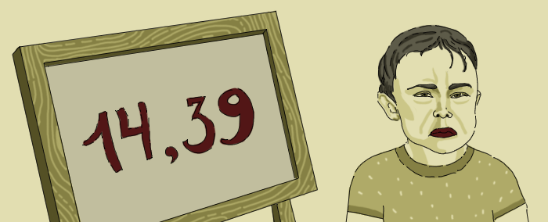 Credits: This challenge has appeared in a google competition before.
Once upon a time in a strange situation, people called a number ugly if it was divisible by any of the one-digit primes (2, 3, 5 or 7). Thus, 14 is ugly, but 13 is fine. 39 is ugly, but 121 is not. Note that 0 is ugly. Also note that negative numbers can also be ugly: -14 and -39 are examples of such numbers.
One day on your free time, you are gazing at a string of digits, something like:
123456
You are amused by how many possibilities there are if you are allowed to insert plus or minus signs between the digits. For example you can make:
1 + 234 - 5 + 6 = 236
which is ugly. Or
123 + 4 - 56 = 71
which is not ugly.
It is easy to count the number of different ways you can play with the digits: Between each two adjacent digits you may choose put a plus sign, a minus sign, or nothing. Therefore, if you start with D digits there are 3^(D-1) expressions you can make. Note that it is fine to have leading zeros for a number. If the string is '01023', then '01023', '0+1-02+3' and '01-023' are legal expressions.
Your task is simple: Among the 3^(D-1) expressions, count how many of them evaluate to an ugly number.

Input sample:
Your program should accept as its first argument a path to a filename. Each line in this file is one test case. Each test case will be a single line containing a non-empty string of decimal digits. The string in each test case will be non-empty and will contain only characters '0' through '9'. Each string is no more than 13 characters long. E.g.
1
9
011
12345

Output sample:
Print out the number of expressions that evaluate to an ugly number for each test case, each one on a new line. E.g.
0
1
6
64

Following Integer

Challenge Description:
Credits: This challenge has appeared in a past google competition
You are writing out a list of numbers.Your list contains all numbers with exactly Di digits in its decimal representation which are equal to i, for each i between 1 and 9, inclusive. You are writing them out in ascending order. For example, you might be writing every number with two '1's and one '5'. Your list would begin 115, 151, 511, 1015, 1051. Given N, the last number you wrote, compute what the next number in the list will be. The number of 1s, 2s, ..., 9s is fixed but the number of 0s is arbitrary.

Input sample:
Your program should accept as its first argument a path to a filename. Each line in this file is one test case. Each test case will contain an integer n < 10^6. E.g.
115
842
8000

Output sample:
For each line of input, generate a line of output which is the next integer in the list. E.g.
151
2048
80000

Palindromic Ranges

Challenge Description:
A positive integer is a palindrome if its decimal representation (without leading zeros) is a palindromic string (a string that reads the same forwards and backwards). For example, the numbers 5, 77, 363, 4884, 11111, 12121 and 349943 are palindromes.
A range of integers is interesting if it contains an even number of palindromes. The range [L, R], with L <= R, is defined as the sequence of integers from L to R (inclusive): (L, L+1, L+2, ..., R-1, R). L and R are the range's first and last numbers.
The range [L1,R1] is a subrange of [L,R] if L <= L1 <= R1 <= R. Your job is to determine how many interesting subranges of [L,R] there are.

Input sample:
Your program should accept as its first argument a path to a filename. Each line in this file is one test case. Each test case will contain two positive integers, L and R (in that order), separated by a space. eg.
1 2
1 7
87 88

Output sample:
For each line of input, print out the number of interesting subranges of [L,R] eg.
1
12
1
For the curious: In the third example, the subranges are: [87](0 palindromes), [87,88](1 palindrome),[88](1 palindrome). Hence the number of interesting palindromic ranges is 1

Discount Offers

Challenge Description:

Our marketing department has just negotiated a deal with several local merchants that will allow us to offer exclusive discounts on various products to our top customers every day. The catch is that we can only offer each product to one customer and we may only offer one product to each customer.
Each day we will get the list of products that are eligible for these special discounts. We then have to decide which products to offer to which of our customers. Fortunately, our team of highly skilled statisticians has developed an amazing mathematical model for determining how likely a given customer is to buy an offered product by calculating what we call the "suitability score" (SS). The top-secret algorithm to calculate the SS between a customer and a product is this:
1. If the number of letters in the product's name is even then the SS is the number of vowels (a, e, i, o, u, y) in the customer's name multiplied by 1.5.
2. If the number of letters in the product's name is odd then the SS is the number of consonants in the customer's name.
3. If the number of letters in the product's name shares any common factors (besides 1) with the number of letters in the customer's name then the SS is multiplied by 1.5.
Your task is to implement a program that assigns each customer a product to be offered in a way that maximizes the combined total SS across all of the chosen offers. Note that there may be a different number of products and customers. You may include code from external libraries as long as you cite the source.

Input sample:
Your program should accept as its only argument a path to a file. Each line in this file is one test case. Each test case will be a comma delimited set of customer names followed by a semicolon and then a comma delimited set of product names. Assume the input file is ASCII encoded. For example (NOTE: The example below has 3 test cases):
Jack Abraham,John Evans,Ted Dziuba;iPad 2 - 4-pack,Girl Scouts Thin Mints,Nerf Crossbow
Jeffery Lebowski,Walter Sobchak,Theodore Donald Kerabatsos,Peter Gibbons,Michael Bolton,Samir Nagheenanajar;Half & Half,Colt M1911A1,16lb bowling ball,Red Swingline Stapler,Printer paper,Vibe Magazine Subscriptions - 40 pack
Jareau Wade,Rob Eroh,Mahmoud Abdelkader,Wenyi Cai,Justin Van Winkle,Gabriel Sinkin,Aaron Adelson;Batman No. 1,Football - Official Size,Bass Amplifying Headphones,Elephant food - 1024 lbs,Three Wolf One Moon T-shirt,Dom Perignon 2000 Vintage

Output sample:
For each line of input, print out the maximum total score to two decimal places. For the example input above, the output should look like this:
21.00
83.50
71.25

Peak Traffic

Challenge Description:
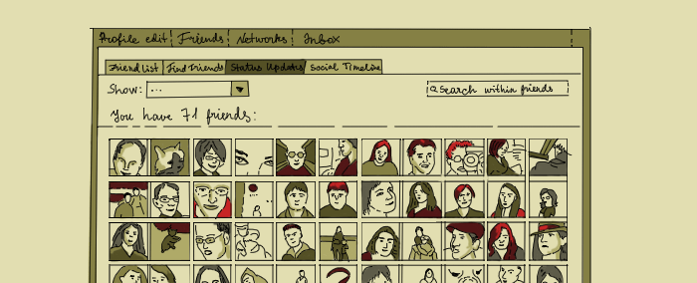 Credits: This challenge is from the facebook engineering puzzles
Facebook is looking for ways to help users find out which friends they interact with the most on the site. Towards that end, you have collected data from your friends regarding who they interacted with on the site. Each piece of data represents a desirable but one-way interaction between one user of Facebook towards another user of Facebook. By finding groups of users who regularly interact with one another, you hope to help users determine who among their friends they spend the most time with online.
Being a popular user, you have collected a lot of data; so much that you cannot possibly process it by hand. But being a programmer of no small repute, you believe you can write a program to do the analysis for you. You are interested in finding clusters of users within your data pool; in other words, groups of users who interact among one another. A cluster is defined as a set of at least three users, where every possible permutation of two users within the cluster have both received and sent some kind of interaction between the two.
With your program, you wish to analyze the collected data and find out all clusters within.

Input sample:
Your program should accept as its first argument a path to a filename. The input file consists of multiple lines of aggregated log data. Each line starts with a date entry, whose constituent parts are separated by single white spaces. The exact format of the date always follows the examples given below. Following the date is a single tab, and then the email address of the user who is performing the action. Following that email is another single tab and then finally the email of the Facebook user who receives the action. The last line of the file may or may not have a newline at its end.
Thu Dec 11 17:53:01 PST 2008 a@facebook.com b@facebook.com
Thu Dec 11 17:53:02 PST 2008 b@facebook.com a@facebook.com
Thu Dec 11 17:53:03 PST 2008 a@facebook.com c@facebook.com
Thu Dec 11 17:53:04 PST 2008 c@facebook.com a@facebook.com
Thu Dec 11 17:53:05 PST 2008 b@facebook.com c@facebook.com
Thu Dec 11 17:53:06 PST 2008 c@facebook.com b@facebook.com
Thu Dec 11 17:53:07 PST 2008 d@facebook.com e@facebook.com
Thu Dec 11 17:53:08 PST 2008 e@facebook.com d@facebook.com
Thu Dec 11 17:53:09 PST 2008 d@facebook.com f@facebook.com
Thu Dec 11 17:53:10 PST 2008 f@facebook.com d@facebook.com
Thu Dec 11 17:53:11 PST 2008 e@facebook.com f@facebook.com
Thu Dec 11 17:53:12 PST 2008 f@facebook.com e@facebook.com
Every line in the input file will follow this format, you are guaranteed that your submission will run against well formed input files.

Output sample:
You must output all clusters detected from the input log file with size of at least 3 members. A cluster is defined as N >= 3 users on Facebook that have send and received actions between all possible permutations of any two members within the cluster.
Your program should print to standard out, exactly one cluster per line. Each cluster must have its member user emails in alphabetical order, separated by a comma and a single space character each. There must not be a comma (or white space) after the final email in the cluster; instead print a single new line character at the end of every line. The clusters themselves must be printed to standard out also in alphabetical order; treat each cluster as a whole string for purposes of alphabetical comparisons. Do not sort the clusters by size or any other criteria.
a@facebook.com, b@facebook.com, c@facebook.com
d@facebook.com, e@facebook.com, f@facebook.com
Finally, any cluster that is a sub-cluster (in other words, all users within one cluster are also present in another) must be removed from the output. For this case, your program should only print the largest super-cluster that includes the other clusters. Your program must be fast, efficient, and able to handle extremely large input files.

Telephone Words

Challenge Description:
Given a 7 digit telephone number, print out all the possible sequences of letters that can represent the given telephone number. Note that in a standard 12 key pad, 0 and 1 do not have any letters associated with them. They are to be treated as such, i.e. a 0/1 in the telephone number will be retained in the final word as well. You may use the following mapping between numbers and characters:
0 => 0
1 => 1
2 => abc
3 => def
4 => ghi
5 => jkl
6 => mno
7 => pqrs
8 => tuv
9 => wxyz

Input sample:
Your program should accept as its first argument a path to a filename.The input file contains 7 digit telephone numbers, one per line.
4155230

Output sample:
Print out the words that can produce the telephone number, alphabetically sorted and comma delimited. E.g.
g1jjad0,g1jjae0,g1jjaf0,g1jjbd0,g1jjbe0,g1jjbf0,g1jjcd0,g1jjce0,g1jjcf0,g1jkad0,g1jkae0,g1jkaf0,g1jkbd0,g1jkbe0,g1jkbf0,g1jkcd0,g1jkce0,g1jkcf0,g1jlad0,g1jlae0,g1jlaf0,g1jlbd0,g1jlbe0,g1jlbf0,g1jlcd0,g1jlce0,g1jlcf0,g1kjad0,g1kjae0,g1kjaf0,g1kjbd0,g1kjbe0,g1kjbf0,g1kjcd0,g1kjce0,g1kjcf0,g1kkad0,g1kkae0,g1kkaf0,g1kkbd0,g1kkbe0,g1kkbf0,g1kkcd0,g1kkce0,g1kkcf0,g1klad0,g1klae0,g1klaf0,g1klbd0,g1klbe0,g1klbf0,g1klcd0,g1klce0,g1klcf0,g1ljad0,g1ljae0,g1ljaf0,g1ljbd0,g1ljbe0,g1ljbf0,g1ljcd0,g1ljce0,g1ljcf0,g1lkad0,g1lkae0,g1lkaf0,g1lkbd0,g1lkbe0,g1lkbf0,g1lkcd0,g1lkce0,g1lkcf0,g1llad0,g1llae0,g1llaf0,g1llbd0,g1llbe0,g1llbf0,g1llcd0,g1llce0,g1llcf0,h1jjad0,h1jjae0,h1jjaf0,h1jjbd0,h1jjbe0,h1jjbf0,h1jjcd0,h1jjce0,h1jjcf0,h1jkad0,h1jkae0,h1jkaf0,h1jkbd0,h1jkbe0,h1jkbf0,h1jkcd0,h1jkce0,h1jkcf0,h1jlad0,h1jlae0,h1jlaf0,h1jlbd0,h1jlbe0,h1jlbf0,h1jlcd0,h1jlce0,h1jlcf0,h1kjad0,h1kjae0,h1kjaf0,h1kjbd0,h1kjbe0,h1kjbf0,h1kjcd0,h1kjce0,h1kjcf0,h1kkad0,h1kkae0,h1kkaf0,h1kkbd0,h1kkbe0,h1kkbf0,h1kkcd0,h1kkce0,h1kkcf0,h1klad0,h1klae0,h1klaf0,h1klbd0,h1klbe0,h1klbf0,h1klcd0,h1klce0,h1klcf0,h1ljad0,h1ljae0,h1ljaf0,h1ljbd0,h1ljbe0,h1ljbf0,h1ljcd0,h1ljce0,h1ljcf0,h1lkad0,h1lkae0,h1lkaf0,h1lkbd0,h1lkbe0,h1lkbf0,h1lkcd0,h1lkce0,h1lkcf0,h1llad0,h1llae0,h1llaf0,h1llbd0,h1llbe0,h1llbf0,h1llcd0,h1llce0,h1llcf0,i1jjad0,i1jjae0,i1jjaf0,i1jjbd0,i1jjbe0,i1jjbf0,i1jjcd0,i1jjce0,i1jjcf0,i1jkad0,i1jkae0,i1jkaf0,i1jkbd0,i1jkbe0,i1jkbf0,i1jkcd0,i1jkce0,i1jkcf0,i1jlad0,i1jlae0,i1jlaf0,i1jlbd0,i1jlbe0,i1jlbf0,i1jlcd0,i1jlce0,i1jlcf0,i1kjad0,i1kjae0,i1kjaf0,i1kjbd0,i1kjbe0,i1kjbf0,i1kjcd0,i1kjce0,i1kjcf0,i1kkad0,i1kkae0,i1kkaf0,i1kkbd0,i1kkbe0,i1kkbf0,i1kkcd0,i1kkce0,i1kkcf0,i1klad0,i1klae0,i1klaf0,i1klbd0,i1klbe0,i1klbf0,i1klcd0,i1klce0,i1klcf0,i1ljad0,i1ljae0,i1ljaf0,i1ljbd0,i1ljbe0,i1ljbf0,i1ljcd0,i1ljce0,i1ljcf0,i1lkad0,i1lkae0,i1lkaf0,i1lkbd0,i1lkbe0,i1lkbf0,i1lkcd0,i1lkce0,i1lkcf0,i1llad0,i1llae0,i1llaf0,i1llbd0,i1llbe0,i1llbf0,i1llcd0,i1llce0,i1llcf0

Da Vyncy

Challenge Description:

You were reading The Da Vyncy Code, the translation of a famous murder mystery novel into Python. The Code is finally revealed on the last page. You had reached the second to last page of the novel, and then you went to take a bathroom break.
While you were in the bathroom, the Illuminati snuck into your room and shredded the last page of your book. You had 9 backup copies of the book just in case of an attack like this, but the Illuminati shredded the last page from each of the those books, too. Then they propped up a fan, aimed it at the remains, and turned it on at high-speed.
The last page of your book is now in tatters.
However, there are many text fragments floating in the air. You enlist an undergraduate student for a 'summer research project' of typing up these fragments into a file. Your mission: reassemble the last page of your book.
Problem Description
=============
(adapted from a problem by Julie Zelenski)
Write a program that, given a set of fragments (ASCII strings), uses the following method (or a method producing identical output) to reassemble the document from which they came:
At each step, your program searches the collection of fragments. It should find the pair of fragments with the maximal overlap match and merge those two fragments. This operation should decrease the total number of fragments by one. If there is more than one pair of fragments with a maximal overlap, you may break the tie in an arbitrary fashion.Fragments must overlap at their start or end. For example:
- "ABCDEF" and "DEFG" overlap with overlap length 3
- "ABCDEF" and "XYZABC" overlap with overlap length 3
- "ABCDEF" and "BCDE" overlap with overlap length 4
- "ABCDEF" and "XCDEZ" do *not* overlap (they have matching characters in the middle, but the overlap does not extend to the end of either string).
Fear not - any test inputs given to you will satisfy the property that the tie-breaking order will not change the result, as long as you only ever merge maximally-overlapping fragments. Bonus points if you can come up with an input for which this property does not hold (ie, there exists more than 1 different final reconstruction, depending on the order in which different maximal-overlap merges are performed) -- if you find such a case, submit it in the comments to your code!
All characters must match exactly in a sequence (case-sensitive). Assume that your undergraduate has provided you with clean data (i.e., there are no typos).

Input sample:
Your program should accept as its first argument a path to a filename. Each line in this file represents a test case. Each line contains fragments separated by a semicolon, which your assistant has painstakingly transcribed from the shreds left by the Illuminati. You may assume that every fragment has length at least 2 and at most 1022 (excluding the trailing newline, which should *not* be considered part of the fragment). E.g. Here are two test cases.
O draconia;conian devil! Oh la;h lame sa;saint!
m quaerat voluptatem.;pora incidunt ut labore et d;, consectetur, adipisci velit;olore magnam aliqua;idunt ut labore et dolore magn;uptatem.;i dolorem ipsum qu;iquam quaerat vol;psum quia dolor sit amet, consectetur, a;ia dolor sit amet, conse;squam est, qui do;Neque porro quisquam est, qu;aerat voluptatem.;m eius modi tem;Neque porro qui;, sed quia non numquam ei;lorem ipsum quia dolor sit amet;ctetur, adipisci velit, sed quia non numq;unt ut labore et dolore magnam aliquam qu;dipisci velit, sed quia non numqua;us modi tempora incid;Neque porro quisquam est, qui dolorem i;uam eius modi tem;pora inc;am al

Output sample:
Print out the original document, reassembled. E.g.
O draconian devil! Oh lame saint!
Neque porro quisquam est, qui dolorem ipsum quia dolor sit amet, consectetur, adipisci velit, sed quia non numquam eius modi tempora incidunt ut labore et dolore magnam aliquam quaerat voluptatem.

Bay Bridges

Sponsoring Companies:

Challenge Description:
A new technological breakthrough has enabled us to build bridges that can withstand a 9.5 magnitude earthquake for a fraction of the cost. Instead of retrofitting existing bridges which would take decades and cost at least 3x the price we're drafting up a proposal rebuild all of the bay area's bridges more efficiently between strategic coordinates outlined below.
You want to build the bridges as efficiently as possible and connect as many pairs of points as possible with bridges such that no two bridges cross. When connecting points, you can only connect point 1 with another point 1, point 2 with another point 2.
At example given on the map we should connect all the points except points with number 4.

Input sample:
Your program should accept as its first argument a path to a filename. Input example is the following
1: ([37.788353, -122.387695], [37.829853, -122.294312]) 2: ([37.429615, -122.087631], [37.487391, -122.018967]) 3: ([37.474858, -122.131577], [37.529332, -122.056046]) 4: ([37.532599,-122.218094], [37.615863,-122.097244]) 5: ([37.516262,-122.198181], [37.653383,-122.151489]) 6: ([37.504824,-122.181702], [37.633266,-122.121964])
Each input line represents a pair of coordinates for each possible bridge.

Output sample:
You should output bridges in ascending order.
1 2 3 5 6
(Check lines on the map)

Computer Terminal

Sponsoring Company:


Challenge Description:

In this problem you are writing the software for a small terminal with a 10-row, 10-column display (perhaps for a point-of-sale terminal). Rows and columns are numbered 0 through 9. The character that introduces a control sequence is ^, the circumflex. The character (or in one case, the two characters) immediately following the control sequence introducer will direct your software in performing its special functions.
Here is the complete list of control sequences you will need to interpret:
^c - clear the entire screen; the cursor row and column do not change
^h - move the cursor to row 0, column 0; the image on the screen is not changed
^b - move the cursor to the beginning of the current line; the cursor row does not change
^d - move the cursor down one row if possible; the cursor column does not change
^u - move the cursor up one row, if possible; the cursor column does not change
^l - move the cursor left one column, if possible; the cursor row does not change
^r - move the cursor right one column, if possible; the cursor row does not change
^e - erase characters to the right of, and including, the cursor column on the cursor's row; the cursor row and column do not change
^i - enter insert mode
^o - enter overwrite mode
^^ - write a circumflex (^) at the current cursor location, exactly as if it was not a special character; this is subject to the actions of the current mode (insert or overwrite)
^DD - move the cursor to the row and column specified; each D represents a decimal digit; the first D represents the new row number, and the second D represents the new column number
No illegal control sequences will ever be sent to the terminal. The cursor cannot move outside the allowed screen locations (that is, between row 0, column 0 and row 9, column 9).
When a normal character (not part of a control sequence) arrives at the terminal, it is displayed on the terminal screen in a manner that depends on the terminal mode. When the terminal is in overwrite mode (as it is when it is first turned on), the received character replaces the character at the cursor's location. But when the terminal is in insert mode, the characters to the right of and including the cursor's location are shifted right one column, and the new character is placed at the cursor's location; the character previously in the rightmost column of the cursor's row is lost.
Regardless of the mode, the cursor is moved right one column, if possible.

Input sample:
Your program should accept as its first argument a path to a filename. Input example is the following
^h^c
^04^^
^13/ \^d^b / \
^u^d^d^l^l^l^l^l^l^l^l^l
^r^r^l^l^d<CodeEval >^l^l^d/^b \
^d^r^r^66/^b \
^b^d \ /
^d^l^lv^d^b===========^i^94O123456
789^94A=======^u^u^u^u^u^u^l^l\^o^b^r/

Output sample:
Print results in the following way.
^
/ \
/ \
/ \
<CodeEval>
\ /
\ /
\ /
v
====A=====

