IR Tone Mapping
This document describes approaches to tone mapping for the infrared camera data and presents analysis and examples from early test flight data.

Summary
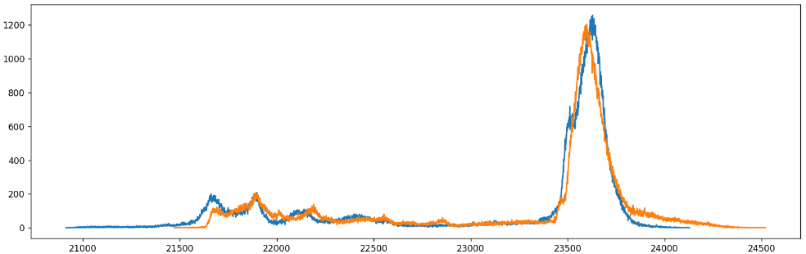
Flight data in a region including rocks, hills, trees, and cloudy skies was analyzed:
- A range of around 5,000 out of 65,000 available values were present
- A double peak of around 700 counts covered the ground, with an additional 2000 counts covering sky.
- This range shifted by around 800 counts over the course of the flight.
Approaches to mapping from value to color were applied, including NUC adjustments and several color maps.
- Keeping the 99th percentile pixel at the same value and keeping a peak mean value at the same location both provided temporal NUC consistency, but both also introduced scene-dependent value shifts.
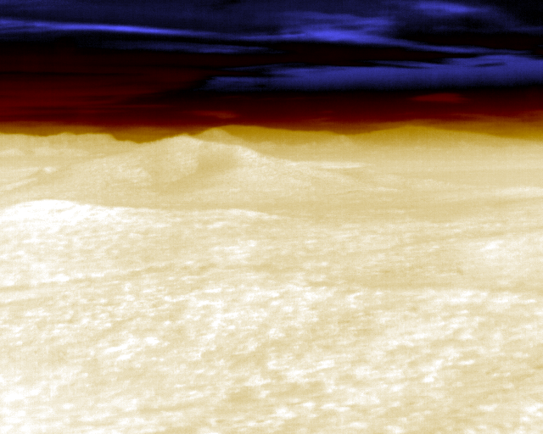
- A bright-blue cool map adjacent to a blackbody radiator spectrum produced the highest-contrast set of regions across the entire image range compared to monochrome, red-yellow-white, and blackbody.
- A custom two-zone mapping that focused less of the range on sky contrast performed better on the ground portions than a linear color map.
  - A cool-hot map that had blue on the left through black to hot on the right worked better than having black through blue to hot.
  - The scene-dependent shifts caused by NUC adjustments made this approach ineffective.

Future work
- Mapping:
  - Advanced temperature-to-value mappings: AHE/CLAHE, edge detection.
  - NUC adjustment: Camera overlapped edges, histogram from all edge-adjusted cameras.
  - Color: Brightcool-blackbody together with piecewise-linear mapping if NUC is handled.
- Testing:
  - Feedback from pilots will be quite helpful in determining whether the non-realistic addition of cool at the bottom of the blackbody map provides enough contrast improvement to overcome its strangeness.
  - Study the video from an ensemble of 21 cameras to see the impact on NUC adjustment.
Videos showing various color mappings are available, named TR-015v01_IR_Tone_Mapping_*.mp4.

Data
The data set being studied was from a pair of IR cameras flown on a commercial helicopter in a hilly natural region. The portion of the flight path studied has the helicopter spinning in place, viewing both hills and sky.
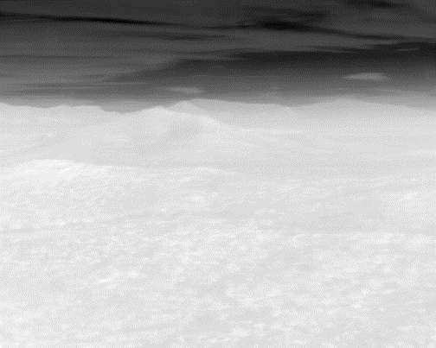
As seen in the image to the right, the range of values in this 16-bit data was quite compressed compared to the available range.
Some of the images include only ground. Others also include sky and clouds. A contrast-enhanced image showing ground, sky, and clouds is inset in the lower-right of the image.
The primary analysis was done on the camera that had less shake during the flight. This was the camera used to construct the associated videos.

Histograms
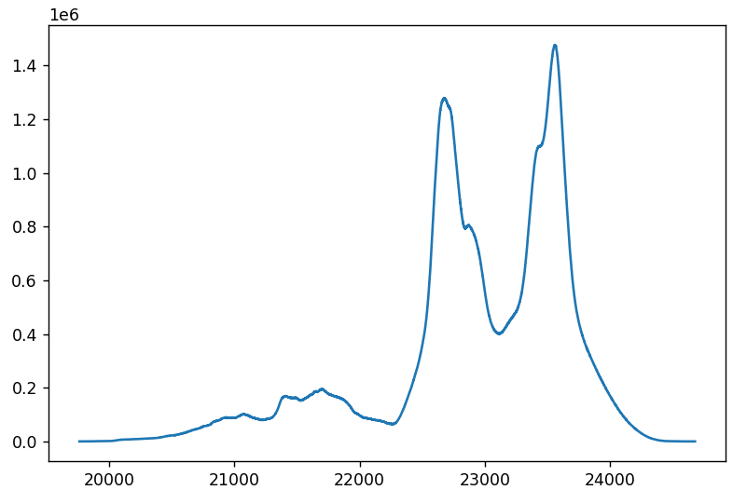
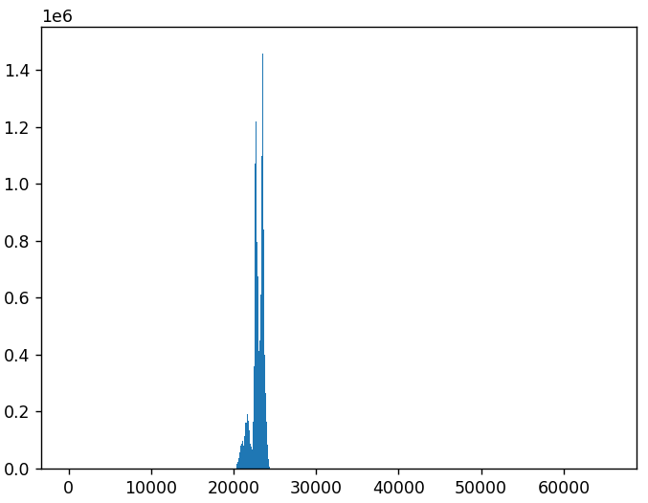
The histogram computed over all images shown above reveals that the range of measurements is indeed quite narrow compared to the potential range, lying between around 20,000-25,000. An inset shows the region of the graph that has nonzero bins. This graph has three lobes, with the two to the right being much taller and somewhat narrower than the one to the left.
The three histogram peaks are colored below on an image; blue below 22200, gray through 23150 and red above.
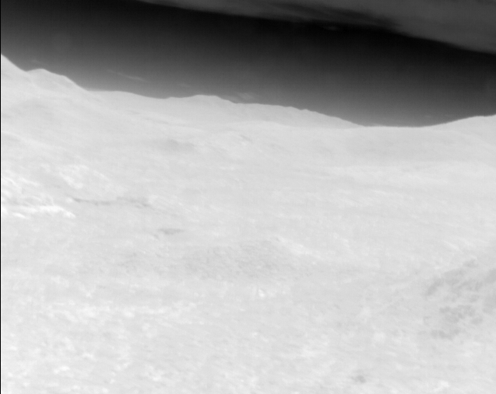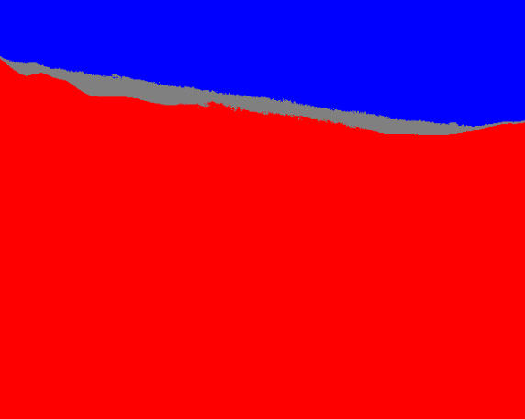
This shows that the sky and clouds are the lowest peak, the ground is the highest, and the atmospheric zone just above the ground is the middle peak.
Another image that views only the ground shows that the gray zone is sometimes seen in cool regions on the ground:
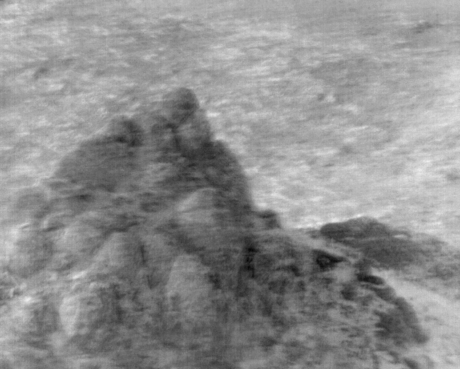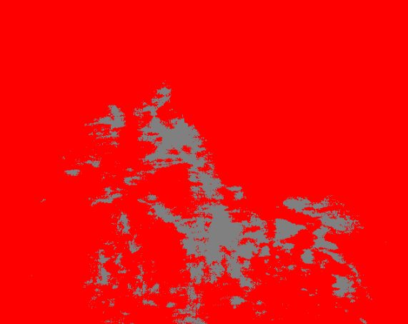
Together, these imply that (for this particular environment) the atmospheric region in the far field is the same effective temperature as some cooler regions on the ground. Sky and cloud above the atmospheric region appear to be consistently cooler than the ground.
Note: The rocky region in the lower pair of images has much less gray the first time it is seen, looks as shown above the second time, it is entirely gray the third and fourth times it is seen, and it is slightly blue the fifth time it is seen. The overall temperature offset is shifting during the video.
The histogram the first time it is seen is shown below to the left and the last time below to the right:
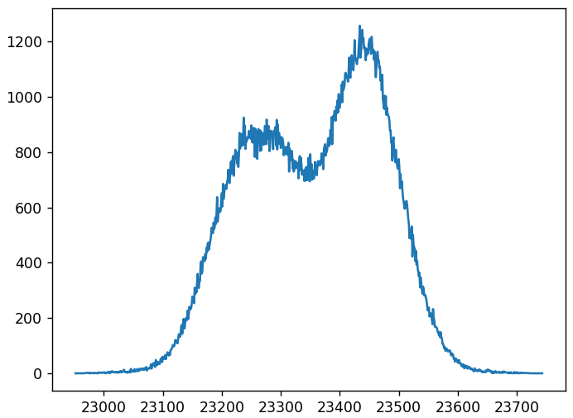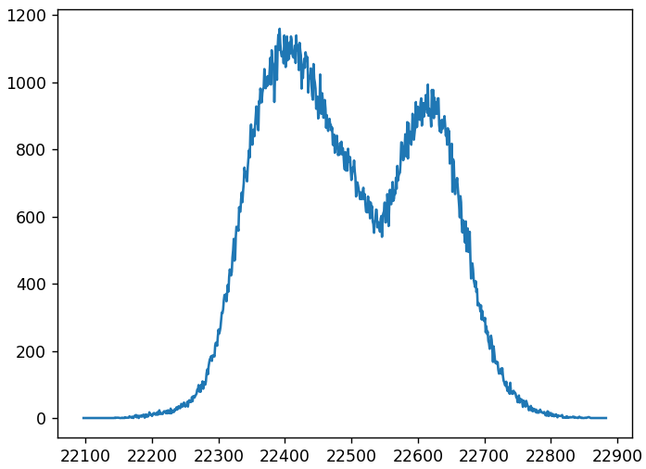
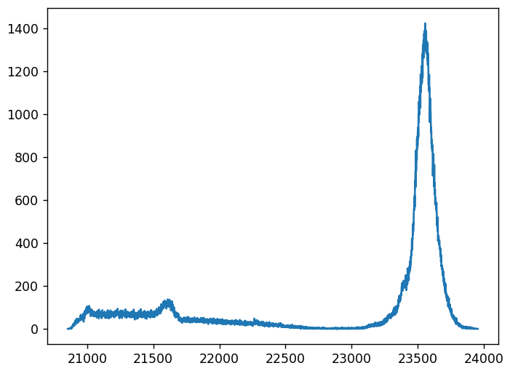
The views are slightly different, causing the ratio of the two peaks to vary, but the overall center of the pattern has shifted lower by around 800 counts between the two images.
To understand the histogram behavior in a single frame that has sky, clouds, horizon, and ground, the histogram from frame 100 is shown to the right.
The frame itself is shown below, and to the right of it is seen the frame colored with blue below 21500, gray through 23150, and red above 23200. This shows the sky as blue, the clouds and horizon as gray, and the ground as red. This ground does not have the double-peaked darker and lighter region seen in the histograms from the images above of rocky + non-rocky ground, having only a slight shoulder on the left of the rocky peak. It also has a left-hand sky tail that goes more than 2000 counts further to the left than the 800-count range of the ground-only images.
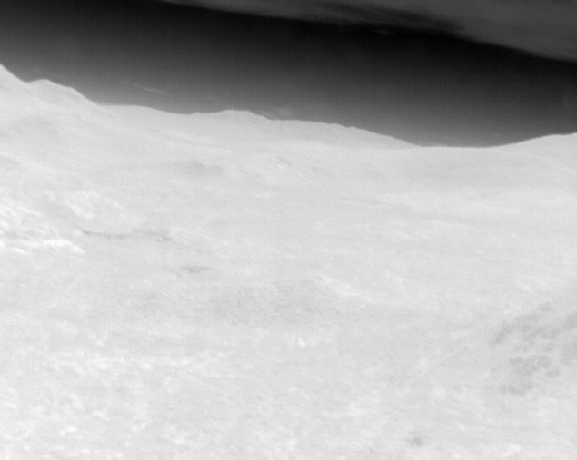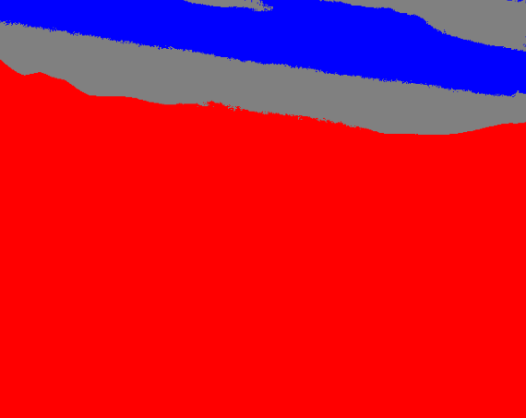

Mapping
The data mapping consists of two steps: temperature to (normalized) value (perhaps requiring NUC adjustment) and then value to color.
Temperature to value: As described in TR006v15_Software_Architecture, the Tone Mapping Submodule from the Render Module will use the histograms provided by the Histograms submodule and the images provided by the NUC submodule to determine the appropriate mapping from pixel value to display output value for each pixel in each region. Several modes are possible (alone or in combination):
- Joint-histogram-based: The histogram for all pixels in all cameras may be used to determine the mapping:
  - Mean+std-based: The mean value and standard deviation (or one of the means from K-means) may be used to determine the lower and upper bounds to map to the output intensity range, perhaps from X standard deviations below the mean to Y standard deviations above.
  - Percentile based: To ensure that a minimum number of pixels are clamped, a minimum to maximum percentile range may be used.
- AHE: Adaptive histogram equalization, or CLAHE (contrast-limited AHE) may be applied across all pixels.
- Edge detection: Edge detection can be used to display gradient magnitudes or other edge metrics.
- Neural: A neural mapping routine could provide either a global map or a per-pixel mapping across images.
- Custom: The specific needs of the pilotage application may combine with the characteristics of the color mapping chosen below to provide a custom mapping, perhaps with the cooler sky colors mapped to blue and the hotter colors mapped to an increasing-intensity range.
NUC Adjustments: The reported temperatures between cameras can be different, and the same camera’s reported values can drift over time with camera and sensor temperature changes. Stabilizing these changes between cameras and across time can require adjusting the relative offset (and perhaps scale) of the cameras. These require assumptions of similar scenes between cameras or across time. Some potential approaches follow:
- Mean+std-based: Calculated on a per-camera or per-frame basis, mapping from some number of standard deviations below and above the mean can be used to maintain a mapping between the currently-visible scene and the displayable color range that automatically adjusts to display the full range of intensities. This will produce strong intensity discontinuities between neighboring cameras that are viewing scenes with different compositions of elements.
- Percentile based: By making assumptions about the contents of a scene (for example, that it will always contain a significant region of ground, or that it will always contain a significant region of sky), the offset can be adjusted to maintain a fixed mapping for the 98th (or 2nd) percentile. For images with highly sloped histograms at the top of bottom, this will tend to stabilize across frames within the same camera. It will produce smaller discontinuities between neighboring cameras with similar scene compositions than the mean+std-based approach.
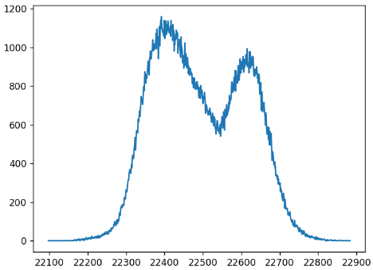
- Histogram curvature based: For videos such as the one studied above where the camera always sees ground on a significant fraction of each image but where the fraction of ground to sky changes, a more consistent metric may be the location of the point of maximum positive curvature measured at an appropriate scale from the top of the image to the first peak (location of negative curvature) in the histogram. A similar metric might be the location of the most negative slope at an appropriate scale above the rightmost peak in the histogram. Another, the top of the rightmost peak.
- Edge based: To help bring all cameras into the same range, the joint histograms of the pixels at overlapping edges between every pair of cameras may be used to adjust the offset and/or gain so that they match. The solution for the mesh of neighboring images can be obtained by minimizing the total error across all neighbors.
Value to color: Once the range of temperatures has been normalized and clamped to the range 0-1, this range must be mapped to a curve through color space before being displayed to the pilot. This should be done based on the known characteristics of the human visual system and the tasks to be performed by the pilot. Potential approaches including the following:
- Gamma correction: To highlight the lower or higher regions of a selected region, the normalized values may be taken to the power of gamma before being mapped to brightness. This will even out the spacing of perceptible differences across the temperature range.

- Monochromatic: The human eye is not completely achromatic, focusing red, green, and blue light at different distances. (Ware, 2012) This means that the three components of white light coming from a point source are blurred somewhat. This focus difference is larger for blue than the other two. To increase sharpness, monochromatic images should be drawn in green (the most-responding color channel) to increase sharpness or yellow (providing larger maximum brightness).

- Black-body emission: The number of different values visible in a map increases when it includes regions with different hues and saturations. However, luminance (a weighted sum of red and green) is the channel used to perceive detail while hue (mixture of red, green, and blue) is used for low-resolution identification of object type. For cases where the identification of shapes is of utmost importance and there is a desire to provide a large range of colors, the black-body radiator curve is often the most effective mapping.
  - Blue lower edge: To increase the range of perceived color even further, a blue range can be applied below the red range. The blue channel on displays is not a pure purple, so still adds to the luminance calculation and so can add an additional region. This is shown in the figure below.
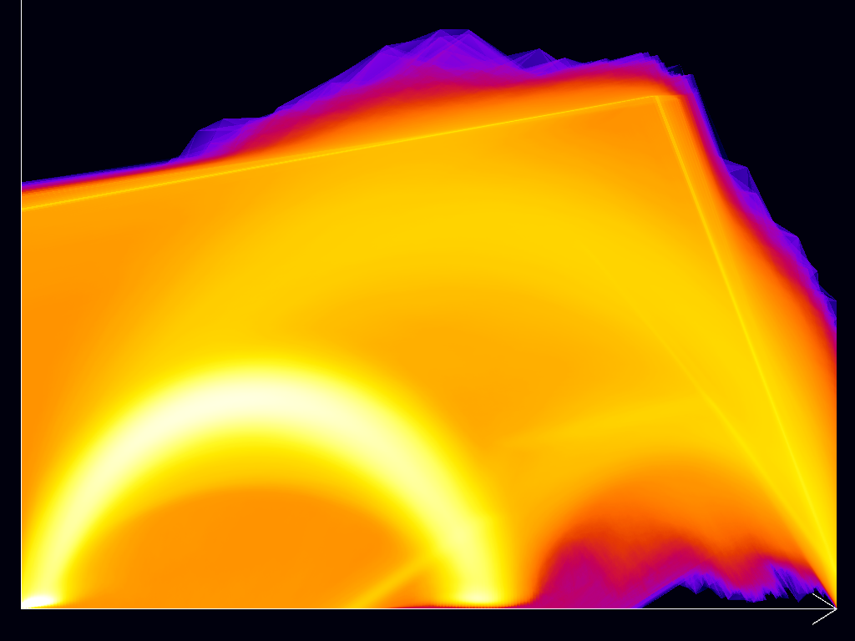
http://www.vis.uni-stuttgart.de/scatterplot/

Design Round 1
Images and videos were made to compare the different approaches above in different combinations. Two frames from each video are shown below for each approach: (1) a sky + ground frame from early in the video (frame 590), (2) a rocky ground-only frame from later in the video (frame 3762).
Only techniques that try to provide a consistent view for the entire range of values (sky, horizon, ground) over the entire time of the video are studied, because the ensemble of cameras is expected to always see the full range of values.
Normalization and NUC Adjustment: All approaches map the 99th percentile value of the image to 1.0 and the value that is 2700 counts below that value to 0.0, clamping values outside that range. This covers the entire range of lowest sky to highest ground temperature near the beginning of the video and tracks changes in offset across the entire video.
Note that the computer display system will treat the colors as being in sRGB or another gamma-based color space and display with a gamma of 2.2.
Approach 1: Monochromatic: This approach linearly maps from black (0,0,0) at 0 to yellow (255,255,0) at 1. This avoids having blue in the map, avoiding blurring due to the different focus depths of blue compared to red and green.

Approach 2: Red-Yellow-White: This map has red increasing from the left to 1/3, yellow from 1/3 to 2/3, and white from 2/3 to the right edge. It takes a longer path through color space, providing more distinguishable values than the monochromatic approach.

Approach 3: Blackbody: This map approximates the blackbody radiation spectrum, with red increasing from the left to the right, green starting 1/3 of the way and increasing to the right, and blue starting 2/3 of the way and increasing to the right. This is like the emission of a blackbody radiator and has a different brightness increase profile compared to red-yellow-white, with larger increases at higher levels, highlighting features in brighter regions more compared to those in lower regions.

Approach 4: Custom Blue-Hot: This is a custom piecewise-linear color map that maps from black to blue (0,0,255) from the left end of the range to the value that is 700 counts below the highest value. It maps the highest 700 counts in two stages, transitioning to red (255, 0, 0) over the first 350 counts and then to yellow (255, 255, 0) over the next 350 counts. This map has the following features:


- Has increasing luminance across its entire range (because red produces a much stronger luminance response than blue).
- Provides three hue zones across the image; (1) blue for sky + clouds; (2) transition to blackbody radiator red zone; (3) blackbody radiator yellow zone.
- Provides different luminance values within each region, providing discrimination of features.
Approach 5: Custom Cool-Hot: This map is double-ended, with luminance dropping from the left and then rising again to the right as the blue-hot map. It uses the same ranges as the blue-hot approach. It uses the metaphor of increasing blue for cooler and increasing red and yellow emission for hotter. It places blue only in the sky and red + yellow only in the ground, avoiding blurring due to focus depth differences between the two groups. It has three zones (one sky and two in the ground), with ground separated from sky at black.
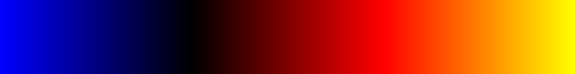

NUC Adjustment
Five frames showing the same rocky outcropping from different times in the video are shown below to see how the 99th-percentile adjustment worked at keeping the values the same.
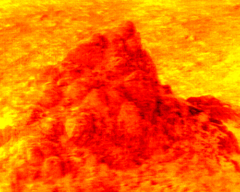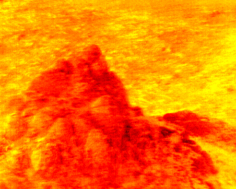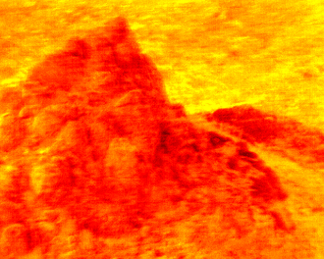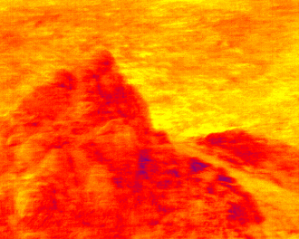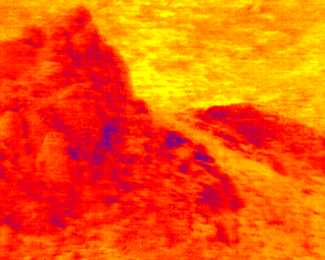
It appears that the offsets are working, keeping the values in a similar range of colors for the duration of the video.

Comparing approaches
Frame 590 is shown below using all five mappings. Monochromatic and Red-Yellow-White are on the first row, Blackbody on the next, and Blue-Hot and Cool-Hot on the last row.
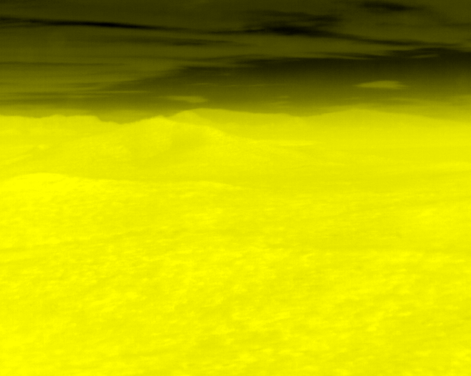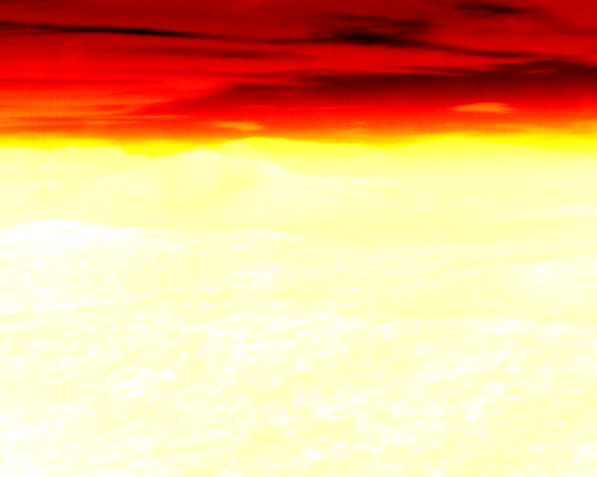
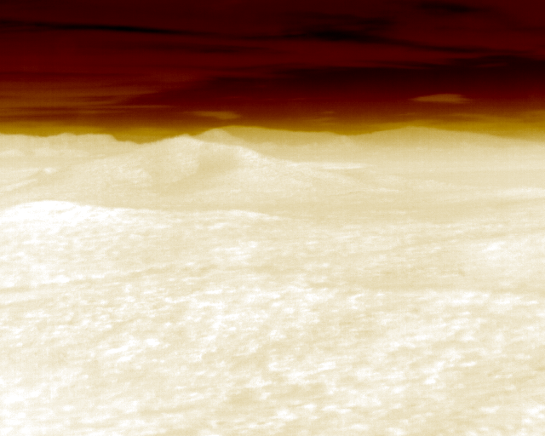
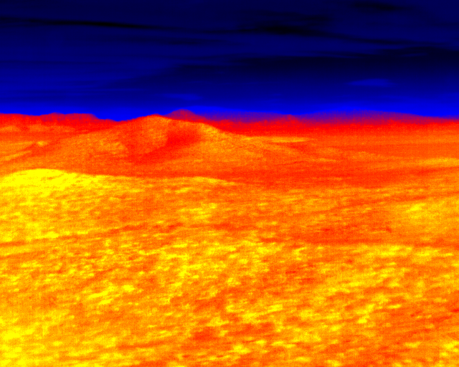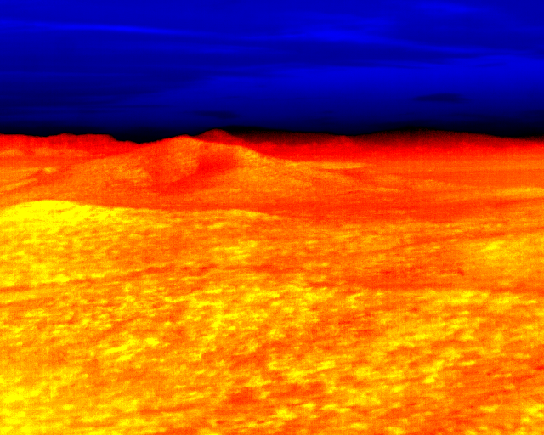
Frame 3762 is shown below using all five mappings. Monochromatic and Red-Yellow-White are on the first row, Blackbody on the next, and Blue-Hot and Cool-Hot on the last row.
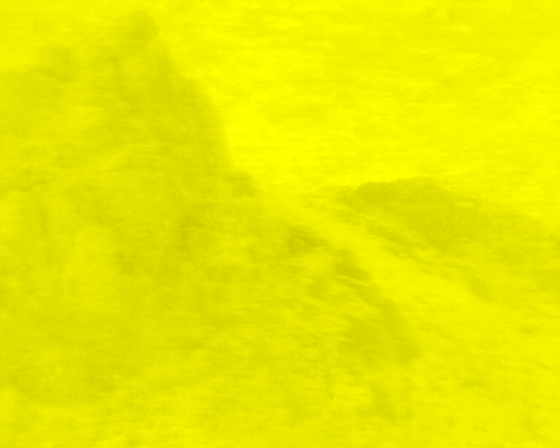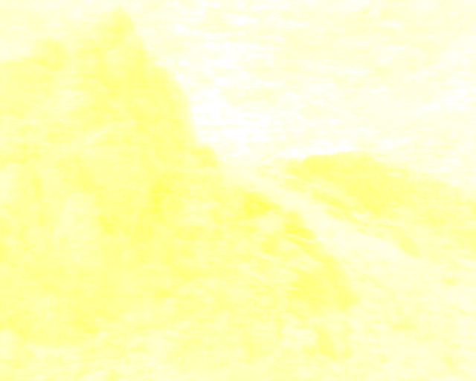
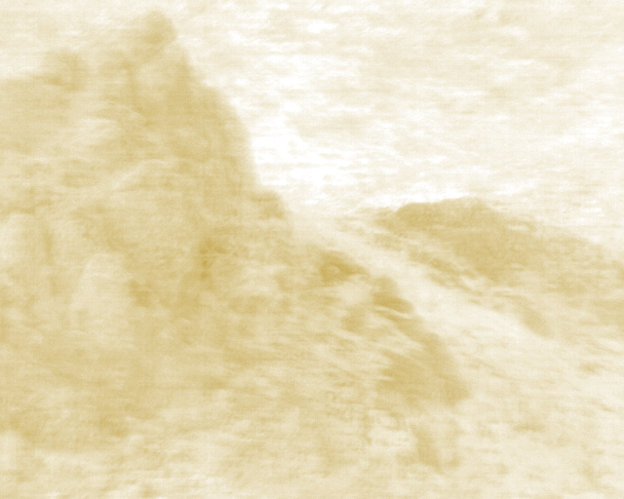
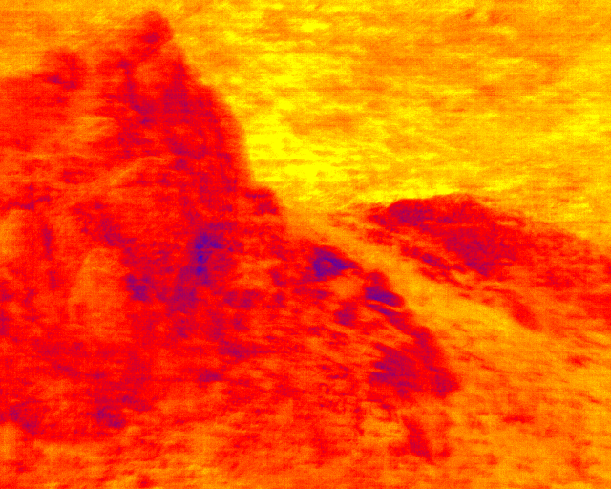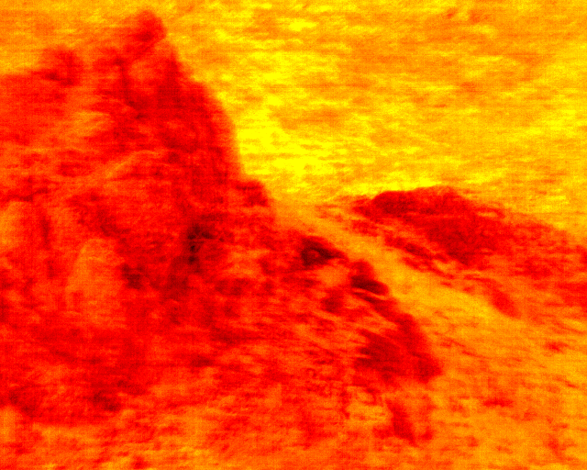

Artifacts
When viewing the video, it becomes clear that although the 99th percentile adjustment removed offsets over time for a given viewpoint, it also introduces new offsets based on the scene being viewed. Even views that see the same region along with different neighboring regions have very different values. This can be seen between frames 655 and 686, particularly on the custom mappings that focus intensity differences on the ground ranges.
Looking at the histograms for frames 655 and 686 from the original data shows the following nonzero ranges:
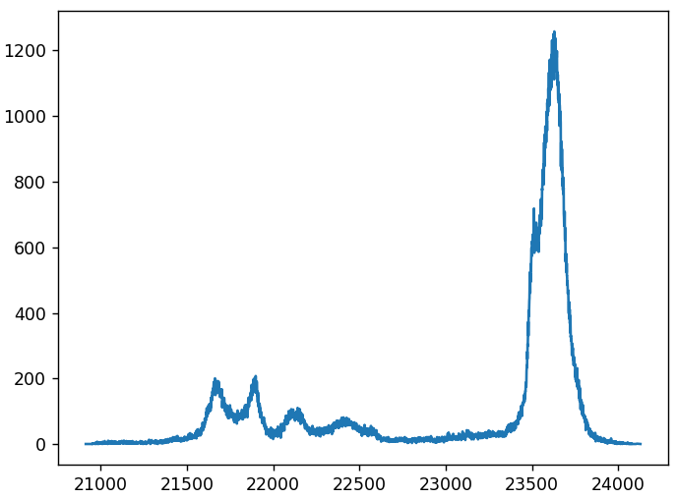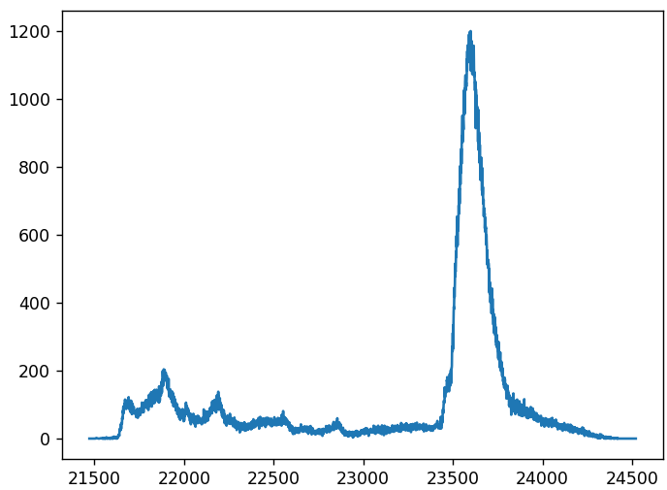
From this, we can see that the 99th percentile shifts further to the right of the peak, dragging the left side of the color range into the peak along with it. They are plotted together here:
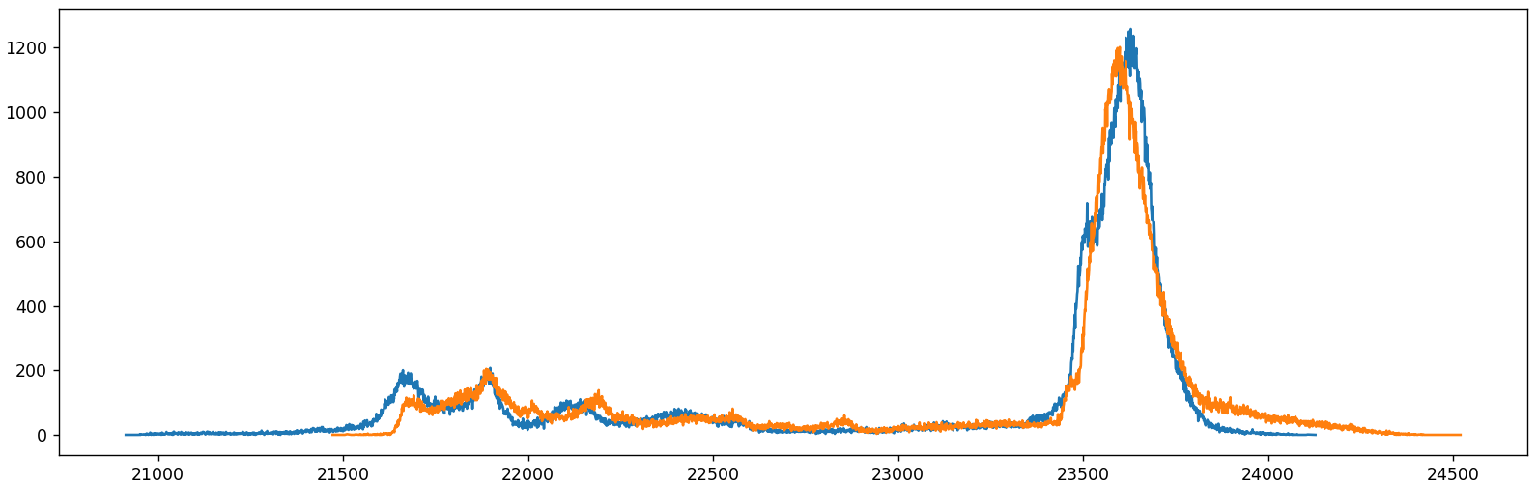
This shows a shift in the rightmost peak between the two along with an increase in the right tail of the peak; the peak moves in the opposite direction from the 99th percentile in this case, though not as far (around 65 values judging by eye on a stretched graph vs. 339 for the percentile). (The 95th percentile moves by 170 and the 90th by 71 in this case. Stabilizing based on the 95th and then 90th percentiles improved the situation somewhat, but significant shifting remained.) The left-most two peaks in the image change shape but remain aligned, indicating that there is probably not a change in the overall camera gain (temperature to counts mapping). It is possible that the center of mass of the rightmost peak is similar between the two in this case.
Note: It is possible that the total histogram across all 21 cameras will encompass a more similar view from frame to frame, so will not exhibit this artifact as strongly as a single-camera histogram does.

Analysis
Of the five approaches tested:
- Among the full-range linear maps Blackbody appears to have the clearest contrast in the ground region while continuing to provide good contrast in the sky.
- Both custom -Hot maps provide even better contrast in the ground but reduced contrast in the sky.
  - Cool-Hot avoids bleeding blue into the cool areas of the ground when viewing rocky outcroppings; it provides a metaphor of a bright blue sky occluded by dark clouds with a dark horizon.
- 99th percentile adjustment:
  - This maintains consistent mappings for the same scene as the camera offset drifts over time.
  - Both custom maps are much more susceptible artifacts caused by scene-dependent histogram changes, making Blackbody a more general solution when this adjustment is used.

Future work
All approaches will benefit from more scene-stable NUC adjustment techniques.
- A technique that properly aligns the value offsets for all 21 cameras and that uses the combined histogram from all offset camera images to determine the scene histogram may be less influenced by scene composition because it will more often view a scene with similar composition.
- A new technique that continues to adjust for time-varying offsets while remaining insensitive to differences in scene composition might be found that works across a range of environments, or a different technique for each environment may be found. For example, tracking the center of mass of the histogram in the region covering ground temperatures may be more stable than 99th percentile.
If a more-stable NUC adjustment can be found, three potential modifications to the cool-hot map may further increase its contrast. They can be implemented independently.
- Switching to cool-blackbody, where the ground portion uses blackbody rather than red-yellow may produce even more contrast within the ground region.
- Modifying the blue region to use unsaturated blue would increase the luminance contrast in the sky region, providing more discrimination of clouds from sky. However, this would also reduce the luminance contrast between the sky and hot objects in the sky (drones, aircraft, etc.).
- Starting the red value above zero for the ground region would provide a sharp transition and indicate the boundary more clearly. However, the presence of atmospheric effects makes this boundary uncertain, so the current black does a better job of displaying this uncertainty. The current approach of placing the boundary outside of the histogram’s peak already shows red when points in the peak are seen, leaving the uncertainty only present at the small number of pixels right at the horizon.

Design Round 2: Attempt to improve NUC adjustment
Normalization and NUC Adjustment: Looking more closely at the NUC adjustment options listed before, the mean of the double-peak histogram region where there is ground will shift as the fraction of darker and lighter ground shifts, as seen below (ignoring the large total shift in offset, the peak shape changes as more dark ground region appears in the one to the right).

The maximum value also shifts when the 99th percentile shifts, and does so even more (even if it did not in this case, it will change with small bright objects entering and exiting the scene):

Any singular percentile seems like it will be vulnerable to changes in scene composition even if there is one that can be found to be stable for this pair of scenes.
The point of maximum curvature above the peak for the yellow curve appears to be shifted to the left compared to the blue curve.
The peak of the histograms in the two scenes shown above have different widths, due to the reduction in lower-brightness ground regions in the yellow curve compared to the blue. A technique that relied on the average of the two edges would shift the center associated with the yellow curve to the right near the bottom and to the left near the top.
The point of maximum curvature above the peak for the yellow curve appears to be shifted to the left compared to the blue curve.
Selecting from among the single-image metrics, the NUC adjustment approach taken here was to stabilize based on the center of mass of the histogram peaks in the region above the location that is 800 counts below the 99th percentile. The histogram below the peak is close to zero in this region, and the histogram above (by definition) contains less than 1% of the values, so this range should place a safe buffer around the peak. The “1” location will be placed 350 counts above the mean location and the “0” will be placed 2700 counts below the “1” location.

Artifacts
The scene-dependent darkening from the 99th percentile adjustment persists with the center-of-mass adjustment. The shift was perceptually similar between the two approaches when using the cool-hot mapping.

Future work
It is possible that a more computationally expensive approach that considers all values in both histograms could align based on all available features: normalized cross correlation or maximum mutual information (minimum joint entropy). Given that a particular scene may contain only one region (sky, for example), this seems likely to fail without stitching a histogram from multiple cameras using their overlapping edges to align each to its neighbors.

Design Round 3: Attempt to improve local contrast
To move from a color map with three regions to a color map with four, this section prepends the blackbody color map with a ramp down from blue to black on the left. This produces a family of maps depending on the saturation of blue chosen, with low saturation maximizing the detail perception within the band (and necessarily reducing the contrast with hot objects in the cool areas) and full saturation doing the opposite. The full saturation map is shown below.
The 1/3-desaturated map from this family is shown below.
Using the original 99th percentile mapping, the 1/3-desaturated map for frame 590 is shown below next to the blackbody frame. Then frames 3762 from both are shown.

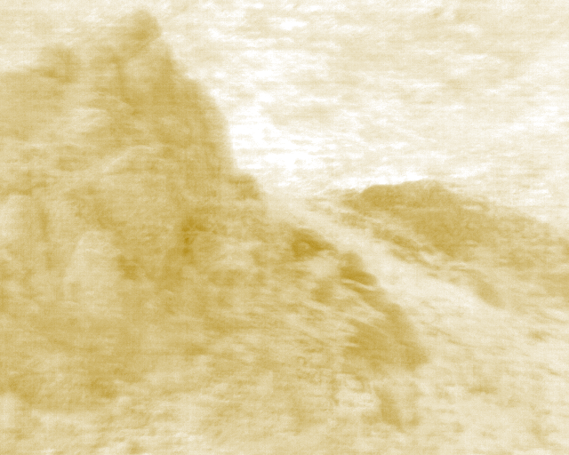
As expected, the contrast is improved in both the sky and ground regions because the change in mapped brightness varies faster with change in value (4/3 as fast) in the brightcool-blackbody map as in the blackbody map (there are more steps in the visible map over the same range of values).
Feedback from the pilots will be quite helpful in determining whether the non-realistic addition of cool at the bottom of the map provides enough contrast improvement to overcome its strangeness.

Future work
If an improved NUC adjustment algorithm can be found that keeps the ground values within the same range, one of the cool-blackbody maps could be used with it, mapping the entire blue-black range to sky and the remainder to ground.

https://www.cs.unc.edu/~taylorr/Comp715/slides/2014_01_23_Color.pdf
https://www.cs.unc.edu/~taylorr/Comp715/slides/2014_01_28_2D.pdf

