Google Colab setup for tfod

Steps to start training in Google Colab for tfod-

### STEP 1. Do all the necessary steps shown on the previous page in your local system except the last step where training starts-

Note: I mean do everything before the following step-

python train.py --logtostderr --train_dir=training/ --pipeline_config_path=training/ssdlite_mobilenet_v1_coco.config

### STEP 2.Move whole tfod folder to your google drive.

verify that it should have atleast the below content-

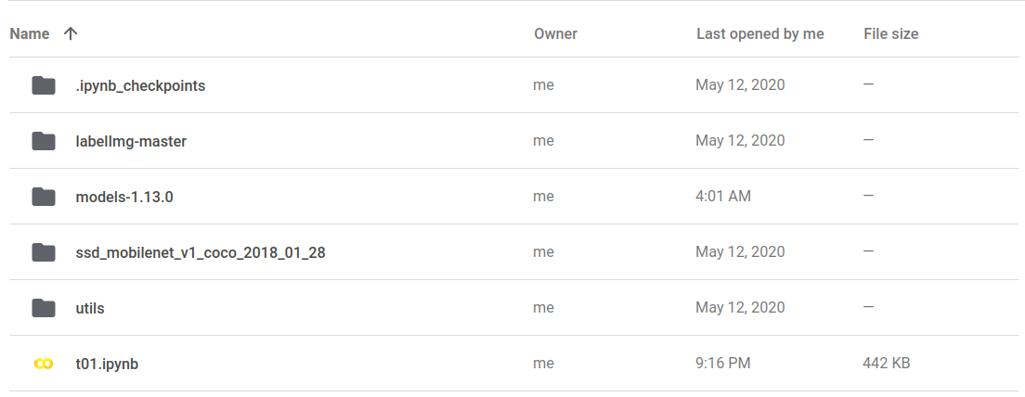

Note : I'm using the ssd_mobilenet_v1_coco model that's I have ssd_mobilenet_v1_coco folder in the screenshot. You can upload your choice of the model there.

Tip : Since you have already done tfod set up in your local system and already copied utils and your model zoo folder (i.e ssd_mobilenet_v1_coco in my case).

So if you want then you can only upload models-1.13.0 , folder instead of all of them.

Here I have uploaded all of them just to replicate the exact same steps in local and Google Colab.

### STEP 3. Open a jupyter notebook in the root of your folder structure. I mean just inside the tfod folder.

As you can see in the below screenshot you can see **t01.ipynb**.



### STEP 4. Mount the drive in Colab and initialize it with GPU.

### STEP 5. In the first cell run the following command so that it selects TensorFlow 1 for the training-

%tensorflow_version 1.x

### STEP 6. In the notebook import os. And set a path to the research directory in a Variable as per your google drive.

import os

RESEARCH_DIR = "/content/drive/My Drive/PATH_TO_TFOD/tfod/models-1.13.0/research"

### STEP 7. Run the following line to change the directory-

os.chdir(RESEARCH_DIR)

### STEP 8. Run the following line to verify that you are in the research folder-

os.getcwd()

### STEP 9. Now run the training command to start the training in Google Colab-

Note : Change the name of the config file as per your model name

!python train.py --logtostderr --train_dir=training/ --pipeline_config_path=training/ssdlite_mobilenet_v1_coco.config

### STEP 10. Copy and paste following code in your browser console to prevent Google Colab from terminating-

JS code[1](https://c17hawke.github.io/tfod-setup/p02/#fn:1)-

function ClickConnect(){

console.log("Working");

document.querySelector("colab-toolbar-button").click()

}setInterval(ClickConnect,60000)

## Screenshot of Google Colab code-

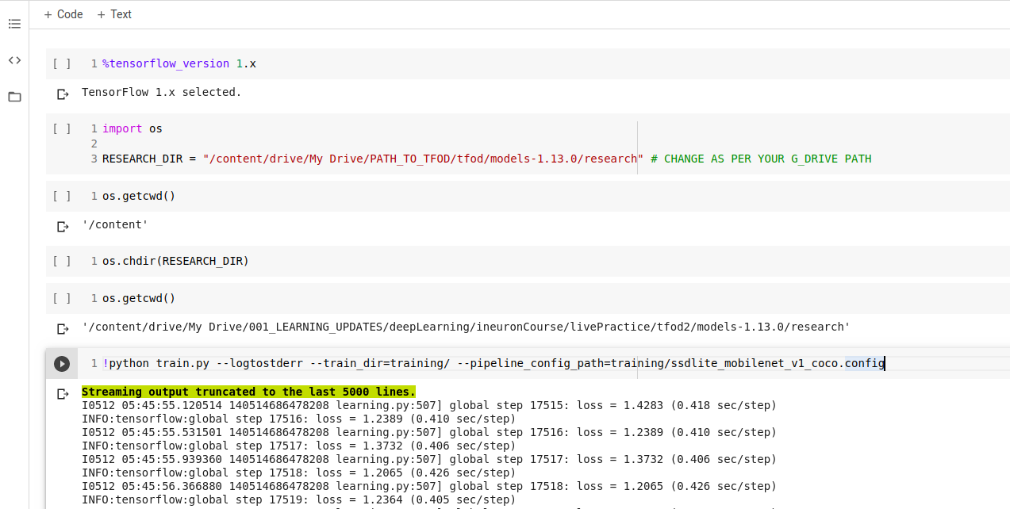

## Screenshot of begining of final training-

