CSci 435: Formal Languages and Automata

Instructor: Dr. M. E. Kim Date: September 7th, 2018

Due: 5:00 PM, September 7th (Fri.), 2018. (No Extension) Name: __**Aaron Johnson**__

**Home Assignment 1: 100 points + 10 points (optional) ­­­­­­­**

Q1. [20] For Σ = {a, b}, construct a DFA that accept the language

1. 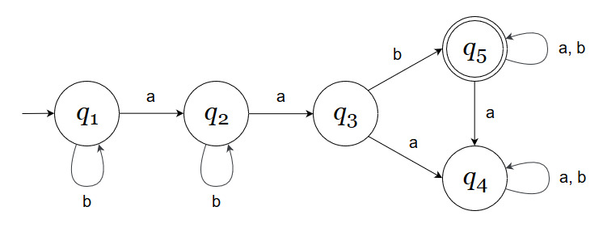[10] consisting of all strings with at least one b and exactly two a’s.
2. 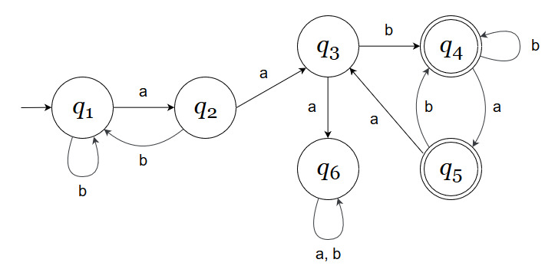[10] every ‘*aa’* is followed immediately by a ‘*b’*. For example, the strings *aab*, *aaba*, *aabaabbaab* are in the language, but *aaab* and *aabaa* are not.

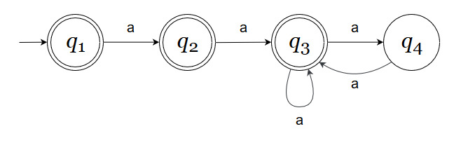Q2. [10] Show that the language L = { *a****n***| *n* ≥ 0, *n* ≠ 3 } is regular.

Q3. [20] For a given NFA in the figure,

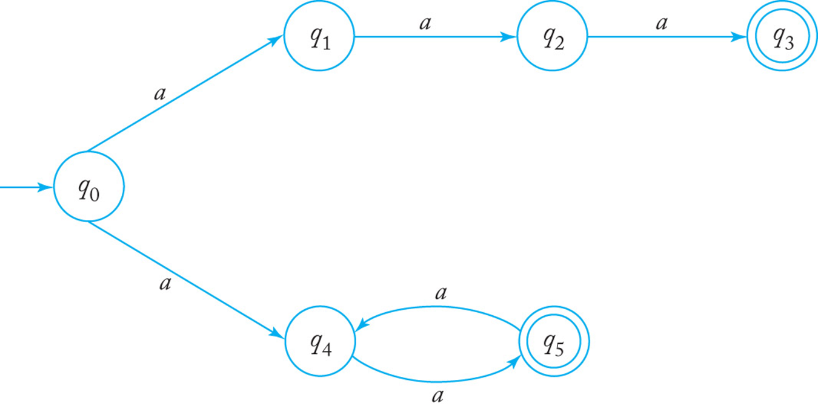

1. [10] Give a language *L* that is accepted by the NFA. Describe L in the proper mathematical format, not in the verbal English description. E.g.) L = { *a****n***| *n* ≥ 0, *n* ≠ 3 }

**L = { *an* | *n* % 2 = 0, *n* = 3, n > 1}**

1. 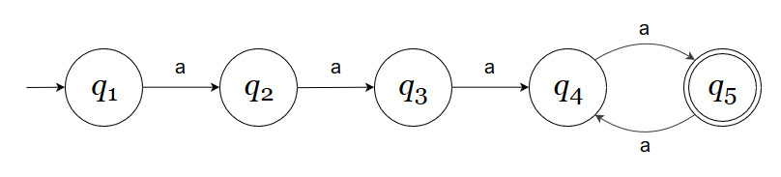[10] Find a *DFA* that accepts the ***complement*** of the language defined by the NFA, i.e. $\overline{L}$.

Q4. [10] Construct an NFA with the minimum number of states that accepts

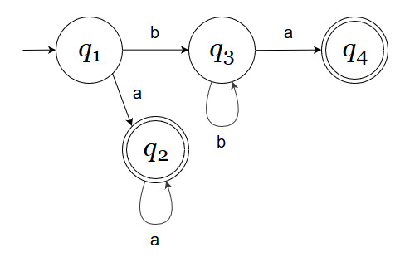*L* = { *an* | *n* ≥ 0 } ∪ { *bna* | *n* ≥ 1 }.

Q5. [10] Convert the NFA defined by the transitions below with the initial state *q0* and the final state *q2* into an *equivalent DFA*. Draw the transition graph of the DFA.

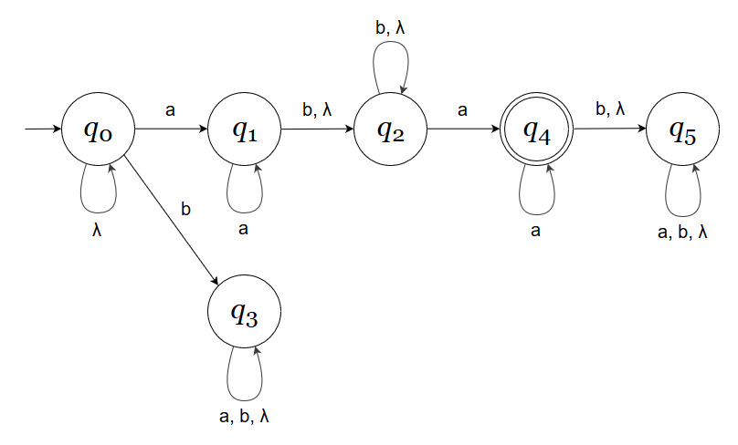 δ(*q0, a*) = { *q0, q1* }, δ(*q1, b*) = { *q1, q2* }, δ(*q2, a*) = { *q2* }, δ(*q1,* λ) = { *q1, q2* }.

Q6. [10] Show that if L is regular, so is LR.

**Suppose L = { *an* | *n* ≥ 0 }, a regular language.**

**LR = { *an* | *n* ≥ 0 }, L = LR**

**So LR must be regular.**

Q7. [20] For a given language, L = { *anb* | *n* ≥ 1 } ∪ { *bna* | *n* ≥ 1},

1. [10] Construct a *minimal DFA* with the minimum number of states that accepts L .

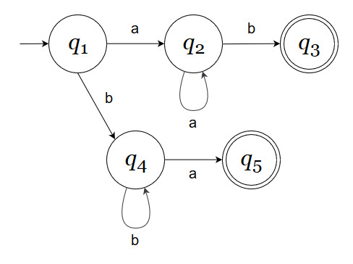

1. [10] Prove that your DFA in 1) is minimal. Hint: Check if any pair of the states are indistinguishable to be merged in the same class so that the number of states are minimized

**There are no cycles to consolidate in this DFA, meaning it is minimal.**

Q8. [10, optional] Prove or disprove the following conjecture.

If M = (Q, Σ, δ, *q0*, F) is a minimal DFA for a regular language *L*,

then = (Q, Σ, δ, *q0*, Q - F) is a minimal DFA for $\overline{L}$.

**Suppose in M, Q = 8 and F = 5. This means that Q-F states are not final in M.**

**In M, Q-F = 3.**

**If in M, Q = 8 and F = 5, then in $\overline{M}$, Q = 8 and F = 3.**

**In $\overline{M}$, Q-F = 5.**

**F in M = Q-F in $\overline{M}$, so $\overline{M}$ must be minimal DFA.**