CSci 435: Formal Languages and Automata

Instructor: Dr. M. E. Kim Date: October 23rd, 2018

Due: 5:00 PM, October 31st (Wed.), 2018. (No Extension) Name: **____Aaron Johnson___**

**Home Assignment 4: 100 points + 25 points (optional)**

Q1. [20] For a given language L = {*anb2n* | *n* ≥ 0 }.

1. [10] Construct a PDA M that accepts L.

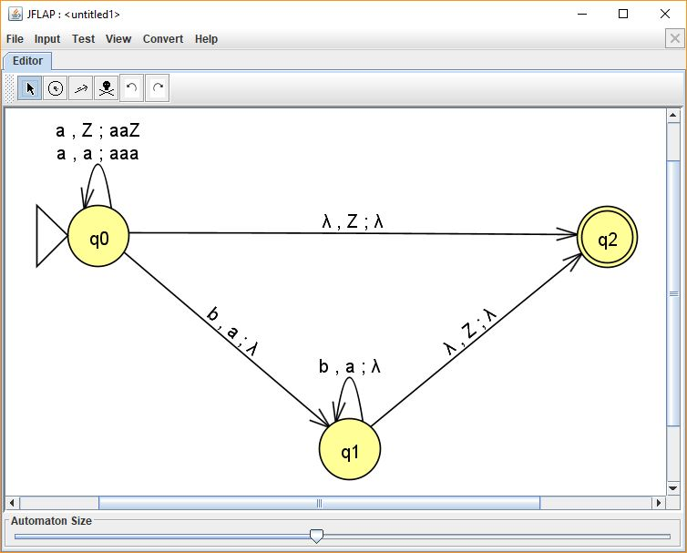

1. [10] Show the sequence of instantaneous descriptions for the acceptance of *aabbbb* by the above M.

**(q0, aabbbb, Z)** ⊢ **(q0, abb, aaZ)** ⊢ **(q0, bb, aaaaZ)** ⊢ **(q1, bbb, aaaZ)** ⊢ **(q1, bb, aaZ)** ⊢ **(q1, b, aZ)** ⊢ **(q2, λ, λ)**

Q2. [20] Construct an NPDA for given languages..

1. 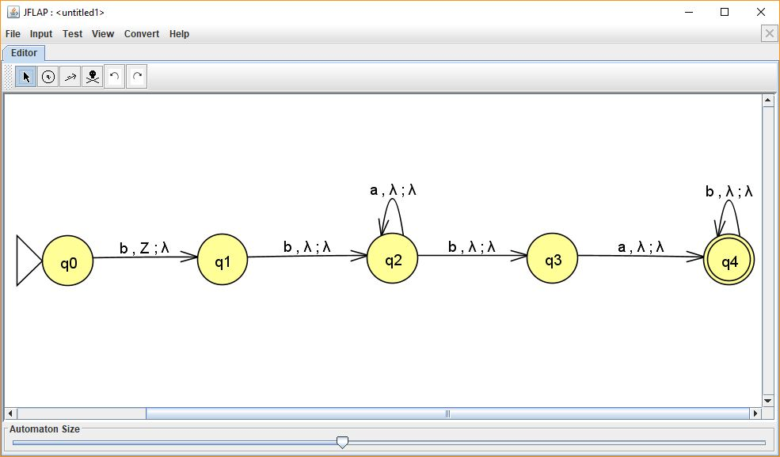[10] L1 = {*bba*\**bab*\* }
2. 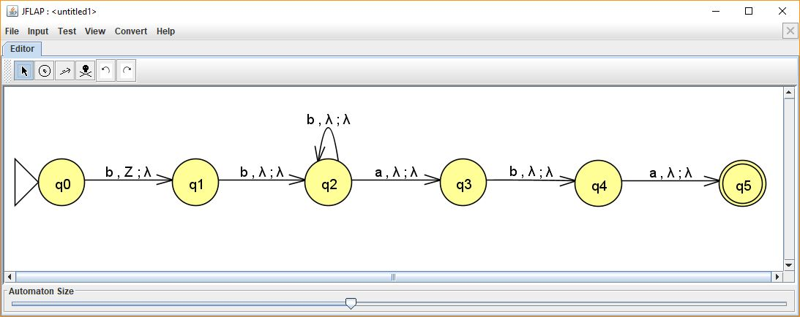[10] L2 = {*bbb*aba* }
3. 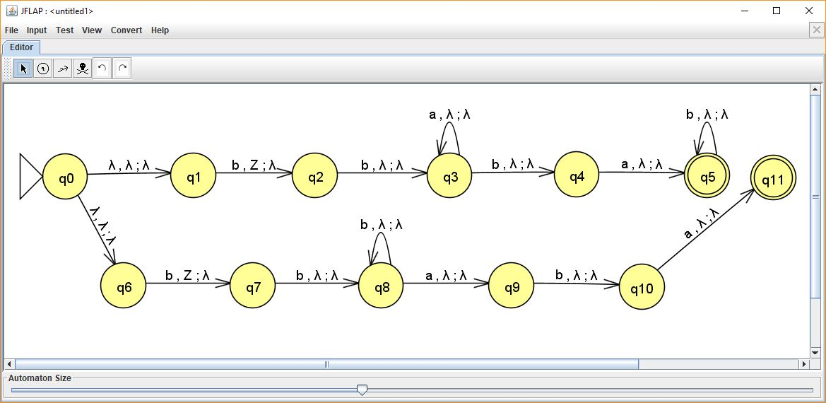[5, optional] L3 = L1 ∪ L2 from (1) & (2)
4. [5, optional] L4 = L2 – L1.
5. [5, optional] L5 = L1 ∩ L2.

Q3. [10] Give the language that is accepted by the PDA M = ({*q0, q1, q2*}, {*a, b*}, {*a, b*, z}, δ, *q0*, z, {*q2*}), with ♦ δ(*q0*, *a*, z) = {(*q1*, *a*), (*q2*, λ)}, ♦ δ(*q1*, *b*, *a*) = {(*q1*, *b*)}, ♦ δ(*q1*, *b*, *b*) = {(*q1*, *b*)}, ♦ δ(*q1*, *a*, *b*) = {(*q2*, λ)}, in a formal expression (including a regular expression).

**L = {anaabma | n > 0, m ≥ 0}**

**a+(abb*a)**

Q4. [20] Construct a PDA that accepts the language defined by the given grammar and give the language in a formal expression (including a regular expression).

1. 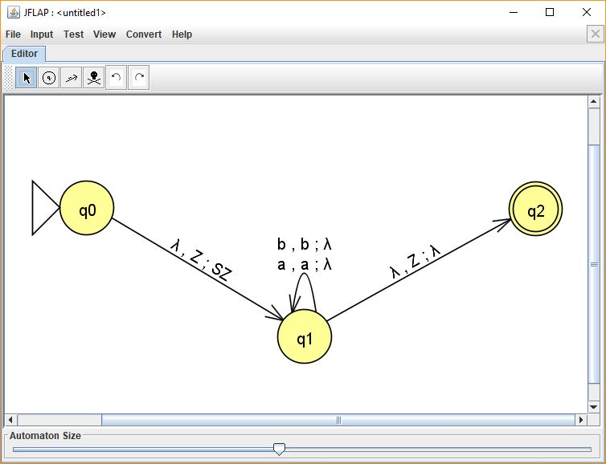S → *ab*S*b* | λ.

**S’ → S**

**S → abA**

**A → abA | b**

**ab*b**

1. S → AA | *a*, A → SA | *ab*.

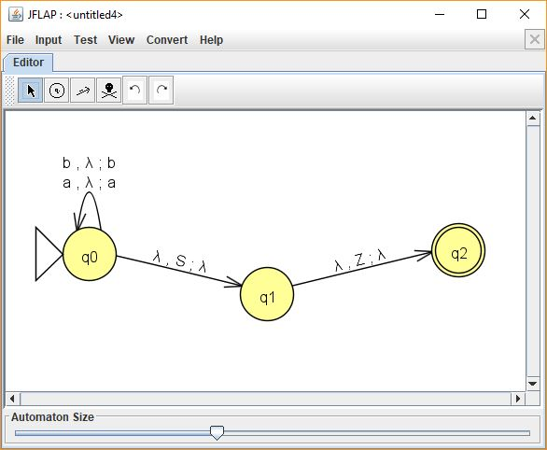

Hint: Convert the grammar into Greibach Normal Form, then apply Thm. 7.1.

**S → aAA | aCA | aCZA | aAZA**

**A → aA | aC | aAZ | aCZ**

**Z → aAA | aCA | aAZA | aCZA | aAAZ | aCAZ | aAZAZ | aCZAZ**

**B → a**

**C → b**

Q5. [10] Find a Context-Free Grammar that generates the language accepted by the NPDA M = ({*q0, q1*}, {*a, b*}, {*A*, z}, δ, *q0*, z, {*q1*}), with the transitions

♦ δ(*q0*, *a*, z) = {(*q0*, *Az*)}, ♦ δ(*q0*, *b*, *A*) = {(*q0*, *AA*)}, ♦ δ(*q0*, *a*, *A*) = (*q1*, λ).

**(q0Aq1) → a,**

**(q1Aq1) → λ,**

**(q1zq2) → λ,**

**(q0zq0) → a(q0Aq0)(q0zq0),**

**(q0zq1) → a(q0Aq0)(q0zq1),**

**(q0zq2) → a(q0Aq0)(q0zq2),**

**(q0Aq0) → a(q0Aq0)(q0Aq0),**

**(q0Aq1) → a(q0Aq0)(q0Aq1),**

**(q0Aq2) → (q0Aq0)(q0Aq2), start variable = (q0Zq2)**

Q6. [10] In the final grammar in Example 7.8, find any useless variables.

**(q0Aq0), (q0Aq2)**

Q7. [10] Show that L = { *anbm* | *n* > *m* ≥ 0 } is a deterministic context-free language by constructing a Deterministic-PDA.

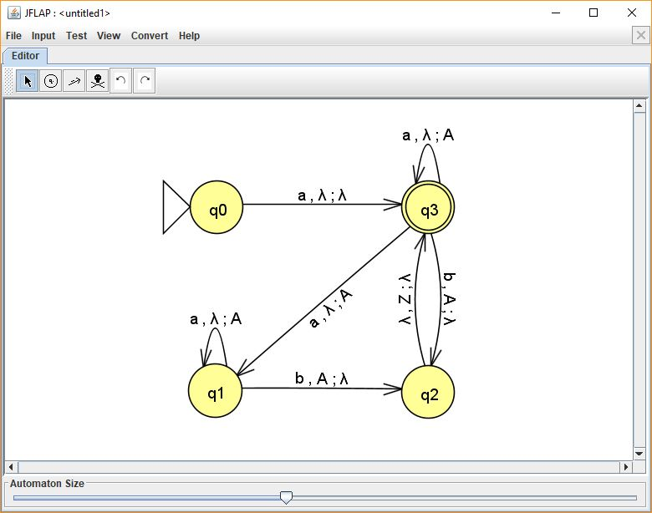

Q8. [10, optional] Show that if L1 is Deterministic Context-Free and L2 is regular, then the language L1∪ L2 is deterministic context-free.

**Let L1 = {anbn | n ≥ 0 }. Let L2 = {a*b*}. L1 is deterministic context-free and L2 is regular. Let L3 = L1∪ L2. L3 = {a*b*}, a regular language. All regular languages are deterministic context-free, so a union of any regular language with a deterministic context-free language will always be context-free, which means L3 is deterministic context-free.**