Java and Web Programming Practical

Phase 2: Structured Programming and Reliability
Project: User Authentication System
Field | Details
Candidate name | Aaron Joseph
Registration number | 26MCAB01
Programme and semester | 1 MCA B
Practical course | Java and Web Programming Practical
Guide | Dr. Arulmozhiarasu K
Date of submission | 27/10/2026

This phase extends the Phase 1 model into a structured Java application. The syllabus asks for three things: that classes be organised into packages, that an interface be created for user operations such as validation and authentication, and that exception handling be introduced for invalid inputs. The phase uses core Java only. Database access, servlets and web pages are introduced in later phases.

1. Setting Up the Project
Open Visual Studio Code and select File, then Open Folder. Create a folder named Java Campus SkillConnect and open it. Inside it, create four package folders: dao, model, exception and servlet. The folder names are the package names, and this correspondence is what allows the Java compiler and runtime to locate each class.
Java Campus SkillConnect
└── src
└── main
└── java
└──▼ com.campusskillconnect
├── ▼ dao
│ ├── Connectable.java <-- (Interface: matches UserOperations)
│ ├── DatabaseConnection.java
│ └── UserDAO.java <-- (Service/DAO: matches UserService)
├── ▼ exception
│ └── AppException.java <-- (Custom Exception: matches InvalidInputException)
├── ▼ model
│ └── User.java <-- (Entity: matches User.java)
└── ▼ servlet
├── LoginServlet.java <-- (Controller / Execution entry point)
└── RegisterServlet.java <-- (Controller / Execution entry point)

[SCREENSHOT 1: Package structure in the Explorer panel]
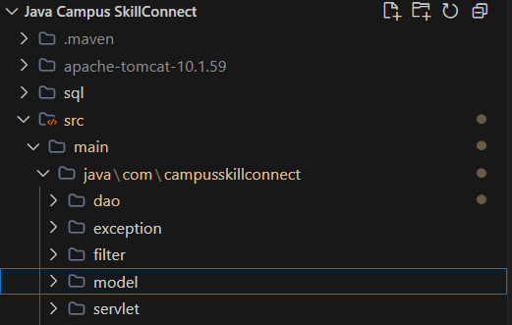

2. Organising Classes into Packages
A package is a named group of related classes. Each file begins with a package declaration that states its place in the hierarchy. Grouping classes in this way keeps the entity, the operations, the exceptions and the entry point separate, which makes the application easier to read and to extend. The User class moves into the model package, as shown below.
Listing 1: model/User.java
package model;

public class User {

private String username;
private String password;

// Constructor
public User(String username, String password) {
this.username = username;
this.password = password;
}

// Getters
public String getUsername() {
return username;
}

public String getPassword() {
return password;
}

// Display Method
public void displayUser() {
System.out.println("\nUser Details");
System.out.println("Username : " + username);
}
}

The class keeps the constructor and getter methods from Phase 1, and it adds the package declaration on its first line. The displayUser() method prints the username, which is sufficient for the authentication demonstration.

[SCREENSHOT 2: model/User.java in the editor]
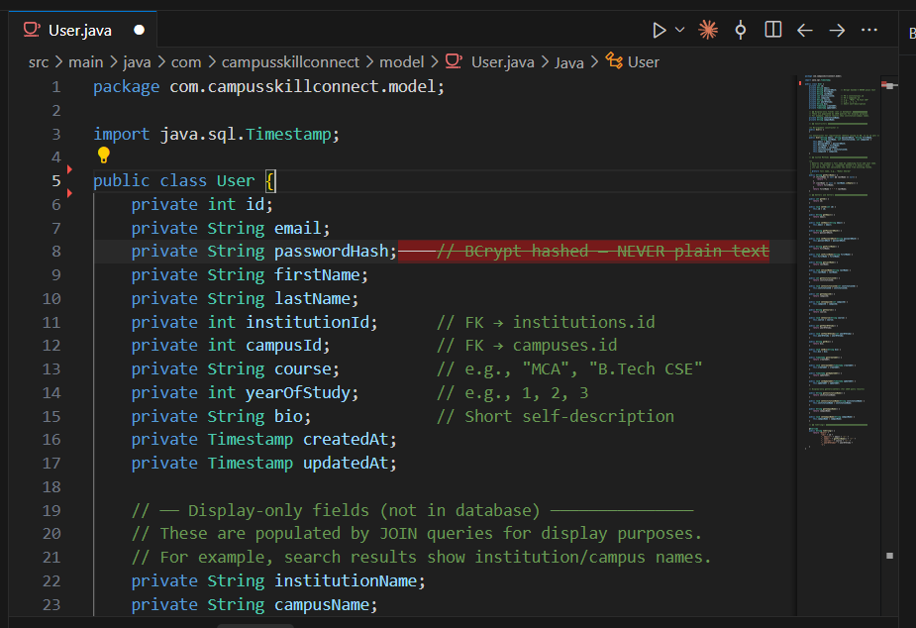

3. Creating an Interface for User Operations
An interface declares a set of method signatures without providing their implementation. It defines what a class must be able to do, and leaves the question of how to the implementing class. The UserOperations interface in the service package declares two operations: validateUser(), which checks the input, and login(), which checks the credentials. Declaring these operations in an interface separates the contract from its implementation.
Listing 2: connectable.java
package service;

public interface UserOperations {

boolean validateUser(String username, String password);

boolean login(String username, String password);
}

[SCREENSHOT 3: Connectable.java in the editor]
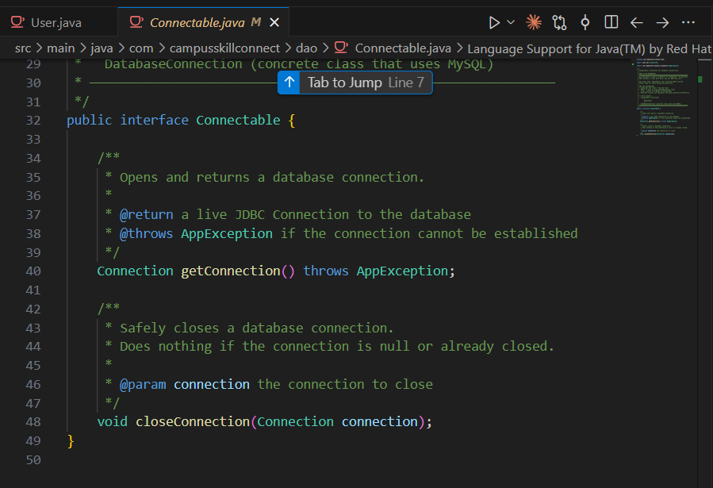

4. Implementing the Service Class
UserService implements the UserOperations interface. The @Override annotation confirms to the compiler that each method implements a method declared in the interface, so that a misspelt name is reported as an error rather than silently creating a new method. Validation failures are reported by throwing an InvalidInputException. The exception is caught within the same method, which prints the message and returns false to the caller.
Listing 3: service/UserService.java
package service;

import exception.InvalidInputException;

public class UserService implements UserOperations {

@Override
public boolean validateUser(String username, String password) {
try {
if (username == null || username.trim().isEmpty()) {
throw new InvalidInputException("Username cannot be empty.");
}
if (username.length() < 5) {
throw new InvalidInputException("Username must contain at least 5 characters.");
}
if (password.length() < 8) {
throw new InvalidInputException("Password must contain at least 8 characters.");
}
return true;
} catch (InvalidInputException e) {
System.out.println("Validation Error: " + e.getMessage());
return false;
}
}

@Override
public boolean login(String username, String password) {
return username.equals("admin") && password.equals("admin123");
}
}

The validateUser() method performs its checks in the order in which they are written. Once one check fails, the exception is thrown and the remaining checks are skipped. The login() method compares the supplied credentials with fixed values. This arrangement is sufficient for a demonstration of the interface, and it is replaced by a database-backed check in a later phase.
[SCREENSHOT 4: UserService.java in the editor]
What to capture: The VS Code editor showing UserService.java, with the try block and the catch block visible.
Antigravity prompt (copy and paste): Open service/UserService.java in VS Code and take a screenshot showing the validateUser method, including the throw statements and the catch block.

5. Defining a Custom Exception
InvalidInputException is a checked exception, because it extends Exception. A checked exception must be either caught or declared by the method that may throw it. This requirement forces the programmer to decide how each invalid input is handled. The class has a constructor that passes the message to the superclass, so that getMessage() returns the text describing the failure.
Listing 4: exception/InvalidInputException.java
package exception;

public class InvalidInputException extends Exception {

public InvalidInputException(String message) {
super(message);
}
}

[SCREENSHOT 5: AppException.java in the editor]
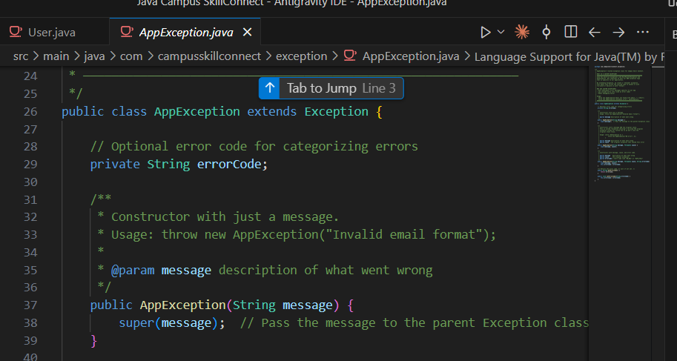

6. The Main Application
Main is placed in the app package and combines the other packages. It reads a username and a password, creates a UserService, and calls validateUser(). Only when validation succeeds does it create a User object and call login(). The sc.close() call releases the Scanner once input has been read.
Listing 5: app/Main.java
package app;

import java.util.Scanner;

import model.User;
import service.UserService;

public class Main {

public static void main(String[] args) {
Scanner sc = new Scanner(System.in);

System.out.println("===== User Authentication System =====");
System.out.print("Enter Username : ");
String username = sc.nextLine();
System.out.print("Enter Password : ");
String password = sc.nextLine();

UserService service = new UserService();

if (service.validateUser(username, password)) {
User user = new User(username, password);
if (service.login(username, password)) {
System.out.println("\nLogin Successful");
user.displayUser();
} else {
System.out.println("\nInvalid Username or Password");
}
}
sc.close();
}
}

[SCREENSHOT 6: Main method in PasswordUtil.java in the editor]
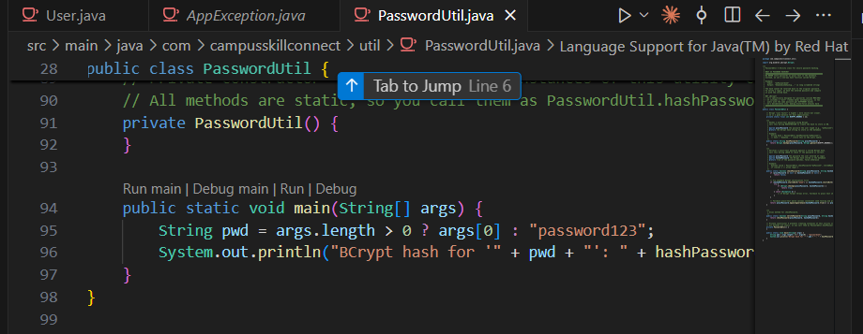

7. Compilation and Execution
Open the VS Code integrated terminal in the UserAuthenticationSystem folder. Because the source files are arranged in packages, all of them are passed to the compiler, and an output directory named out is specified so that the class files are placed in matching package folders. The compiler is given the full path of each file, which PowerShell builds with the command below.
Command 1: compile all packages
javac -d out (Get-ChildItem -Recurse -Filter *.java).FullName

The program is then run from the root of the project. The fully qualified name of the entry class is app.Main, which includes its package.
Command 2: run the application
java -cp out app.Main

Three runs are recommended: one with the valid credentials admin and admin123, one with a username shorter than five characters, and one with a password shorter than eight characters. The output of each run should be copied from the candidate's own terminal.

8. Program Flow
Program starts
|
v
Username and password read from the keyboard
|
v
UserService.validateUser()
|
+-- InvalidInputException thrown ---> message printed, return false ---> program ends
|
v returns true
UserService.login()
|
+-- credentials do not match ---> "Invalid Username or Password"
|
v credentials match
"Login Successful" followed by User details

10. Conclusion
This phase has organised the application into packages, defined an interface that describes user operations, implemented that interface in a service class, and introduced a checked exception to report invalid input. These changes make the structure of the program clearer and its failure modes more explicit. The next phase connects the user interface to the browser through HTML, CSS and JavaScript.

