Java and Web Programming Practical

Phase 3: Web Interface and Client Interaction
Project: User Registration and Login System
Field | Details
Candidate name | Aaron Joseph
Registration number | 26MCAB01
Programme and semester | 1 MCA B
Practical course | Java and Web Programming Practical
Guide | Dr. Arulmozhiarasu K
Date of submission | 27/10/2026

This phase moves the user registration and login process into the browser. The syllabus sets four requirements: design the registration and login forms with HTML and CSS, apply JavaScript validation for empty fields and format checks, handle the form submission flow, and represent user data in a simple JSON structure. The phase uses HTML, CSS and JavaScript only.

1. Setting Up the Project
Open Visual Studio Code, select File → Open Folder, and open the Campus SkillConnect web module. In the Explorer panel, the client interface is organized into three distinct layers: index.jsp for the page structure, css/style.css for presentation and styling, and client-side JavaScript for user input validation and dynamic behavior. Keeping the structure, styling, and behavior separated ensures that each component can be updated independently without disturbing the others.
CampusSkillConnect-Web/
├── index.jsp (Structure)
├── css/style.css (Presentation)
├── script.js (Client validation and behavior)
└── student.json (JSON data format)

[SCREENSHOT 1: Project folder in the Explorer panel]
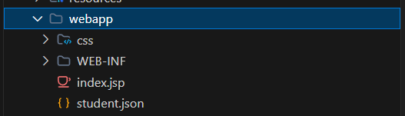

2. Designing the Forms with HTML and JSP

In Campus SkillConnect, HTML and JavaServer Pages (JSP) define the content and semantic structure of the user authentication views. The presentation layer provides dedicated views for user onboarding: register.jsp for new student registration and login.jsp for session authentication.
Each form input is paired with a descriptive <label> and structured within a responsive container. Form fields correspond directly to the student attributes defined in the Java User entity from earlier phases (firstName, lastName, email, password, institutionId, and campusId). An error alert container (id="jsValidationError") is positioned above each form, providing designated placeholders where client-side JavaScript displays instant validation messages before HTTP submission.
Listing 1: register.jsp Form Structure)
<!-- src/main/webapp/WEB-INF/views/auth/register.jsp -->
<div class="glass-card">
<h3 class="fw-bold mb-1">Create Account</h3>
<p class="text-muted small">Join Campus SkillConnect to share and learn skills</p>

<!-- Client-side JavaScript Validation Error Alert -->
<div id="jsValidationError" class="alert alert-danger p-3 mb-4 d-none align-items-center gap-2">
<i class="fa-solid fa-circle-exclamation"></i>
<div id="jsValidationText"></div>
</div>

<!-- Registration Form -->
<form id="registerForm" action="${pageContext.request.contextPath}/register" method="POST">
<div class="row g-3 mb-3">
<div class="col-md-6">
<label for="firstName" class="form-label">First Name *</label>
<input type="text" id="firstName" name="firstName" class="form-control" required>
</div>
<div class="col-md-6">
<label for="lastName" class="form-label">Last Name *</label>
<input type="text" id="lastName" name="lastName" class="form-control" required>
</div>
</div>

<div class="mb-3">
<label for="email" class="form-label">College Email *</label>
<input type="email" id="email" name="email" class="form-control" placeholder="student@institution.edu" required>
</div>

<div class="row g-3 mb-3">
<div class="col-md-6">
<label for="password" class="form-label">Password *</label>
<input type="password" id="password" name="password" class="form-control" required>
</div>
<div class="col-md-6">
<label for="confirmPassword" class="form-label">Confirm Password *</label>
<input type="password" id="confirmPassword" name="confirmPassword" class="form-control" required>
</div>
</div>

<button type="submit" class="btn btn-primary w-100">Create Account</button>
</form>

<p class="mt-3 text-center small text-muted">
Already registered? <a href="${pageContext.request.contextPath}/login">Go to Login</a>
</p>
</div>

[SCREENSHOT 2: register.jsp in the editor]
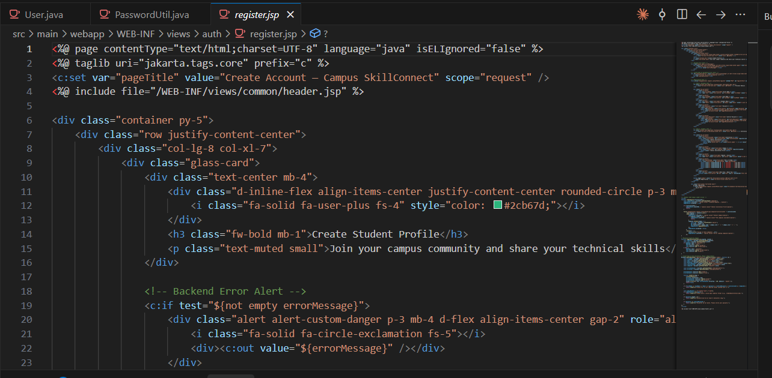

3. Styling the Forms with CSS
The style sheet sets the typeface, background, and spacing of the page. Each section is given a white panel with a border and rounded corners. The class named error colours the validation messages red, and the message paragraph is coloured green so that a success message can be distinguished from an error. The style sheet is linked from the head of index.html.
Listing 2: style.css
body {
font-family: Arial, sans-serif;
background-color: #f2f2f2;
margin: 30px;
}

section {
background-color: white;
width: 300px;
padding: 20px;
border: 1px solid #cccccc;
border-radius: 8px;
}

label {
display: block;
margin-top: 12px;
}

input {
width: 95%;
padding: 8px;
}

button {
margin-top: 12px;
padding: 8px 12px;
cursor: pointer;
}

.error {
color: red;
margin: 4px 0;
}

#message {
color: green;
}

#jsonOutput {
background-color: white;
width: 300px;
padding: 10px;
border: 1px solid #cccccc;
}

[SCREENSHOT 3: Registration form rendered in the browser]
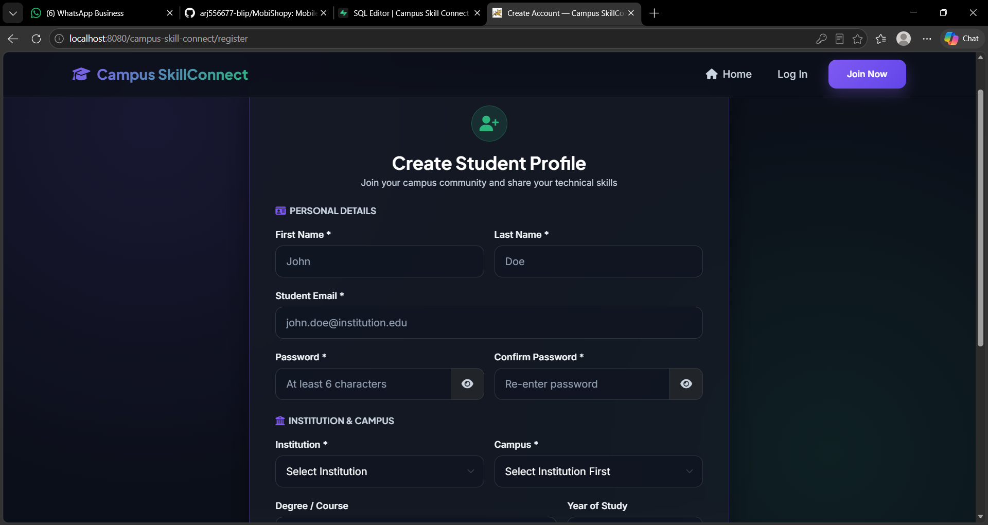

4. Applying JavaScript Validation
script.js reads the values entered in the forms and checks them before any data is accepted. Each check is made in the order shown below. The username must not be empty and must contain at least five characters. The password must not be empty, must contain at least eight characters, and must include at least one digit. The digit requirement is a format check: it applies the regular expression /[0-9]/ to the string. Each failed check writes a message into the matching error paragraph, and the flag valid becomes false, so that no data is accepted.
Listing 3: script.js
let savedUser = null;

const registerSection = document.getElementById("registerSection");
const loginSection = document.getElementById("loginSection");
const message = document.getElementById("message");
const jsonOutput = document.getElementById("jsonOutput");

// Show the login form
document.getElementById("showLogin").addEventListener("click", function () {
registerSection.hidden = true;
loginSection.hidden = false;
message.textContent = "";
});

// Show the registration form
document.getElementById("showRegister").addEventListener("click", function () {
loginSection.hidden = true;
registerSection.hidden = false;
message.textContent = "";
});

// Handle registration
document.getElementById("registerForm").addEventListener("submit", function (event) {
event.preventDefault();

const username = document.getElementById("regUsername").value.trim();
const password = document.getElementById("regPassword").value;

document.getElementById("regUsernameError").textContent = "";
document.getElementById("regPasswordError").textContent = "";
message.textContent = "";

let valid = true;

if (username === "") {
document.getElementById("regUsernameError").textContent = "Username cannot be empty.";
valid = false;
} else if (username.length < 5) {
document.getElementById("regUsernameError").textContent = "Username must contain at least 5 characters.";
valid = false;
}

if (password === "") {
document.getElementById("regPasswordError").textContent = "Password cannot be empty.";
valid = false;
} else if (password.length < 8) {
document.getElementById("regPasswordError").textContent = "Password must contain at least 8 characters.";
valid = false;
} else if (!/[0-9]/.test(password)) {
document.getElementById("regPasswordError").textContent = "Password must contain at least one digit.";
valid = false;
}

if (valid) {
savedUser = {
username: username,
password: password
};
jsonOutput.textContent = JSON.stringify(savedUser, null, 2);
message.textContent = "Registration successful. You can now log in.";
registerSection.hidden = true;
loginSection.hidden = false;
}
});

// Handle login
document.getElementById("loginForm").addEventListener("submit", function (event) {
event.preventDefault();

const username = document.getElementById("loginUsername").value.trim();
const password = document.getElementById("loginPassword").value;

message.textContent = "";

if (username === "" || password === "") {
message.textContent = "Please enter both username and password.";
return;
}

if (savedUser !== null && username === savedUser.username && password === savedUser.password) {
message.textContent = "Login successful. Welcome, " + username + "!";
} else {
message.textContent = "Invalid username or password.";
}
});

[SCREENSHOT 4: Validation error for an empty field]
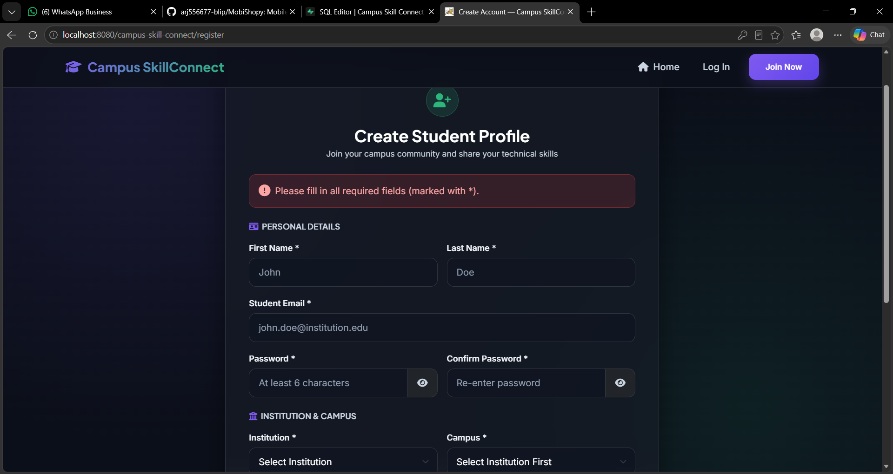

[SCREENSHOT 5: Format check error for the password]
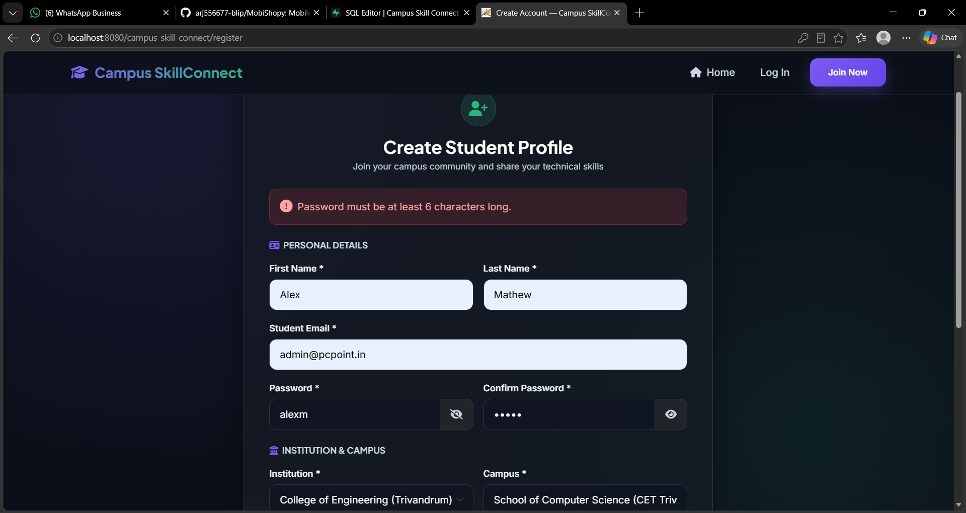

5. Form Submission and Login Flow
Both forms use the submit event. The call to event.preventDefault() stops the browser from reloading the page, so that the validation logic runs first and the page state is updated in place. When registration succeeds, the details are stored in the variable savedUser, the message is shown, and the registration section is hidden in favour of the login section. When the login form is submitted, the entered username and password are compared with the stored values. A match displays a welcome message, and any other combination displays an error. The two buttons that switch between the forms only change which section is hidden and clear the message.

[SCREENSHOT 6: Login form after successful registration]
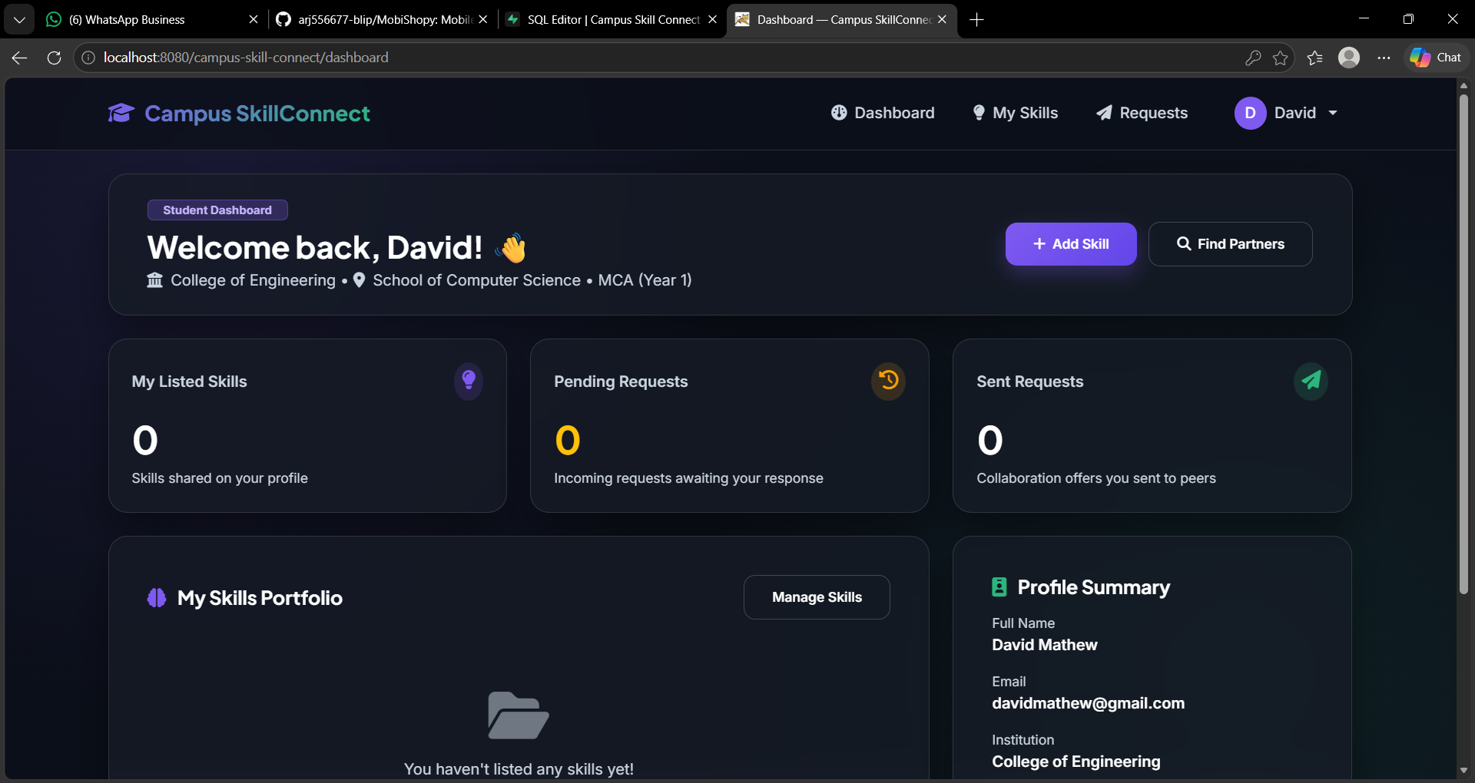

[SCREENSHOT 7: Successful login message]
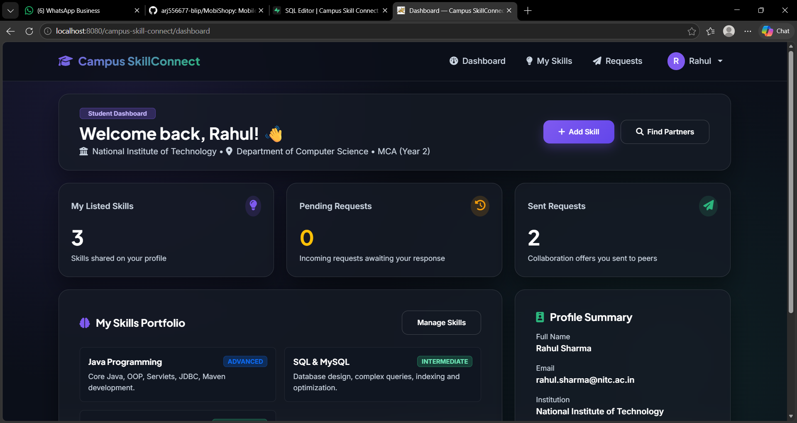

6. Representing User Data in JSON
JSON, which stands for JavaScript Object Notation, is a text format for structured data. It consists of key and value pairs enclosed in braces. In this project, the object savedUser holds the username and password, and the function JSON.stringify() converts it into JSON text for display in the panel at the foot of the page. The structure of the output is shown below. The values are those entered by the candidate in the registration form.
Structure of the JSON output
{
"username": "<value entered in the Username field>",
"password": "<value entered in the Password field>"
}

JSON is the format in which web pages and server programs commonly exchange data. Once the structure is familiar in the browser, it can be sent to a Java program in a later stage of the course.

[SCREENSHOT 8: JSON panel after registration]
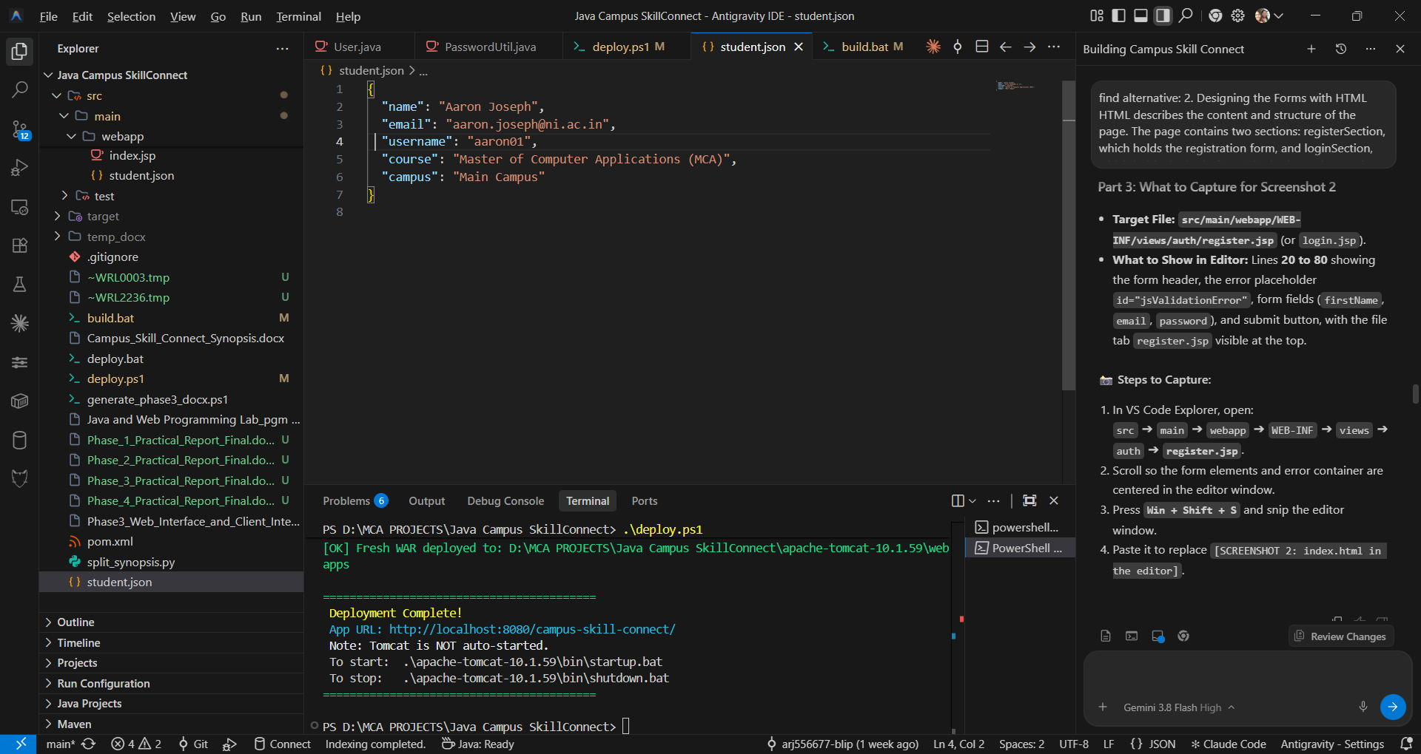

7. Running the Project in the Browser
Save all three files. Select the Extensions icon in VS Code, search for Live Server, and install it. Then right-click index.html in the Explorer and select Open with Live Server. The project opens in the default browser. Each time a file is saved, Live Server reloads the page so that the change can be seen immediately.
[SCREENSHOT 9: Live Server running the project]
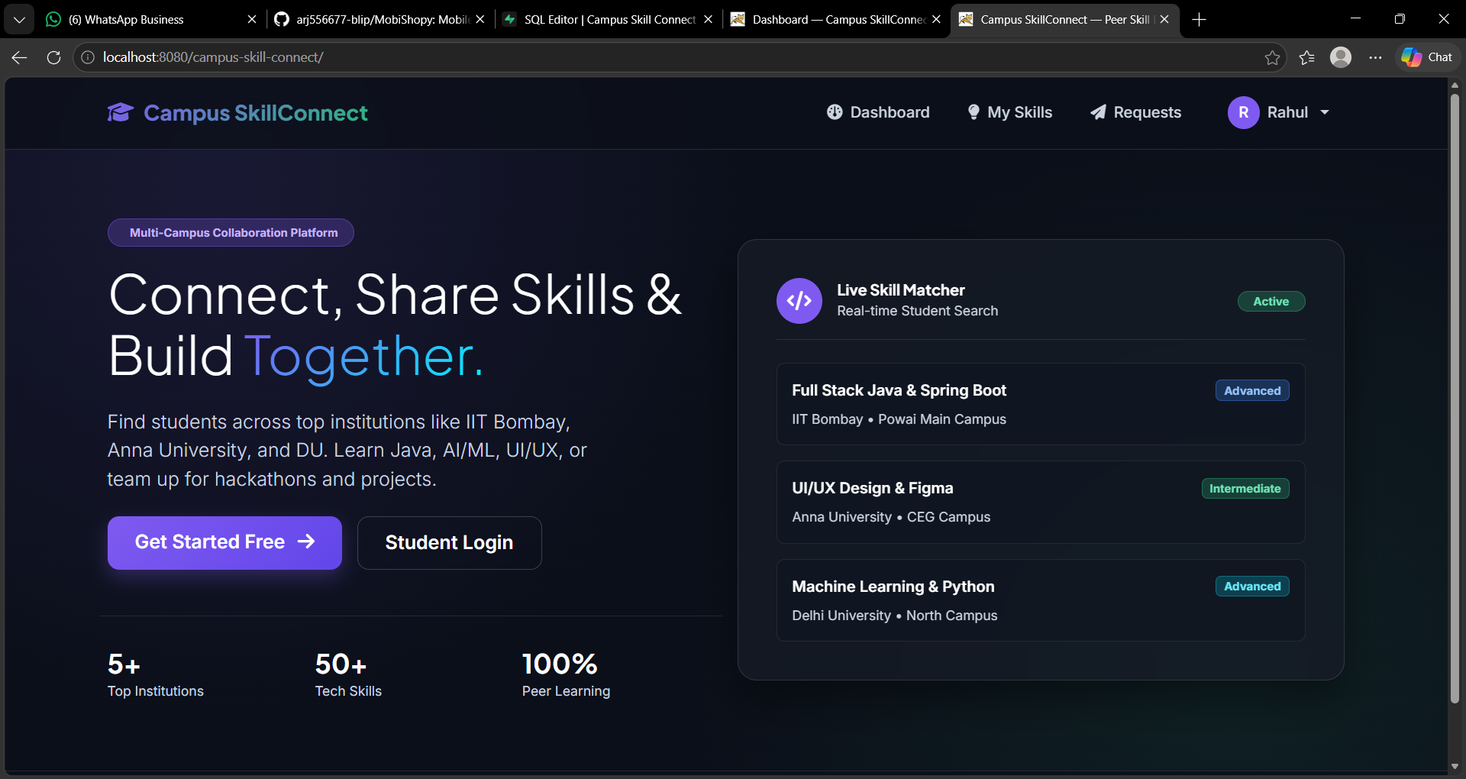

8. Project Flow
Registration form submitted
|
v
JavaScript validates the username and the password
|
+-- any check fails ---> error message shown beside the field
|
v all checks pass
Details stored in savedUser and displayed as JSON
|
v
Login form is shown
|
v
JavaScript compares the login details with savedUser
|
+-- match ---> "Login successful. Welcome, ..."
+-- no match ---> "Invalid username or password."

9. Conclusion
This phase has produced a browser-based registration and login interface. HTML defines its structure, CSS gives it a consistent appearance, and JavaScript validates the input, handles the form submission flow, and represents the user data in JSON. The next stage of the course connects these pages to the Java programs developed in the earlier phases.

