

Project-based Practical Report on

“PC Point: Online Computer Sales and Accessories”

Submitted in partial fulfilment of the requirements for “Data Structures and Algorithmic Problem Solving” for the 1st Semester

Master of Computer Applications (MCA)

Submitted by

Aaron Joseph 26MCAB01

Under the guidance of
Dr. Abinaya S

Contents
1. Title of the Project 3
2. Introduction 4
2.1 Background 4
2.2 Problems addressed 4
2.3 Proposed solution 4
2.4 Why these structures 5
3. Objectives 6
3.1 Learning outcomes 6
4. Scope 7
5. Software Specification 8
5.1 Hardware and software requirements 9
5.2 Database tables 9
5.3 Backend interface 10
5.4 Installation and configuration 11
6. Workflow 12
6.1 Start-up sequence 12
6.2 Session and access workflow 13
6.3 Recording a sale 13
6.4 Error handling 14
6.5 Example request and response 14
7. Modules and Their Phases 15
7.1 Phase 1: Product array 15
7.2 Phase 1: Sales linked list 15
7.3 Phase 1: Service queue and billing stack 16
7.4 Phase 2: Component graph and BFS 18
7.5 Phase 3: Binary search and merge sort 19
7.6 Phase 4: Greedy budget recommender 21
7.7 Testing and verification 22
7.8 Summary of phase results 23
7.10 Front-end pages 23
7.9 Module summary 24
8. Key Code 25
8.5 Remaining listings 25
8.6 Session check 26
9. Features 27
9.1 Comparison with a paper register 27
9.2 Features in more detail 27
9.3 Usability notes 28
10. Limitations and Future Work 29
10.1 Challenges during development 29
10.3 Limitations by module 30
11. Conclusion 31
References 32
Appendix A. Glossary 33
Appendix B. Requirements Checklist 34

1. Title of the Project
PC Point: Online Computer Sales and Accessories
PC Point is a web application for a small computer shop. Customers can browse laptops, desktops, memory, storage, graphics cards and peripherals, look parts up, and ask for a parts list that fits a budget. The shop owner can record sales, see how each bill was worked out, manage a service queue and keep the catalogue up to date. On the surface it is an ordinary shop website. The reason I built it is different: each feature is meant to show one data structure or algorithm from the course, working on data that a shop would actually have.
The backend is Python with Flask, the database is SQLite, and the front end is plain HTML, CSS and JavaScript. The code is in a public repository at github.com/arj556677-blip/PC-Point. Table 1.1 gives the main details.
Table 1.1 Project details
Item | Details
Project title | PC Point: Online Computer Sales and Accessories
Submitted by | Aaron Joseph
Register number | 26MCAB01
Programme and class | Master of Computer Applications (MCA), Class B, 1st Semester
Course | Data Structures and Algorithmic Problem Solving
Guide | Dr. Abinaya S
Academic year | 2026 - 27
Backend and database | Python 3, Flask 3, SQLite
Front end | HTML5, CSS3, JavaScript (no framework)
Source repository | github.com/arj556677-blip/PC-Point

2. Introduction

2.1 Background
Running a computer shop involves a lot of small, repeated decisions. The catalogue changes every week. Stock has to match what is physically on the shelf. Customers queue up with repair questions and expect to be served in the order they arrived. Each bill is a short calculation, but it has to come out right every time. Many shops still do this with a register book or a spreadsheet, and both are slow to search and easy to get wrong.
Software does not need to be large to help with this, but the way it stores information decides how quickly it can answer questions. Whether sales sit in an array or a linked list, and whether the waiting line is a queue or a sorted list, changes the cost of every insertion, search and removal. That is the link between a shop and a data structures course.

2.2 Problems addressed
- Slow product lookup. Without sorting, finding a product by ID means checking records one at a time.
- Sales history that keeps growing. New sales arrive constantly and the most recent ones are the ones people ask about.
- Bills that are hard to explain. A total built from several steps is difficult to check when a customer disputes it.
- Unfair service order. A repair desk should serve people strictly in arrival order.
- Guesswork in recommendations. A customer with a fixed budget wants a clear answer about what fits.

2.3 Proposed solution
PC Point is a three-layer application. The browser shows pages and sends JSON requests. A Flask backend applies the relevant data structure or algorithm and returns JSON. SQLite keeps the records that must survive a restart. When the server starts, the stored rows are loaded into in-memory structures, so most reads work on those structures rather than going back to the database. Figure 2.1 shows the layers.
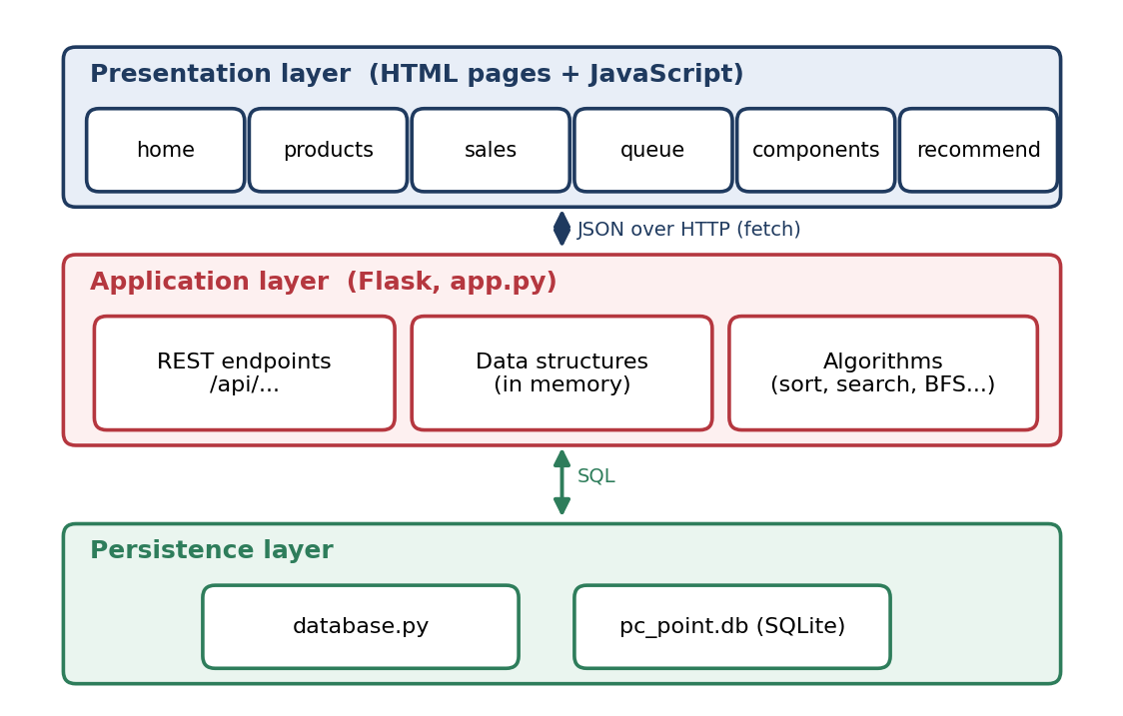
Figure 2.1 The three layers of PC Point

2.4 Why these structures
Table 2.1 pairs each real shop need with the structure I chose for it. The reasons are given in full in section 7, so the table is only a quick reference.
Table 2.1 Shop needs and the structures that answer them
Shop need | Structure or algorithm | Phase
Hold the live catalogue | Array | 1
Keep sales, newest first | Singly linked list | 1
Serve customers in arrival order | Queue (linked) | 1
Work out and explain a bill | Stack (linked) | 1
Show which parts connect | Graph with breadth-first search | 2
Find a product by id | Binary search on sorted data | 3
Order the catalogue | Merge sort | 3
Choose parts for a budget | Greedy selection | 4

3. Objectives
- Build a shop management application that both a customer and an administrator can use in a browser.
- Implement a singly linked list, a stack and a queue by hand, and connect each one to a real feature.
- Model the relationships between computer components as a graph and traverse it with breadth-first search.
- Implement binary search for lookup by product ID, and merge sort for ordering the catalogue.
- Solve budget-based part selection with a greedy algorithm.
- Keep data across restarts with SQLite, and keep the whole project small enough to explain in a viva.
A secondary aim was to make the algorithms visible. Each one returns a short trace of what it did: the comparisons in merge sort, the probes in binary search, the stack operations in the bill, and the decisions in the greedy selection. A trace that is wrong is easy to spot on screen, which makes it a good way to check the code.

3.1 Learning outcomes
The project was also meant to teach me something, so it helps to say what I expected to learn and where that shows up in the work. Table 3.1 maps each outcome to the evidence that backs it.
Table 3.1 Learning outcomes and evidence
Outcome | Evidence in the project
Difference between a data type and its implementation | Linked nodes written by hand for the stack, queue and list (sections 7.2 and 7.3)
Choosing a structure from how it will be used | Table 2.1 and the Design paragraph of each module
Reasoning about cost | Complexity tables in sections 7.1 to 7.5
Writing an algorithm that can explain itself | Trace output from merge sort, binary search, the evaluator and the greedy selector
Keeping a database and in-memory state consistent | Write order in section 6.3 and the defect in section 10
Testing honestly | Table 7.7, including a failing case

4. Scope
The project covers one shop. A visitor can browse the catalogue, filter and sort it, search by ID, explore component compatibility and ask for a budget build. An administrator can also add and delete products, record sales, review the sales ledger with its bill traces, and manage the service queue. Table 4.1 lists the roles.
Table 4.1 Access by role
Capability | Visitor | Customer | Admin
Browse, sort, search the catalogue | Yes | Yes | Yes
Component explorer and budget builder | Yes | Yes | Yes
Add or delete products | No | No | Yes
Record sales and view the ledger | No | No | Yes
Manage the service queue | No | No | Yes

I left out payments, delivery, multiple branches, trees and dynamic programming. The last two were outside the scope of the synopsis, and keeping them out kept each included structure tied to a real feature. Security is at the level of a coursework prototype, and section 10 lists what a real deployment would still need.
The design assumes a catalogue of tens to a few thousand products, one server process, and integer product IDs issued by the database. The seed data has 18 products across nine categories, four customers and three user accounts. That is enough to exercise every feature.

5. Software Specification
The project runs on any machine with Python 3.10 or later, a current browser and about 200 MB of disk space. Flask is the only third-party package and is listed in requirements.txt. SQLite is bundled with Python, so there is no database server to install. Visual Studio Code with the Pylance configuration was used for editing.
Python keeps the data structures readable, since a linked node is only a few lines. Flask was chosen because a route is a single decorated function and nothing else needs configuring. SQLite stores the whole database in one file next to the code, which makes the project easy to copy and run on another machine.
Listing 5.1 Project layout
PC-Point/
backend/
app.py Flask routes and session handling
database.py SQLite schema and seed data
data_structures/ ProductArray, SalesLinkedList, BillingStack,
CustomerQueue, ComponentGraph
algorithms/ merge_sort, binary_search, bfs, greedy,
expression_evaluator
frontend/ HTML pages
js/, css/ Page scripts and shared stylesheet
requirements.txt Flask>=3.0.0

To run it, clone the repository, run pip install -r requirements.txt, and start the server with python backend/app.py. The database is created and seeded on first launch, and the application is then available at http://127.0.0.1:5000.
The database has five tables: products, customers, sales, sale_items and users. A sale stores the unit price in sale_items, not just a reference to the product. Prices change over time, and an old bill has to show what was actually charged. Figure 5.1 shows the relationships.
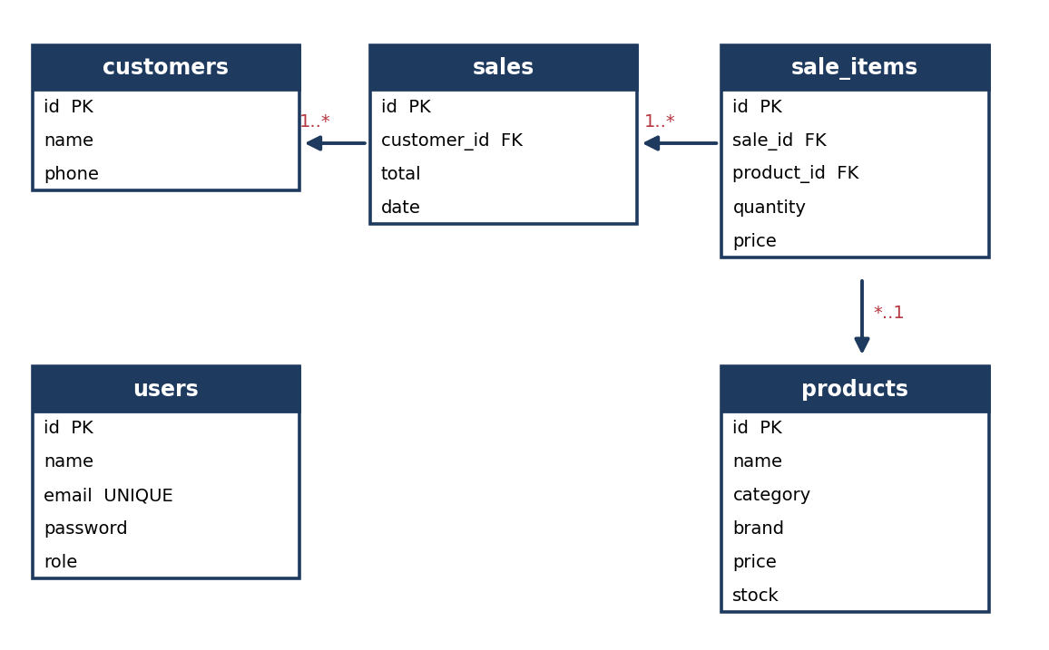
Figure 5.1 Database tables and relationships

5.1 Hardware and software requirements
Nothing here is demanding. The in-memory structures hold a few thousand small records at most, and SQLite runs inside the same process as the server. Any laptop that can run Python and a modern browser is enough.
Table 5.1 Hardware and software requirements
Component | Minimum | Recommended
Processor | Dual core, 1.8 GHz | Quad core, 2.4 GHz
Memory | 4 GB | 8 GB
Free disk space | 200 MB | 1 GB
Operating system | Windows 10/11, Ubuntu 22.04 or macOS | Current release
Python | 3.10 | 3.12
Browser | Chrome, Edge or Firefox | Current release

5.2 Database tables
The database has five tables. Every table uses an integer primary key with auto increment, and the foreign keys are declared in the schema. The product table is the one most of the code reads, so it is described first.
Table 5.2 products
Column | Type | Notes
id | INTEGER | Primary key. The key used by binary search.
name | TEXT | Not null
category | TEXT | Laptop, Desktop, RAM, SSD, GPU, Monitor, Keyboard, Mouse or Accessory
brand | TEXT | Not null
price | REAL | Price in rupees
stock | INTEGER | Default 0

Table 5.3 Remaining tables
Table | Main columns | Purpose
customers | id, name, phone | People who buy from the shop and who appear on the service desk
sales | id, customer_id, total, date | One row per completed sale, with the final amount after tax and discount
sale_items | id, sale_id, product_id, quantity, price | Line items. price is copied at the time of sale so old bills stay correct
users | id, name, email, password, role | Login accounts. role is admin or customer

Copying the price into sale_items is a deliberate choice. Product prices change, and an invoice printed last month must still show what was charged then. The same reasoning applies to the sales total, which is stored instead of being recalculated from the current catalogue.

5.3 Backend interface
The backend exposes a JSON interface under the /api prefix. Read-only endpoints such as sorting, searching, billing preview, graph scans and recommendations are public, because they reveal nothing private and they are what a visitor uses. Endpoints that change shop data go through an admin check. Table 5.4 lists them.
Table 5.4 Backend endpoints
Method and path | Access | Purpose
POST /api/auth/login | Public | Checks credentials and starts a session
POST /api/auth/register | Public | Creates a customer account
GET /api/products | Public | Whole catalogue from the array
POST /api/products | Admin | Adds a product to SQLite and the array
DELETE /api/products/<id> | Admin | Removes a product from both
GET /api/products/sort | Public | Merge sort by key and order, with comparison count
GET /api/products/search | Public | Binary search by id, with probe trace
POST /api/billing/evaluate | Public | Stack-based bill with step log
GET /api/sales | Admin | Sales ledger, newest first
POST /api/sales | Admin | Records a sale and reduces stock
GET /api/queue | Admin | Current waiting line
POST /api/queue | Admin | Adds a customer to the line
POST /api/queue/serve | Admin | Removes the customer at the front
GET /api/components/bfs | Public | Breadth-first scan from a chosen node
POST /api/recommend | Public | Greedy selection for a budget

5.4 Installation and configuration
Setting the project up takes four steps. The commands below assume a terminal in the folder where the repository was cloned.
Listing 5.2 Commands to run the project
git clone https://github.com/arj556677-blip/PC-Point.git
cd PC-Point
pip install -r requirements.txt
python backend/app.py
# open http://127.0.0.1:5000 in a browser

On first launch the server creates pc_point.db, adds the tables and inserts the seed rows. The seed data includes an administrator account and customer accounts, so the pages can be tried straight away. A new customer can also register from the login page.
Two settings are worth changing before the project is shared. The session secret key is written in app.py for convenience, and debug mode is turned on. Both should come from environment variables in any setting other than a local demonstration.

6. Workflow
Start-up runs in a fixed order. The tables are created if they are missing and seeded if empty. Products are loaded into the array. Stored sales are read oldest first and inserted at the head of the sales list, so the newest sale ends up first. The component graph is built from twelve links. The customer queue starts empty each time the server runs, because a waiting line has no meaning after the shop closes.
Every request goes through the same path. A session check runs first and clears the session after fifteen idle minutes or four hours in total. The route handler then runs, with a role check if the route is restricted. Reads come from the in-memory structures. Changes are written to SQLite first and then applied to the structure. Finally the response is sent with headers that stop the browser caching pages meant for signed-in users.
Recording a sale is the longest operation. The request lists the products and quantities. Stock is checked for every line, and if any line fails the whole sale is rejected. The bill is then worked out on the stack. The sale and its items are written to SQLite, stock is reduced, and the sale is added to the front of the ledger with its calculation trace attached.
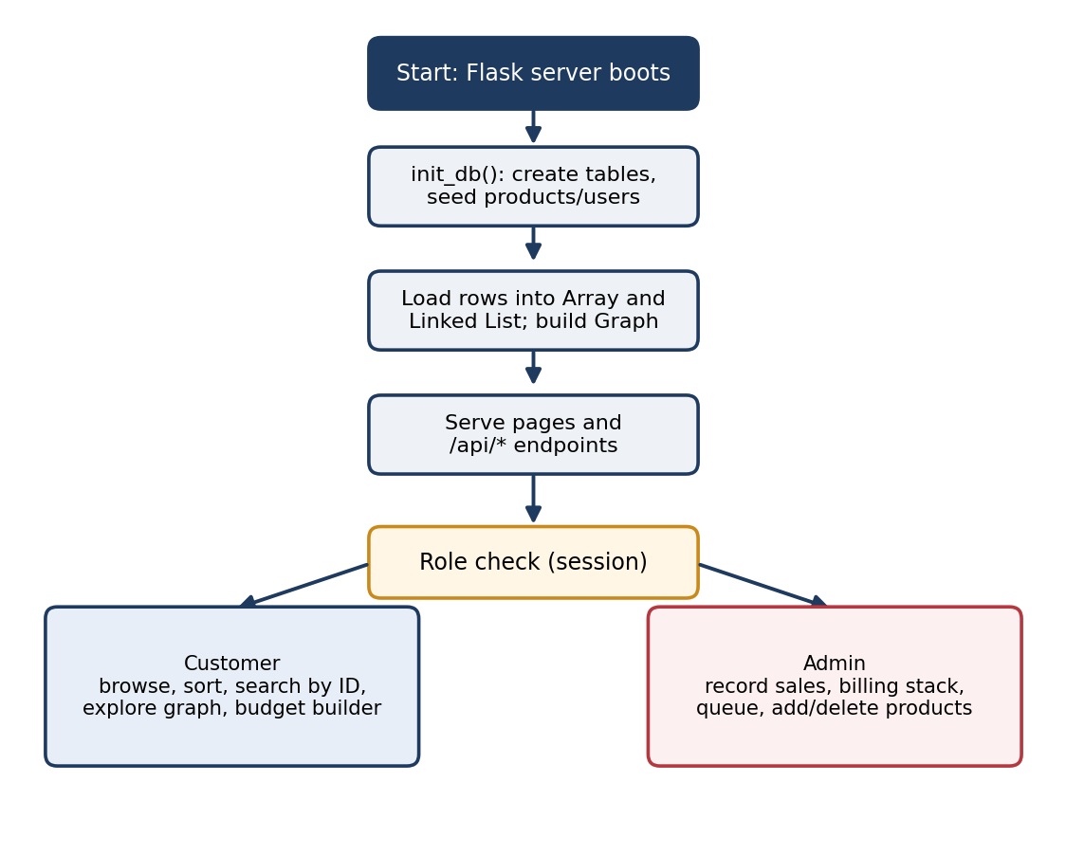
Figure 6.1 Start-up and request routing

6.1 Start-up sequence
Everything that must be ready before the first request is handled happens in one function, which runs once when the server starts. It creates the tables if they are missing, loads products into the array, reads stored sales and builds the graph. The order matters. Sales are read oldest first, so that inserting each one at the head leaves the newest sale in front. This is the only point where the linked list is filled from stored data.

6.2 Session and access workflow
A user signs in with an email and password. The server looks the email up in the users table, compares the password and, on success, stores the user id, name, role and timestamps in a session cookie. The cookie is HttpOnly and SameSite=Lax, and it is not permanent, so closing the browser ends it.
Every later request runs a check before the route does anything else. If the session has been idle for more than fifteen minutes, or has lasted more than four hours, it is cleared. Admin routes then test the stored role. A missing session gets 401 and a customer trying an admin route gets 403. The browser side adds an idle timer and stops the Back button from showing a dashboard after logout, but those are conveniences. The server checks are the ones that count.

6.3 Recording a sale
Recording a sale touches almost every structure in the project, so it is worth going through step by step.
- The admin page sends the customer name, the list of product IDs and quantities, a tax rate and a discount.
- For each line the handler finds the product in the array and checks the stock. If any line fails, the whole request is refused and nothing changes.
- The accepted lines go to the billing evaluator, which pushes and pops on the stack and records every step.
- The sale is written to SQLite, with one sale_items row per line, and stock is reduced in the database.
- The array is updated to match, and the finished sale, with its trace, is inserted at the head of the sales list.
- The response returns the sale, and the page redraws the chain and shows the trace for the new invoice.
The trace is stored on the sale, so the same calculation can be replayed later from the ledger without recalculating anything from the current catalogue.

6.4 Error handling
Table 6.1 Expected responses to common errors
Situation | Response | Where it is handled
Not enough stock for a line | 400, whole sale refused | Sales handler, before any write
Dequeue from an empty queue | 400, Queue is empty | Queue endpoint
Binary search target not present | found = false, with the probe trace | Search endpoint
Missing or invalid field | 400 with a message | Each POST handler
Not logged in | 401 | Admin decorator
Logged in, wrong role | 403 | Admin decorator
Idle or expired session | Session cleared; login required | Before-request hook

6.5 Example request and response
To make the interface concrete, here is the request a browser sends when a shop assistant asks for a bill preview, and the response it gets back. The numbers match the sample invoice in section 7.3.
Listing 6.1 Billing preview request and response
POST /api/billing/evaluate
Content-Type: application/json

{
"items": [
{"product_id": 1, "product_name": "ThinkPad X1 Carbon",
"price": 85000.0, "quantity": 1},
{"product_id": 6, "product_name": "Vengeance 16GB DDR5",
"price": 4500.0, "quantity": 2}
],
"tax_rate": 0.18,
"discount": 1000.0
}

HTTP 200 OK
{
"subtotal": 94000.0,
"tax": 16920.0,
"discount": 1000.0,
"final_total": 109920.0,
"trace_steps": [ {"step": 1, "action": "PUSH", "token": "85000.0"}, "..." ]
}

The response carries the full trace, so the page can show every stack step without a second request. This is also why the preview endpoint can be public: it only calculates and stores nothing.

7. Modules and Their Phases
Each module below is described in three parts: the design decision, how it was implemented, and what it produced when run on the seed data. The phases in my handwritten plan were: Phase 1, the basic linear structures; Phase 2, graph traversal; Phase 3, searching and sorting; and Phase 4, the greedy recommender. The sections that follow follow that order.

7.1 Phase 1: Product array
Design. The catalogue is read on almost every page, and the common operation is to give me everything, or to look up a position. An array does both in constant time for indexed access. Adding to the end is cheap on average, so the array fits the access pattern better than anything else in the plan.
Implementation. ProductArray wraps a Python list and loads its rows from SQLite at start-up. append, remove_by_id and update keep it in step with the database. to_list returns a copy, so the sorter cannot reorder the live catalogue by accident.
Result. At start-up the array holds 18 products. Adding a product increases the count to 19, and deleting it brings the count back.

Complexity of the array operations
Table 7.1 Array operations and their cost
Operation | Cost | Reason
get by index | O(1) | Direct indexing into contiguous storage
append | O(1) amortised | Occasional resize, otherwise constant
remove by id | O(n) | Every element is examined and the list rebuilt
update by id | O(n) | Linear scan for the matching id

The array is effectively a cache in front of SQLite. Database writes happen first, so that a failed write never leaves the array ahead of the stored data. The one place I am not fully satisfied is delete, which is O(n) because the list is rebuilt. For a few dozen products that cost is invisible.

7.2 Phase 1: Sales linked list
Design. Sales only grow, and people ask about the latest ones. Inserting at the head of a singly linked list takes constant time whatever the length, and reading from the head already gives newest-first order. No sorting or copying is needed.
Implementation. SalesLinkedList holds a head pointer and a size counter. insert_at_head creates a node that points at the old head and then becomes the new head. A generator walks the list for the ledger, and find_by_id is a linear scan because the list has no index.
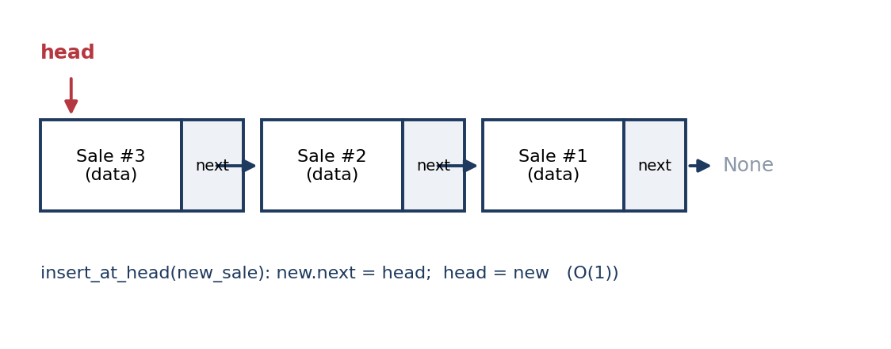
Figure 7.1 Sales chain: the newest sale is at the head
Result. After three sales the ledger lists sale 3, sale 2 and sale 1, which is the order Figure 7.1 shows.

Operations and their cost
Table 7.2 Linked list operations
Operation | Cost | Note
insert at head | O(1) | Two pointer assignments
traverse or to_list | O(n) | Visits every node once
find by id | O(n) | No index, so the scan starts at the head
size | O(1) | Counter kept alongside the list

The trade-off for the sales list is clear. Adding a sale is instant and the newest sale is always first. Finding an old sale by id costs a full walk. A dictionary keyed by sale id would fix that, but then the list would be a second structure beside the first, and the course point is the linked list itself.

7.3 Phase 1: Service queue and billing stack
Design. The service desk needs first-in, first-out order, so a queue is the obvious choice. The billing module is different. An invoice is an arithmetic expression: price times quantity, added together, plus tax, minus a discount. Evaluating that is the classic use of a stack, because operands are pushed and operators pop what they need. The stack also leaves a trace, so the shopkeeper can show a customer how the total was reached.
A note on undo. My original plan listed the stack for undoing the last operation. I did not implement undo. The stack is used for the bill, and the same last-in, first-out idea applies there. If undo is added later, it would need a separate stack of reversible actions, and that is listed in section 10.
Implementation. CustomerQueue is built on linked nodes with front and rear pointers, so enqueue and dequeue are both constant time. BillingStack is also built on linked nodes. evaluate_billing_expression pushes each price and quantity, multiplies them, sums the lines, applies tax, subtracts the discount, and logs every step. The discount is capped so the total cannot go negative.
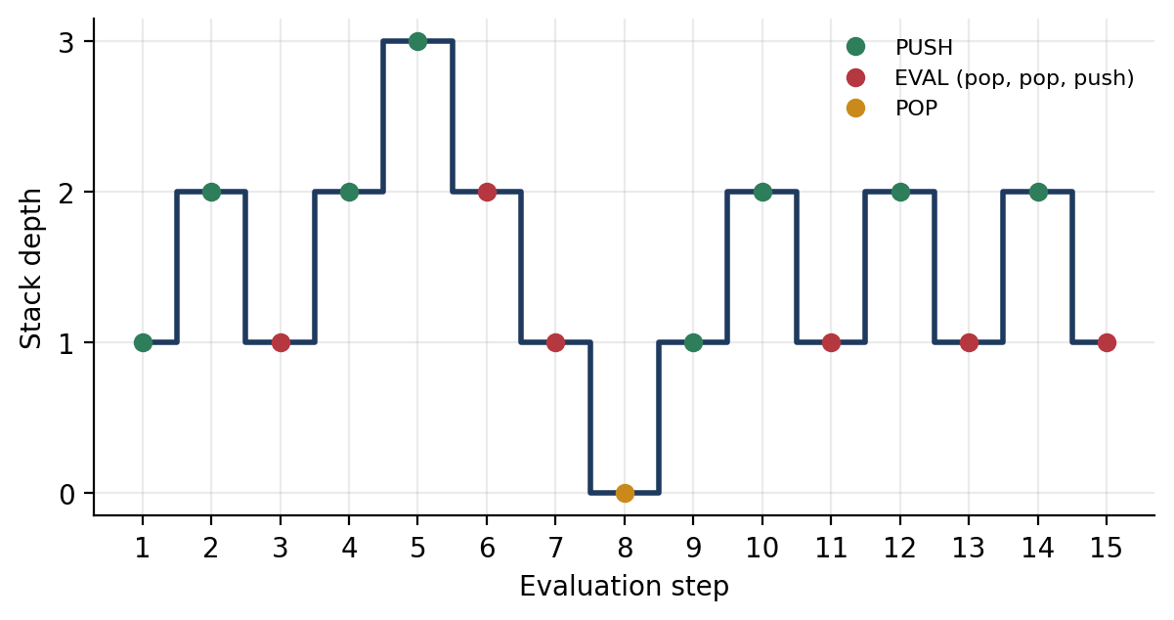
Figure 7.2 Depth of the billing stack through the sample invoice
Result. The sample invoice has one ThinkPad at 85,000 rupees and two 16 GB DDR5 kits at 4,500 each, with 18 per cent tax and a 1,000 rupee discount. The evaluator gives a subtotal of 94,000, tax of 16,920 and a final total of 109,920 in fifteen logged steps. The queue serves Rahul, then Priya, then Anish, in that order, and reports “Queue is empty” when asked for a fourth ticket.
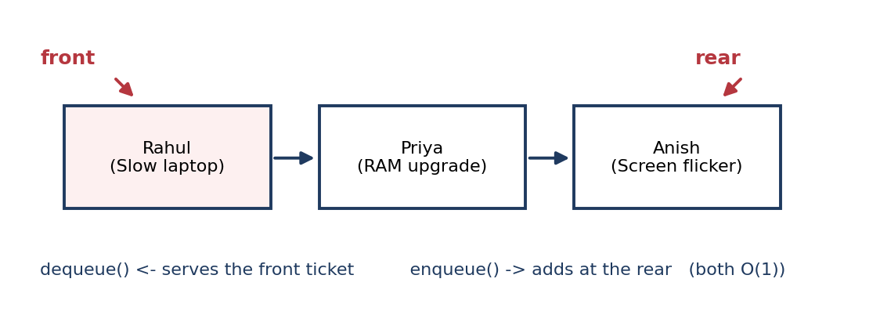
Figure 7.3 Customer queue with front and rear pointers

Operations and their cost
Table 7.3 Queue, stack and evaluator
Structure | Operations | Cost | Used for
Queue (linked) | enqueue, dequeue, peek | O(1) each | Service desk ticket order
Stack (linked) | push, pop, peek | O(1) each | Operand handling in the bill
Billing evaluator | k line items | O(k) | A full invoice, logged step by step

The billing evaluator makes a fixed number of stack operations for each line item, so its cost grows in a straight line with the number of lines. Each stack step is constant time, so the total is linear. The step log is the reason the bill can be explained to a customer, and it costs almost nothing extra to produce.

7.4 Phase 2: Component graph and BFS
Design. Computer parts are linked to each other in a web. RAM fits both laptops and desktops and also connects to the motherboard. A GPU feeds a monitor but only exists in a desktop build. A tree forces each part under one parent, which does not match hardware. An undirected graph does, and breadth-first search lists the nearest components first.
Implementation. ComponentGraph stores an adjacency list, since the graph is sparse. bfs_traversal uses a deque and a visited set, so each node and edge is handled once, at O(V + E) cost. It returns both the visiting order and the tree edges.
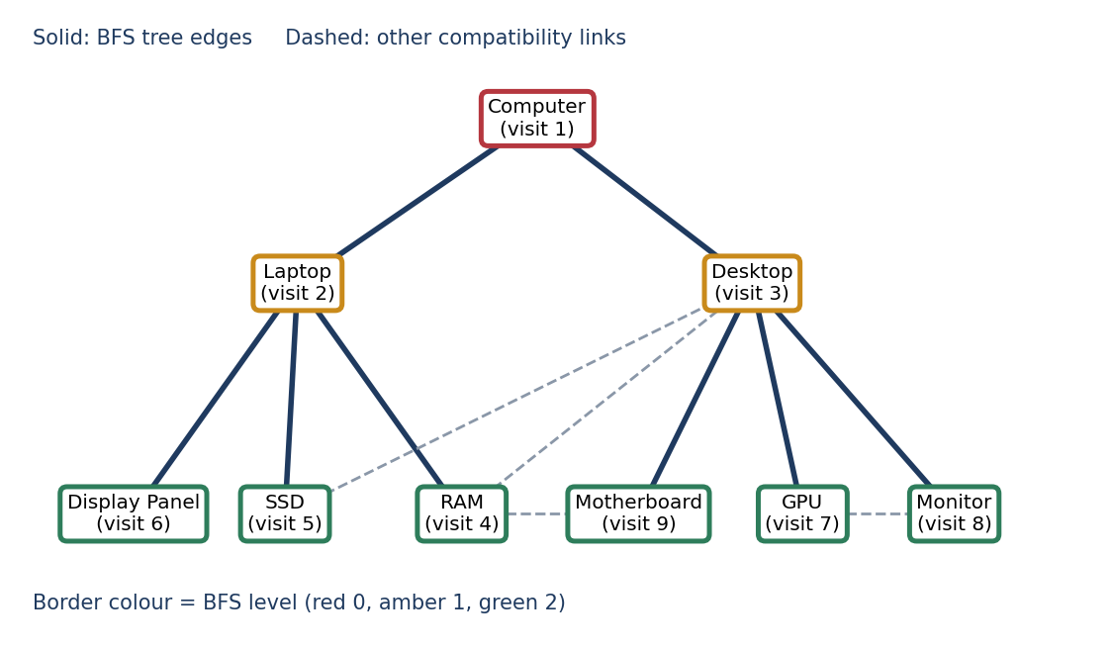
Figure 7.4 Component graph with the BFS tree from Computer
Result. Starting from Computer visits all nine components, with Laptop and Desktop first, followed by their parts. Starting from GPU gives a different order that begins with the components closest to it.

Operations and their cost
Table 7.4 Graph operations
Operation | Cost | Note
add node | O(1) | Creates an empty neighbour list if needed
add edge | O(1) | Duplicate edges are ignored
neighbours of a node | O(deg) | Reads one list
BFS from a start node | O(V + E) | Each node and edge handled once
Storage | O(V + E) | Adjacency list, suited to a sparse graph

The adjacency list was a sensible choice for this data. A matrix for nine nodes would be 81 cells with only 12 links set, so most of the storage would be empty. A list stores exactly what exists.

7.5 Phase 3: Binary search and merge sort
Design. Customers want to reorder the catalogue by price or name, and staff want to jump to a product by ID. Merge sort has a guaranteed O(n log n) cost and is stable, so products with equal prices keep their order. Binary search halves the sorted list on each probe, which reduces a lookup from n steps to about log n. Text search is different: a partial match on a name cannot use a sorted index, so a linear scan is the right tool there.
Implementation. merge_sort returns the sorted list and the number of comparisons it made. binary_search returns the product and a list recording the low, high and mid indices at each probe. The search endpoint sorts by ID first, so binary search always has sorted input.
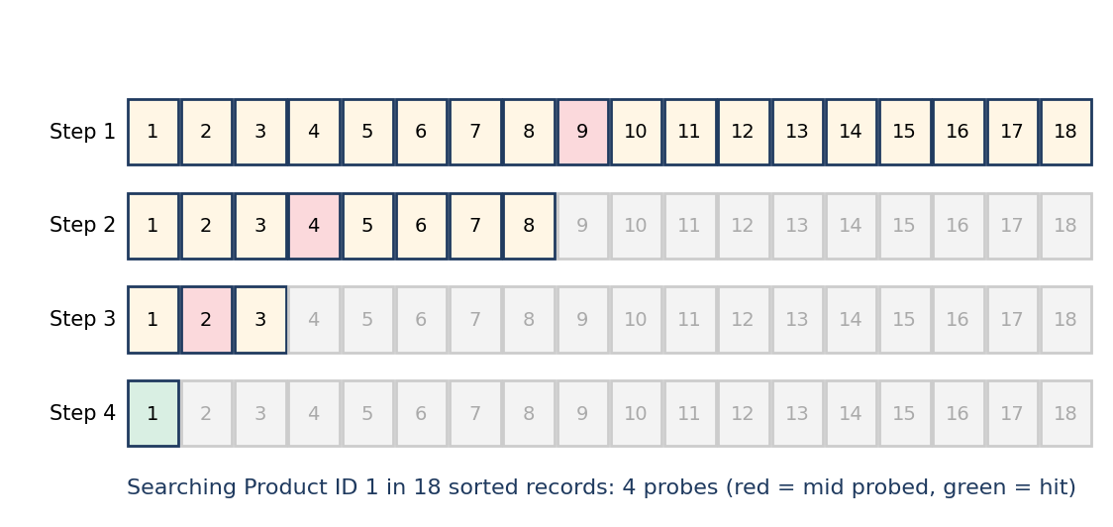
Figure 7.5 Four probes to find product ID 1 among 18 records
Result. Sorting the 18 products by price takes 53 comparisons, against 324 for a simple exchange sort. Searching for ID 14 takes two probes, ID 1 takes four and a missing ID ends after five. The graph below shows merge sort’s comparisons on larger random lists.
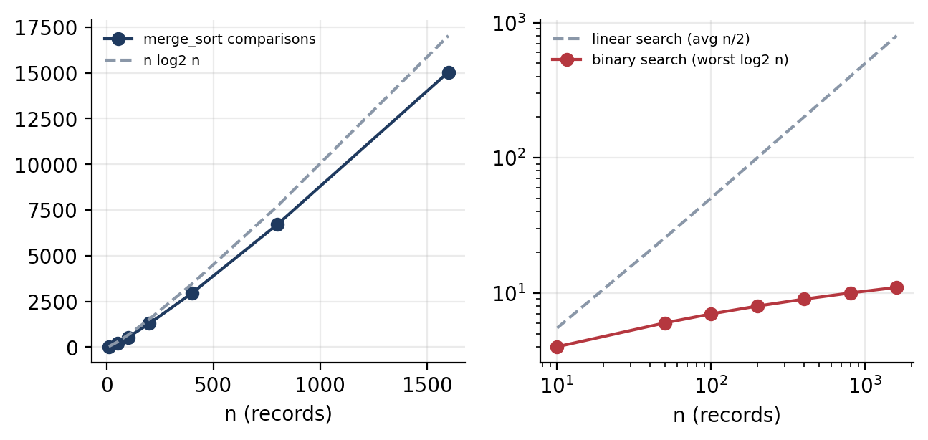
Figure 7.6 Merge sort comparisons against n log n (left), and search cost (right)

Comparing the search and sort methods
Table 7.5 Complexity of search and sort
Method | Best | Average or worst | Extra space | Precondition
Merge sort | O(n log n) | O(n log n) | O(n) | None
Binary search | O(1) | O(log n) | O(1) | Sorted on the search key
Linear search | O(1) | O(n) | O(1) | None

Merge sort was chosen over quicksort mainly for its guarantee. Quicksort is usually faster, but its worst case is O(n squared), and I preferred a method whose behaviour I could state without a caveat. The extra O(n) space is the price, and for a catalogue this size it does not matter.
Binary search needs sorted data, so the search endpoint sorts first. That makes each lookup O(n log n) overall, which is a real cost. Section 10 describes how a sorted copy kept up to date would remove it.
Figure 7.9 shows the splitting and merging steps for six prices, which is the easiest way to see why the cost is n log n. Each level of the split does a linear amount of merging, and there are log n levels.
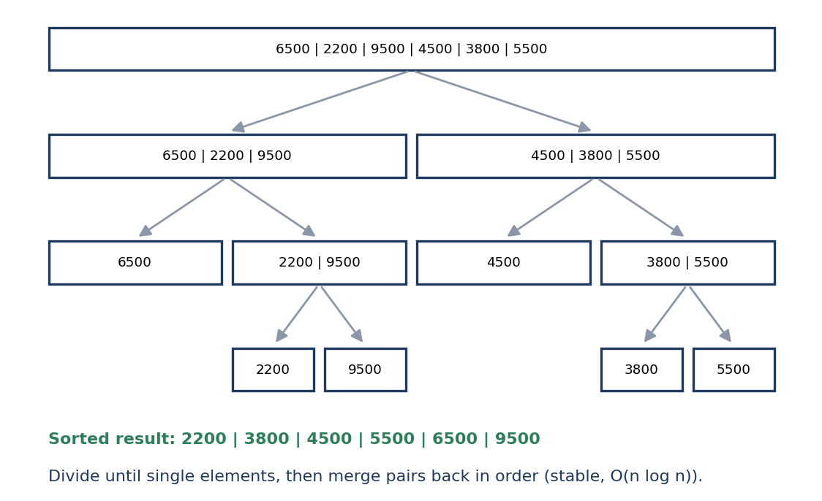
Figure 7.9 Merge sort splitting six prices and merging them back in order

7.6 Phase 4: Greedy budget recommender
Design. A customer with a set amount to spend wants to know what they can buy. The rule I chose is to consider parts from cheapest to most expensive and take each one that still fits the remaining money. This gives the largest number of parts for the budget. It is an exchange argument: swapping a cheap part for an expensive one never makes a selection better in terms of item count.
A note on what it optimises. Greedy maximises the number of items. It does not maximise performance. A performance-based choice would be a knapsack problem and would need dynamic programming, which is outside this project.
Implementation. greedy_budget_selection sorts the products by price and walks them once. Each part is accepted if it is in stock and its price is within the remaining budget. Every decision, accepted or rejected, is recorded with the reason.
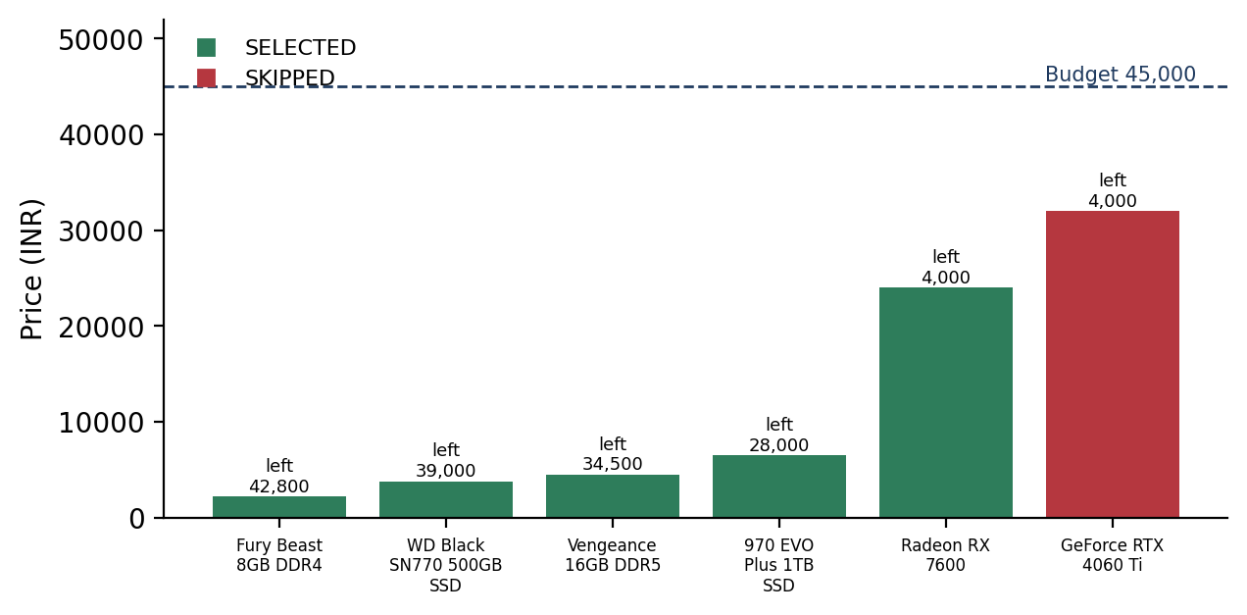
Figure 7.7 Greedy decisions for a 45,000 rupee budget
Result. With 45,000 rupees across RAM, SSD and GPU parts, five items were taken for 41,000. The RTX 4060 Ti at 32,000 was rejected because only 4,000 remained when it came up. With the full catalogue, budgets of 10,000, 50,000 and 120,000 rupees bought 3, 8 and 11 parts respectively.

Budget results on the full catalogue
Table 7.6 Greedy selection with three budgets
Budget (rupees) | Parts selected | Total spent | Left over
10,000 | 3 | 8,500 | 1,500
50,000 | 8 | 43,000 | 7,000
120,000 | 11 | 111,000 | 9,000

The numbers in the table show the behaviour I expected. Each budget spends most of its money, and the leftover is always smaller than the price of the next part that was skipped. The greedy result is not the best possible spend on performance, which is the boundary described in section 7.6.

7.7 Testing and verification
Testing ran at three levels. The data structures and the billing evaluator were checked with a console script, test_stack.py. The SQL behaviour and the sample data were checked by calling the project functions directly. The web endpoints were checked over HTTP against the running server. Table 7.7 lists the cases.
Table 7.7 Test cases and outcomes
No. | Test case | Expected | Result
1 | Sample invoice: 85,000 x 1, 4,500 x 2, 18 per cent tax, 1,000 discount | Final 109,920 in 15 steps | Pass
2 | Sort 18 products by price | Ascending order, 53 comparisons | Pass
3 | Binary search for id 14 | Found in 2 probes | Pass
4 | Binary search for id 25 | Not found after 5 probes | Pass
5 | BFS from Computer | All 9 nodes, 8 tree edges | Pass
6 | Greedy with a 10,000 budget | 3 parts, 8,500 spent | Pass
7 | Dequeue from an empty queue | Queue is empty, status 400 | Pass
8 | Customer calls an admin endpoint | 403 Forbidden | Pass
9 | Anonymous call to a sale endpoint | 401 Unauthorized | Pass
10 | Sale with quantity above stock | Refused, nothing written | Pass

Cases 1 to 6 were run by calling the project functions on the seed data. Cases 7 to 10 were run against the Flask application with its test client. Access control on every route is not fully tested, and section 10 says so. The table covers the cases that were actually run.

7.8 Summary of phase results
Table 7.8 collects the main result from each phase in one place, so the four phases can be compared at a glance.
Table 7.8 Results by phase
Phase | Structure or algorithm | Main result
1 | Array, linked list, queue, stack | 18 products loaded; sample bill 109,920 in 15 steps; queue order preserved
2 | Graph with BFS | Scan from Computer visits 9 nodes and 8 tree edges
3 | Binary search and merge sort | Id 14 found in 2 probes; price sort in 53 comparisons
4 | Greedy selection | 45,000 budget gives 5 parts for 41,000; 120,000 budget gives 11 parts

7.10 Front-end pages
The front end exists to make the structures visible. Each page is a thin layer over one or two endpoints, and the table below shows which endpoints each one calls and what it displays.
Table 7.10 Front-end pages and the endpoints they use
Page | Calls | What it shows
home.html | products | Storefront with featured products
products.html | products, sort, search | Catalogue with filters, sort and id lookup
sales.html | sales, billing | Linked sales chain, order form and stack trace
queue.html | queue, queue/serve | Waiting line and the next customer
components.html | components, components/bfs | Compatibility nodes and an animated BFS scan
recommendation.html | recommend | Budget slider, greedy result and manual builder
index.html | auth, stats | Login and the admin dashboard counters

The pages keep their own logic small. Most of the work happens on the server, and the page only draws what comes back. That split was deliberate, because it keeps the algorithms in one place where they can be tested without a browser.

7.9 Module summary
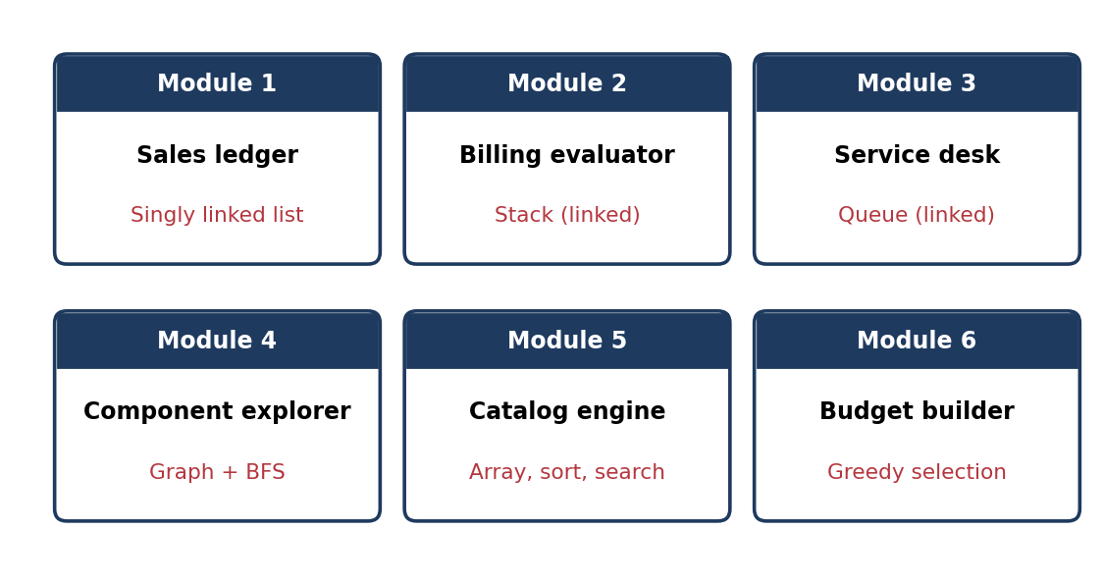
Figure 7.8 Modules and the structure behind each

8. Key Code
The full source is in the repository. Listings 8.1 to 8.4 are adapted from the core of the code for length. Names and structure match the repository, but some lines and comments are left out.
Listing 8.1 Inserting a sale at the head
class SalesLinkedList:
def __init__(self):
self.head = None
self.size = 0

def insert_at_head(self, sale_data):
node = SaleNode(sale_data)
node.next = self.head
self.head = node
self.size += 1

Listing 8.2 Merge sort with a comparison counter (adapted)
def merge_sort(products, key='id', reverse=False):
comparisons = [0]
def merge_sort_rec(items):
if len(items) <= 1:
return items
mid = len(items) // 2
left = merge_sort_rec(items[:mid])
right = merge_sort_rec(items[mid:])
merged, i, j = [], 0, 0
while i < len(left) and j < len(right):
comparisons[0] += 1
if left[i][key] <= right[j][key]:
merged.append(left[i]); i += 1
else:
merged.append(right[j]); j += 1
merged.extend(left[i:]); merged.extend(right[j:])
return merged
return merge_sort_rec(list(products)), comparisons[0]

Listing 8.3 Greedy selection (simplified)
def greedy_budget_selection(products, budget):
selected, remaining = [], budget
for p in sorted(products, key=lambda x: x['price']):
if p['stock'] > 0 and p['price'] <= remaining:
selected.append(p)
remaining -= p['price']
return selected, budget - remaining

Listing 8.4 The search endpoint (adapted)
@app.route('/api/products/search')
def search_product():
sorted_products, _ = merge_sort(product_array.to_list(), key='id')
target = int(request.args.get('id'))
result, steps = binary_search(sorted_products, target)
return jsonify({'found': result is not None, 'product': result, 'trace': steps})

8.5 Remaining listings
The next two listings show the sale recording path and the schema for the sales tables. They are the parts of the code that touch the most structures at once.
Listing 8.5 Sales tables (adapted)
CREATE TABLE IF NOT EXISTS sales (
id INTEGER PRIMARY KEY AUTOINCREMENT,
customer_id INTEGER REFERENCES customers(id),
total REAL NOT NULL,
date TEXT NOT NULL
);
CREATE TABLE IF NOT EXISTS sale_items (
id INTEGER PRIMARY KEY AUTOINCREMENT,
sale_id INTEGER REFERENCES sales(id),
product_id INTEGER REFERENCES products(id),
quantity INTEGER NOT NULL,
price REAL NOT NULL
);

Listing 8.6 Recording a sale (simplified)
def record_sale(items, customer_id, tax_rate, discount):
for item in items:
product = product_array.find_by_id(item['product_id'])
if product is None or product['stock'] < item['quantity']:
return error_response('Insufficient stock', 400)
result = evaluate_billing_expression(items, tax_rate, discount)
sale_id = db.insert_sale(customer_id, result['final_total'], items)
sales_list.insert_at_head(build_sale_record(sale_id, result))
return success_response(sale_id, result)

8.6 Session check
The session check below runs before every request. It is short, but it carries the idle and absolute timeouts described in section 6.2.
Listing 8.7 Idle and absolute session timeouts (adapted)
@app.before_request
def check_session_timeout():
if 'user_id' not in session:
return
now = datetime.utcnow().timestamp()
idle = now - session.get('last_active', now)
age = now - session.get('created_at', now)
if idle > SESSION_IDLE_TIMEOUT or age > SESSION_ABSOLUTE_LIFETIME:
session.clear()
return
session['last_active'] = now

9. Features
- Catalogue: filter by category, search by name or brand, sort by price or name, and look up by ID.
- Sales: multi-item sales with stock checks, a ledger with newest first, and a stored trace for each bill.
- Service desk: add a ticket, see who is next, and serve the front customer.
- Component explorer: the compatibility graph, plus an animated BFS scan from any component.
- Budget builder: a greedy recommendation with the reason for every decision, and a manual builder.
- Accounts: registration, login, logout, role-based access and session timeouts.

9.1 Comparison with a paper register
The clearest way to show what the system adds is to set each shop task against how it was done before. Table 9.1 does that.
Table 9.1 Paper register compared with PC Point
Shop task | Register or spreadsheet | PC Point
Find a product by id | Read down the list | Binary search, at most 5 probes for 18 products
Order products by price | Rewrite the list by hand | Merge sort in one request
See the latest sales | Turn to the last page | Sales list with the newest at the head
Check how a bill was worked out | Recalculate on a calculator | Stored step log for each sale
Serve customers in order | Depends on memory | Queue enforces arrival order
Suggest parts for a budget | Judgement at the counter | Greedy rule with reasons shown

9.2 Features in more detail
The list in section 9 is short on purpose. This section explains what each feature does for the person using it, because the same feature can look very different to a customer and to the person running the shop.
Catalogue. A visitor can filter by category, search by name or brand, and sort by price or name. A search by product id uses binary search and shows the probes, so a visitor can see how the answer was reached. The page is built to make the structure visible rather than hide it.
Sales and billing. A shop assistant adds several items to a sale and the system checks stock for each one. The bill is then calculated on the stack. The ledger keeps every sale with its trace, so a disputed amount can be checked without redoing the sum by hand.
Service desk. The queue page shows the next customer clearly, and the add and serve actions update the line immediately. Because the order is fixed by arrival, a customer can see their place without asking anyone.
Component explorer. The compatibility graph is drawn as a set of nodes and links, and the breadth-first scan animates the order of visits. This makes it easy to see which parts sit close to a given component.
Budget builder. A visitor sets a budget and receives a list of parts chosen by the greedy rule, with a reason for every part that was taken or skipped. A manual builder also lets the visitor assemble a machine one slot at a time and see the running total.

9.3 Usability notes
The interface is deliberately plain, with one page per task and results shown in words as well as numbers. I did not run a formal usability study, though. The pages were checked by using them with the seed data, and no outside user was asked to try them. This is recorded as a gap in section 10, and a proper study with a few shop staff would be the first thing to add if the project continued.

10. Limitations and Future Work
Testing showed several things I want to fix. The most important is access control. Admin routes use a role decorator, but I have not audited every route to confirm each one has it. Other points:
- Stock after multi-item sales. The in-memory stock can disagree with the database after a sale with more than one line, until the server restarts. The fix is to compute each line’s new stock from its own product.
- Edge labels on the component page. The BFS edges come back as objects with from and to fields, but the front end reads them as pairs, so the labels show undefined. Reading the named fields fixes it.
- Plain-text passwords. Passwords are stored and compared as plain text, which is fine for a classroom prototype but not for real users. They should be hashed.
- Secret key and debug mode. The session key is written in the source and debug mode is on. Both should come from the environment.
- Search re-sorts every time. Each ID lookup sorts the whole catalogue first. Keeping a sorted copy up to date would remove that cost.
- Queue and graph are not persisted. The queue starts empty after each restart, and the graph is built from code.
- Undo is not implemented. Adding it would need a stack of reversible actions, separate from the billing stack.
- No automated tests beyond a console script. test_stack.py checks the stack and billing directly. Endpoint tests are still needed.

10.1 Challenges during development
Most of the difficulties were not in the algorithms, which are well documented. They came from making the pieces agree with one another.
Keeping two copies in step. The structures live in memory and the rows live in SQLite, and the two have to agree. I settled on writing to the database first and then updating the structure. Testing still caught a stock mismatch after multi-item sales, which is the defect in section 10.
Binary search needs order. Searching by id is only correct on sorted data, so every lookup sorts first. That works, but it makes the request more expensive than the search alone, and it was the cost I most wanted to avoid.
Making the output explain itself. It would have been easy to return only the answer. I chose to return the trace as well, which meant every algorithm had to keep a record of its steps. That added code, but it made wrong results far easier to find.
Session safety on a shared machine. Idle timeouts, role checks and stopping the Back button from reopening a dashboard after logout each took more care than expected. Cache headers turned out to matter as much as the login check itself.

10.3 Limitations by module
Each module has its own weak point. Table 10.1 lists them so that the limitations are easy to find in one place.
Table 10.1 Limitations by module
Module | Limitation | Possible fix
Product array | Delete rebuilds the list, O(n) | Index by id in a dictionary alongside the list
Sales list | Finding an old sale is a full walk | Keep a second index by sale id
Queue | Empty after every restart | Store waiting tickets in SQLite
Billing stack | Used only for billing, not undo | Separate stack of reversible actions for undo
Component graph | Built from code, not from data | Load links from a table
Binary search | Sorts on every request | Keep a sorted copy updated on insert and delete
Greedy selection | Maximises item count, not value | Knapsack with dynamic programming

11. Conclusion
PC Point started from a set of course topics and ended up as a shop application where each topic has a job to do. The array holds the catalogue. The linked list keeps sales with the newest first. The stack evaluates each bill and leaves a trail that explains the total. The queue keeps the service desk fair. The graph shows how parts relate, and breadth-first search lists the nearest ones first. Merge sort and binary search make the catalogue orderable and searchable, and the greedy rule gives a budget answer that can be checked.
The most useful habit was to make every algorithm return its own trace. It added some code, but a sort that reports 53 comparisons or a bill that shows fifteen stack steps can be checked by eye, and a wrong trace points straight at the faulty step. The limitations in section 10 are the normal gap between a working prototype and a system that can be deployed. None of them changes the main result: the structures work together inside a real web application, backed by a database that persists across restarts.

References
- Cormen, T. H., Leiserson, C. E., Rivest, R. L., & Stein, C. Introduction to Algorithms. MIT Press.
- Sedgewick, R., & Wayne, K. Algorithms (4th ed.). Addison-Wesley.
- Python Software Foundation. Python Documentation. https://docs.python.org
- Pallets Projects. Flask Documentation. https://flask.palletsprojects.com
- SQLite Consortium. SQLite Documentation. https://www.sqlite.org/docs.html

Appendix A. Glossary
Table A.1 Terms used in this report
Term | Meaning in this report
Array | A fixed-order collection with direct access by position, used for the product catalogue
Linked list | A chain of nodes, each pointing to the next, used for the sales history
Stack | A last-in, first-out structure, used for evaluating each bill
Queue | A first-in, first-out structure, used for the customer service line
Graph | Nodes joined by edges, used for component compatibility
BFS | Breadth-first search: visits neighbours level by level
Binary search | Halves a sorted list at each step to find a value
Merge sort | Sorts by splitting, sorting the halves and merging them
Greedy algorithm | Makes the locally best choice at each step
Probe | One comparison made by binary search, recorded in its trace
Trace | The recorded steps an algorithm took, shown on screen

Appendix B. Requirements Checklist
Table B.1 Requirements and their status
Requirement from the synopsis | Status
Store products in an array with direct access | Met
Keep sales in a linked list | Met
Serve customers first in, first out | Met
Evaluate bills with a stack | Met
Show component relationships as a graph and traverse with BFS | Met
Search products by id with binary search | Met
Sort products by price or name with merge sort | Met
Recommend parts for a budget with a greedy algorithm | Met
Keep data across restarts | Met, for products, sales and users
Undo the last operation | Not met, planned for later
Access control enforced on the server for every route | Met on the routes checked; full audit not done
Formal usability testing | Not met

