# High Impact Skills Development Program

# AI & Data Science

**Lab 01: Installation and setup of Anaconda and Jupyter Notebook**

**Lab 01**

**Step 1:** Go to the link below:

[**https://www.anaconda.com/download/**](https://www.anaconda.com/download/)

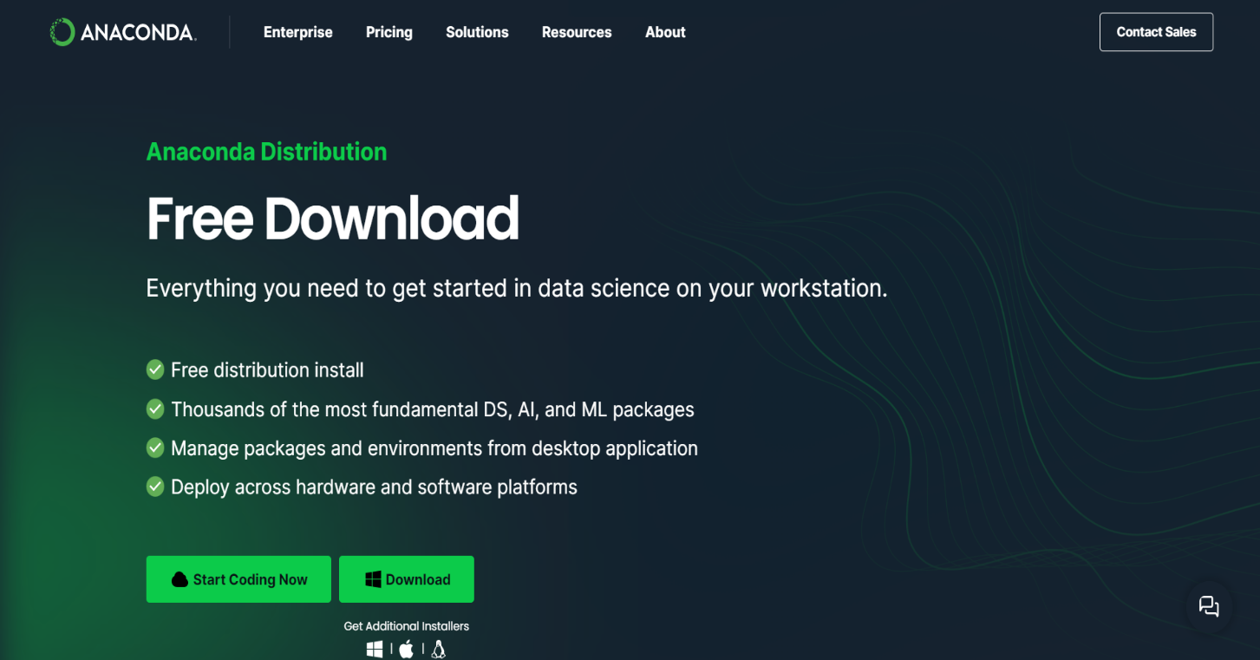

**Step 2:** Click **Download** and wait for downloading to be completed.

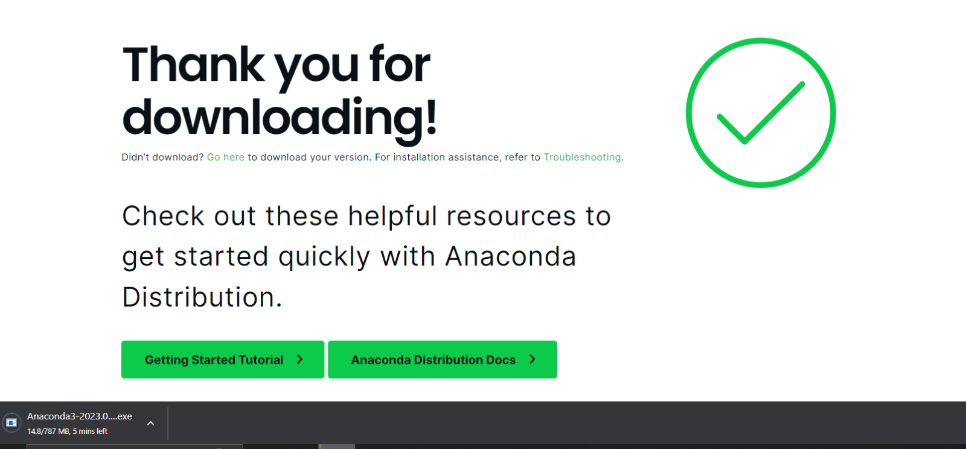

**Step 3:** Click on **exe** and wait until a pop-up shows.

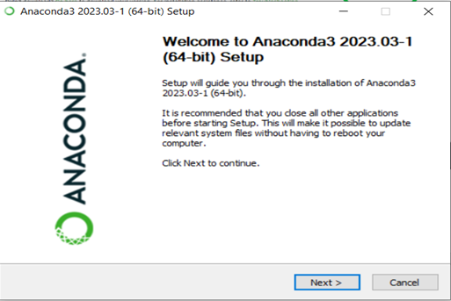

**Step 4:** Click **Next,** then select **I Agree**.

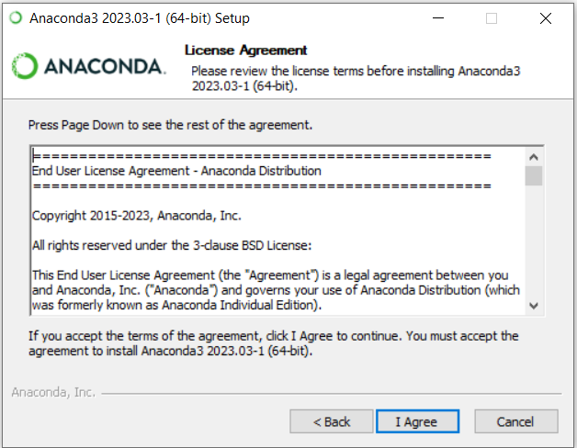

**Step 5:** Select **Just Me** option and thenClick **Next**.

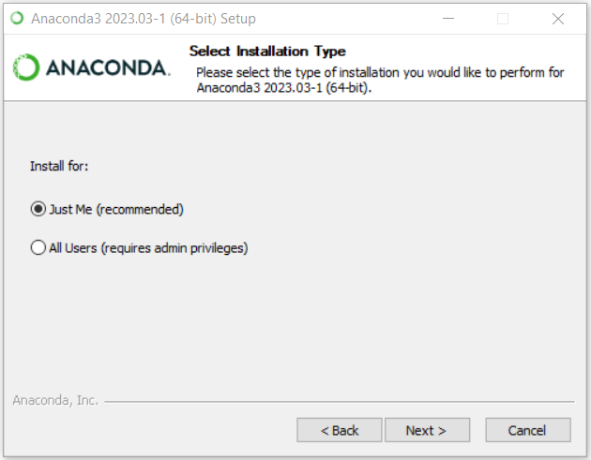

**Step 6:** Select **Installing Directory**.Make sure **C drive** has extra space for future installations. If **C drive** has low space, browse and select another directory. Click **Next**.

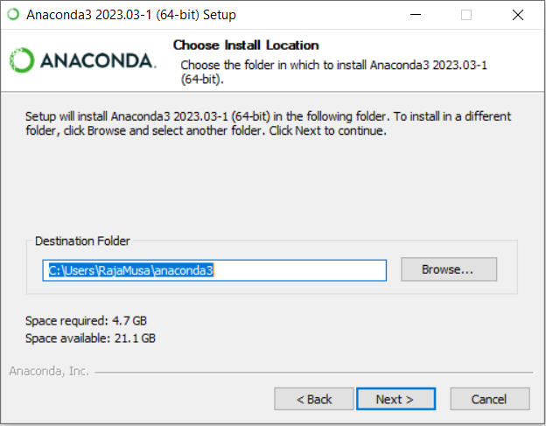

**Step 7:** Do not change anything. just select **Install**.

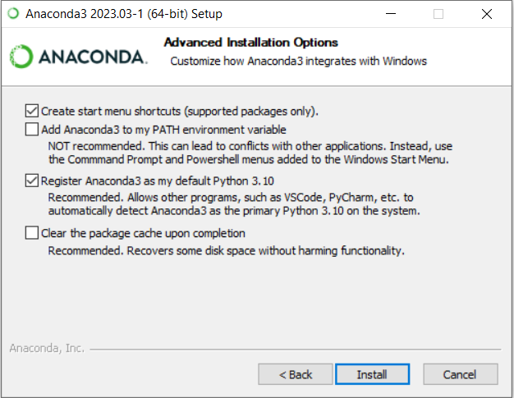

**Step 8:** Wait for **Installation** to end. Click **Next** once completed.

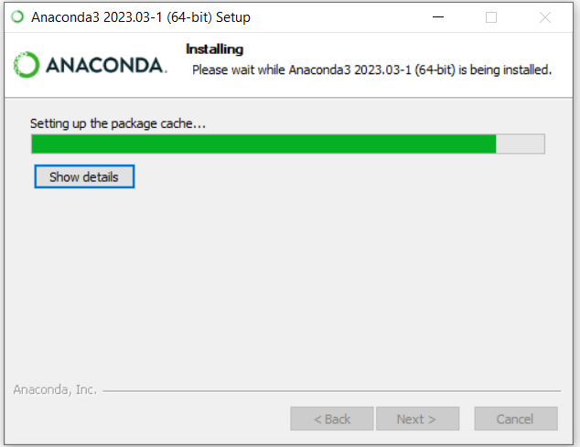

**Step 9:** Click **Next**.

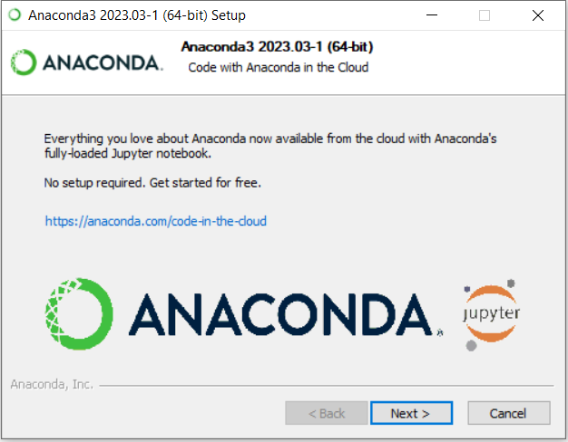

**Step 10:** Click **Finish**.

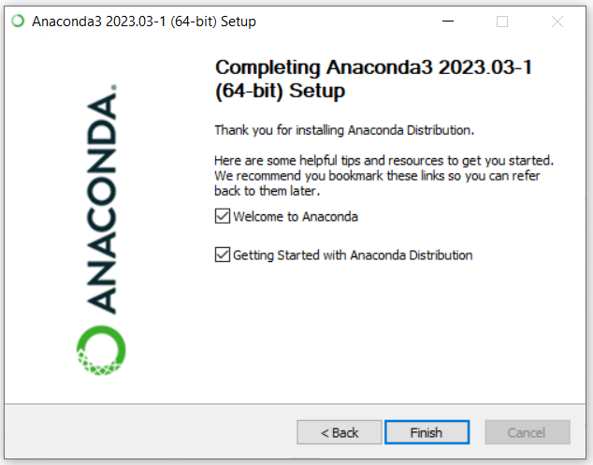

**Step 11:** Check the location of anaconda in **C drive** where it is installed**.**

**C:\Users\RajaMusa\anaconda3**

**Step 12:** Once **installation** is completed, go to the windows search bar and look for **Anaconda Navigator App**. Run the app. Wait for this screen to show up.

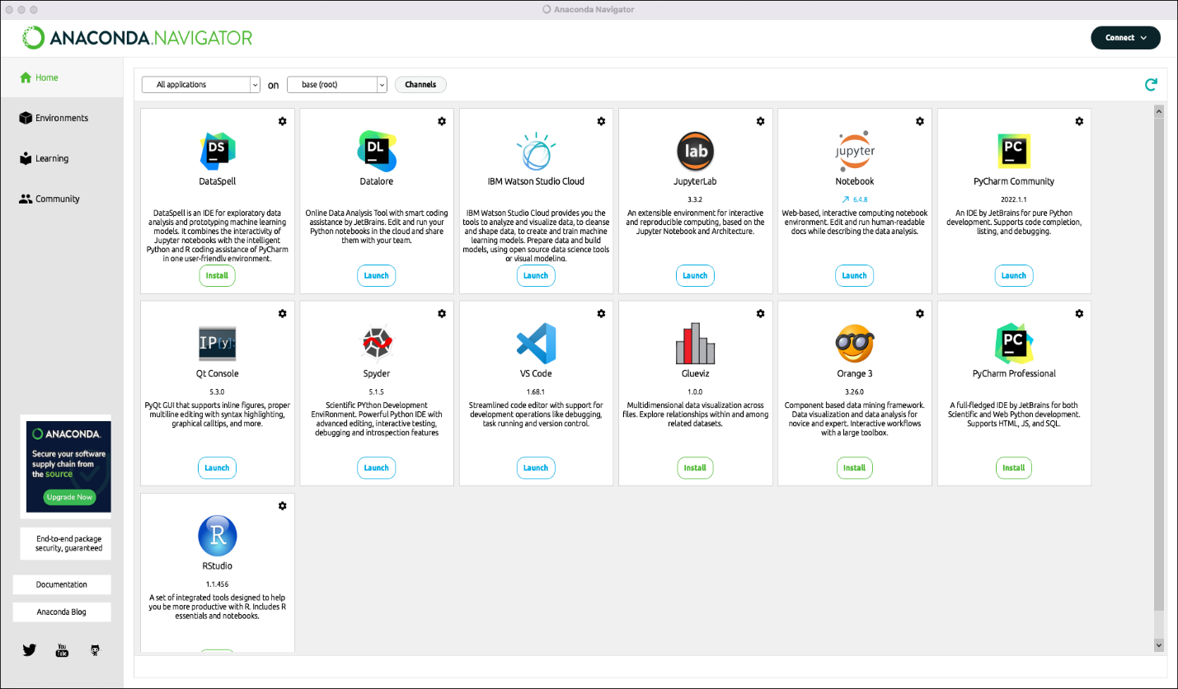

**Step 13:** On the screen shown above, launch **Jupyter Notebook** andwait for a tab in your browser to open.

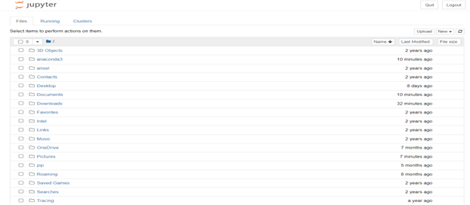

**Step 14:** Your jupyter notebook will look like this.

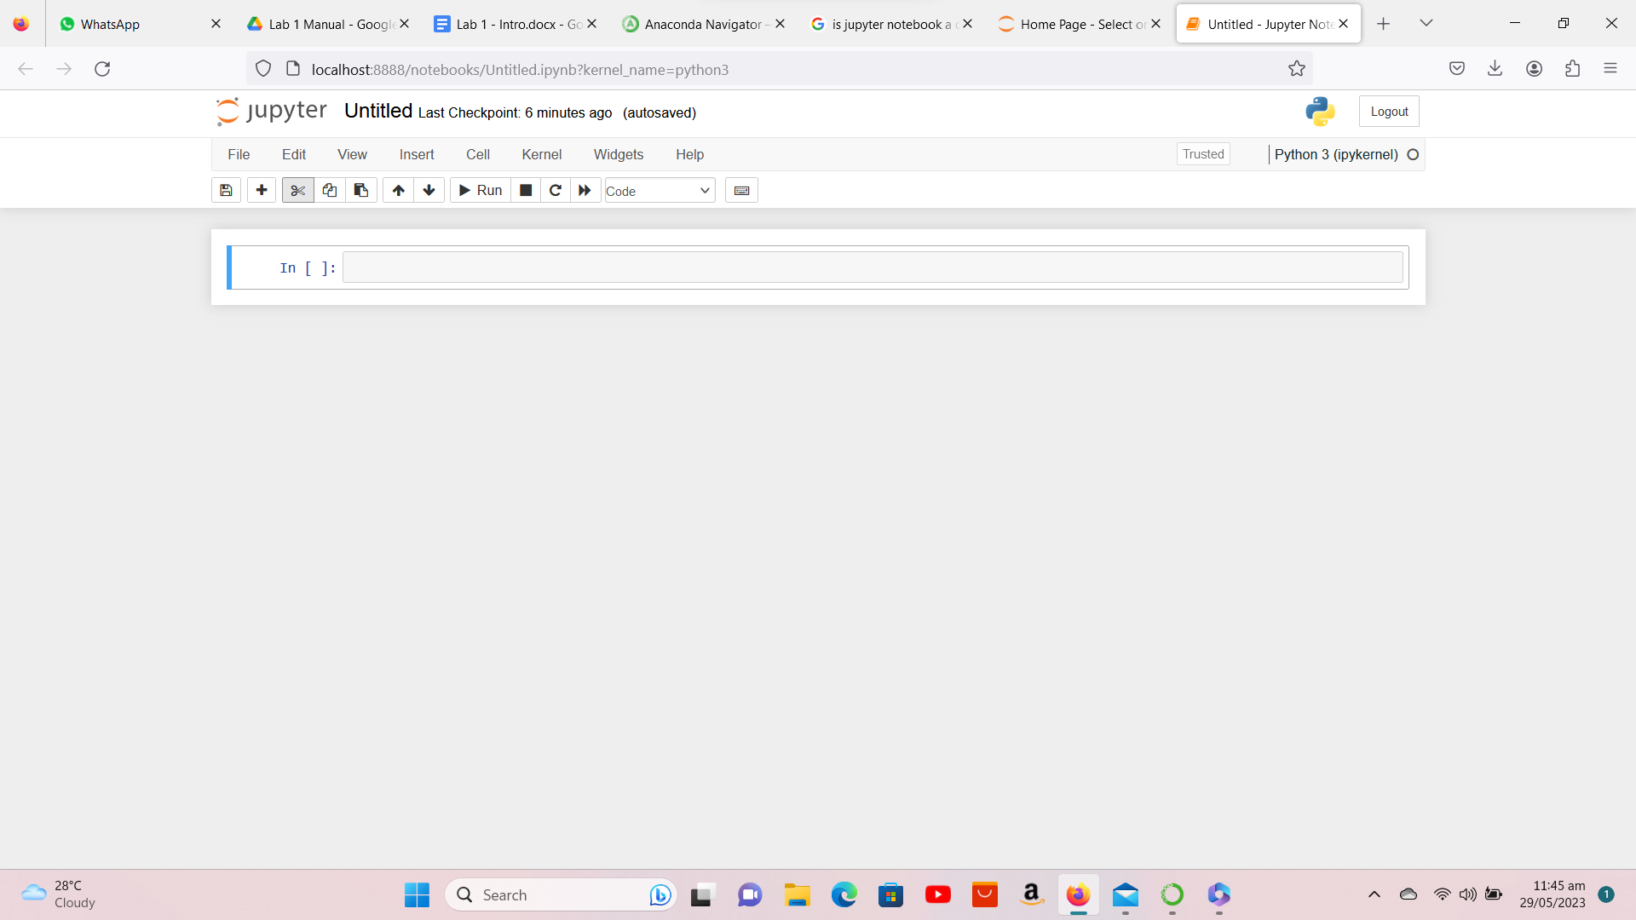

#### Lab Tasks:

1. Write a program in jupyter notebook, that prints on screen the message Hello, World.
2. Using the program in (1), what happens if we remove the closing quotation around the text Hello, World?
3. Using the program in (1), what happens if we remove both the quotations around the text Hello, World? How is it different from the behavior in (2)
4. Write a program using the print() command that produces the following output:

**\***

**\*\***

**\*\*\***

**\*\*\*\***

**\*\*\*\*\***