

USER MANUAL



mADE BY: TANISH dHIR, Arjan dangol, jamil deris

Table of Contents

**Important Information2**

**What User Can Do Using The Tool3-7**

SEARCH ROOMS IN A SUBURB IN A TIME FRAME3

VIEW PRICECHART BASED ON DATE RANGE…………………………………………………………………………………4

SHOW REVIEWS OF A PARTICULAR ROOM………………………………………………………………………………….5

SHOW ROOMUSAGE DETAILS…………………………………………………………………………………………………6

SHOW USER SPECIFIC ROOMS…………………………………………………………………………………………………7

**USER MANUAL FOR SYDNEY AIRBNB DATASET ANALYSIS TOOL**

**IMPORTANT INFORMATION**

This user manual is for new users of the application. This application is designed to give users option to search dataset which contains information about Airbnb rooms available for use in Sydney. Following terms are used in buttons and headings which users should be aware of while using the application:

* Listings: Button created to go to search rooms listed in a suburb.
* PriceChart: Button created to make a price chart of rooms.
* Reviews: Button created to show review of a room.
* RoomUsage: Button created to show number of times a room has been used.
* UserSpecific: Button created to show rooms specified by user.
* ChoiceBox: This box has list of choices with names of cities in it. User can select one from there.
* DatePicker: There are two date pickers, one with from label indicates start of date range and other with to label indicates end of date range. Currently the tool is restricted from 7 December 2018 to 6 December 2019.
* Search: Button created to allow user to search with the input they entered.
* KeywordBox: There is an input box on user specific page where user can enter their specific keywords which will filter the data based on what user enters.
* CreateChart: Button created which will generate a price chart based on user input.

**WHAT USER CAN DO USING THE TOOL**

Activities user can perform using the application:

* SEARCH ROOMS IN A SUBURB IN A TIME FRAME:

1. Press the Listings button as shown in figure1.1. It will take you to listings page if you are on any other page. If you are on listings page nothing will happen.

Figure1.1 ListingsPage

1. Select a Suburb and date range from the given date pickers can be any date from 7 December 2018 to 6 December 2019 and choice box as shown in figure1.2.

Figure1.2

1. Then, user clicks search button, the tool will create a table of rooms as shown in Figure1.3.

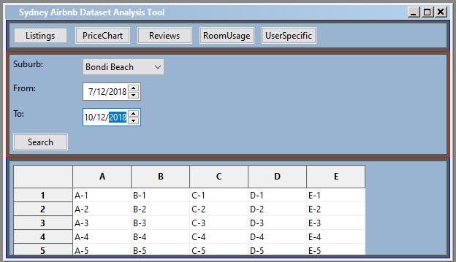

Figure1.3

* VIEW PRICECHART BASED ON DATE RANGE

1. Press PriceChart button as shown in figure2.1. If user is on any other page, it will take them to price chart page but if they are already on the page nothing will happen.

Figure2.1

1. User needs to choose date range in date pickers. They can choose any date from 7 December 2018 to 6 December 2019 as shown in Figure2.2.

Figure2.2

1. Then user clicks on CreateChart button as shown in Figure2.3, a chart is generated displaying the price range of rooms in all suburbs.

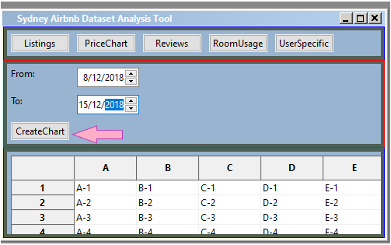

Figure2.3

* SHOW REVIEWS OF A PARTICULAR ROOM

1. Press Reviews button as shown in Figure3.1. If user is on another page, it will take user to review page, if user is on review page nothing will happen.

Figure3.1

1. User needs to select a suburb, a date range from 7 December 2018 to 6 December 2019 as shown in Figure3.2.

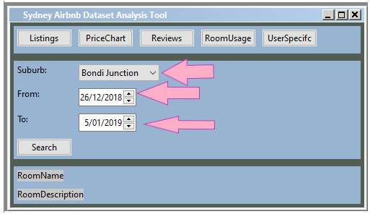

Figure3.2

1. User press the search button, it shows names of rooms with their reviews as shown in Figure3.3.

Figrue3.3

* SHOW ROOMUSAGE DETAILS

1. Press RoomUsage button as shown in Figure4.1. If user is on another page, it will take user to RoomUsage page, if user is on RoomUsage page nothing will happen.

Figure4.1

1. User needs to select a suburb, a date range from 7 December 2018 to 6 December 2019 as shown in Figure4.2.

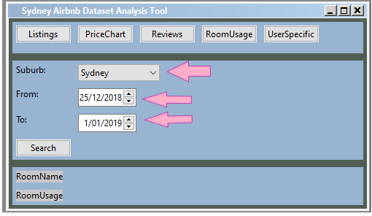

Figure4.2

1. User clicks on search button which shows names of rooms with their roomusage as shown in figure4.3.

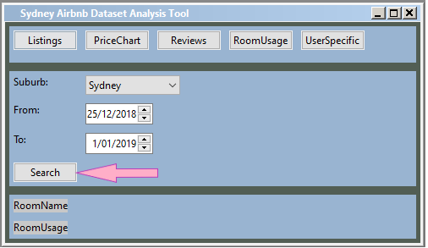

Figure4.3

* SHOW USER SPECIFIC ROOMS

1. Press UserSpecific button as shown in Figure5.1. If user is on another page, it will take user to UserSpecific page, if user is on UserSpecific page nothing will happen.

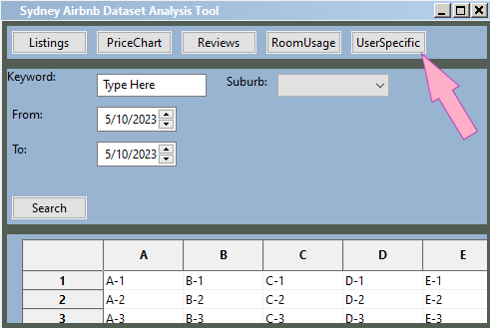

Figure 5.1

1. User needs to type a keyword like pool, spa and other words related to user’s requirements. User select a suburb, a date range from 7 December 2018 to 6 December 2019 as shown in Figure5.2.

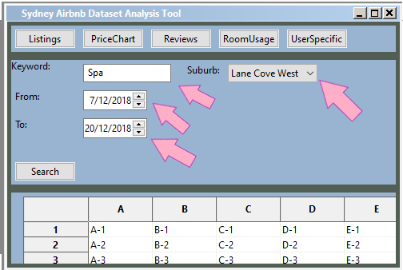

Figure5.2

1. User needs to click search, the application will show output in form of table which will list rooms with user entered keywords as shown in Figure5.3.

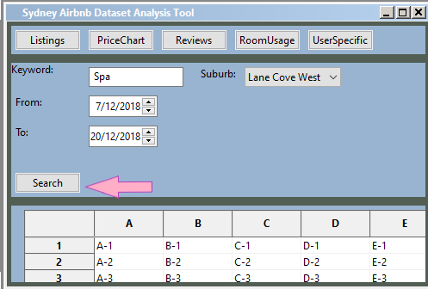

Figure5.3