Taylor Bergeron and Arjan Gupta

Week 4 Dynamic Programming Exercise

Results

Deterministic

Policy Iteration

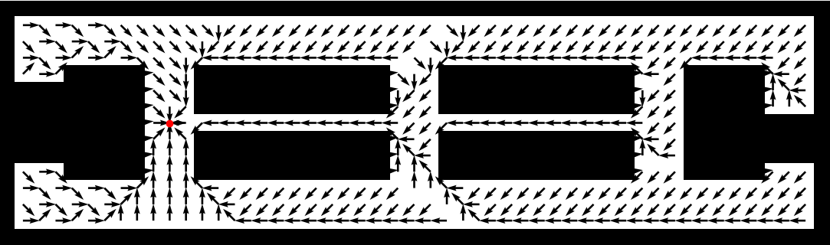
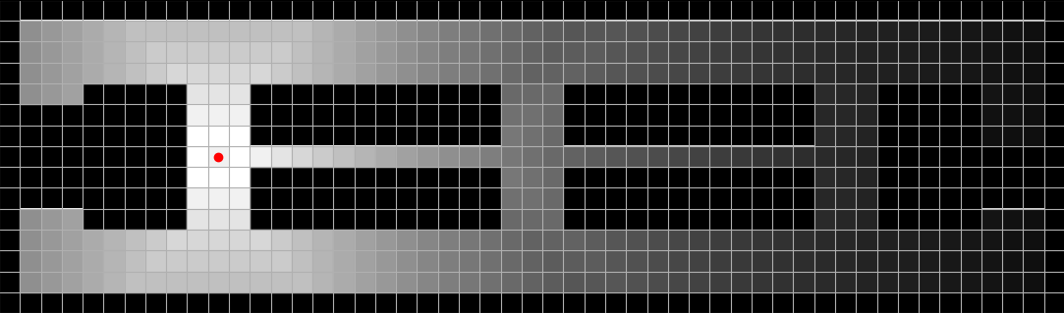

Run time: 0.56 seconds

Value Iteration



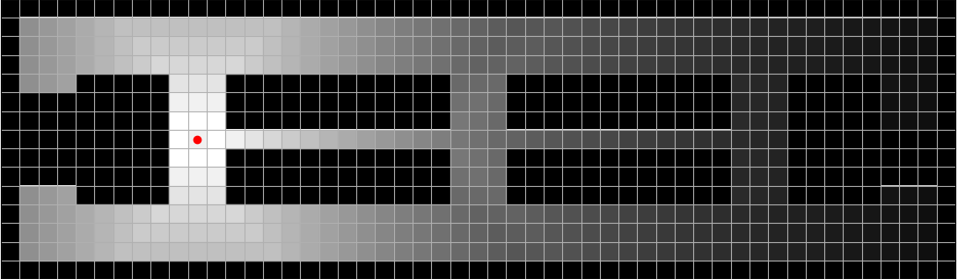

Run time: 0.88 seconds

Generalized Policy Iteration


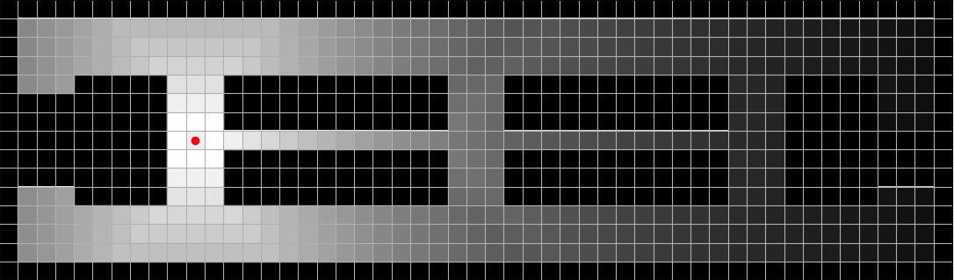

Run time: 0.29 seconds

Stochastic

Policy Iteration

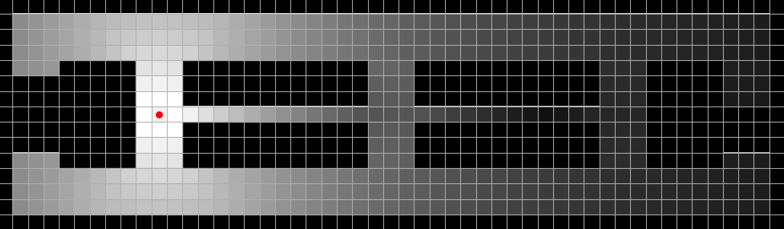

Run time: 1.63 seconds

Value Iteration


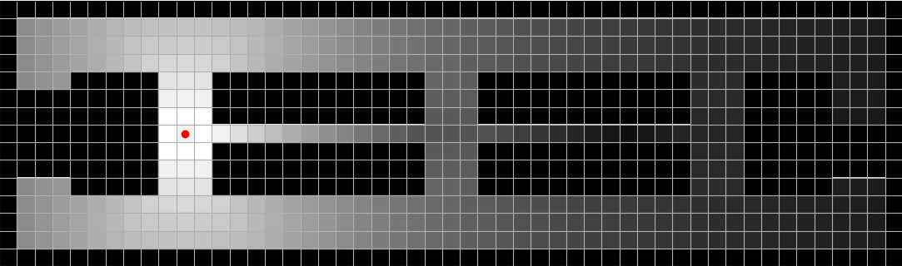
Run time: 1.71 seconds

Generalized Policy Iteration


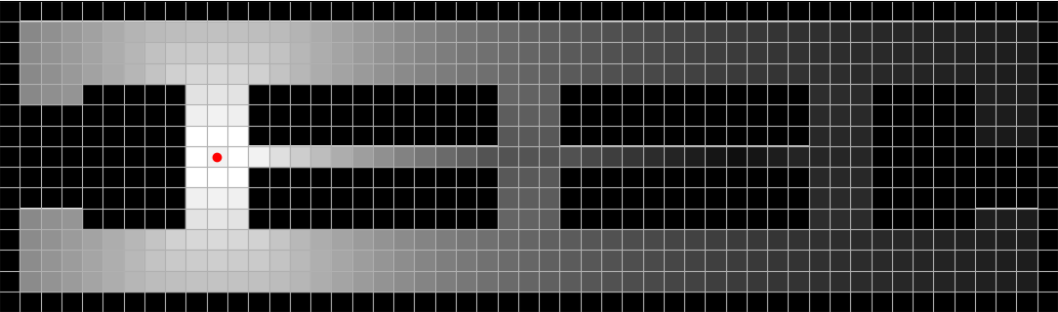
Run time: 0.84 seconds

Discussion of Results

Our plots closely match the plots provided:
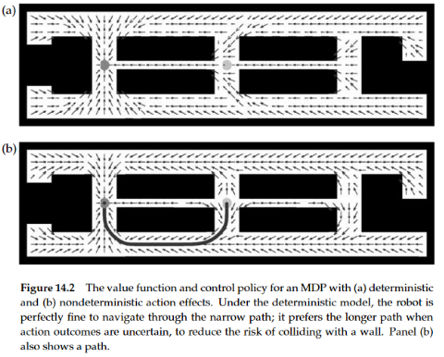

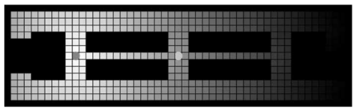

Our value plots are identical to the provided plots.
Our policy plots are nearly the same. Our stochastic plots are identical, but our deterministic plots vary slightly. Our deterministic model avoids the outer wall more than in the provided plot. For example, in the topmost long corridor, we have two rows of “down and to the right” preferred action, rather than one in the image provided. However, our deterministic and stochastic relationship is the same as in the assignment. The deterministic model the robot prefers traveling through the narrow center passageway, since actions are guaranteed; however, in the stochastic model, the robot avoids the narrow passageway, as there is a 20% chance it will run into the wall and get penalized. Because the overall behavior of our deterministic policy matches that of the assignment, and all the policies make logical sense, the slight differences in preferred actions could result from slight differences in implementation.

As for timing, we found that in general, the stochastic model of the robot took longer to run as compared to the deterministic model. This makes sense since more actions are being considered in the stochastic model, even though their probability is lower. However, regardless of the model, the Generalized Policy Iteration algorithm ran the fastest. In second place was Policy Iteration, and Value Iteration was the slowest.

