University of Wollongong
Singapore Institute of Management
Bachelor of Computer Science
CSIT321 - Final Year Project

CSIT-26-S3-18: Develop a Chatbot for Book and Video Recommendation for Kids
FYP-26-S3-18: Project Requirement Documentation

Supervisor: | TBD -- to be confirmed with course coordinator
Project Website: | TBD

Team:
Name | UOW ID | Email | Role
Arjan Singh Bhasin | 8941877 | asb479@uowmail.edu.au / arjan-related SIM email (TBD) | Project Manager
Desmond Won Thiang Feng | TBD | TBD | Technical Writing
Lee Jihyeon | TBD | TBD | Research
Kiefer Russell Sulijanto | TBD | TBD | Programming
Tan Kian Hong | TBD | TBD | Testing

Revision History:
Revision Number | Revision Date | Revised By | Remarks
FYP-26-S3-18-PRD-R0 | 16 Jul 2026 | Team | Initial Release

Table of Contents
Table of Contents 2
1. Introduction 4
1.1 Overview 4
1.2 Project Scope 4
1.3 Research Finding Analysis 4
Comparable Products in the Market 4
Product Comparison 5
1.4 Project Description 6
1.5 Business Model 6
Key Partners 6
Key Activities 6
Key Resources 7
Value Propositions 7
Customer Relationships 7
Customer Segments 7
Channels 7
Cost Structure 8
Revenue Streams 8
2. Project Motivation 8
3. Functional Requirements 9
3.1 Functional Hierarchy 9
Consolidated View (All Actors) 10
Unregistered Visitor (zoomed in) 11
Parent / Guardian (zoomed in) 12
Child Profile (zoomed in) 13
Content Moderator (zoomed in) 13
System Admin (zoomed in) 14
3.2 Preliminary Use Case Diagram(s) 14
Unregistered Visitor 14
Parent / Guardian 15
Child Profile 18
Content Moderator 19
System Admin 20
3.3 Preliminary Use Case Descriptions 20
Unregistered Visitor 20
Parent / Guardian 23
Child Profile 33
Content Moderator 38
System Admin 42
3.4 Non-Functional Requirements 45
3.5 Other Requirements 46
4. Proposed Plan 46
4.1 Execution Strategy 46
4.2 Software Development Methodology 47
Waterfall 47
Scrum 47
Methodology Chosen: Scrum 48
4.3 Risk Analysis 48
4.4 Proposed Duration & Schedule 50
4.5 Roles and Responsibilities 50
5. Development Tools 51
6. Expected Results 52
7. Conclusion 53
8. References 53

1. Introduction

1.1 Overview
In today's digital-first world, children are growing up with constant access to books, videos, and online content — but parents are often left navigating this landscape largely on their own, without reliable tools to help them find content that's genuinely appropriate for their child's age and interests. Existing platforms tend to solve only part of this problem: some offer curated libraries but no real personalization, others personalize aggressively but optimize for engagement rather than safety, and few offer parents any meaningful visibility into what their child is actually engaging with. This creates a persistent tension for parents between convenience, safety, and relevance — a tension this project aims to resolve.

1.2 Project Scope
This project aims to develop a chatbot application that helps parents and children discover age-appropriate books and videos through natural, conversational interaction. The system will:
- Accept natural-language queries from a child (via a linked profile) and generate personalized book and video recommendations
- Maintain a curated, pre-vetted content database spanning both books and videos, rather than pulling from open, unfiltered sources
- Allow parents to create and manage linked child profiles, view activity/recommendation history, and adjust age-band settings
- Explain the reasoning behind each recommendation, rather than returning results with no context
The application will be developed for mobile and web platforms. Out of scope for this phase: full multi-language support, in-app purchases beyond the subscription model, and image-recognition-based features.

1.3 Research Finding Analysis

Comparable Products in the Market
- Epic!: Books + videos, 40,000+ titles, personalized profiles (up to 4), age-based auto-filter refined by Lexile/AR reading levels. Browse-based, not conversational. Subscription ~$12/month.
- YouTube Kids: Video only. Three age tiers (Preschool/Younger/Older) with a three-layer content filter (automated + human + user reports). Weakness: optimizes for watch time, not safety; algorithmic drift toward autoplay can still surface borderline content.
- Common Sense Media: Not a recommender — a rating/reference layer. Dual scoring (age-appropriateness + quality) by trained reviewers. No conversational interface, no child-facing accounts.
- Amazon Kids+: Books + video + games + apps in one subscription. Adjustable age-filter bands per child, parent dashboard shows activity. Strongest structural comparable, but not conversational.
- PinwheelGPT: General-knowledge kids' chatbot (ages 7–12), not book/video specific. No links/images/ads, capped vocabulary complexity. Parents view chat logs via a separate Caregiver app (no proactive alerts).
- Readow: AI book-similarity matcher: input a book you liked, get similar titles. Single-turn (no back-and-forth), links out to Amazon to purchase. No age filtering, not built for children.

Product Comparison
The team's consolidated competitor research (13 products across two categories — direct-to-kids platforms and AI conversational recommenders — see docs/02-research/Consolidated-Research.docx) found a consistent gap: products either combine books and video with a curated, safety-first catalogue but no conversational interface (Epic!, Amazon Kids+), or offer a conversational/chatbot interface but are not built for children, not curated for age-appropriateness, or not scoped to book/video recommendation specifically (Readow, PinwheelGPT). No comparable product combines all of: a conversational interface, a closed curated catalogue spanning both books and videos, age-band filtering, a parent oversight dashboard, and an explained recommendation. The six-product matrix below is representative of the full competitor set; the remaining products researched showed the same pattern.
Functions / Features | Epic! | YouTube Kids | Common Sense  Media | Amazon Kids+ | PinwheelGPT | Readow | Our App
Conversational/chatbot interface | No | No | No | No | Yes | Not Exactly | Yes
Book recommendations | Yes | No | Not Exactly | Yes | No | Yes | Yes
Video recommendations | Yes | Yes | Not Exactly | Yes | No | No | Yes
Curated, pre-vetted catalogue (not open web/algorithmic) | Yes | Not Exactly | Yes | Yes | Not Exactly | No | Yes
Age-band content filtering | Yes | Yes | Yes | Yes | Yes | No | Yes
Parent activity/history dashboard | Yes | Yes | No | Yes | Yes | No | Yes
Explains reasoning behind each recommendation | No | No | Yes | No | No | Yes | Yes
NF1: Child-safe by design (no ads/external links exposed directly to the child) | Yes | Not Exactly | Yes | Yes | Yes | No | Yes
NF2: Documented parental-consent flow aligned with COPPA/PDPA | Yes | Yes | No | Yes | Yes | No | Yes

1.4 Project Description
The application allows a parent to create an account, set up one or more linked child profiles, and assign an appropriate age band (5–8 or 9–12) for each. The child interacts with the chatbot directly, describing what kind of book or video they're in the mood for; the system asks clarifying follow-up questions where useful, then returns a small set of curated recommendations, each with a short, plain-language explanation of why it was chosen, adjusted in vocabulary and complexity for the child's age band.
Parents can review their child's chat and recommendation history through a linked dashboard, flag content for review, and adjust settings — and for content specifically, never need to worry about their child being exposed to unfiltered, unvetted material, since all recommendable content is pre-screened by a dedicated content moderation process before it enters the system. Where a recommendation requires leaving the app's controlled environment (e.g., accessing a book through a library catalog or retailer), this is handled as a parent-facing action within the dashboard rather than a link exposed to the child directly.

1.5 Business Model

Key Partners
The project's key partners fall into two groups: content/platform partners and advisory partners. Content and platform partners include book and video content data providers (e.g., Open Library, Google Books API, and curated video sources) and cloud/NLP platform providers, who supply the metadata, hosting, and language-model infrastructure the chatbot depends on.
Early-childhood education consultants act as advisory partners, validating the age-appropriateness criteria and content-curation standards the moderation team applies. Parents also function as an informal partner group: their usage patterns and direct feedback are used to refine recommendation quality over time. A schools/libraries distribution partnership is under consideration as a future extension but is not committed for Phase 1.

Key Activities
The team's key activities centre on building and maintaining a safe, relevant recommendation experience. This starts with curating and continuously vetting the book/video content database for age-appropriateness, and extends into developing and refining the NLP-based conversational recommendation engine that interprets a child's request. Alongside this, the team maintains a content moderation/filtering pipeline to prevent inappropriate material from ever reaching a recommendation, and builds and maintains the parent-child account linking and activity-history system that gives parents oversight. Ensuring COPPA/PDPA compliance — consent flows, data minimisation, and retention limits — and managing the subscription tier system (Free/Premium feature gating) round out the core activity set.

Key Resources
- Development team
- Curated, pre-vetted content database (books + videos)
- NLP/AI recommendation and conversation engine
- Content moderation/filtering system
- Age-rating framework (adapted from Lexile and Common Sense Media's methodology)
- Cloud hosting and database infrastructure

Value Propositions
The product's core value proposition is a single conversational assistant that recommends both books and videos — no existing comparable product combines both formats in one interface. Its scope is deliberately closed and curated rather than an open search or algorithmic feed, which reduces exposure to inappropriate content compared to platforms like YouTube Kids. Rather than returning a one-shot result, the chatbot refines its understanding conversationally, asking clarifying questions and explaining why each recommendation was made. For parents, the value proposition is visibility and control: a linked account gives them insight into their child's activity and content history, and faster, more relevant discovery than manual browsing translates into genuine peace of mind rather than a vague promise of safety.

Customer Relationships
The child's relationship with the product is self-service and conversational — they interact directly with the chatbot within the boundaries their parent has set. The parent's relationship is one of oversight: a dedicated dashboard lets them monitor activity, adjust settings, and stay in control without needing to supervise every conversation directly. Trust is the relationship's foundation, built through demonstrated safety and privacy compliance (COPPA/PDPA) rather than asserted through marketing alone.

Customer Segments
The primary, paying customer segment is parents and guardians of children aged 4–12, who create the account, manage settings, and hold billing visibility. The secondary segment is the child profiles themselves — usage-restricted, with no visibility into billing or account-level settings. A schools/educators segment is a plausible future extension but is not committed for Phase 1.

Channels
- Mobile/web application — the primary point of interaction
- Project website
- App stores
- Word of mouth among parent communities

Cost Structure
The project's cost structure is dominated by development and ongoing content-safety operations rather than one-off costs:
- Development costs (team time, tooling, QA)
- API and content licensing/curation costs
- Cloud hosting and database maintenance
- Content moderation and review costs
- Compliance/legal costs (COPPA/PDPA)

Revenue Streams
Revenue comes from a parent-paid Premium subscription. The Free tier is deliberately generous on the part of the product that matters most: it includes one child profile and full, unlimited chatbot conversation, alongside basic recommendations with a short reason and basic activity history. The Premium tier adds depth and convenience rather than “unlocking” safety — multiple child profiles (up to four), saved lists and favourites, deeper activity insights and trends, and richer “why this recommendation” explanations. The guiding principle carried through both tiers is that the chatbot conversation itself is never limited or degraded; only parent-facing depth and convenience features are gated behind Premium.

2. Project Motivation
Children today spend significant amounts of time consuming digital content, yet the tools available to guide that consumption tend to force a tradeoff parents shouldn't have to make. Broad, algorithm-driven platforms are convenient and often free, but they are optimized for engagement rather than for a child's wellbeing — a well-documented pattern, seen for instance in regulatory action against major platforms for failing to adequately protect younger users. Curated, safety-first platforms exist as an alternative, but they typically sacrifice personalization: content is filtered by static age bands rather than genuinely understood preferences, and a child must still browse and search much like an adult would, rather than simply describing what they want.
Separately, general-purpose conversational AI tools have shown that natural-language interaction is a viable, even preferable way to discover content — but these tools are either not built for children at all, or, where they are, are not built specifically for book and video recommendation.
This project's core motivation is that no existing solution removes this tradeoff entirely. A parent should not have to choose between a safe experience and a personalized one, and a child should not have to browse a static catalogue when they could simply ask, in their own words, for what they're looking for. This gap — a safe, curated, conversational, cross-format recommendation experience built specifically for children — is the space this project aims to fill.

3. Functional Requirements

3.1 Functional Hierarchy
The functional hierarchy breaks down the system's capabilities by actor. It corresponds directly to the actor and use-case list defined in the team's business-model and actors research (docs/02-research/Business-Model-and-Actors.docx). The consolidated diagram below shows all five actors and their full use-case list at a glance; the zoomed-in diagrams that follow group each actor's use cases into logical categories for readability.

Consolidated View (All Actors)
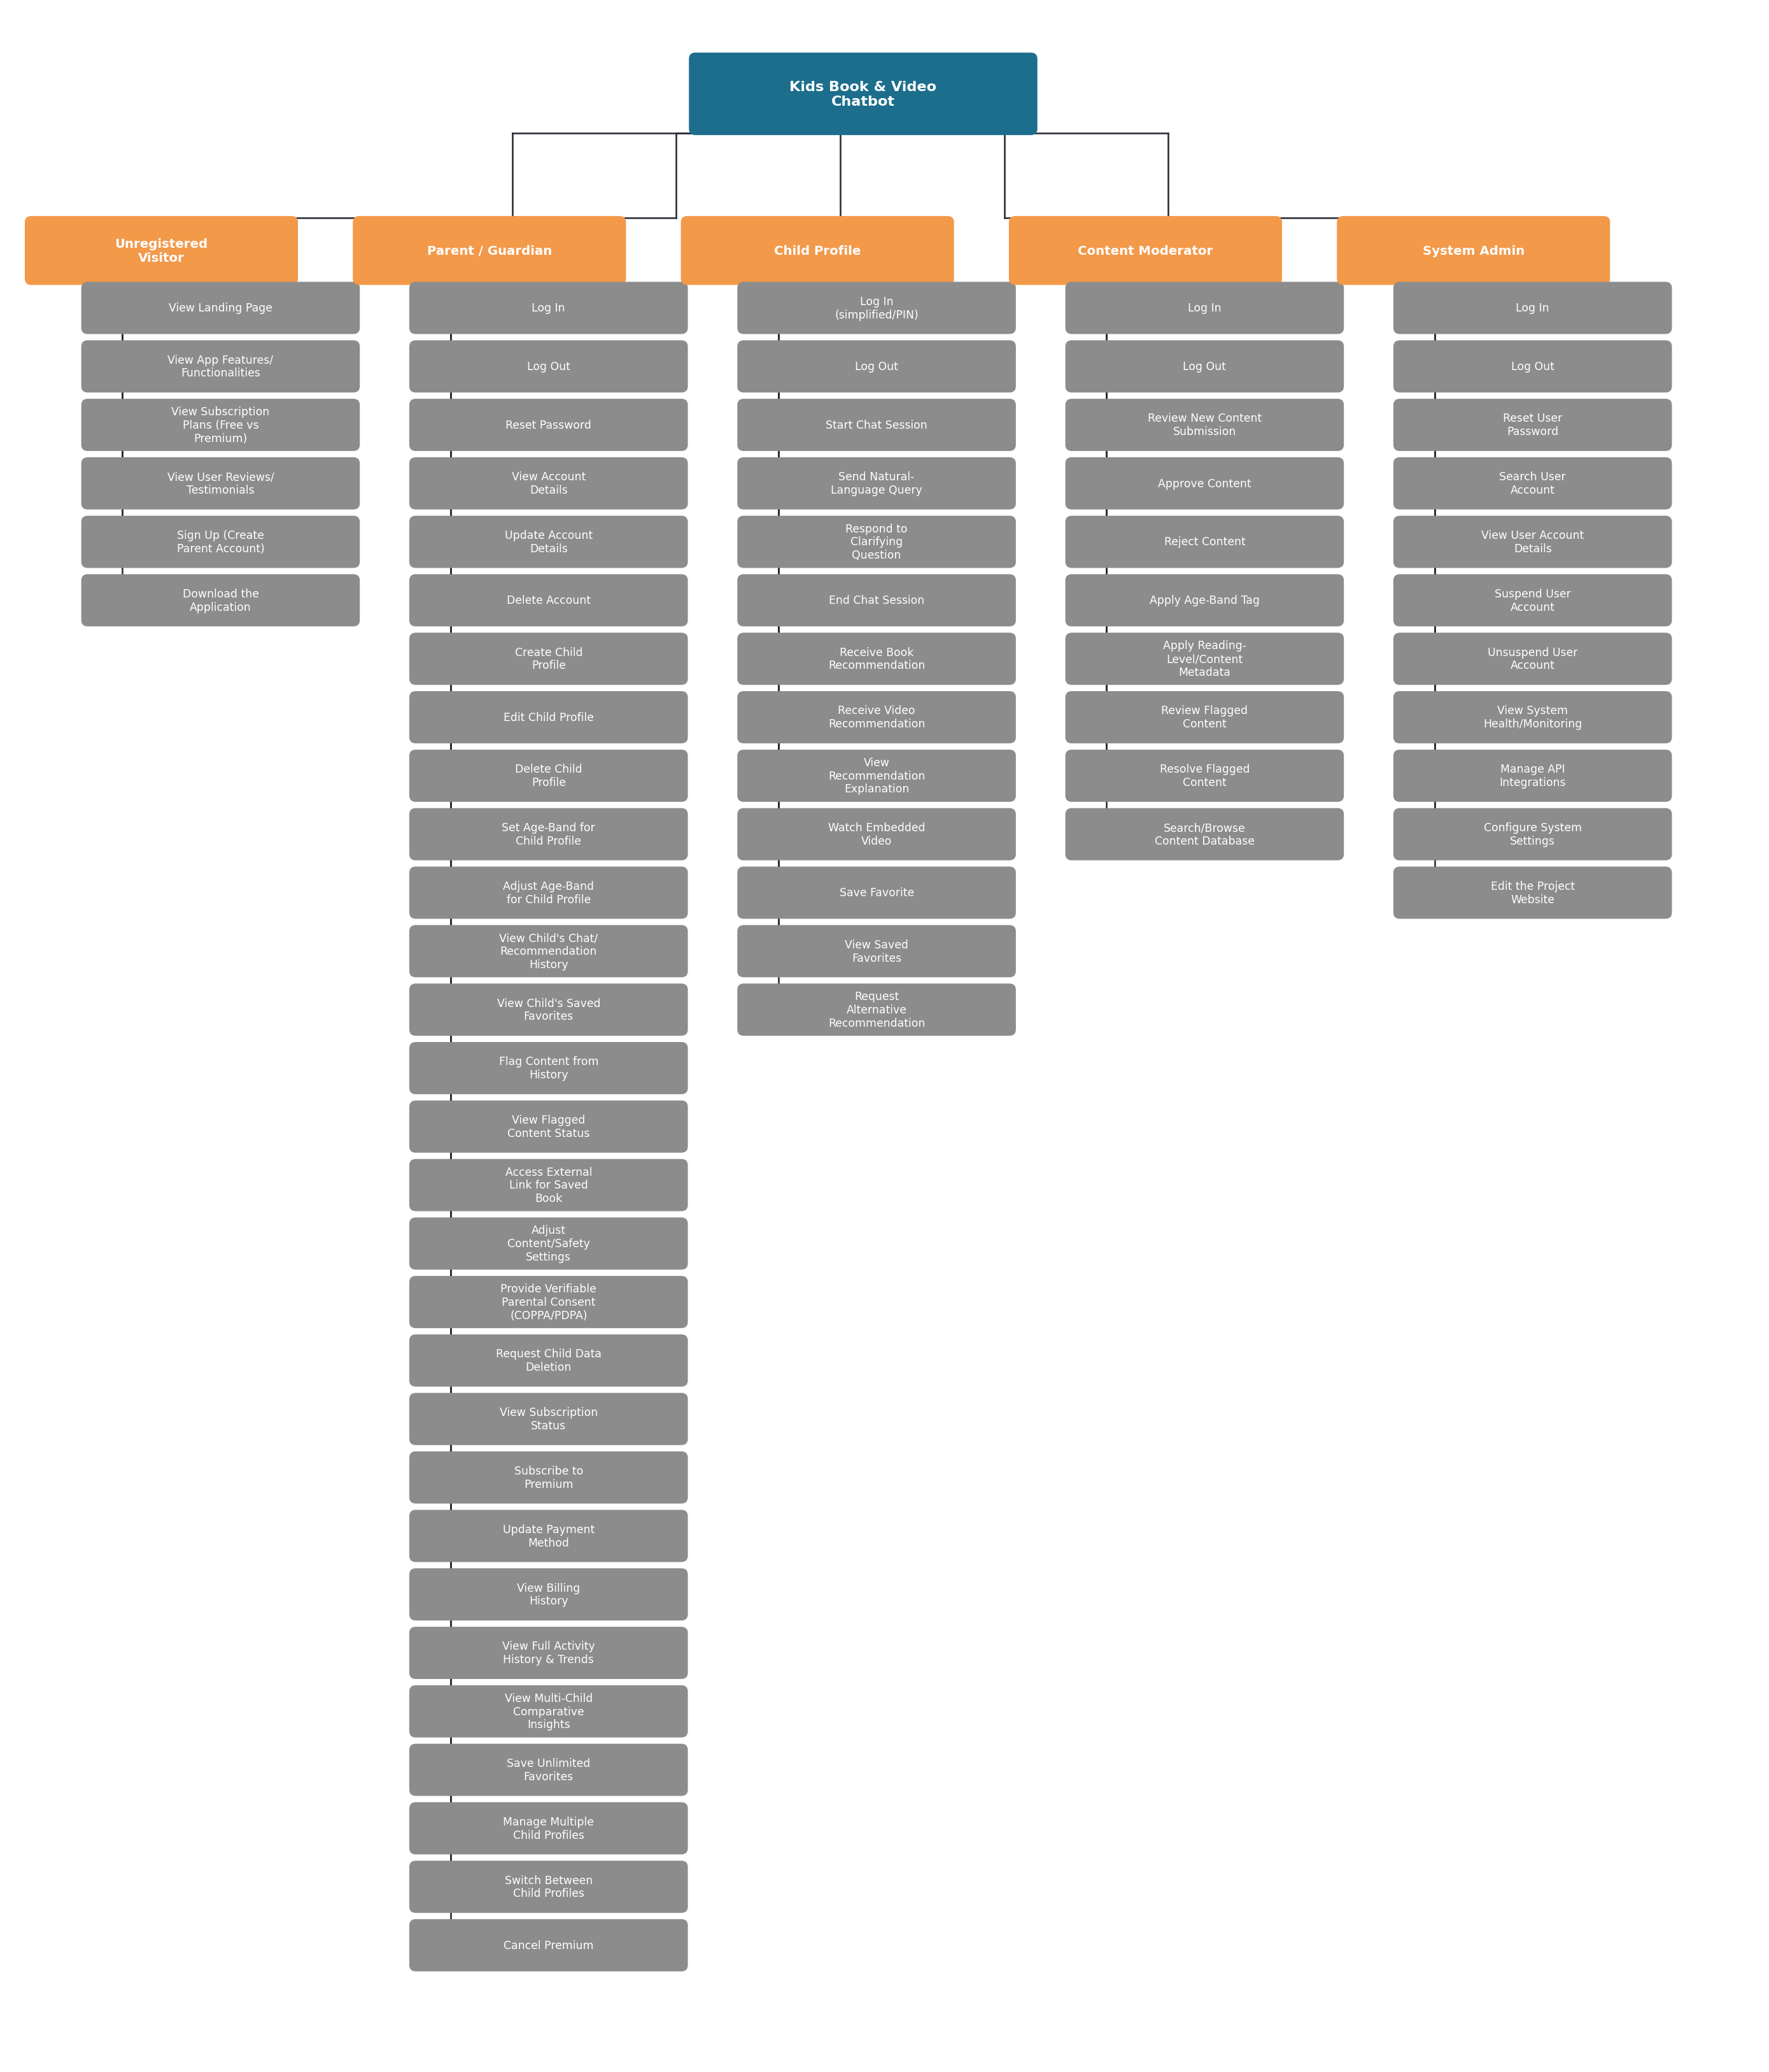
The zoomed-in diagrams below break each actor's use cases into logical categories (e.g. Account Management, Child Profile Management) for readability.

Unregistered Visitor (zoomed in)
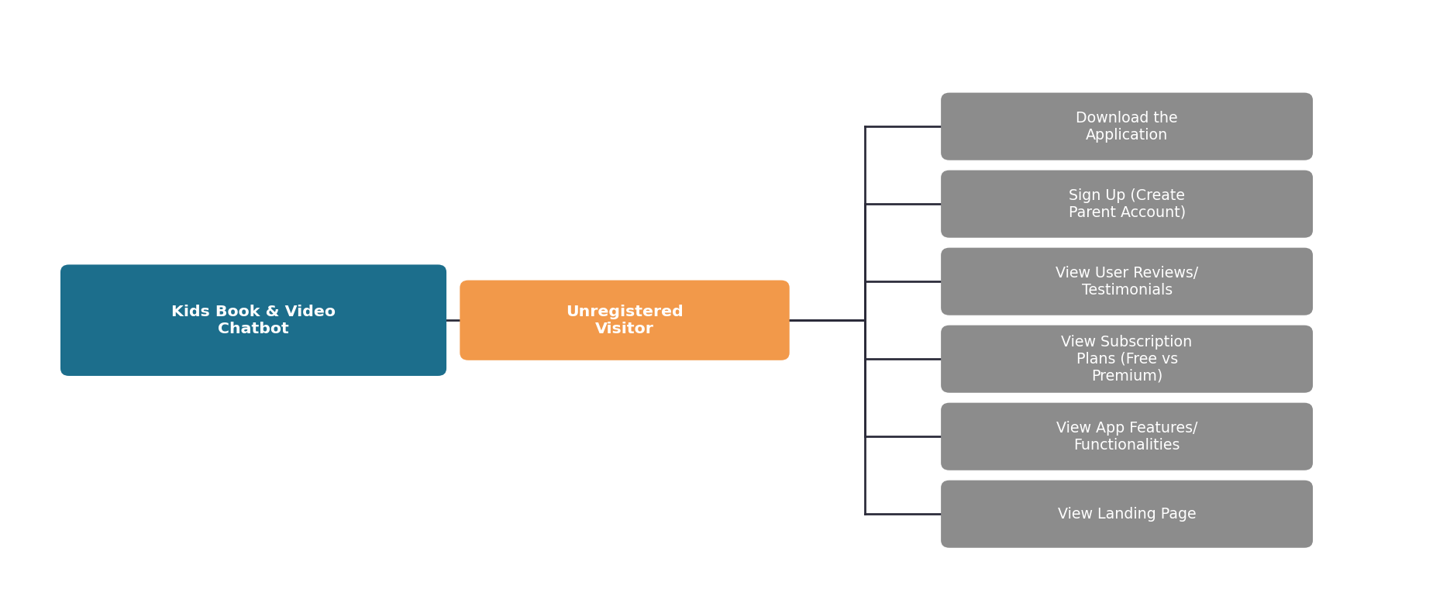

Parent / Guardian (zoomed in)
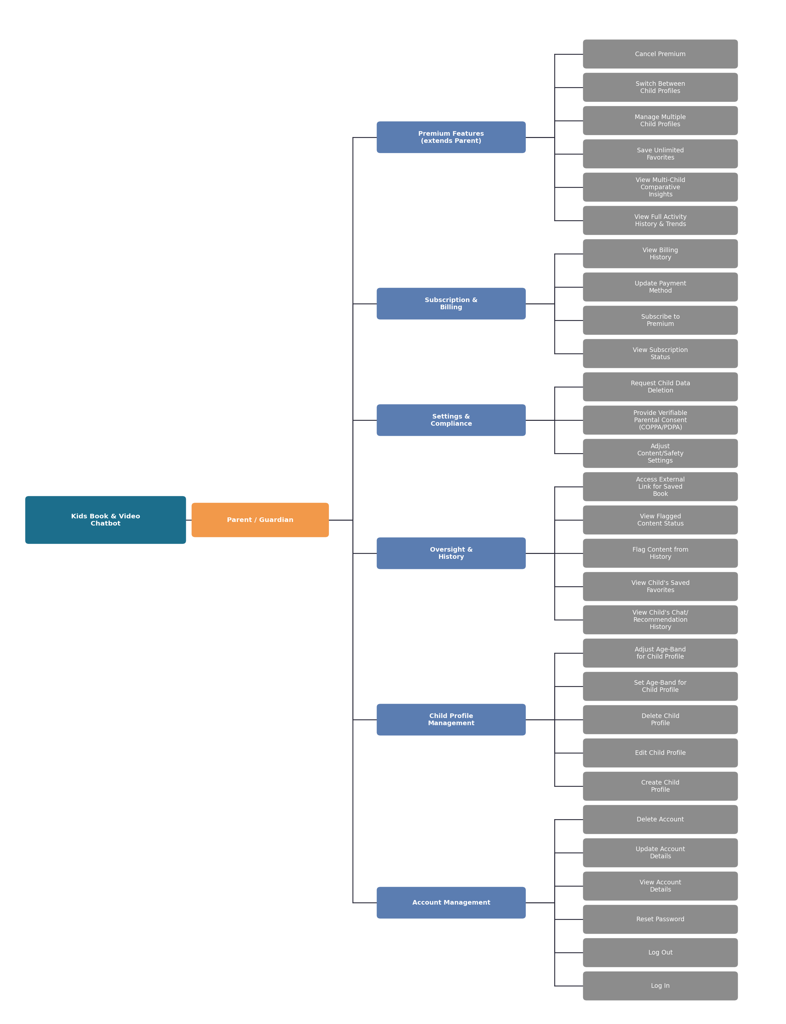

Child Profile (zoomed in)
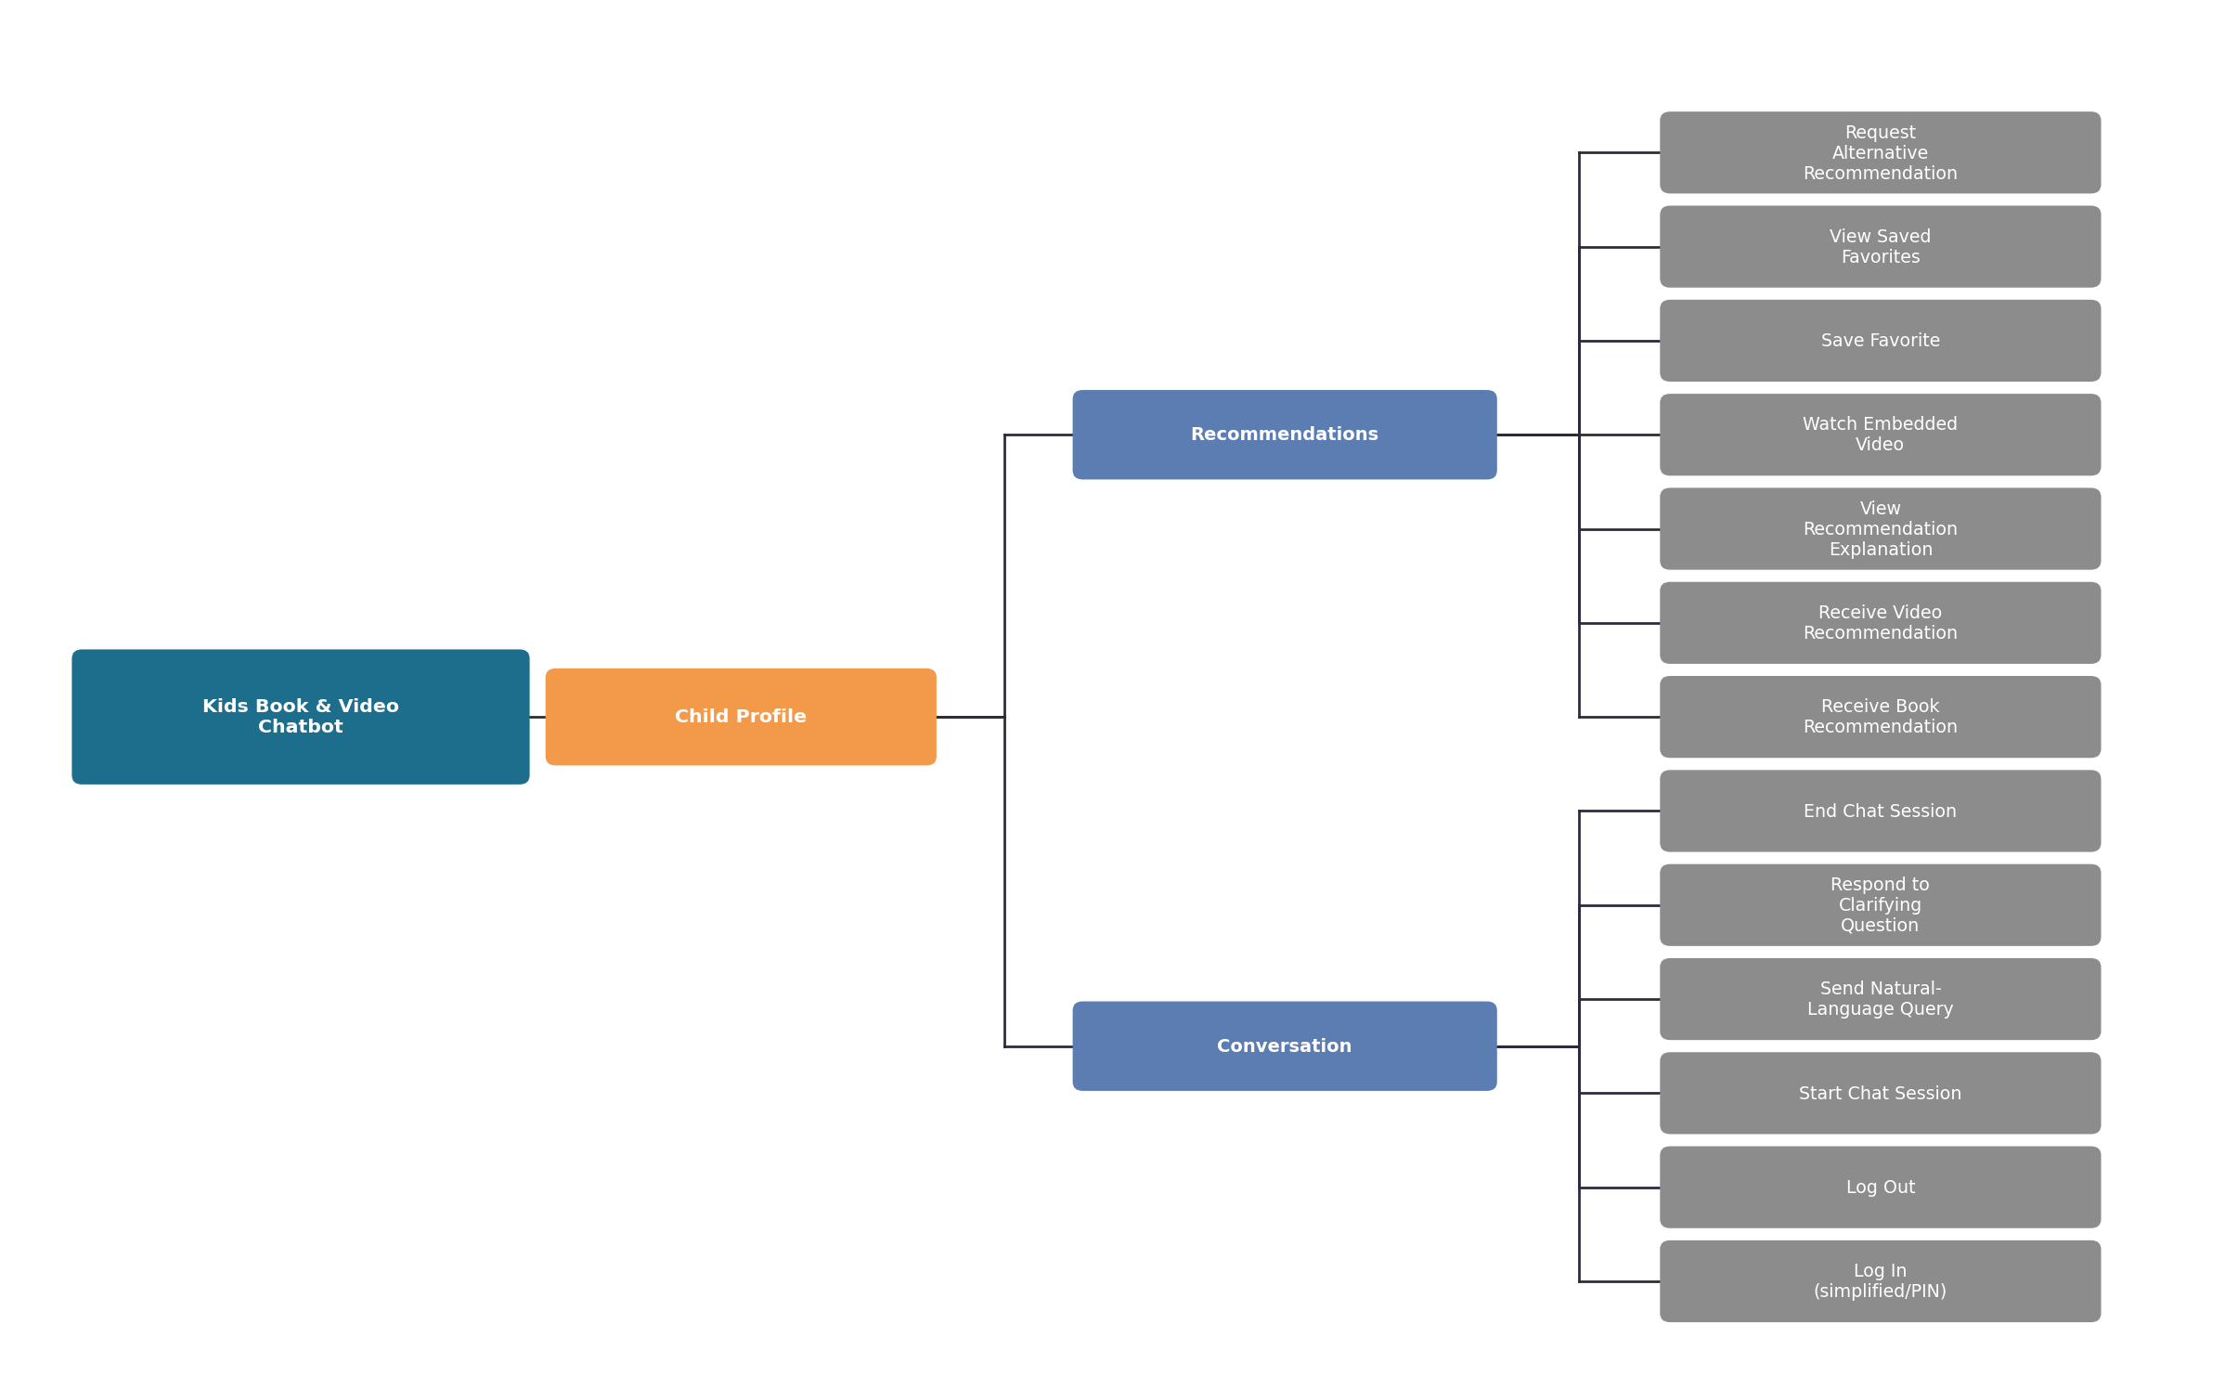

Content Moderator (zoomed in)
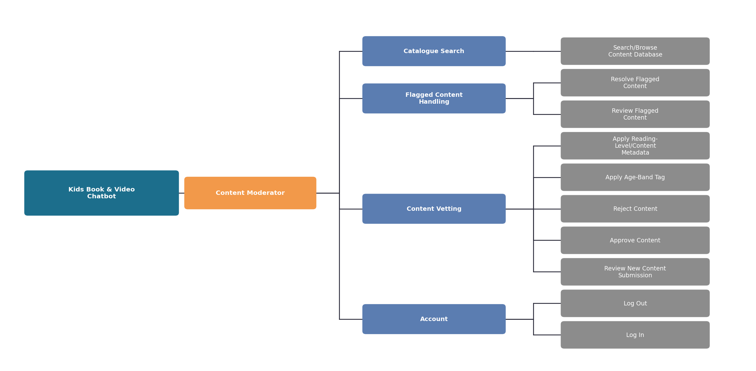

System Admin (zoomed in)
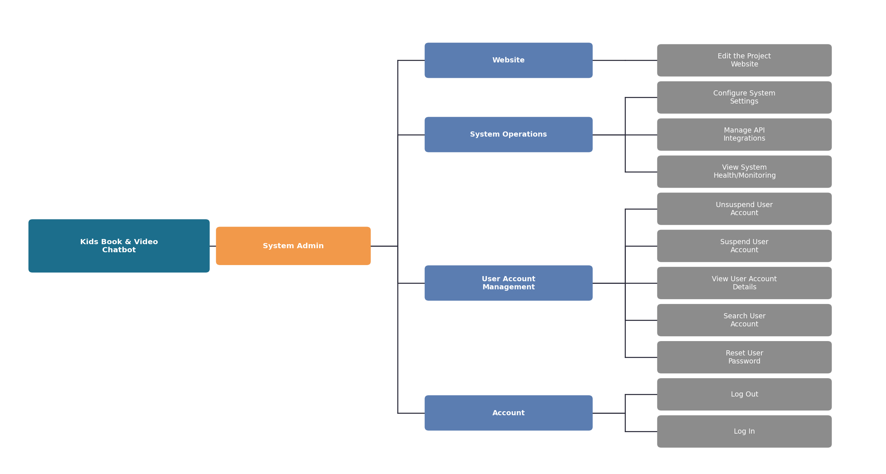

3.2 Preliminary Use Case Diagram(s)
Each diagram below shows the actor and their use cases in standard UML notation, including <<include>> and <<extend>> relationships where one use case's flow depends on another.

Unregistered Visitor
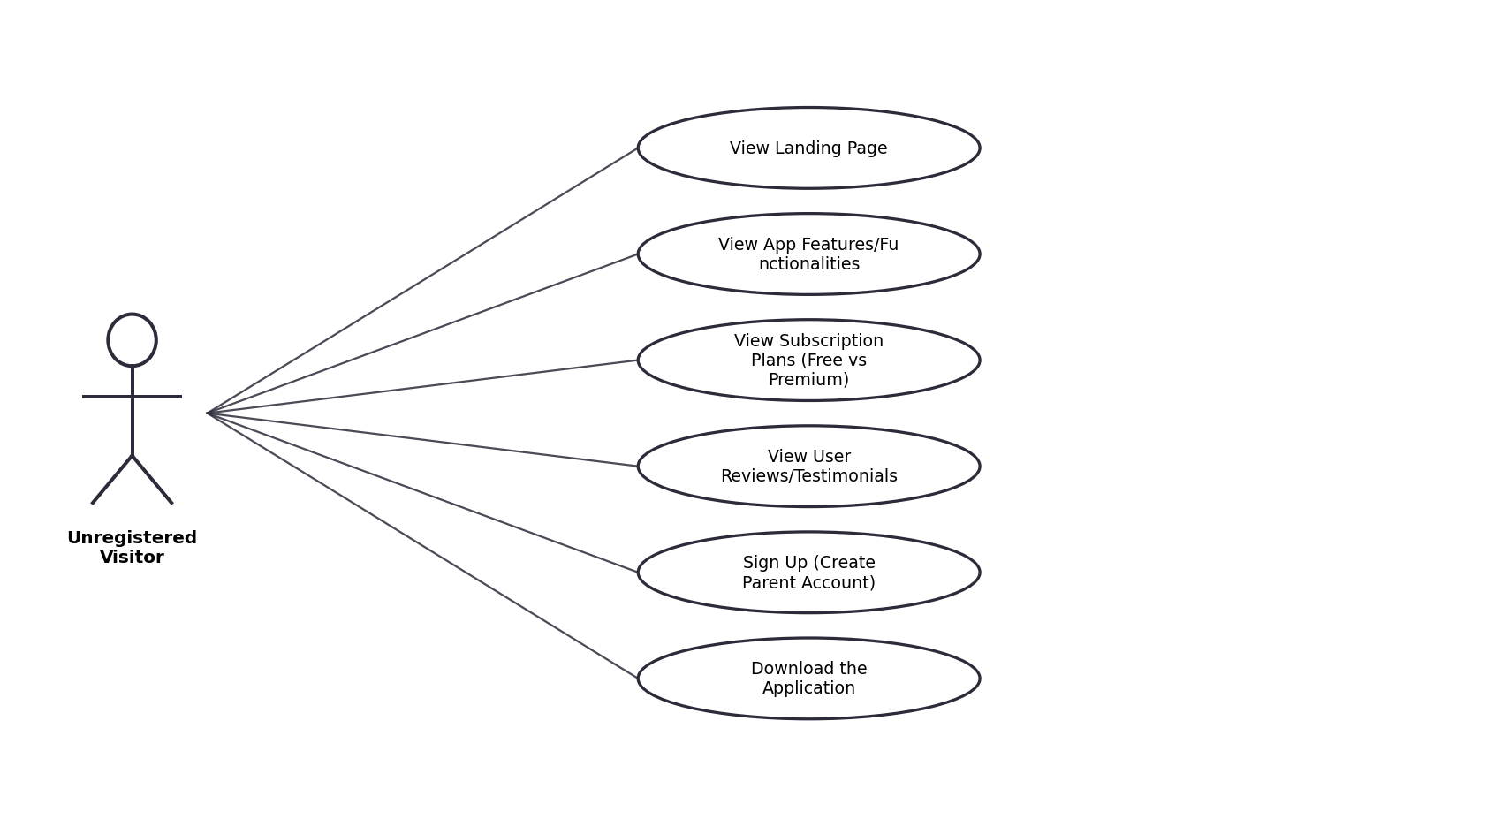

Parent / Guardian
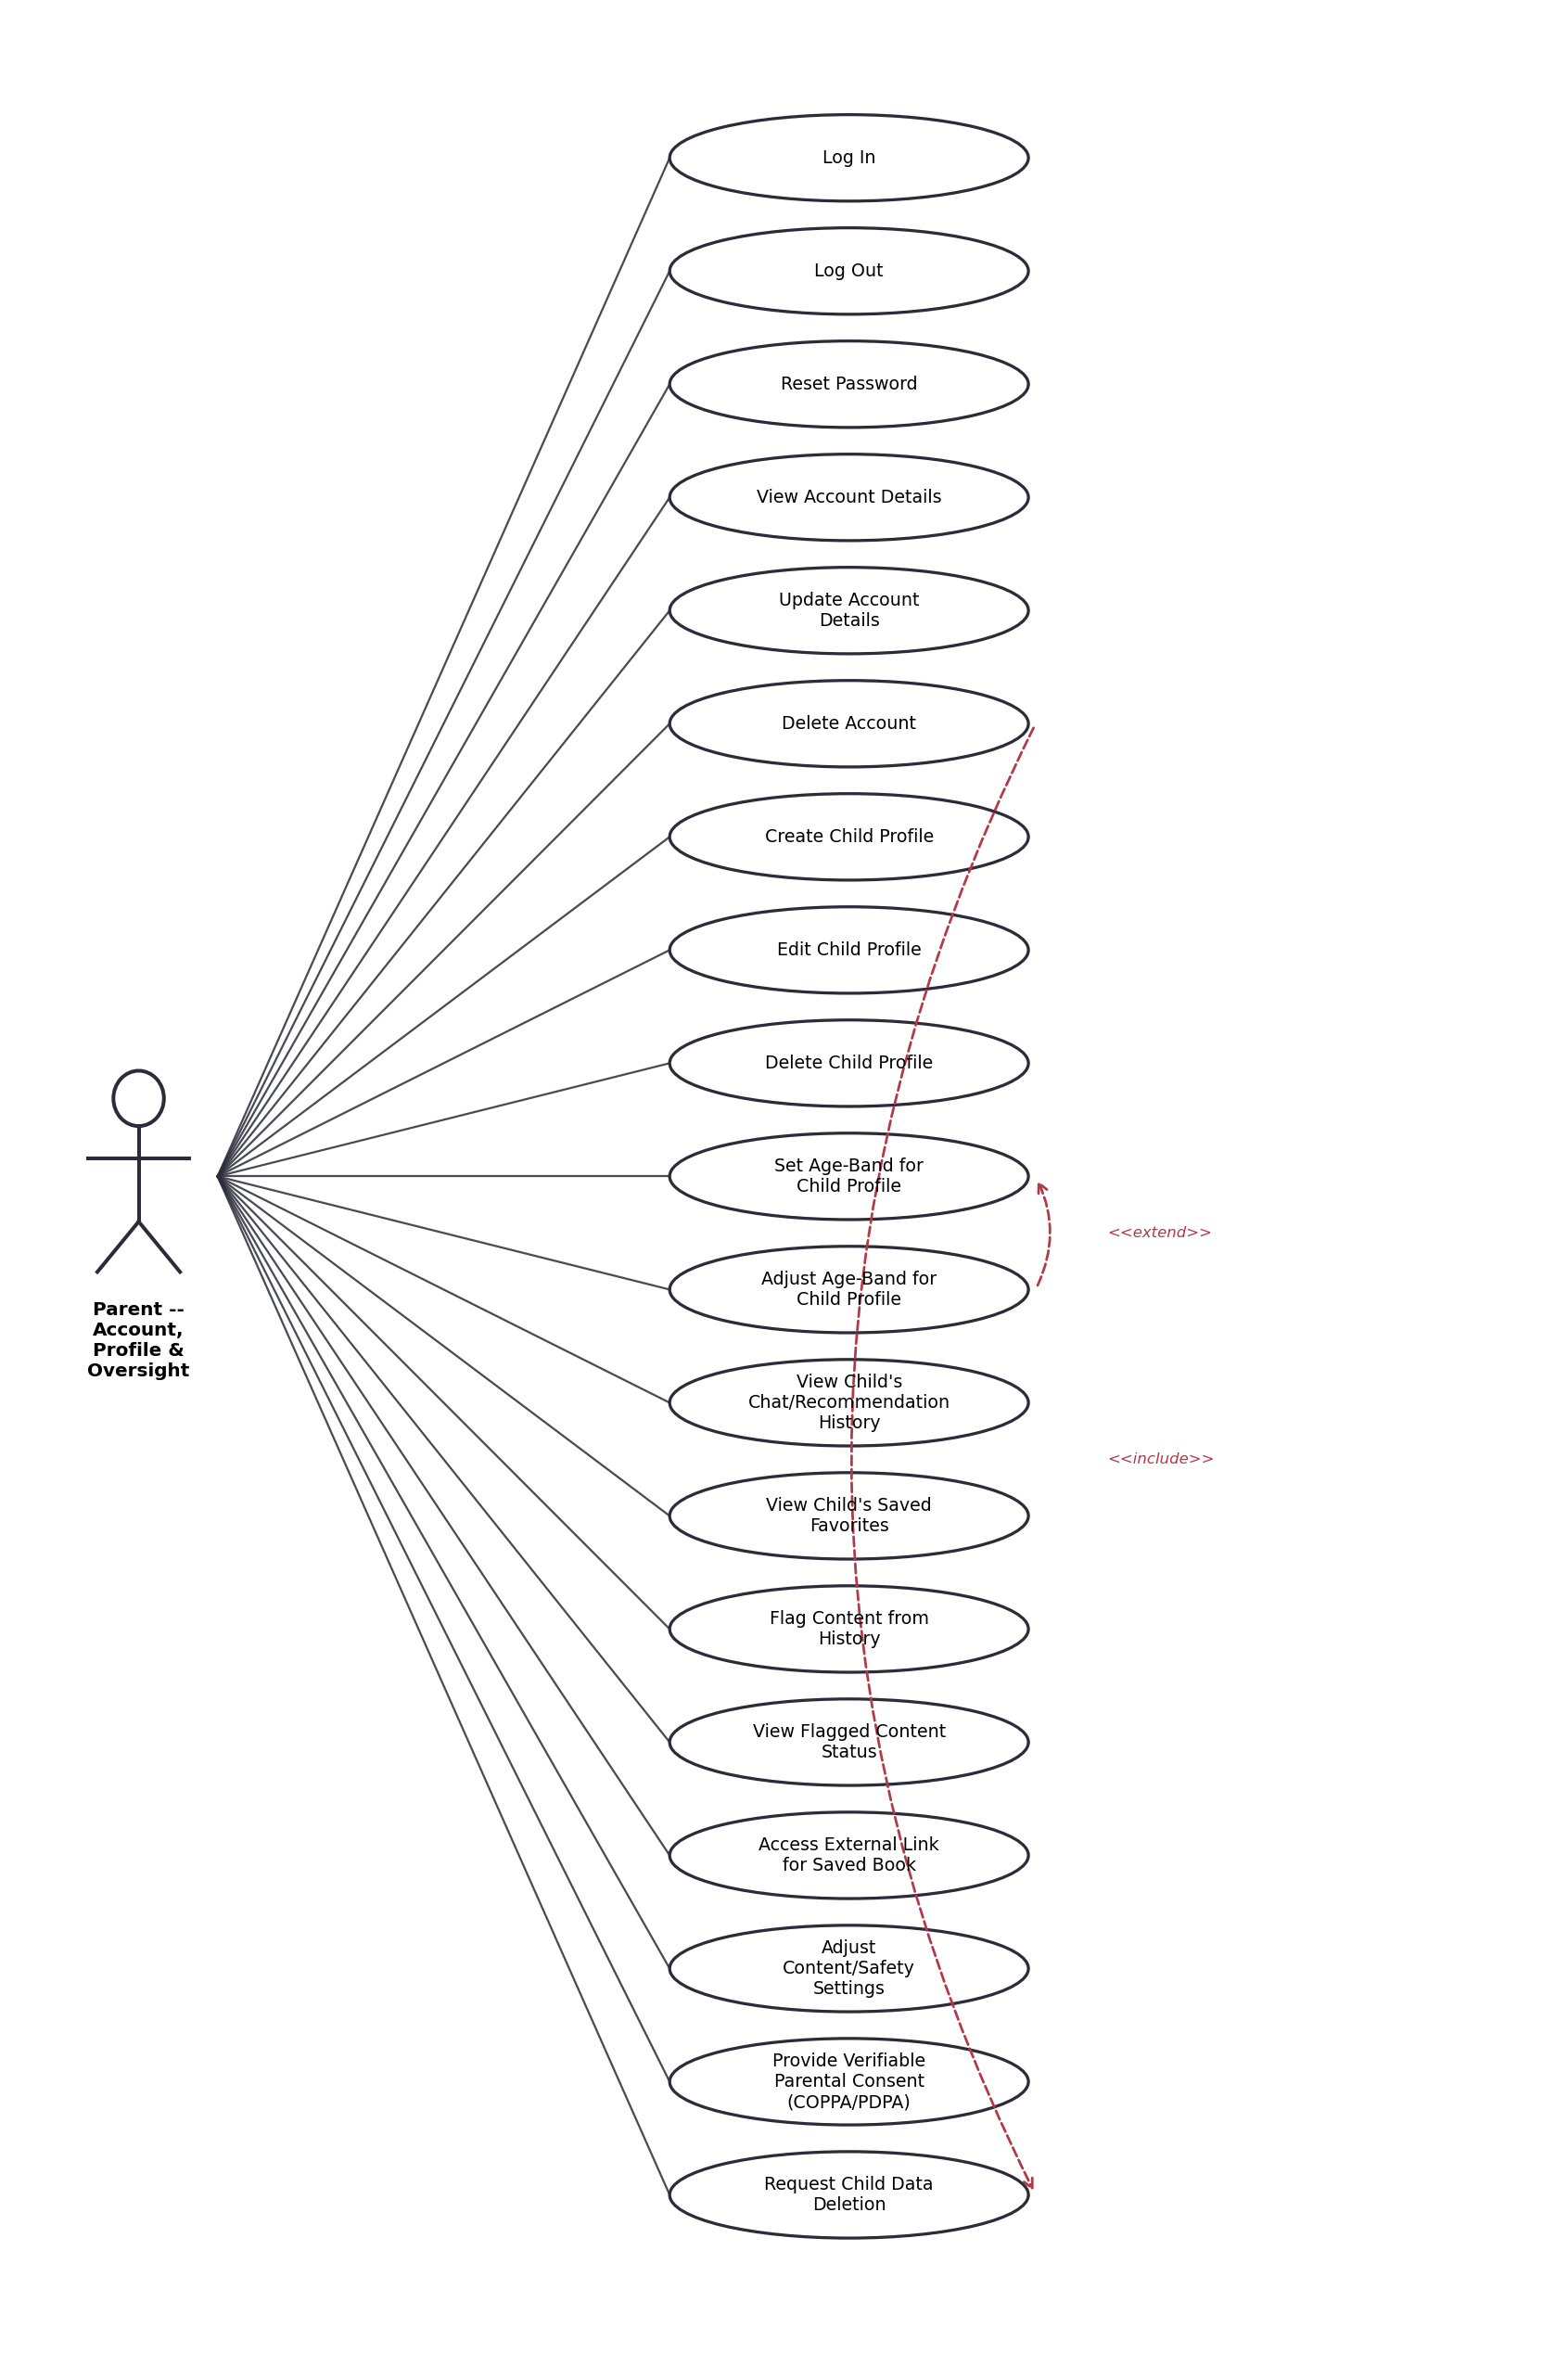
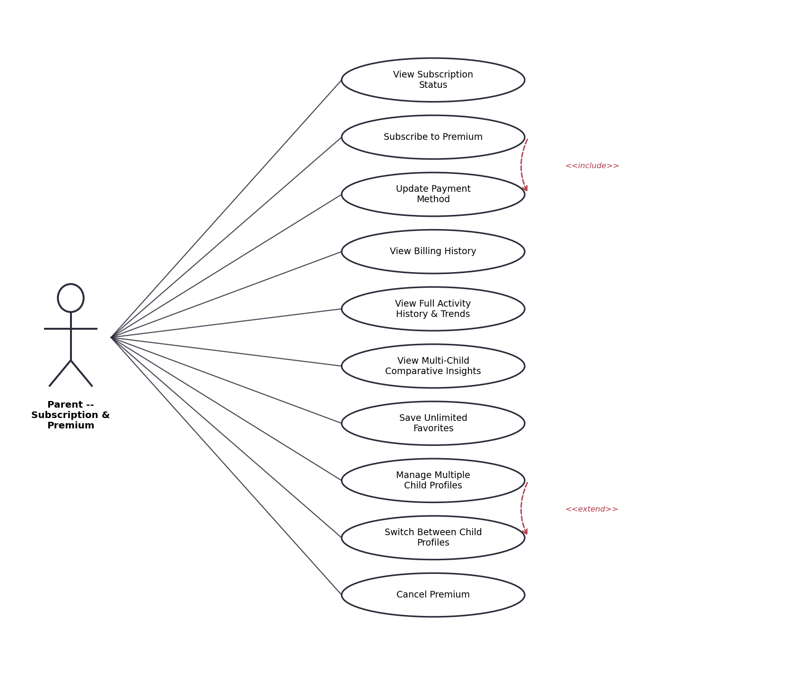

Child Profile
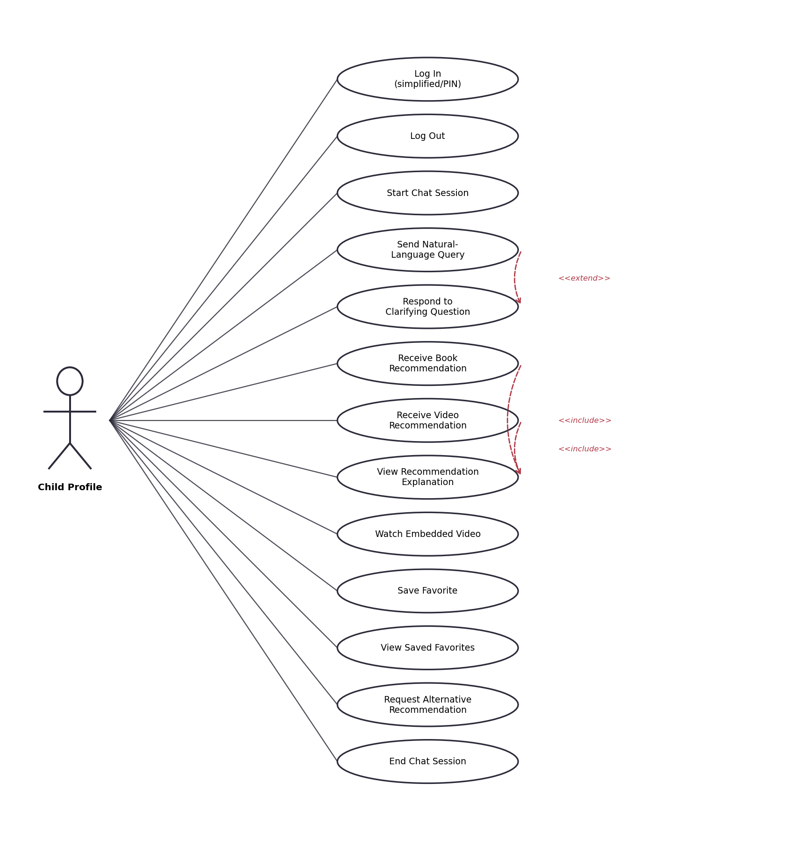

Content Moderator
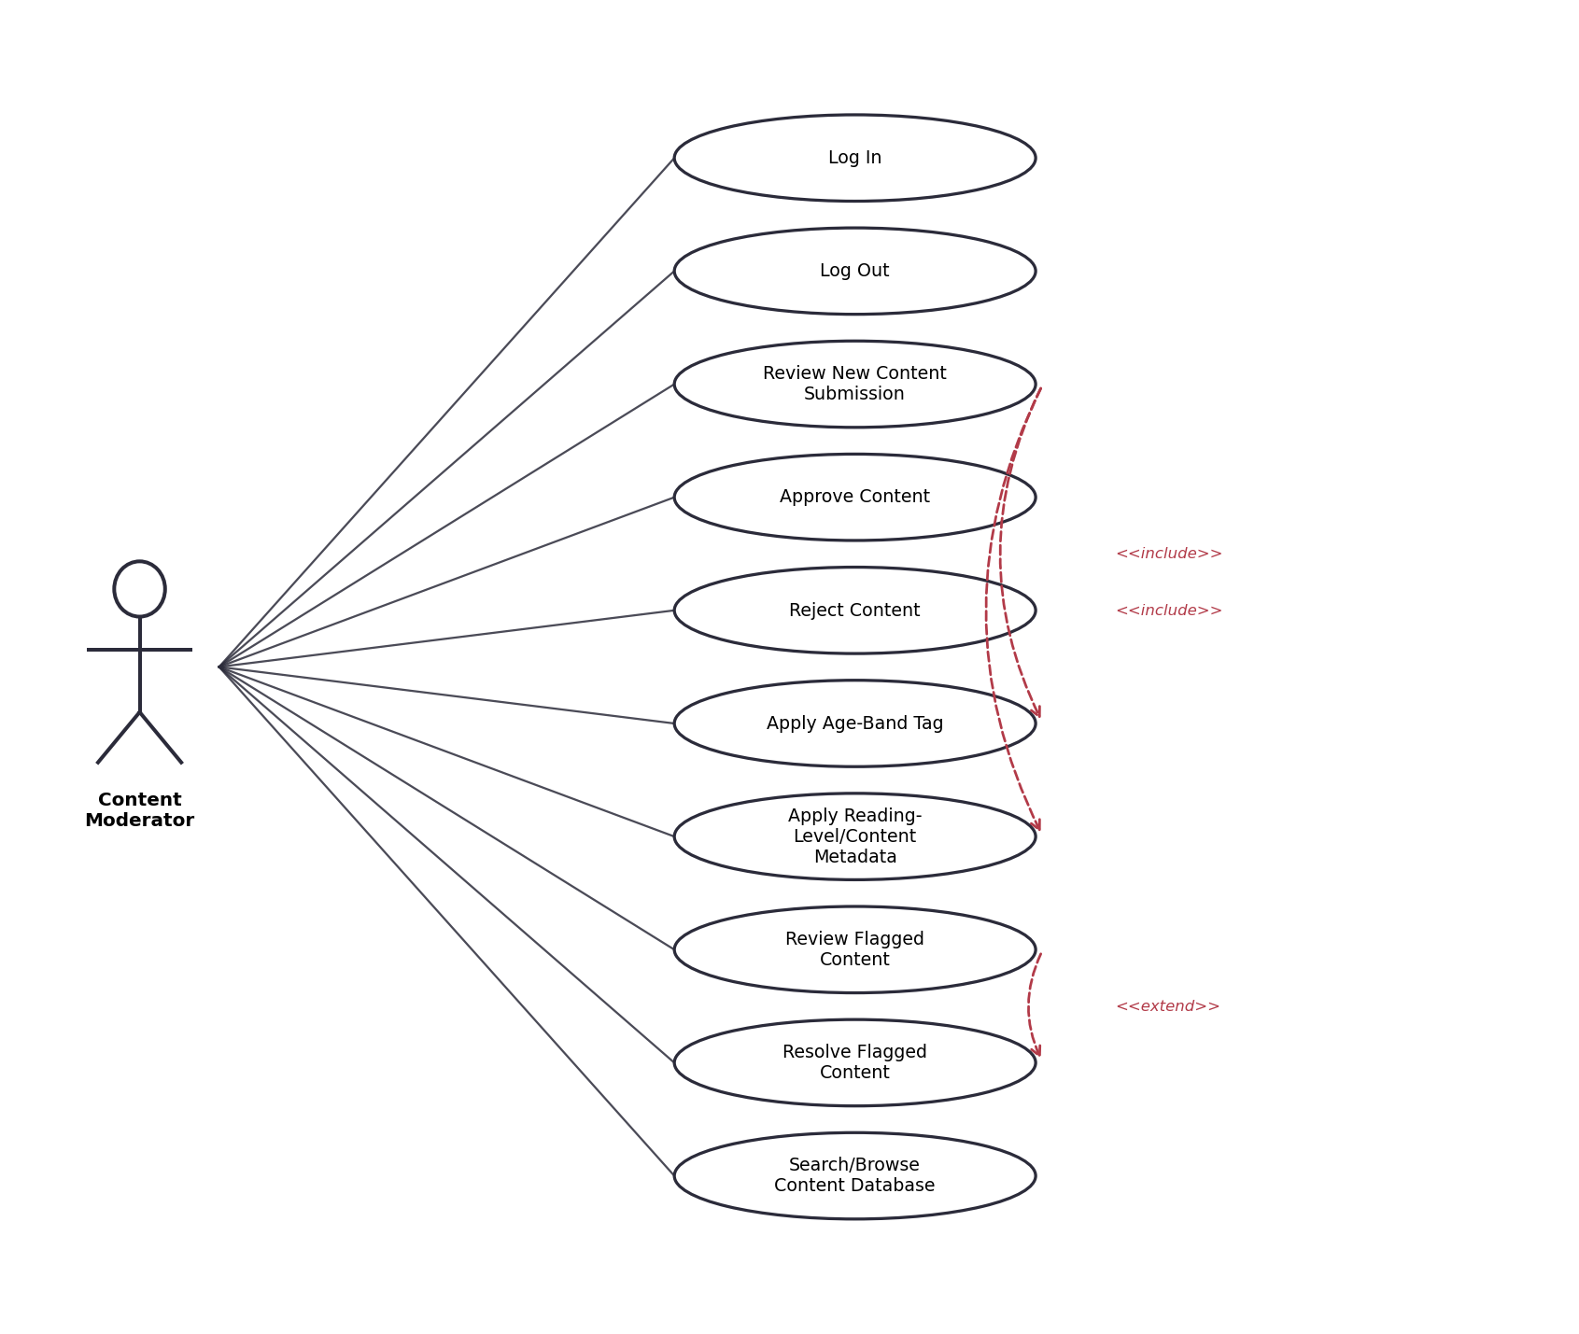

System Admin
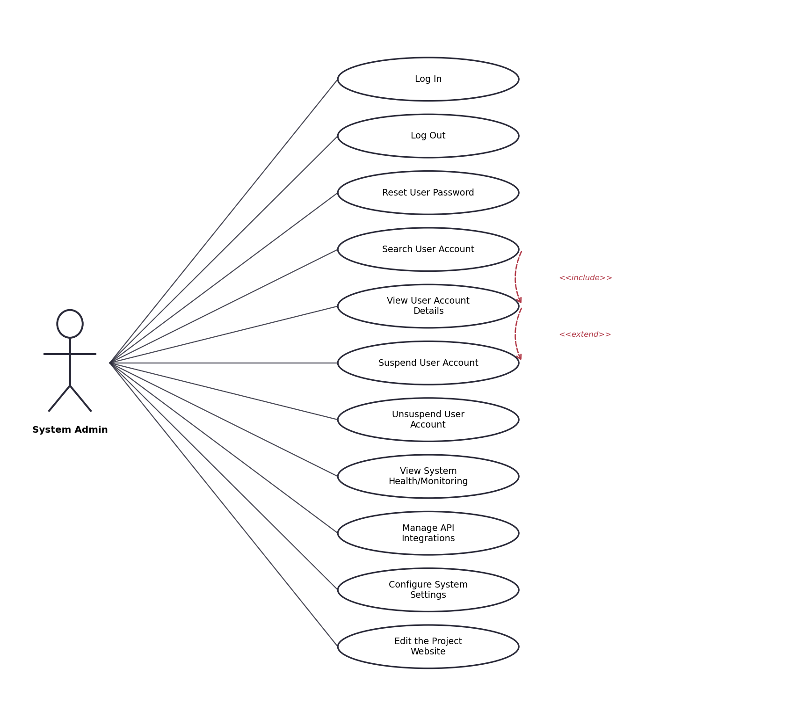

3.3 Preliminary Use Case Descriptions
A full detail table is provided for every use case identified for the system, organised by actor.

Unregistered Visitor
Name: View Landing Page | ID: UV01
Stakeholders and Goals | Unregistered Visitor -- to understand what the app offers before signing up.
Description | Displays the app's landing page describing the chatbot's purpose, safety approach, and target age range.
Actors | Unregistered Visitor
Trigger | Visitor opens the app or project website.
Precondition | None.
Normal Flow | 1. Visitor opens the app/website.  2. System displays the landing page with a summary of the product and a call to action to sign up.
Sub-Flows | None.
Alternative/Exceptional Flows | None.

Name: View App Features/Functionalities | ID: UV02
Stakeholders and Goals | Unregistered Visitor -- to evaluate whether the app fits their family's needs.
Description | Displays a features page listing key functionality: conversational recommendations, curated catalogue, parent dashboard, age-band filtering.
Actors | Unregistered Visitor
Trigger | Visitor selects "Features" from the landing page.
Precondition | Visitor is on the landing page.
Normal Flow | 1. Visitor clicks "Features".  2. System displays feature descriptions with short explanations of each.
Sub-Flows | None.
Alternative/Exceptional Flows | None.

Name: View Subscription Plans (Free vs Premium) | ID: UV03
Stakeholders and Goals | Unregistered Visitor -- to compare Free and Premium tiers before committing.
Description | Displays a pricing/comparison page contrasting Free and Premium tier features.
Actors | Unregistered Visitor
Trigger | Visitor selects "Pricing" or "Plans".
Precondition | Visitor is on the landing page.
Normal Flow | 1. Visitor clicks "Pricing".  2. System displays a Free vs Premium comparison table.
Sub-Flows | None.
Alternative/Exceptional Flows | None.

Name: View User Reviews/Testimonials | ID: UV04
Stakeholders and Goals | Unregistered Visitor -- to gauge trust in the product from other parents.
Description | Displays parent testimonials and ratings collected post-launch.
Actors | Unregistered Visitor
Trigger | Visitor selects "Reviews".
Precondition | Visitor is on the landing page.
Normal Flow | 1. Visitor clicks "Reviews".  2. System displays a list of testimonials/ratings.
Sub-Flows | None.
Alternative/Exceptional Flows | 1a. No reviews exist yet: system displays an empty state instead of an error.

Name: Sign Up (Create Parent Account) | ID: UV05
Stakeholders and Goals | Unregistered Visitor -- to create an account and begin using the app.
Description | An unregistered visitor fills in a registration form to create a parent account.
Actors | Unregistered Visitor
Trigger | Visitor clicks "Sign Up".
Precondition | Visitor is not already registered.
Normal Flow | 1. Visitor clicks "Sign Up".  2. Visitor enters name, email, and password.  3. Visitor accepts the terms of service and privacy policy.  4. System validates and creates the account.  5. System redirects to child-profile setup.
Sub-Flows | None.
Alternative/Exceptional Flows | 3a. Email already registered: system prompts to log in instead.  3b. Missing/invalid fields: system highlights the offending field and blocks submission.

Name: Download the Application | ID: UV06
Stakeholders and Goals | Unregistered Visitor -- to install the app on their device.
Description | Provides platform-specific download links (App Store, Google Play, or web app).
Actors | Unregistered Visitor
Trigger | Visitor clicks "Download".
Precondition | None.
Normal Flow | 1. Visitor clicks "Download".  2. System detects platform and redirects to the appropriate store, or opens the web app directly.
Sub-Flows | None.
Alternative/Exceptional Flows | None.

Parent / Guardian
Name: Log In | ID: PA01
Stakeholders and Goals | Parent -- to access their account and linked child profiles.
Description | A registered parent authenticates to access the account.
Actors | Parent
Trigger | Parent clicks "Log In" and submits credentials.
Precondition | Parent has a registered account.
Normal Flow | 1. Parent enters email and password.  2. System validates credentials.  3. System redirects to the parent dashboard.
Sub-Flows | None.
Alternative/Exceptional Flows | 2a. Invalid credentials: system displays an error and permits retry.  2b. Account locked after repeated failures: system prompts a password reset.

Name: Log Out | ID: PA02
Stakeholders and Goals | Parent -- to end the session securely.
Description | A logged-in parent ends their session.
Actors | Parent
Trigger | Parent clicks "Log Out".
Precondition | Parent is logged in.
Normal Flow | 1. Parent clicks "Log Out".  2. System ends the session and returns to the landing page.
Sub-Flows | None.
Alternative/Exceptional Flows | None.

Name: Reset Password | ID: PA03
Stakeholders and Goals | Parent -- to regain access after forgetting a password.
Description | Parent requests a password reset link via email.
Actors | Parent
Trigger | Parent clicks "Forgot Password".
Precondition | Parent has a registered account.
Normal Flow | 1. Parent enters their registered email.  2. System sends a reset link.  3. Parent follows the link and sets a new password.
Sub-Flows | None.
Alternative/Exceptional Flows | 1a. Email not registered: system shows a generic confirmation message without revealing whether the account exists (privacy safeguard).

Name: View Account Details | ID: PA04
Stakeholders and Goals | Parent -- to review their own registered information.
Description | Displays the parent's name, email, and account status.
Actors | Parent
Trigger | Parent navigates to Account Settings.
Precondition | Parent is logged in.
Normal Flow | 1. Parent opens Account Settings.  2. System displays current account details.
Sub-Flows | None.
Alternative/Exceptional Flows | None.

Name: Update Account Details | ID: PA05
Stakeholders and Goals | Parent -- to keep account information current.
Description | Parent edits name, email, or password.
Actors | Parent
Trigger | Parent clicks "Edit" on Account Settings.
Precondition | Parent is logged in.
Normal Flow | 1. Parent edits a field.  2. Parent confirms changes.  3. System validates and saves.
Sub-Flows | None.
Alternative/Exceptional Flows | 3a. New email already in use: system blocks the change and shows an error.

Name: Delete Account | ID: PA06
Stakeholders and Goals | Parent -- to permanently remove their account and associated data.
Description | Parent requests deletion of their account and all linked child profiles.
Actors | Parent
Trigger | Parent clicks "Delete Account".
Precondition | Parent is logged in.
Normal Flow | 1. Parent clicks "Delete Account".  2. System asks for confirmation and explains data-deletion scope.  3. Parent confirms.  4. System deletes the account and linked child data per the retention policy.
Sub-Flows | None.
Alternative/Exceptional Flows | 2a. Parent cancels: no action is taken.

Name: Create Child Profile | ID: PA07
Stakeholders and Goals | Parent -- to set up a linked profile for their child.
Description | Parent creates a new child profile with a name and initial age band.
Actors | Parent
Trigger | Parent clicks "Add Child Profile".
Precondition | Parent is logged in; profile-count limit not exceeded for their tier.
Normal Flow | 1. Parent clicks "Add Child Profile".  2. Parent enters child's name/nickname and date of birth (or age).  3. System suggests an age band; parent confirms or adjusts.  4. System creates the profile.
Sub-Flows | None.
Alternative/Exceptional Flows | 1a. Free-tier limit (1 profile) reached: system prompts an upgrade to Premium.

Name: Edit Child Profile | ID: PA08
Stakeholders and Goals | Parent -- to keep a child's profile details accurate.
Description | Parent edits a child profile's name or details.
Actors | Parent
Trigger | Parent selects "Edit" on a child profile.
Precondition | Child profile exists.
Normal Flow | 1. Parent selects a child profile.  2. Parent edits fields.  3. System saves changes.
Sub-Flows | None.
Alternative/Exceptional Flows | None.

Name: Delete Child Profile | ID: PA09
Stakeholders and Goals | Parent -- to remove a profile no longer needed.
Description | Parent deletes a linked child profile and its history.
Actors | Parent
Trigger | Parent selects "Delete" on a child profile.
Precondition | Child profile exists.
Normal Flow | 1. Parent selects a child profile.  2. Parent clicks "Delete".  3. System asks for confirmation.  4. Parent confirms; system deletes the profile and history.
Sub-Flows | None.
Alternative/Exceptional Flows | 3a. Parent cancels: no action is taken.

Name: Set Age-Band for Child Profile | ID: PA10
Stakeholders and Goals | Parent -- to ensure recommendations match the child's developmental stage.
Description | Parent assigns an age band (5-8 or 9-12) to a new child profile.
Actors | Parent
Trigger | Parent completes child-profile creation.
Precondition | Child profile is being created.
Normal Flow | 1. System suggests an age band from date of birth.  2. Parent confirms or selects a different band.  3. System saves the age band.
Sub-Flows | None.
Alternative/Exceptional Flows | None.

Name: Adjust Age-Band for Child Profile | ID: PA11
Stakeholders and Goals | Parent -- to update the age band as the child grows or as needed.
Description | Parent changes an existing child profile's age band.
Actors | Parent
Trigger | Parent selects "Change Age Band" on a profile.
Precondition | Child profile exists.
Normal Flow | 1. Parent opens profile settings.  2. Parent selects a new age band.  3. System confirms and applies the new band to future recommendations.
Sub-Flows | None.
Alternative/Exceptional Flows | None.

Name: View Child's Chat/Recommendation History | ID: PA12
Stakeholders and Goals | Parent -- to monitor what the child has asked and been shown.
Description | Displays a chronological log of the child's chat queries and the recommendations returned.
Actors | Parent
Trigger | Parent selects "Activity History" for a child profile.
Precondition | Child profile has at least one recorded session.
Normal Flow | 1. Parent opens a child profile.  2. Parent selects "Activity History".  3. System displays the chat/recommendation log.
Sub-Flows | None.
Alternative/Exceptional Flows | 1a. No history yet: system displays an empty state.

Name: View Child's Saved Favorites | ID: PA13
Stakeholders and Goals | Parent -- to see what content the child liked enough to save.
Description | Displays the list of books/videos the child has bookmarked as favorites.
Actors | Parent
Trigger | Parent selects "Favorites" for a child profile.
Precondition | Child profile exists.
Normal Flow | 1. Parent opens a child profile.  2. Parent selects "Favorites".  3. System displays saved items.
Sub-Flows | None.
Alternative/Exceptional Flows | None.

Name: Flag Content from History | ID: PA14
Stakeholders and Goals | Parent -- to raise a concern about a specific recommendation.
Description | Parent flags a previously recommended item for moderator review.
Actors | Parent
Trigger | Parent selects "Flag" on a history item.
Precondition | Item exists in the child's history.
Normal Flow | 1. Parent opens history.  2. Parent selects an item and clicks "Flag".  3. Parent optionally adds a reason.  4. System submits the flag to the moderation queue.
Sub-Flows | None.
Alternative/Exceptional Flows | None.

Name: View Flagged Content Status | ID: PA15
Stakeholders and Goals | Parent -- to know whether a flagged concern has been addressed.
Description | Displays the resolution status (pending/approved/removed) of items the parent has flagged.
Actors | Parent
Trigger | Parent selects "Flagged Items".
Precondition | Parent has flagged at least one item.
Normal Flow | 1. Parent opens "Flagged Items".  2. System displays each flagged item with its current status.
Sub-Flows | None.
Alternative/Exceptional Flows | None.

Name: Access External Link for Saved Book | ID: PA16
Stakeholders and Goals | Parent -- to obtain a physical/e-book copy of a recommended title.
Description | Parent-facing action to open an external retailer/library link for a saved book (never exposed directly to the child).
Actors | Parent
Trigger | Parent selects "Get this book" on a saved item.
Precondition | Saved item is a book with an associated external link.
Normal Flow | 1. Parent opens Favorites.  2. Parent selects a book and clicks "Get this book".  3. System opens the external link in a new tab.
Sub-Flows | None.
Alternative/Exceptional Flows | None.

Name: Adjust Content/Safety Settings | ID: PA17
Stakeholders and Goals | Parent -- to fine-tune the safety controls beyond the default age-band filtering.
Description | Parent adjusts settings such as blocking specific topics or content sources.
Actors | Parent
Trigger | Parent opens "Safety Settings".
Precondition | Parent is logged in.
Normal Flow | 1. Parent opens Safety Settings.  2. Parent toggles or edits a setting.  3. System saves and applies the setting immediately.
Sub-Flows | None.
Alternative/Exceptional Flows | None.

Name: Provide Verifiable Parental Consent (COPPA/PDPA) | ID: PA18
Stakeholders and Goals | Parent -- to satisfy legal consent requirements before a child profile becomes active.
Description | Parent completes a verifiable consent step (e.g., re-authentication or payment-method verification) required under COPPA/PDPA before any child data is collected.
Actors | Parent
Trigger | Parent creates the first child profile.
Precondition | Parent has not yet provided consent.
Normal Flow | 1. System presents the consent notice describing data collected and its use.  2. Parent reviews and completes the verification step.  3. System records consent with a timestamp and unlocks child-profile creation.
Sub-Flows | None.
Alternative/Exceptional Flows | 2a. Parent declines: system blocks child-profile creation and explains why.

Name: Request Child Data Deletion | ID: PA19
Stakeholders and Goals | Parent -- to exercise data-deletion rights under COPPA/PDPA.
Description | Parent requests deletion of a specific child's stored data, separate from full account deletion.
Actors | Parent
Trigger | Parent selects "Delete Child Data" on a profile.
Precondition | Child profile exists.
Normal Flow | 1. Parent selects a child profile.  2. Parent clicks "Delete Child Data".  3. System confirms scope and deletion timeline.  4. Parent confirms; system schedules deletion.
Sub-Flows | None.
Alternative/Exceptional Flows | 3a. Parent cancels: no action is taken.

Name: View Subscription Status | ID: PA20
Stakeholders and Goals | Parent -- to check current tier and renewal date.
Description | Displays current subscription tier (Free/Premium) and, if Premium, renewal date.
Actors | Parent
Trigger | Parent opens "Subscription".
Precondition | Parent is logged in.
Normal Flow | 1. Parent opens Subscription settings.  2. System displays tier and status.
Sub-Flows | None.
Alternative/Exceptional Flows | None.

Name: Subscribe to Premium | ID: PA21
Stakeholders and Goals | Parent -- to unlock Premium features.
Description | Parent upgrades from Free to a paid Premium subscription.
Actors | Parent
Trigger | Parent clicks "Upgrade to Premium".
Precondition | Parent is on the Free tier.
Normal Flow | 1. Parent clicks "Upgrade".  2. Parent selects a billing cycle (monthly/annual).  3. Parent enters/confirms a payment method.  4. System processes payment and activates Premium.
Sub-Flows | Includes: Update Payment Method (PA22).
Alternative/Exceptional Flows | 4a. Payment declined: system shows an error and keeps the account on Free tier.

Name: Update Payment Method | ID: PA22
Stakeholders and Goals | Parent -- to keep billing information current.
Description | Parent adds or updates the payment method on file.
Actors | Parent
Trigger | Parent selects "Payment Method" in Subscription settings.
Precondition | Parent has or is creating a Premium subscription.
Normal Flow | 1. Parent opens Payment Method settings.  2. Parent enters new payment details.  3. System validates and saves via the payment gateway.
Sub-Flows | None.
Alternative/Exceptional Flows | 2a. Card validation fails: system shows an error and retains the previous method.

Name: View Billing History | ID: PA23
Stakeholders and Goals | Parent -- to review past charges.
Description | Displays a list of past subscription charges and dates.
Actors | Parent
Trigger | Parent opens "Billing History".
Precondition | Parent has at least one billing event.
Normal Flow | 1. Parent opens Billing History.  2. System displays past transactions.
Sub-Flows | None.
Alternative/Exceptional Flows | None.

Name: View Full Activity History & Trends | ID: PA24
Stakeholders and Goals | Premium Parent -- to understand patterns in a child's interests over time, not just individual sessions.
Description | Displays trend insights (e.g., recurring topics/genres) derived from the child's history, beyond the Free tier's raw log.
Actors | Parent (Premium)
Trigger | Premium parent opens "Insights" for a child profile.
Precondition | Parent is on Premium tier; child has sufficient history.
Normal Flow | 1. Parent opens a child profile.  2. Parent selects "Insights".  3. System aggregates history and displays trend summaries.
Sub-Flows | None.
Alternative/Exceptional Flows | 1a. Insufficient history to generate trends: system explains more activity is needed.

Name: View Multi-Child Comparative Insights | ID: PA25
Stakeholders and Goals | Premium Parent with multiple children -- to compare interests/engagement across profiles.
Description | Displays a side-by-side comparison of activity trends across the parent's child profiles.
Actors | Parent (Premium)
Trigger | Premium parent opens "Compare Children".
Precondition | Parent has 2+ child profiles.
Normal Flow | 1. Parent opens Compare Children.  2. System displays a side-by-side trend comparison.
Sub-Flows | None.
Alternative/Exceptional Flows | 1a. Only one profile exists: option is hidden/disabled.

Name: Save Unlimited Favorites | ID: PA26
Stakeholders and Goals | Premium Parent -- so the child is not constrained by the Free tier's favorites limit.
Description | Removes the Free-tier cap on the number of saved favorites per child profile.
Actors | Parent (Premium)
Trigger | Child or parent attempts to save a favorite beyond the Free-tier limit.
Precondition | Parent is on Premium tier.
Normal Flow | 1. Child/parent saves an item as a favorite.  2. System checks tier; Premium has no cap, so the save proceeds without restriction.
Sub-Flows | None.
Alternative/Exceptional Flows | None.

Name: Manage Multiple Child Profiles | ID: PA27
Stakeholders and Goals | Premium Parent -- to support families with more than one child.
Description | Allows creation of additional child profiles beyond the Free tier's limit of one.
Actors | Parent (Premium)
Trigger | Premium parent clicks "Add Child Profile" with an existing profile already present.
Precondition | Parent is on Premium tier.
Normal Flow | 1. Parent clicks "Add Child Profile".  2. System checks tier and permits creation up to the Premium limit.  3. Parent completes profile setup as in PA07.
Sub-Flows | Includes: Create Child Profile (PA07).
Alternative/Exceptional Flows | 2a. Premium profile limit also reached: system explains the current cap.

Name: Switch Between Child Profiles | ID: PA28
Stakeholders and Goals | Premium Parent -- to navigate between multiple children's dashboards.
Description | Provides a profile switcher in the dashboard for parents managing multiple children.
Actors | Parent (Premium)
Trigger | Parent clicks the profile switcher.
Precondition | Parent has 2+ child profiles.
Normal Flow | 1. Parent clicks the profile switcher.  2. Parent selects a different child profile.  3. Dashboard reloads with that profile's data.
Sub-Flows | Extends: Manage Multiple Child Profiles (PA27).
Alternative/Exceptional Flows | None.

Name: Cancel Premium | ID: PA29
Stakeholders and Goals | Premium Parent -- to downgrade back to the Free tier.
Description | Parent cancels their Premium subscription, reverting to Free-tier limits at the end of the billing period.
Actors | Parent (Premium)
Trigger | Parent clicks "Cancel Subscription".
Precondition | Parent is on Premium tier.
Normal Flow | 1. Parent clicks "Cancel Subscription".  2. System confirms the effective downgrade date.  3. Parent confirms cancellation.
Sub-Flows | None.
Alternative/Exceptional Flows | 2a. Parent cancels the cancellation (opts to stay): no change is made.

Child Profile
Name: Log In (simplified/PIN) | ID: CH01
Stakeholders and Goals | Child -- to access their own profile without needing a full adult login.
Description | Child authenticates using a simplified PIN set up by the parent, rather than an email/password.
Actors | Child Profile
Trigger | Child opens the app on a shared/linked device.
Precondition | Parent has set up a child profile and PIN.
Normal Flow | 1. Child selects their profile icon.  2. Child enters their PIN.  3. System validates and opens the chat interface.
Sub-Flows | None.
Alternative/Exceptional Flows | 2a. Incorrect PIN: system allows limited retries, then requires parent intervention.

Name: Log Out | ID: CH02
Stakeholders and Goals | Child -- to end their session, e.g., before handing back a shared device.
Description | Child ends their current session.
Actors | Child Profile
Trigger | Child selects "Log Out" or closes the session via a parent-triggered lock.
Precondition | Child is logged in.
Normal Flow | 1. Child selects "Log Out".  2. System ends the session and returns to the profile-selection screen.
Sub-Flows | None.
Alternative/Exceptional Flows | None.

Name: Start Chat Session | ID: CH03
Stakeholders and Goals | Child -- to begin a new conversation with the recommender.
Description | Initializes a new chat session tied to the child's profile and age band.
Actors | Child Profile
Trigger | Child logs in or taps "New Chat".
Precondition | Child is logged in.
Normal Flow | 1. Child taps "New Chat".  2. System opens a chat window and greets the child.
Sub-Flows | None.
Alternative/Exceptional Flows | None.

Name: Send Natural-Language Query | ID: CH04
Stakeholders and Goals | Child -- to describe, in their own words, what they want to read or watch.
Description | Child types or speaks a free-text request (e.g., "something funny about dinosaurs").
Actors | Child Profile
Trigger | Child submits a message in the chat window.
Precondition | Chat session is active.
Normal Flow | 1. Child types/speaks a query.  2. Child submits the message.  3. System passes the query to the NLP engine for interpretation.
Sub-Flows | Extends: Respond to Clarifying Question (CH05), if the query is ambiguous.
Alternative/Exceptional Flows | 3a. Query is empty or unintelligible: system asks the child to try rephrasing.

Name: Respond to Clarifying Question | ID: CH05
Stakeholders and Goals | Child -- to refine an ambiguous request so the system can recommend well.
Description | System asks a short follow-up question when the initial query is too broad; child answers to narrow it down.
Actors | Child Profile
Trigger | System determines the query needs clarification.
Precondition | A query has been submitted and flagged as ambiguous.
Normal Flow | 1. System asks a clarifying question (e.g., "Book or video?").  2. Child answers.  3. System proceeds to generate a recommendation.
Sub-Flows | None.
Alternative/Exceptional Flows | 2a. Child's answer is still unclear: system falls back to a manual browse suggestion.

Name: Receive Book Recommendation | ID: CH06
Stakeholders and Goals | Child -- to get a book suggestion matching their request and age band.
Description | System returns a book recommendation from the curated catalogue.
Actors | Child Profile
Trigger | Recommendation engine completes processing of the child's query.
Precondition | Query has been interpreted successfully.
Normal Flow | 1. System matches the query against the curated catalogue within the child's age band.  2. System returns a book title with a short reason (View Recommendation Explanation, CH08).
Sub-Flows | Includes: View Recommendation Explanation (CH08).
Alternative/Exceptional Flows | 1a. No close match found: system offers the closest alternatives or suggests rephrasing.

Name: Receive Video Recommendation | ID: CH07
Stakeholders and Goals | Child -- to get a video suggestion matching their request and age band.
Description | System returns a video recommendation from the curated allowlist.
Actors | Child Profile
Trigger | Recommendation engine completes processing of the child's query.
Precondition | Query has been interpreted successfully.
Normal Flow | 1. System matches the query against the curated video allowlist within the child's age band.  2. System returns a video title with a short reason.
Sub-Flows | Includes: View Recommendation Explanation (CH08).
Alternative/Exceptional Flows | 1a. No close match found: system offers the closest alternatives.

Name: View Recommendation Explanation | ID: CH08
Stakeholders and Goals | Child -- to understand why a specific item was suggested.
Description | Displays a short, age-appropriate explanation alongside each recommendation.
Actors | Child Profile
Trigger | A recommendation is returned.
Precondition | A recommendation exists.
Normal Flow | 1. System displays the recommendation.  2. System displays a one-line reason beneath it (e.g., "because you liked stories about animals").
Sub-Flows | None.
Alternative/Exceptional Flows | None.

Name: Watch Embedded Video | ID: CH09
Stakeholders and Goals | Child -- to watch a recommended video without leaving the app.
Description | Plays a recommended video in an embedded player within the chat interface.
Actors | Child Profile
Trigger | Child taps a recommended video.
Precondition | A video recommendation is displayed.
Normal Flow | 1. Child taps the video thumbnail.  2. System opens an embedded player and plays the video.
Sub-Flows | None.
Alternative/Exceptional Flows | 1a. Video unavailable/removed upstream: system shows an error and suggests an alternative.

Name: Save Favorite | ID: CH10
Stakeholders and Goals | Child -- to keep track of content they liked.
Description | Child bookmarks a recommended book or video to a personal favorites list.
Actors | Child Profile
Trigger | Child taps "Save" on a recommendation.
Precondition | A recommendation is displayed.
Normal Flow | 1. Child taps "Save".  2. System adds the item to the child's favorites list.
Sub-Flows | None.
Alternative/Exceptional Flows | 1a. Free-tier favorites limit reached: system informs the child gently and suggests asking a parent about Premium.

Name: View Saved Favorites | ID: CH11
Stakeholders and Goals | Child -- to revisit previously saved content.
Description | Displays the child's list of saved favorites.
Actors | Child Profile
Trigger | Child taps "My Favorites".
Precondition | Child is logged in.
Normal Flow | 1. Child taps "My Favorites".  2. System displays the saved list.
Sub-Flows | None.
Alternative/Exceptional Flows | 1a. No favorites saved yet: system shows an empty, encouraging state.

Name: Request Alternative Recommendation | ID: CH12
Stakeholders and Goals | Child -- to get a different suggestion if the first one doesn't appeal to them.
Description | Child asks for another recommendation without restarting the conversation.
Actors | Child Profile
Trigger | Child taps "Show me something else" or types a similar request.
Precondition | A recommendation has already been given in the current session.
Normal Flow | 1. Child taps "Show me something else".  2. System generates a new recommendation excluding items already shown this session.
Sub-Flows | None.
Alternative/Exceptional Flows | 1a. Catalogue exhausted for the query's scope: system suggests broadening the request.

Name: End Chat Session | ID: CH13
Stakeholders and Goals | Child -- to close the current conversation.
Description | Ends the active chat session and saves it to history for the parent to review.
Actors | Child Profile
Trigger | Child taps "Done" or navigates away.
Precondition | Chat session is active.
Normal Flow | 1. Child taps "Done" (or closes the app).  2. System saves the session to the activity history.
Sub-Flows | None.
Alternative/Exceptional Flows | None.

Content Moderator
Name: Log In | ID: CM01
Stakeholders and Goals | Content Moderator -- to access the moderation queue and catalogue tools.
Description | Moderator authenticates to access restricted moderation functionality.
Actors | Content Moderator
Trigger | Moderator submits login credentials.
Precondition | Moderator has a staff account.
Normal Flow | 1. Moderator enters credentials.  2. System validates and opens the moderation dashboard.
Sub-Flows | None.
Alternative/Exceptional Flows | 1a. Invalid credentials: system displays an error.

Name: Log Out | ID: CM02
Stakeholders and Goals | Content Moderator -- to end their session securely.
Description | Moderator ends their session.
Actors | Content Moderator
Trigger | Moderator clicks "Log Out".
Precondition | Moderator is logged in.
Normal Flow | 1. Moderator clicks "Log Out".  2. System ends the session.
Sub-Flows | None.
Alternative/Exceptional Flows | None.

Name: Review New Content Submission | ID: CM03
Stakeholders and Goals | Content Moderator -- to vet new catalogue entries before they become recommendable.
Description | Moderator reviews a book/video submitted (by a partner feed or internal curator) for potential addition to the catalogue.
Actors | Content Moderator
Trigger | A new content item enters the review queue.
Precondition | Item is in "pending review" status.
Normal Flow | 1. Moderator opens the review queue.  2. Moderator selects an item and reviews its metadata and content.  3. Moderator proceeds to approve or reject.
Sub-Flows | Includes: Approve Content (CM04), Reject Content (CM05).
Alternative/Exceptional Flows | None.

Name: Approve Content | ID: CM04
Stakeholders and Goals | Content Moderator -- to admit a vetted item into the recommendable catalogue.
Description | Moderator marks a reviewed item as approved, making it eligible for recommendation once tagged.
Actors | Content Moderator
Trigger | Moderator completes review and finds the item suitable.
Precondition | Item is under review.
Normal Flow | 1. Moderator clicks "Approve".  2. System moves the item to "pending tagging" status.
Sub-Flows | Includes: Apply Age-Band Tag (CM06), Apply Reading-Level/Content Metadata (CM07).
Alternative/Exceptional Flows | None.

Name: Reject Content | ID: CM05
Stakeholders and Goals | Content Moderator -- to keep unsuitable material out of the catalogue.
Description | Moderator marks a reviewed item as rejected, with a reason recorded.
Actors | Content Moderator
Trigger | Moderator completes review and finds the item unsuitable.
Precondition | Item is under review.
Normal Flow | 1. Moderator clicks "Reject".  2. Moderator selects/enters a rejection reason.  3. System removes the item from the queue and logs the decision.
Sub-Flows | None.
Alternative/Exceptional Flows | None.

Name: Apply Age-Band Tag | ID: CM06
Stakeholders and Goals | Content Moderator -- to ensure the recommendation engine only surfaces age-appropriate content.
Description | Moderator assigns one or more age bands (5-8, 9-12) to an approved item.
Actors | Content Moderator
Trigger | Item is approved and pending tagging.
Precondition | Item is approved.
Normal Flow | 1. Moderator opens the item.  2. Moderator selects applicable age band(s).  3. System saves the tag.
Sub-Flows | None.
Alternative/Exceptional Flows | None.

Name: Apply Reading-Level/Content Metadata | ID: CM07
Stakeholders and Goals | Content Moderator -- to enrich items with metadata the recommendation engine relies on.
Description | Moderator adds genre, topic, reading-level, and other descriptive metadata to an approved item.
Actors | Content Moderator
Trigger | Item is approved and pending tagging.
Precondition | Item is approved.
Normal Flow | 1. Moderator opens the item.  2. Moderator enters genre/topic/reading-level metadata.  3. System saves and marks the item live in the catalogue.
Sub-Flows | None.
Alternative/Exceptional Flows | None.

Name: Review Flagged Content | ID: CM08
Stakeholders and Goals | Content Moderator -- to investigate concerns raised by parents.
Description | Moderator reviews an item flagged by a parent, checking its metadata and tagging against the concern raised.
Actors | Content Moderator
Trigger | A flagged item appears in the moderation queue.
Precondition | A parent has flagged an item.
Normal Flow | 1. Moderator opens the flagged-items queue.  2. Moderator reviews the flagged item and the reason given.  3. Moderator proceeds to resolve the flag.
Sub-Flows | Includes: Resolve Flagged Content (CM09).
Alternative/Exceptional Flows | None.

Name: Resolve Flagged Content | ID: CM09
Stakeholders and Goals | Content Moderator -- to close out a flag with an appropriate action.
Description | Moderator resolves a flag by re-tagging, removing the item from the catalogue, or dismissing the flag as unfounded.
Actors | Content Moderator
Trigger | Moderator completes review of a flagged item.
Precondition | Item is under flag review.
Normal Flow | 1. Moderator selects a resolution (re-tag / remove / dismiss).  2. System applies the resolution and notifies the flag status as resolved.
Sub-Flows | None.
Alternative/Exceptional Flows | None.

Name: Search/Browse Content Database | ID: CM10
Stakeholders and Goals | Content Moderator -- to locate specific catalogue entries for review or correction.
Description | Moderator searches or filters the full content database by title, tag, or status.
Actors | Content Moderator
Trigger | Moderator enters a search term or applies a filter.
Precondition | Moderator is logged in.
Normal Flow | 1. Moderator enters a search term/filter.  2. System displays matching catalogue entries.
Sub-Flows | None.
Alternative/Exceptional Flows | 1a. No results found: system displays an empty state.

System Admin
Name: Log In | ID: SA01
Stakeholders and Goals | System Admin -- to access administrative tools.
Description | Admin authenticates to access the admin console.
Actors | System Admin
Trigger | Admin submits login credentials.
Precondition | Admin has a staff account.
Normal Flow | 1. Admin enters credentials.  2. System validates and opens the admin console.
Sub-Flows | None.
Alternative/Exceptional Flows | 1a. Invalid credentials: system displays an error.

Name: Log Out | ID: SA02
Stakeholders and Goals | System Admin -- to end their session securely.
Description | Admin ends their session.
Actors | System Admin
Trigger | Admin clicks "Log Out".
Precondition | Admin is logged in.
Normal Flow | 1. Admin clicks "Log Out".  2. System ends the session.
Sub-Flows | None.
Alternative/Exceptional Flows | None.

Name: Reset User Password | ID: SA03
Stakeholders and Goals | System Admin -- to help a user regain account access.
Description | Admin triggers a password-reset email on behalf of a user who cannot self-serve.
Actors | System Admin
Trigger | Admin selects "Reset Password" on a user account.
Precondition | User account exists.
Normal Flow | 1. Admin searches for the user account.  2. Admin clicks "Reset Password".  3. System sends a reset link to the user's registered email.
Sub-Flows | Includes: Search User Account (SA04).
Alternative/Exceptional Flows | None.

Name: Search User Account | ID: SA04
Stakeholders and Goals | System Admin -- to locate a specific account for support or moderation purposes.
Description | Admin searches user accounts by name, email, or account ID.
Actors | System Admin
Trigger | Admin enters a search term in the admin console.
Precondition | Admin is logged in.
Normal Flow | 1. Admin enters a search term.  2. System displays matching accounts.
Sub-Flows | None.
Alternative/Exceptional Flows | 1a. No match found: system displays an empty state.

Name: View User Account Details | ID: SA05
Stakeholders and Goals | System Admin -- to investigate account status and history for support purposes.
Description | Displays a user account's registration details, subscription tier, and status.
Actors | System Admin
Trigger | Admin selects an account from search results.
Precondition | Account exists.
Normal Flow | 1. Admin selects an account.  2. System displays account details.
Sub-Flows | Extends: Search User Account (SA04).
Alternative/Exceptional Flows | None.

Name: Suspend User Account | ID: SA06
Stakeholders and Goals | System Admin -- to respond to abuse or policy violations.
Description | Admin temporarily suspends a user account, blocking login.
Actors | System Admin
Trigger | Admin selects "Suspend" on an account.
Precondition | Account exists and is active.
Normal Flow | 1. Admin opens the account.  2. Admin clicks "Suspend" and records a reason.  3. System blocks further login for that account.
Sub-Flows | None.
Alternative/Exceptional Flows | None.

Name: Unsuspend User Account | ID: SA07
Stakeholders and Goals | System Admin -- to restore access once a concern is resolved.
Description | Admin lifts a suspension on a user account.
Actors | System Admin
Trigger | Admin selects "Unsuspend" on a suspended account.
Precondition | Account is currently suspended.
Normal Flow | 1. Admin opens the account.  2. Admin clicks "Unsuspend".  3. System restores login access.
Sub-Flows | None.
Alternative/Exceptional Flows | None.

Name: View System Health/Monitoring | ID: SA08
Stakeholders and Goals | System Admin -- to catch and respond to operational issues early.
Description | Displays system-level metrics: API uptime, error rates, NLP/recommendation service latency.
Actors | System Admin
Trigger | Admin opens the "System Health" dashboard.
Precondition | Admin is logged in.
Normal Flow | 1. Admin opens System Health.  2. System displays current metrics and alerts.
Sub-Flows | None.
Alternative/Exceptional Flows | None.

Name: Manage API Integrations | ID: SA09
Stakeholders and Goals | System Admin -- to keep external content/API integrations functioning.
Description | Admin configures or rotates credentials for external integrations (e.g., book metadata API, video allowlist source).
Actors | System Admin
Trigger | Admin opens "Integrations" settings.
Precondition | Admin is logged in.
Normal Flow | 1. Admin opens Integrations.  2. Admin updates configuration or credentials for an integration.  3. System validates and saves.
Sub-Flows | None.
Alternative/Exceptional Flows | 2a. Validation fails (e.g., bad credentials): system displays an error and keeps the previous configuration active.

Name: Edit the Project Website | ID: SA10
Stakeholders and Goals | System Admin -- to keep the public-facing marketing site current.
Description | Admin updates content on the project's public marketing website.
Actors | System Admin
Trigger | Admin opens the website CMS.
Precondition | Admin is logged in.
Normal Flow | 1. Admin opens the website CMS.  2. Admin edits page content.  3. Admin publishes changes.
Sub-Flows | None.
Alternative/Exceptional Flows | None.

Name: Configure System Settings | ID: SA11
Stakeholders and Goals | System Admin -- to tune platform-wide behaviour as requirements evolve.
Description | Admin adjusts platform-wide settings such as data-retention windows or default age-band thresholds.
Actors | System Admin
Trigger | Admin opens "System Settings".
Precondition | Admin is logged in.
Normal Flow | 1. Admin opens System Settings.  2. Admin edits a setting.  3. System validates and saves.
Sub-Flows | None.
Alternative/Exceptional Flows | None.

3.4 Non-Functional Requirements
Category | Requirement
Performance | Chatbot responses (query interpretation + recommendation) should return within 3–5 seconds under normal load to keep the conversation feeling responsive to a child.
Usability | The child-facing chat interface must use simple, age-appropriate language and large, clear touch targets suitable for ages 5–12 with minimal reading-heavy navigation.
Security & Privacy | All child-related data must be encrypted in transit and at rest; access to a child's profile data is restricted to their linked parent account and authorised staff roles.
Reliability | The curated content database and moderation pipeline must ensure no unvetted item can reach a recommendation result — approval must be a hard gate, not a soft filter.
Scalability | The system should support growth in catalogue size and concurrent users without requiring architectural rework, given the curated catalogue and moderation queue will grow over time.
Compatibility | The application must function consistently across the target mobile (iOS/Android) and web platforms.

3.5 Other Requirements
Regulatory compliance (COPPA/PDPA): As the system collects data from and about children under 13 (COPPA, US) and operates in a Singapore/UOW context (PDPA), verifiable parental consent must be obtained before any child profile is created or child data is collected, data collection must be minimized to what is functionally necessary, and parents must be able to request review or deletion of their child's data at any time (see use cases PA18, PA19).
Interface requirements: The child-facing interface and the parent dashboard are treated as distinct surfaces with different content, tone, and permission levels, even where they share a backend.
Environment/hosting constraints: The system must run on commodity cloud infrastructure available to a student team (see Section 5, Development Tools) without dependence on paid enterprise-only services beyond free/student tiers where possible.

4. Proposed Plan

4.1 Execution Strategy
The team will adopt the Scrum methodology to manage delivery across the two-session FYP timeline. Scrum's iterative sprints allow the team to make steady, demonstrable progress against the fixed assessment milestones (Section 4.4) while staying able to adjust functional scope as requirements are refined during Requirement Specification and Technical Design. Given the team's five members hold distinct primary responsibilities (project management, technical writing, research, programming, testing — Section 4.5), Scrum's role of a clear per-sprint goal and short review cycle keeps everyone's contribution visible and reviewable, which also supports the individual peer-assessment component of the subject.

4.2 Software Development Methodology

Waterfall
A strictly sequential process (requirements → design → implementation → testing → deployment). Well suited to projects with a fixed, fully-understood scope up front. Rejected for this project because requirements around the recommendation engine and content-moderation workflow are expected to be refined once initial user/testing feedback is available — Waterfall's lack of feedback loops would make that costly.
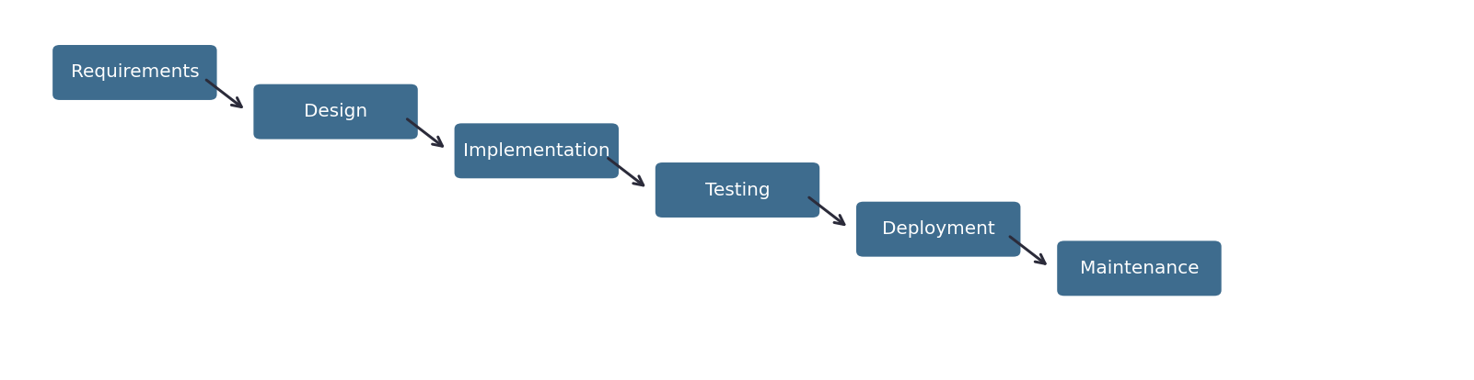

Scrum
An Agile methodology structured around fixed-length sprints, each ending in a review and retrospective. Chosen because it matches the FYP's own cadence of periodic assessed milestones (PRD, progress report, prototype demo, final submission) and lets the team incorporate supervisor feedback between sprints rather than only at the end.
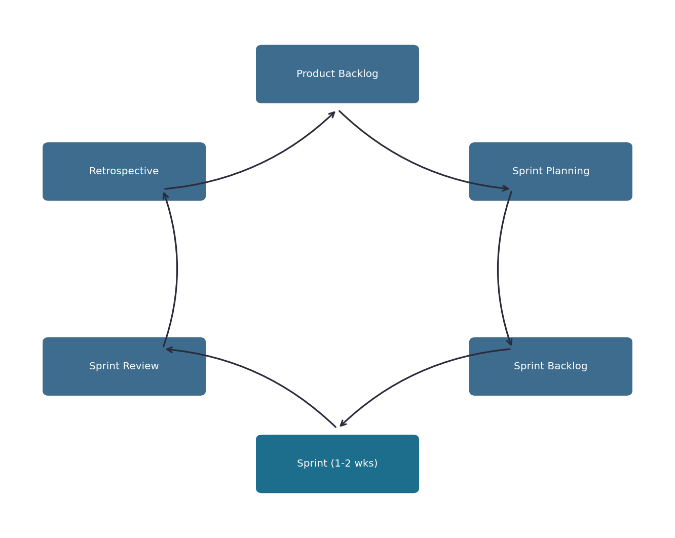

Methodology Chosen: Scrum
Scrum is the team's chosen methodology. It offers the adaptability the project's evolving NLP/recommendation requirements need, while its fixed sprint cadence maps naturally onto the FYP's own periodic assessment milestones (Section 4.4), keeping supervisor feedback incorporated throughout rather than only at the end.

4.3 Risk Analysis
Risks are rated Low (L), Medium (M), or High (H) for both impact and probability; the risk rating column reflects the combined assessment.
Risk Category | Identified Risk | Impact | Probability | Risk Rating
Communication | Miscommunication between team members on functional scope changes | M | L | M
 | Delay in supervisor feedback affecting sprint planning | M | M | M
Resources | Uneven workload distribution across the 5-person team | M | M | M
 | Limited access to real book/video metadata APIs (rate limits, cost) | M | M | M
Technical | NLP engine misinterprets a child's informal or ambiguous queries | H | M | H
 | Integration issues between the recommendation engine and the curated content database | M | M | M
 | Cross-platform (mobile + web) inconsistencies from a single Flutter codebase | M | L | M
User/Child Safety | A moderation gap allows an unvetted item to be recommended | H | L | H
 | Age-band misclassification results in content mismatched to a child's age | H | L | H
Compliance | COPPA/PDPA consent flow is incomplete or unverifiable at launch | H | L | H
 | Data retention/deletion requests are not honoured within policy timelines | M | L | M
Maintenance | Content database becomes stale without ongoing moderator review capacity | M | M | M
 | External content APIs change or deprecate endpoints used by the system | M | L | M

4.4 Proposed Duration & Schedule
The schedule below combines the team's internal work breakdown (docs/07-project-management/Project-Plan-and-WBS.xlsx) with the official CSIT321 assessment milestones (PRD due 2 Aug 2026, progress report 12 Sept 2026, prototype demonstration 19 Sept 2026, final submission 14 Nov 2026, and final presentation 21 Nov 2026), shown as milestone markers.
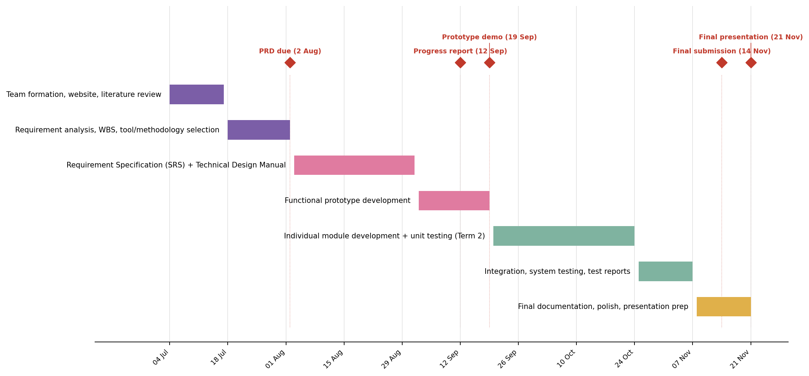

4.5 Roles and Responsibilities
Name | Role | Responsibilities | Contact
Arjan Singh Bhasin | Project Manager | Coordinates the team, owns the project timeline and deliverable submissions, liaises with the supervisor. | TBD
Desmond Won Thiang Feng | Technical Writing | Owns documentation quality across PRD, SRS, TDM, and user manual; ensures consistency and UOW submission compliance. | TBD
Lee Jihyeon | Research | Leads competitor/market research and the age-appropriateness and content safety literature review. | TBD
Kiefer Russell Sulijanto | Programming | Leads system architecture, actor/use-case modelling, and core application development. | TBD
Tan Kian Hong | Testing | Owns the test plan, test-case design, and QA across prototype and final product milestones. | TBD

5. Development Tools
The stack above is a proposal based on the project's requirements and is intended to be confirmed by the full team before implementation begins, consistent with the FYP process's own guidance that tool selection happens during PRD research.
Category | Tool(s) | Rationale
Frontend | Flutter | Single codebase for mobile (iOS/Android) and web, matching both the child chat interface and the parent dashboard's cross-platform needs; reduces a 5-person team's platform-specific workload.
Backend | Python + FastAPI | Chosen over a Node/Express backend because the core differentiator -- the NLP conversational layer -- is more naturally implemented in Python, keeping the API and the NLP/recommendation logic in one language and process boundary.
NLP / Recommendation | LLM API (conversational layer + intent extraction) + content-based filtering over the curated catalogue metadata, evolving toward collaborative filtering as interaction data grows | Matches the use-case model already defined for the NLP/Recommendation Engine actors (see Business-Model-and-Actors.docx); content-based filtering avoids the cold-start problem a purely collaborative approach would have at launch.
Database / Auth | Firebase (Firestore + Authentication) | Matches both example precedents reviewed during research and keeps infrastructure simple for a student team without dedicated backend/DevOps expertise.
Content sources | Google Books API / Open Library (books); a curated allowlist of vetted video channel/source IDs (video) | Consistent with the "closed, curated catalogue" safety positioning established in the differentiation research.
Hosting | Google Cloud Functions (Python) + Firebase Hosting | Keeps the whole stack within one cloud ecosystem (Firebase/Google Cloud), avoiding multi-cloud complexity for a small team.
Version control / PM | GitHub (source control), Figma (wireframes, Technical Design Manual phase), Notion or Taiga (backlog/sprint tracking) | Standard, free/student-tier tools recommended in the subject's own development-tools guidance.

6. Expected Results
Goal | Expected Result
Safe, relevant discovery | A child can describe what they want in their own words and receive a book or video recommendation drawn only from the pre-vetted, curated catalogue.
Explained recommendations | Every recommendation is accompanied by a short, age-appropriate reason, rather than an unexplained result.
Parental oversight without friction | A parent can view their child's activity history, adjust age-band settings, and flag content, without needing to supervise every individual conversation.
Regulatory-aligned data handling | Verifiable parental consent is captured before any child data is collected, and a parent can request review or deletion of that data at any time.
Sustainable content pipeline | New content enters the catalogue only after moderator review and age-band/metadata tagging, keeping the catalogue both safe and current over time.

7. Conclusion
This project responds to a gap that neither curated-but-static children's content platforms nor general-purpose conversational AI tools currently fill: a safe, conversational way for children to discover books and videos, paired with meaningful oversight for parents. By combining a closed, pre-vetted content catalogue with a natural-language recommendation interface and a dedicated parent dashboard, the system aims to remove the tradeoff between safety and personalization that existing products force parents to make. The functional hierarchy, use cases, and development plan set out in this document are intended as the foundation for the Requirement Specification and Technical Design phases that follow.

8. References
This document was prepared with the assistance of Claude (Anthropic), used for drafting structure, synthesising the team's existing research notes, generating diagrams, and formatting, per UOW's GenAI usage guidance for CSIT321. All factual claims about comparable products and regulatory requirements were sourced from the team's own research (see docs/02-research/) and should be verified against primary sources before external submission or citation elsewhere. The system prompt/session history is retained by the project team and available on request.

- Consolidated-Research.docx (internal) — Master Competitor Research, 13 comparable products across direct-to-kids platforms and AI conversational recommenders. docs/02-research/Consolidated-Research.docx.
- Differentiation, Safety, and Parental Oversight Research (internal, 25 sources) — docs/02-research/Differentiation-Safety-and-Parental-Oversight-Research.docx.
- Business Model and Actors (internal, Final Merged Version) — docs/02-research/Business-Model-and-Actors.docx.
- Epic! — https://www.getepic.com/
- YouTube Kids — https://www.youtubekids.com/
- Common Sense Media — https://www.commonsensemedia.org/
- Amazon Kids+ — https://www.amazon.com/amazonkids
- PinwheelGPT — (product research, see Consolidated-Research.docx)
- Readow — (product research, see Consolidated-Research.docx)
- Flutter — https://flutter.dev/
- FastAPI — https://fastapi.tiangolo.com/
- Firebase — https://firebase.google.com/
- Google Books API — https://developers.google.com/books
- Open Library API — https://openlibrary.org/developers/api
- Scrum.org — https://www.scrum.org/
- COPPA (US FTC) — https://www.ftc.gov/legal-library/browse/rules/childrens-online-privacy-protection-rule-coppa
- PDPA (Singapore PDPC) — https://www.pdpc.gov.sg/

