The setups steps expect following tools installed on the system.

Ruby 2.4.0
Rails 5.7.0

Create database.yml file
Copy the sample database.yml file and edit the database configuration as required.
cp config/database.yml or config/database.yml

Create the database
Run the following commands to create the database.
bundle exec rake db:create

Migrate the database
Run the following commands to migrate the database.
bundle exec rake db:migrate

Start the Rails server
You can start the rails server using the command given below.
bundle exec rails s
And now you can visit the site with the URL http://localhost:3000‘

In this application we have use the javascript to crop the image you can upoad the image and crop the image and also you can after that you can destroy the image

Home Page

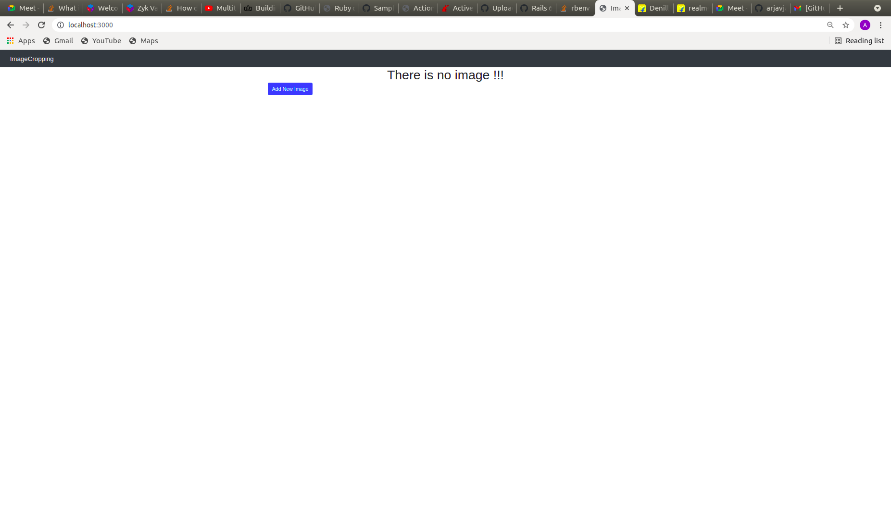

Crop the image

