Project : CampusGig

CampusGig is a collaborative platform designed for students to bring their ideas to life through partnerships with fellow students. Within CampusGig, users can take on two roles: Client or Freelancer.

As a Client, students can post requests for projects they’d like help with, leveraging the skills of their peers to turn their ideas into reality.

As a Freelancer, students can browse and accept available projects, utilizing their skills to deliver results and earn rewards.

This student-to-student collaboration fosters a community where ideas meet execution, allowing participants to develop their skills, build their portfolios, and earn income – all while making their ideas come to life.

Database Design : ER Diagram, table descriptions, and relationships
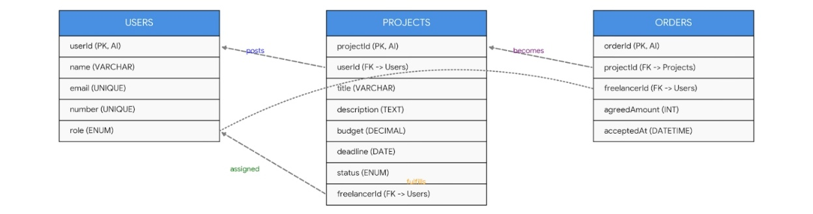
Users Table: Contains the central identity data for both clients and freelancers.

Projects Table: Connects to the users table twice—once for the client who created the post (userId) and once for the assigned freelancer (freelancerId).

Orders Table: Acts as the final contract record, linking a specific project to the freelancer who fulfilled it.

Key Relationships Shown:

- One-to-Many (Users to Projects): A single user (client) can post multiple projects.
- One-to-Many (Users to Projects): A single user (freelancer) can be assigned to multiple projects.
- One-to-One/Many (Projects to Orders): A project transitions into an order once a freelancer is officially hired.

Foreign Key Constraints:

- projects.userId → users.userId (Mandatory).
- projects.freelancerId → users.userId (Optional/Null until hired).
- orders.projectId → projects.projectId.
- orders.freelancerId → users.userId.
Web Interface : Key pages and Functionalities

Home screen
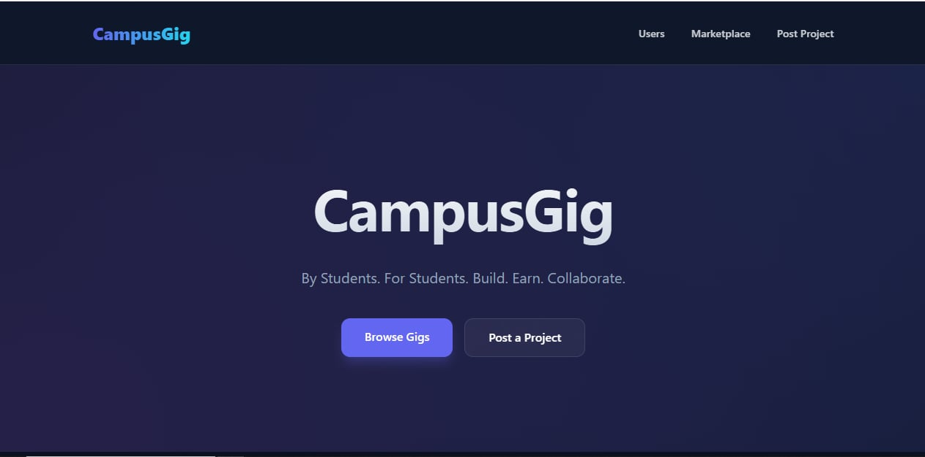

Welcome to CampusGig, a collaborative platform where students can bring their ideas to life through partnerships with fellow students.

At the top corner, you’ll find the main navigation options:
- Users : Connect with other users, find potential collaborators, or discover new talent
- Marketplace : Browse available projects and opportunities
- Post Project : Share your idea and find a freelancer to bring it to life

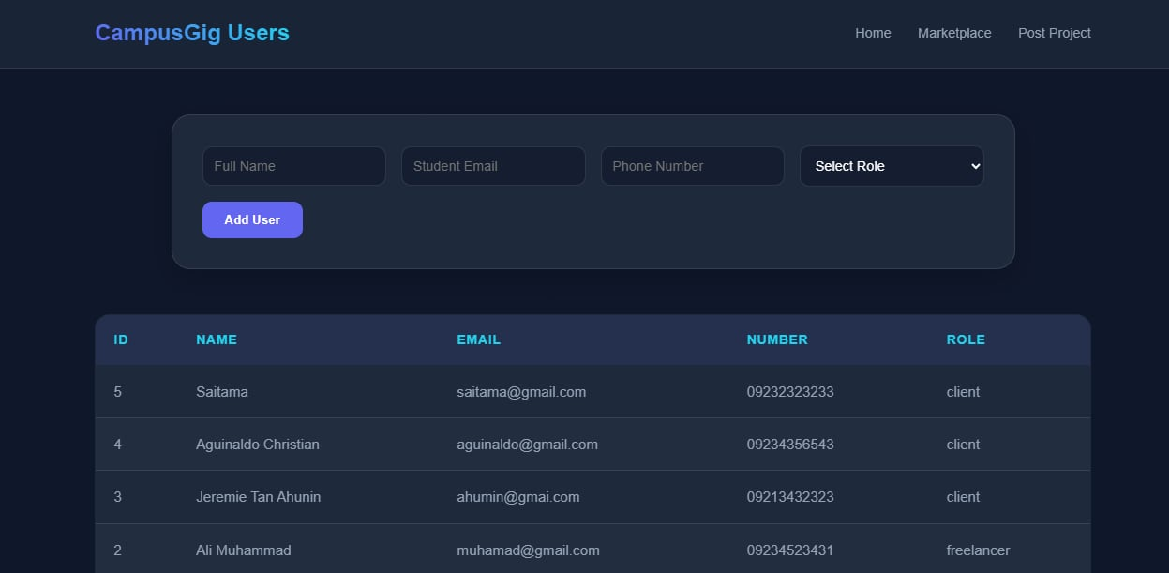
Users

When you click 'Users' at the top corner, you'll be taken to the User Directory page.

Add User
Here, you can add yourself to the directory by filling out the required fields:
- Full Name
- Email
- Phone number
- Role (select either Client or Freelancer)

User List
Below the Add User section, you'll find a transparent list of all registered users. This list is publicly visible, allowing you to connect with others for networking or collaboration. You can browse through the list to find users with specific skills or interests.

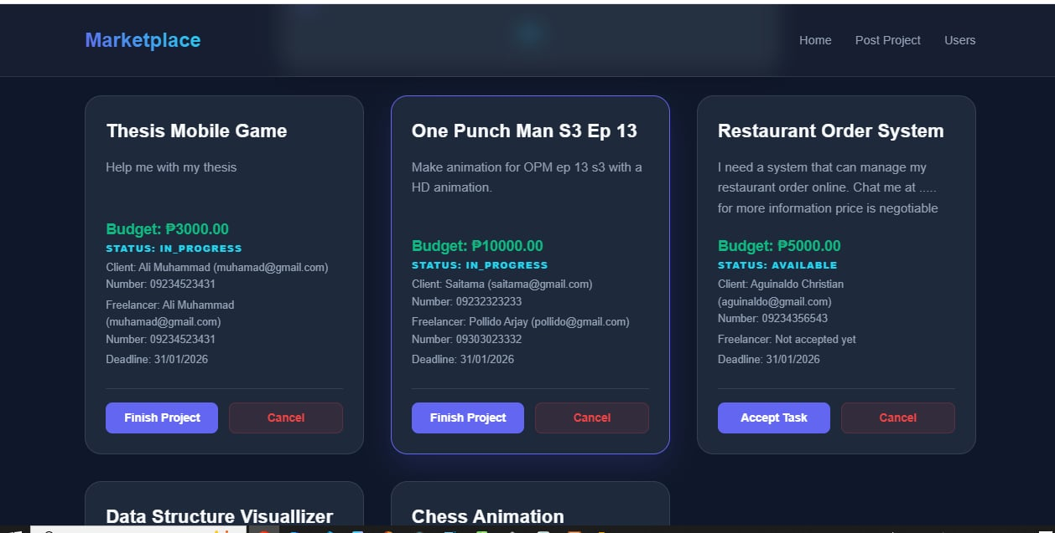
Marketplace

When you click ‘Browse Gigs’ or ‘Marketplace’, you’ll see a list of available projects posted by clients looking for help.

Freelancers can browse these projects and:
- Accept a project: Take on the challenge and start working on it
- Finish Project: Mark the project as complete once you’ve delivered the work

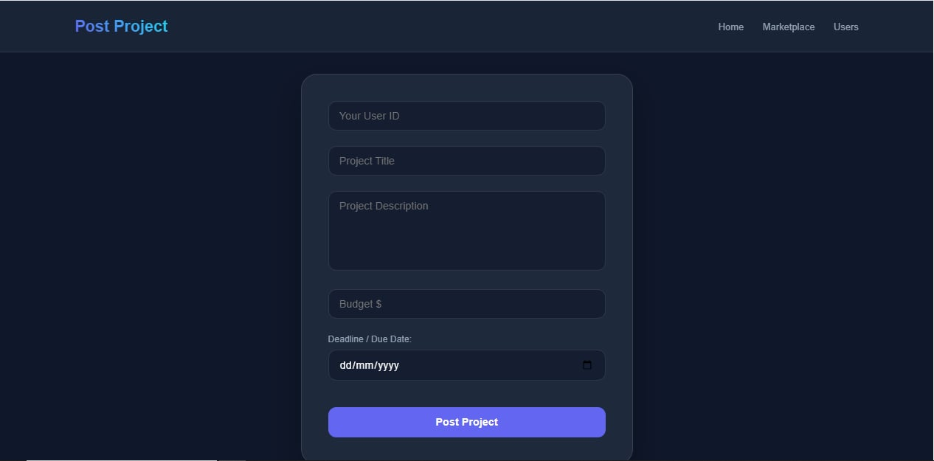
Post Project

When you click ‘Post Project’ on the Home Screen, you’ll be directed to the Project Submission Form. Here, you’ll be asked to provide some details about yourself and the project you’d like help with.

This form is designed to help freelancers understand your needs and provide accurate proposals. Please fill in the required fields, including:

- User ID
- Project Title
- Project Description
- Budget
- Deadline / Due date

Once you’ve filled out the form, submit your project and wait for freelancers to accept it!

Challenges and learning : What you found challenging and insightful.

Challenges :
- Figuring out the tech stack (e.g., frontend, backend, database)
- Designing a user-friendly UI/UX without prior experience
- Implementing features like user authentication

Insights :
- I think I can rearrange something here so it's much easier for the users to navigate my system. I don't know it yet, but once feedbacks are given, I will update it.

