Glossary

Term | Meaning
Raw data file (input, which program should read) | A ‘raw data file’ is a term used to describe a file that contains data that one wishes to plot and which, when plotted, appears as a conventional powder diffraction pattern. It may exist in a number of different formats, some of which are proprietary to the manufacturers of powder diffraction equipment (e.g. BrukerAXS ‘RAW’ format, Panalytical X’Pert Binary format, Stoe RAW format) and ultimately, we may wish to be able to read in such files and display them. For the moment, however, we assume that a raw data file is of format xy, xye.or cif. Details specific to each of these formats are described separately in this glossary (as separate glossary entries).  Regardless of the specific format used to represent a ‘raw data file’ it is worth keeping in mind the ‘kind’ of data that a ‘raw data file’ aims to contain:  1) A ‘raw data file’ will for our purpose consist of a collection of pairs of x and y values; for each x value there is always an associated y value. That is, each (x,y) pair represents a data point. For each x-value a y-value is measured using a powder diffraction instrument. In addition to recording the y-value measured for each x-value, optionally, an error may also be including for each data point that estimates the uncertainty of the y-value. When error estimates are included a data points takes the form (x,y,e), where ‘e’ here stands for the error estimate of the y-value.  2) A typical raw data file consists of many thousands data points, typically in the range 1,000 to 10,000. A data file will rarely exceed 20,000 data points and it is difficult to imagine circumstances in which it will exceed 100,000 data points.  For a nice introduction to the X-ray Diffraction Techniques see http://www.doitpoms.ac.uk/tlplib/xray-diffraction/printall.php, which includes a short animation on powder diffraction and the web page gives some insight into how a ‘raw data file’ might be obtained in practice.
xy and xye ‘raw data files’ | xy and xye files have the following characteristics:  1) Is an ascii file. It may originate from a Unix, Windows or Mac machine, and therefore we need to be careful with carriage returns/line feeds (see e.g. http://en.wikipedia.org/wiki/Newline for a discussion of this).  2) In the case of an xy file, it consists of a series of lines containing two numbers each. These numbers may take the form of integers and / or floating point numbers; examples of such numbers are: 5.897234, 500, 4.22e-10, -2.456. The first column of numbers is to be plotted on the x-axis and the second column of numbers is to be plotted on the y-axis.  3) In the case of an xye file, it consists of a series of lines containing three numbers each. These numbers may take the form of integers and / or floating point numbers; examples of such numbers are: 5.897234, 500, 4.22e-10, -2.456. The first column of numbers is to be plotted on the x-axis and the second column of numbers is to be plotted on the y-axis. The third column of numbers represents the error or estimated standard deviation of the numbers in the second column. It can be used to plot an error bar on each of the y points if required and can also be used in a number of numerical operations.  4) Columns will typically be separated by white space (spaces or tabs) though comma delimited format should also be accepted.  5) A typical raw data file consists of many thousands of lines, typically in the range 1,000 to 10,000. A data file will rarely exceed 20,000 lines and it is difficult to imagine circumstances in which it will exceed 100,000 lines.  6) The program should not depend upon the use of the extensions xy and xye in order to identify a file format. It would be reasonable for a file browser dialog box to display only .xy and .xye files but that should not prevent the user selecting a file called, for example, ks150k.bm16, which happens to be xye format.  7) If any line contains less than two numbers or more than three numbers, then the line should be ignored. Similarly, if a line contains an entry which is not a number then that line should be ignored.
cif ‘raw data files’ | This ‘raw data file’ format is a more intelligent format than the ‘xy’ or ‘xye’ format. It has only relatively recently been introduced to the science community the JPowder program aims to target. At present most ‘raw data file’ files are still stored as ‘xy’ or ‘xye’ files but in the future the ‘cif’ should see more usage (in particular some electronic journals will or have adopted this format for storing ‘raw data files’).  CIF stands for Crystallographic Information File and a cif file aims to store all sorts of crystallographic information including the option to store the ‘raw data’. A ‘cif’ file is a bit like a HTML file in that it is a markup language, which combines extra information with text and numbers contained in the file. The cif markup language is defined by a number of dictionaries. The core dictionary is described here: ftp://ftp.iucr.org/cifdics/cif_core_2.3.1.dic.pdf. And the dictionary of particular relevance to powder diffraction is described here: ftp://ftp.iucr.org/cifdics/cif_pd_1.0.1.dic.pdf. Also, the main web site for the cif format is: http://www.iucr.org/iucr-top/cif/home.html.  For the purpose of JPowder we only need to be concerned with the following markups in the dictionary. Say, that a part of a cif file contains the following lines:  loop_  _pd_meas_2theta_scan  _pd_proc_intensity_total  _pd_calc_intensity_total  _pd_proc_ls_weight  6.00100 0.46500 0.43897 2034.55115  6.01900 0.45700 0.43892 2066.11570  6.03600 0.43300 0.43887 2183.59682  6.05300 0.44400 0.43881 2125.59684  The top five lines mean: loop over the 4 columns below and interpret the 1st column to be two-thata values (_pd_meas_2theta_scan), the 2nd column to be measured intensities values (_pd_proc_intensity_total)…..  When reading a cif file please alert the user as follows:  1) If the above described markups are not present in the .cif file. Alert the user that no ‘raw data’ are contained in the cif file.  2) A cif file must have the extension .cif. In fact the program should assume that any ‘raw data file’ with the extension .cif is a cif file.
Beamline (powder diffraction instrument) | At a large-scale research facility, such as the Rutherford Appleton Laboratory, a ‘beamline’ is a dedicated instrument within a larger laboratory where scientists from all over the world come to perform experiments. One kind of beamline is a powder diffraction beamline. These instruments typically cost many millions of dollars to construct and occupy many square metres of floor space. For more info see e.g. http://en.wikipedia.org/wiki/Beamline .
Laboratory (powder diffraction instrument) | The term ‘laboratory’ powder diffraction instrument is used when referring to a powder diffraction instrument located within at a university. Such ‘laboratory’ instruments are smaller in size (ca. 1m²). In general, they cost around $100,000 and their performance, whilst excellent, is inferior to instruments located at large-scale facilities.
Crystal structure | The underlying structure, at the atomic level, of a molecule in a crystal
Single crystal | The standard form of sample used in crystallography e.g. sugar crystal, or a grain of salt
Powder | The form of sample used in crystallography when a single crystal cannot be grown e.g. icing sugar.
powderCIF | In crystallography reporting of single-crystal structures is generally done in CIF (Crystallographic Information File) format. powderCIF is an extension to cover items particular to powder diffraction data. Further info about the powderCIF dictionary can be found at http://www.iucr.org/cif/pd/index.html.
Synchrotron | A large-scale X-ray facility
Crystalline form | One way of referring to the crystal structure of a material
Scaleable window | The JPowder windows should be scaleable in the sense that  - One can click and drag on the corners or edges of the main application window in order to change its absolute size  - One can click on the corners or edges of one of the windows that is currently displaying a powder plot in order to change its absolute size. Crucially, when the mouse is released once the window has been dragged to its new size, the plot must be redrawn in order to match the new window dimensions. For example  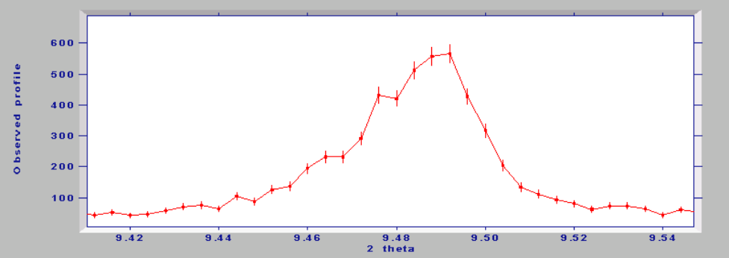  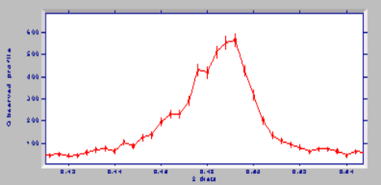
Peak position | A peak in the powder diffraction pattern is defined as a clearly discernible maximum in plot. For example, in the plot below, there is one peak and its position is ca. 9.49 degrees two-theta (the x-axis has units of two-theta)  We frequently wish to identify the peak maxima and this is usually achieved visually by moving the mouse to a particular maximum and performing some mouse operation in order to mark the position. E.g. one might right click over a point and select “Mark peak” from a pop-up menu  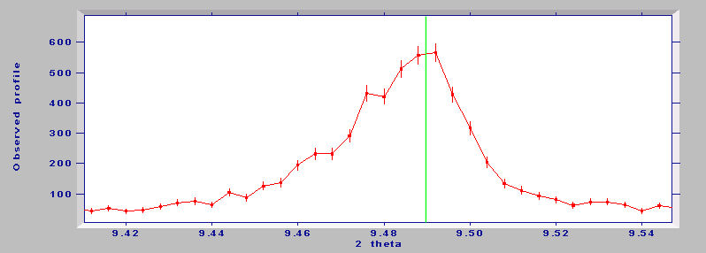  The peak position, as indicated by the green line which is drawn at the selected mouse position, is returned in terms of the x-axis value e.g. 9.486. This value needs to be stored within Jpowder in the form of a peak list.
Peak list | If one or more peaks are selected as described above, then the selected peak positions should be stored within JPowder and be made accessible to the user upon request e.g. using a View->Marked peak positions menu call. The list (which will typically be of order 1 to 20 peaks in size) should also be exportable from the program for permanent storage, most likely in the form of a .txt file to which the user can assign a suitable name.
Two-theta | The most commonly used unit for the x-axis of powder diffraction plots. Two-theta itself is an angle in degrees.
Wavelength | The wavelength of the radiation used in the powder experiment, it has units of Angstroms (1 x 10⁻¹⁰m). Experiments can be performed at different wavelengths. Most laboratory experiments are performed at 1.54056Å. In the case of synchrotron experiments, the wavelength can be selected by the user and thus might take any value, but one typically in the range 0.1 – 2.0 Å. We need to have a way of associating a wavelength value with any given data set, as xy and xye files will not normally have wavelength data in them.
d-spacing | Another unit used for displaying the x-axis of powder diffraction plots. It has the advantage that it is independent of the wavelength of the radiation used in the diffraction experiment. The two-theta axis can be transformed to d-spacing using the following equation  d = wavelength / (2 * sin(theta))  where theta is simply two-theta/2.0  Plots rendered in terms of d-spacing can be conveniently overlaid for comparison purposes.
Q | Another less commonly used unit for displaying the x-axis of powder diffraction plots. It has the advantage that it is independent of the wavelength of the radiation used in the diffraction experiment. The two-theta axis can be transformed to Q-spacing using the following equation  Q = 4 * PI * sin(theta) / wavelength  where theta is simply two-theta/2.0 and PI is 3.14159265357….  Plots rendered in terms of Q can be conveniently overlaid for comparison purposes. Q is also related to d (d-spacing) by the equation  Q = 2 * PI / d
Scaling y-axis | It is frequently necessary to multiply or divide y-axis values by some scalar value in order to make comparison with other data sets easier. Thus the ability to transform a data set xy into another data set xy’ by multiplying the y values by some value z in the range 0 < z < ∞ is extremely valuable.
Reset zoom | Zoom the plot out such that all the data is shown in the plot
Mark peak position | Draw a vertical black line at the current mouse x-axis position. The line should extend from the (current x, y=0) to (current x, y=ymax). The current mouse x-axis position should be stored in a list for subsequent display (see View peak positions). Note that each plot can have a distinct list of peak positions
Rescale Y data to primary Y data | A plot window displays the primary data set that it was created to display. However, it can also display other data sets that are selected using the data visibility panel. If one wishes to scale the y-values of an additional data set to match those of the primary data set, then this can be done automatically (via a least-squares process, AJM can handle this easily) or manually by entering a scale value and multiplying the y-values by the scale.  We need to be able to handle potential rescaling of more than one data set, but for the moment, the ability to rescale a single additional data set is sufficient. Accordingly, the “Rescale Y data to primary Y data -> Manual” option needs to bring up a dialogue box that asks for a scale factor by which to multiply the y-values of the additional data set. The scale factor z should be 0 < z < ∞ as mentioned above.
Copy | The ability to copy a plot to the clipboard in say WMF format for subsequent pasting into a Word document is extremely valuable
View peak positions | A box that displays the list of peak positions selected for the current plot (which will typically be a list of two-theta values) should allow the user to either select, copy and paste the list, or export it to a txt file.
Plot options | Presumably whatever plotting package is being used will allow for the changing of graph properties such as symbol size, line colours etc. Plot options dialogs should be accessed from the plot menu bar.

