Jpowder
Version 0.2
28-05-08

User requirements document

0 Revision history
Version 0.1 (27-05-08): Created by Anders (18-05-08, SVN commit 115). Summary of user requirements as specified by Kenneth, Damian and Anders. This version also includes corrections and comments from Damian (see SVN commit 117-8) and this section, ‘Revision history, is added here as a recommendation from Kai.

Version 0.2 (28-05-08): Updated by Anders. Layout of requirement tables used in V. 0.1 of this document changed as recommended by Kai. User requirements specified in V. 0.1 are here merged with the user requirements expressed in the form of the Java application created by Kai (see SVN commits 1-114) and from user requirement input from Anders. Addition requirements were also added as…

1 Introduction
This document describes the user requirements for the Jpowder project. The intention is to describe what Jpowder should do in plain English with no knowledge about programming required to read this document.

2 Requirement categories
Each requirement in the tables below is prioritized as follows:

M Mandatory requirement. This feature must be built into the final product.

D Desirable requirement. This feature should be built into the final product unless its turns out to be too complicated to do so.

O Optional requirement. This feature may optionally be built into the final product.

E Possible future enhancement. This feature is recorded here so that the idea is not lost, but will not be included in the final product.

2.1 Definition of terms

Ne. – shorthand for Necessity (used as column label)

3 External files (files the system can read)

Label | Requirement | Ne. | Status
U3.1.1 | The system must read powder diffraction data in the xy format.  This is a two-column text format where each row holds an (x,y) data points. The result from reading such a file must display a 2D plot with the x-values along the x-axis and the y-values along the y-axis. An example of such a plot is shown below:  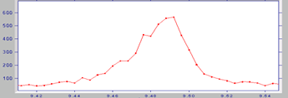  The dots are (x,y) data points and the line segment between the dots are here included to help the eye joint up the dots. | M | Done  (before 27/5/8)
U3.1.2 | The system must read powder diffraction data in the xye format.  This is a three-column text format where each row holds an (x,y,e) data points. The result from reading such a file must display a 2D plot with the x-values along the x-axis, the y-values along the y-axis and the e-values as vertical lines through each data point where the vertical line starts at (x,y-e) and ends at (x,y+e). An example of such a plot is shown below:  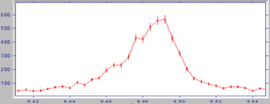  The dots are (x,y) data points. The vertical lines through each point start at (x,y-e) and ends at (x,y+e). | M | Done  (before 27/5/8)
U3.1.3 | The system should be able to read powder data in the cif format (http://www.iucr.ac.uk/iucr-top/cif/home.html)  This format holds powder data either in the way described in U3.1.1 or U3.1.2. See detailed_desciption_file_formats.doc for a detailed description of this format. | D | Not done
U3.1.4 | May allow powder data to be read from proprietary formats such as: BrukerAXS (raw) format, Panalytical X’Pert Binary format, Stoe (raw) format | E

4 Mouse click options over a plot window (displaying powder data)

4.1 Right mouse click options

Label | Requirement | Ne. | Status
U4.1.1 | Right clicking over a plot window must bring up a menu which should contain the menu options  ‘Properties…’ [explained in U4.1.1.1]  ‘Change plot style…’ [explained in U4.1.2]  ‘Save as…’ [explained in U4.1.2.1]  ‘Print…’ [explained in U4.1.2.2]  ‘Mark peak position’ [explained in U4.1.3]  ‘Rescale Y data’ [explained in U4.1.4] | M | Partially done prior to 27/5/8
U4.1.1.1 | The ‘Properties…’ submenu must open a ‘Chart Properties’ taking the form:  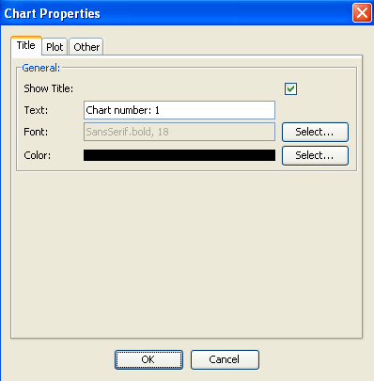  And will contain features for changing the title and x&y-labels, their font and color, change of tick-marks and various other features related to the chart (but not the actually data drawn) | M | Done prior to 27/5/8
U4.1.2 | The ‘Change plot style’ submenu should further contain the following submenus:  ‘turn on/off errorbars’ (only relevant for xye datasets)  ‘turn on/off connecting line’  ‘turn on/off marker circles’  The ‘turn on/off errorbars’ menu option should only be active for xye datasets (i.e. when standard deviations are available).  For example say an xy dataset has been read into Jpowder and presented to user in the default style as:  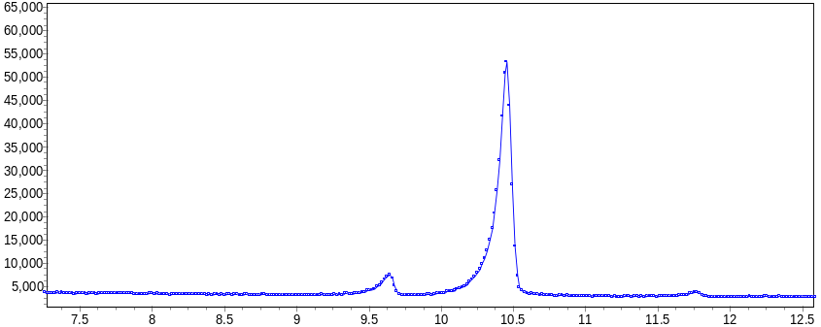  Each circle represents an (x,y) data point and the circles are connected up with line segments to help the eye jointing the circles.  If the ‘turn off connecting line’ option is then selected the default plot changes to:  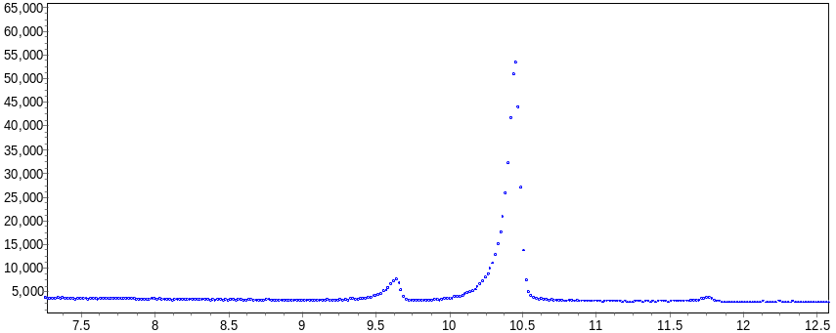  If the connecting lines option is enabled and we then select the ‘turn off marker circles’ option, the default plot changes to:  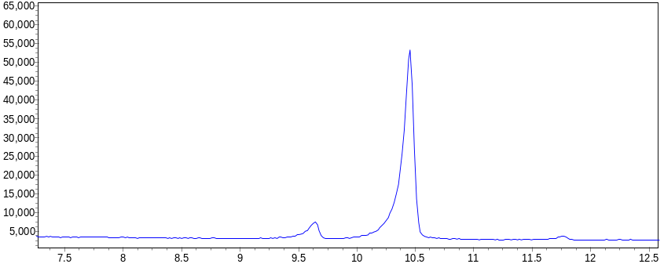 | M | Not done
U4.1.3 | The ‘Mark peak position’ option must enable the user to mark a peak.  A peak in the powder diffraction pattern is defined as a clearly discernible maximum in plot. For example, in the plot below, there is one peak and its position is at ca. 9.49 degrees two-theta (the x-axis has units of two-theta)  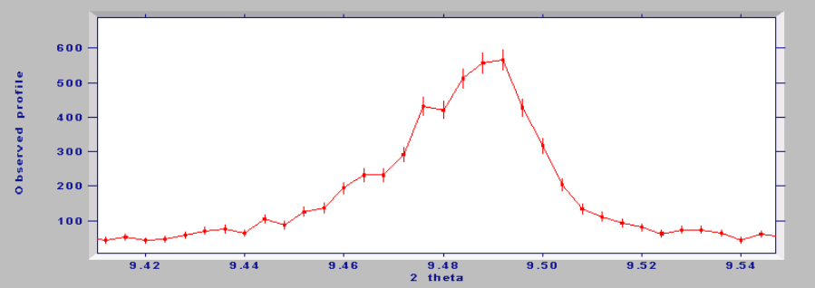  We frequently wish to identify the peak maxima and this is usually achieved visually by moving the mouse to a particular maximum and performing some mouse operation in order to mark the position. For example, one might right click over a point and select “Mark peak position” from a pop-up menu.  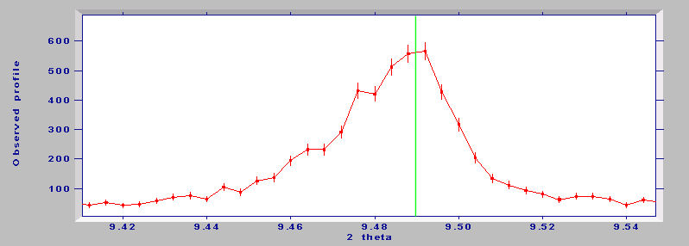  A peak position selected by the user may then be visualised as a green line drawn at the selected mouse position as demonstrated above. This x-value needs to be stored within Jpowder for later retrieval in the form of a peak list e.g. from the main application window menu bar using: View->’Marked peak positions’ (see U8.1.1).  Note that a peak selected for a plot window is associated with that plot window only. | M | Not done
U4.1.4 | The ‘Rescale Y data’ option allows the user to multiply or divide y-axis values by some scalar value; i.e. to transform a data set into another data set by multiplying the y-values by some value z in the range 0 < z < ∞. Rather than letting the user numerically enter such a z-value the user may alternatively (or in addition) be presented with a slider.  Typically this option is of interest when a user has plotted many datasets in the same plot window and would like to scale up or down one or more datasets in this window in order to be able to compare them better visually. | M | Not done
U4.1.5 | As an extension to U4.1.4 we may add an option, which allows the user to automatically scale one dataset to another dataset within the same plot window. This is clearly only of interest when multiple datasets are plotted in the same window.  For example, consider two datasets.  Dataset 1: Dataset 2:  X Y1 X Y2  1 5 1 10  2 6 2 12  3 2 3 4  4 7 4 14  etc  It's clear that if you plotted both datasets in the same plot window then they would match but with the Y values differing by a factor of two. Jpowder may allow scaling of the first dataset to give the best match to the second using some sort of internal least-squared fitting algorithm – which to the user will appear as an automatic scaling feature and an alternative to the manual scaling feature described in U4.1.4. | O | Not done

4.2 Left mouse click options

Label | Requirement | Ne. | Status
U4.2.1 | The following actions are available by using the left mouse button in Jpowder:  Click and drag to zoom in (cursor should be an arrow) – Left clicking with the mouse on a plot will display a bounding rectangle. The area of this bounding rectangle can be increased by keeping the left mouse button depressed and dragging the mouse away from the initial point that was clicked. Upon releasing the left mouse button Jpowder should zoom to display only the data points that are included within this bounding rectangle.  Click on top of window to change focus to that window  Clicking on the  of a plot, removes the plot window but the data stays listed in data visibility panel (see figure 1, end of this document, the area marked (2) is the data visibility area). | M | Done prior to 25/5/8

4.3 middle mouse click options

Label | Requirement | Ne. | Status
U4.3.1 | Middle mouse button (if available)  Click and drag to scroll plot horizontally and vertically (cursor should change to being a hand upon depression of the button) | O | Not done

4.4 Right mouse click followed by mouse movement

Label | Requirement | Ne. | Status
U4.4.1 | After a user have zoomed in on an area a right mouse click followed by a move of the mouse curser before the release of the button must result in the plot window return to the original view of the data as when they were first read into Jpowder. | M | Done  (before 27/5/8)

5 Other display features for a plot window

Label | Requirement | Ne | Status
U5.1.1 | A plot window displaying powder data must be re-sizeable (scalable) in the sense that one can click on the corners or edges of a window that is currently displaying a powder plot in order to change its absolute size. Crucially, when the mouse is released once the window has been dragged to its new size, the plot must be redrawn in order to match the new window dimensions. For example:  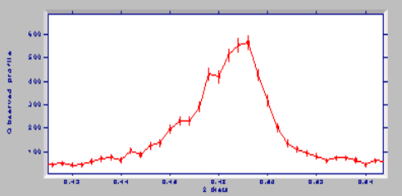 | M | Done prior to 27/5/8
U5.1.2 | It must be possible to change the colour and size of the connecting lines displayed the data in a plot window. | D | Not done
U5.1.3 | It must be possible to zoom in on a region in a plot window and zoom out, with mouse operations to be agreed on and which are designed to be useful for the visual inspection of powder data.  This will include a ‘reset zoom’, which zoom the plot out to how the data was originally plotted.  Note this requirement is likely to result in some mouse (plus possibly shortcut key press) features and this requirement once agreed upon may result in extending the requirements in U4.1.1 and U4.2.1. | M | Requirement needs to be better specified

6 Overall display features for the main application window (as planed for Version 2.0. For V. 1.0 see section)

Label | Requirement | Necessity
U6.1.1 | The main application window basic structure should resemble that shown in Figure 1 (see end of this document). The numbers in brackets in the paragraphs below refer to the labeled regions in Figure 1:  The user interface (UI) of the main application window should follow the conventions found in most everyday applications (such as MS Word) in that it will provide standard menus and toolbars as in (1).  The panel on the left hand side of the application (the 'data visibility' panel) will be used to display the current list of files that are open and available to the application (2).  Right-clicking over the items listed in the data visibility panel will bring up menu options (described in a separate requirement table below).  The main section of the application space (3) will be dedicated to displaying plots for the files that are loaded into the application.  Files that are loaded into the application are listed in the left-hand panel (2) and displayed in (3). Of particular importance is the act of emphasizing which file/dataset is in focus. An idea for this is represented in (4) where the dataset (d10-pyrene-120k.raw) is highlighted in the list/tree in the left hand pane.  Furthermore, the window of the corresponding plot (5) is also highlighted (represented using the darker blue window header) to denote that this dataset ‘d10-pyrene-120k.raw’ is in focus.  A critical requirement of the application is to enable the user to overlay multiple plots within a single window. An example of how this could be achieved is shown in (6). Notice that the checkboxes for ‘d10-pyrene-120k.raw’ and ‘d10-1H-Mix-pyrene-120K.raw’ are selected and that the current dataset in focus is ‘d10-pyrene-120k.raw’. Here, both selected datasets are plotted and overlayed in the window of the dataset that is currently in focus i.e. ‘d10-pyrene-120k.raw’, as shown in (7). Notice that the colour of each plot matches the colour of the corresponding checkbox representing each dataset.  The user should be able to do the following:  A. Load, for example, four datasets labeled for convenience here: 1,2,3 and 4 into four separate plot windows labeled 1,2,3 and 4 into area (3)  B. Click on window 1  C. Select using the tick-boxes in panel (2) that this window now should display not only dataset 1 but dataset 2  D. Click on window 4  E. Select using the tick-boxes in panel (2) that this window displays not only dataset 4 but also dataset 3  F. Delete window 3 from area (3) and this will have no impact on number of files/datasets listed in panel (2)  G. Click on window 2 and unclick dataset two in panel (2) such data no dataset are ticked for this window. This should result in window 2 being empty.  Each window should have access to all the datasets loaded and should have the capacity to display them all. The data visibility panel tick boxes in region (3) show the data status of the window that is currently in focus. Thus with reference to A-G above it should be possible to:  A. Load up datasets 1,2,3 and 4 into separate windows  B. Click on window 1 and select that it displays datasets 1 and 2  C. Click on window 4 and select that it displays datasets 3 and 4 | E
U6.1.2 | The main application window must be re-sizeable (scalable) in the sense that one can click and drag on the corners or edges of this window in order to change its absolute size. | D

7 Mouse click options in the data visibility panel

7.1 Right mouse click options

Label | Requirement | Necessity
U7.1.1 | Right click over a filename in the data visibility panel to bring the options:  “Close plot window” (removes plot window if open, leave data in application)  “Close data set” (removes plot window if open and removes data from application) | M

7.2 Left mouse single and double click options
Label | Requirement | Necessity
U7.1.1 | Left mouse click  Left click on a filename in the visibility panel to change the focus to the corresponding dataset.  Once a dataset is in focus, click the tick-boxes to the left of the filenames to overlay datasets in current plot window of the dataset that is in focus.  Double-click on a filename to open a plot window for that dataset if one is not currently open. | M

8 Menu bar for the main application window
Label | Requirement | Necessity
U8.1.1 | Standard windows-style layout with menus consisting of (left to right)  File  Open… (file dialog, read in a dataset and open a plot window to display data)  Close (close current plot window, remove data from application)  Print…(printer dialog, print current plot)  Export…(functionality to be confirmed!!!)  Exit (exit the application)  Edit  Copy…(copy dialog, gives the option to copy the current plot to a Windows MetaFile, TIF or Scalable Vector Graphics rendition of the plot)  View  Peak positions (brings up a with option to export to text file)  Plot (plot options such as symbol size, line thickness, colour etc)  Icons  There should be one for “file->open” functionality  There should be one “default print” functionality | M
 | The View->’Peak positions’ should bring up a box that displays the list of peak positions selected for the plot window in focus; the list will be a list of number (peak positions, i.e. the x-value part of a xy dataset), which will typically be of order 1 to 20 numbers in size. In addition the user should be allowed to copy and paste items in the list or export it to a txt file.  Note that a peak position list for a plot window is associated with that plot window only. | M

9 Other

Label | Requirement | Necessity
U9.1.1 | Implementation of Undo / Redo functionality would be extremely valuable, even it is was only to ‘last action’ level | D
U9.1.2 | Ability to output high-quality Postscript or PDF plots of any of the above windows | D
U9.1.3 | Ability to transform data. For example, apply a wavelength transformation, or plot as a function of d-spacing or Q. Note that transformation to d or Q is entirely straightforward and quick to calculate. The user would be required to enter a wavelength (a single real number) for the displayed data and also a wavelength for the data to be transformed to. | O
U9.1.4 | The ability to copy a plot to the clipboard in say WMF format for subsequent pasting into a Word document | O

10 Non-functional requirement

Label | Requirement | Necessity
U10.1.1 | A typical data file consists of many thousands data points, typically in the range 1,000 to 10,000. A data file will rarely exceed 20,000 data points and it is difficult to imagine circumstances in which it will exceed 100,000 data points.  Jpowder must be able to load a powder data set with less than 10,000 data points in 1min on a 2Ghz PC (note these number are somewhat arbitrary – someone else put in better target values we should aim for). | M
U10.1.2 | All components in the system must be freely distributable | M
U9.1.3 | Jpowder should be published under the free software license: LGPL (http://www.gnu.org/copyleft/lgpl.html) | D
Figure 1. Design as planned for Version 2.0.

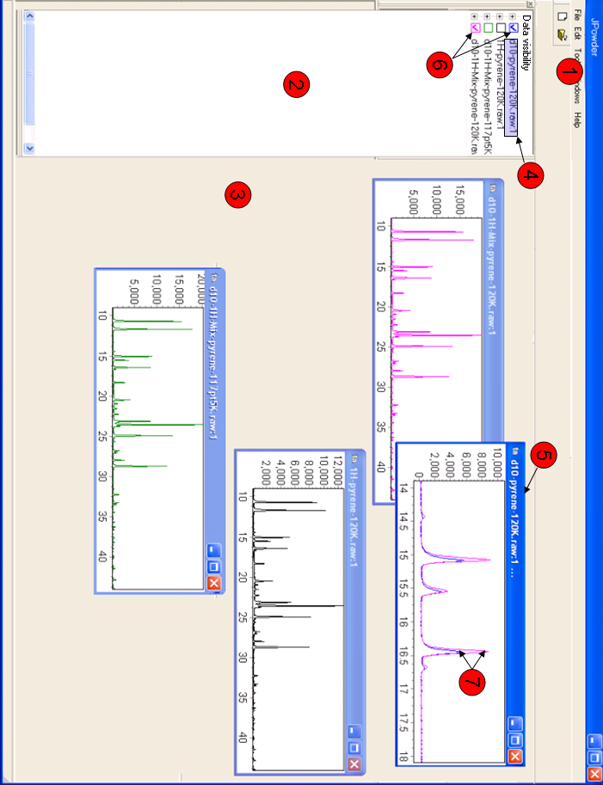
Figure 2: Kai main application window prior to 27/5/8.

