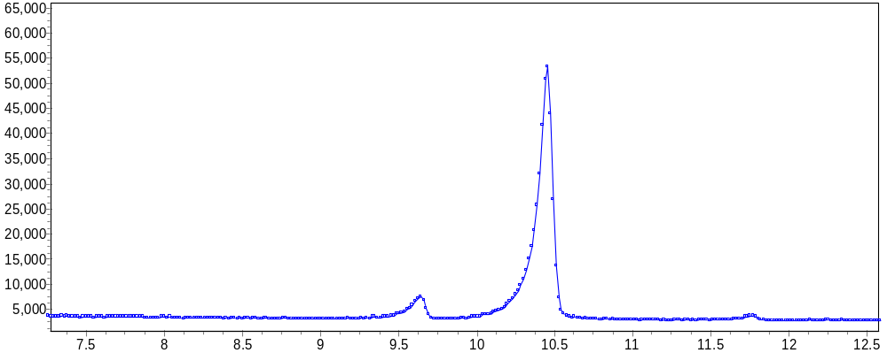

Default style: y values are shown as small circles, connected by straight line segments

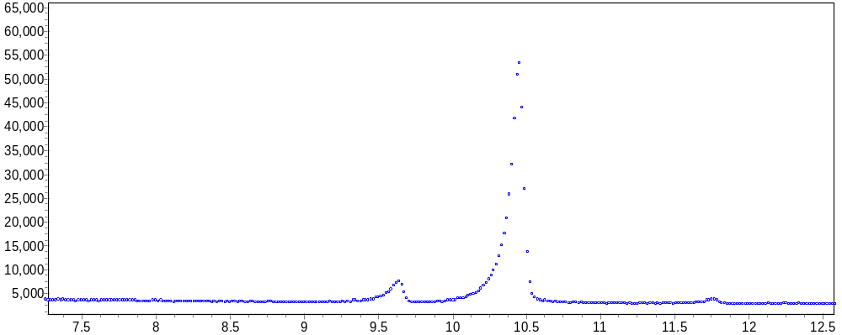

Example of an alternate style: the connecting lines have been turned off

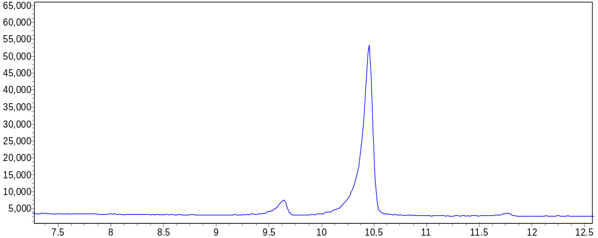

Example of an alternate style: the marker circles have been turned off
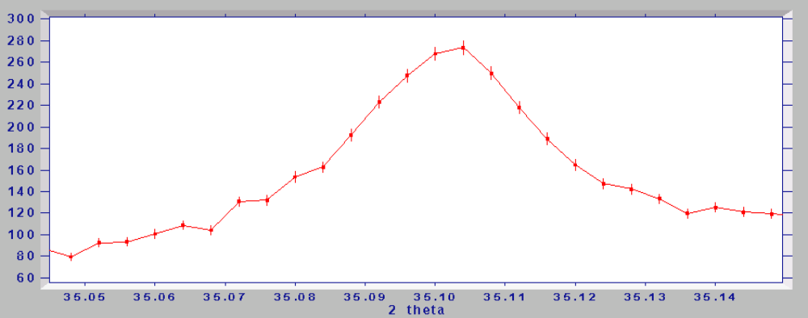
Error bars: the data points have associated vertical lines that show the estimated standard deviations. If you look up 'error bars' in MS Excel Help, you can find out more.

Comment k7: there are examples below of a single window displaying one data set, then another, then both

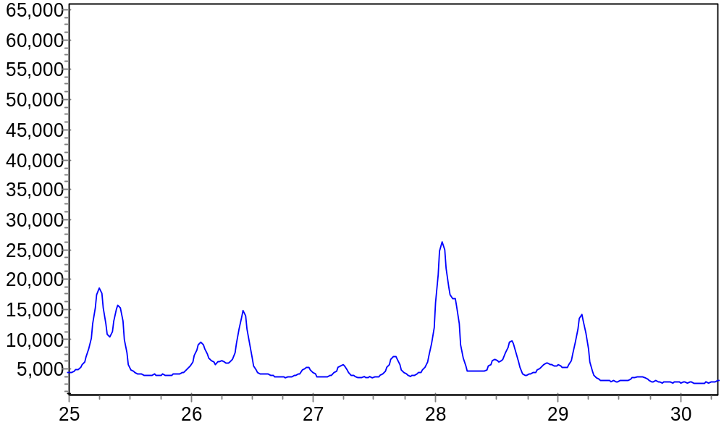

one data set
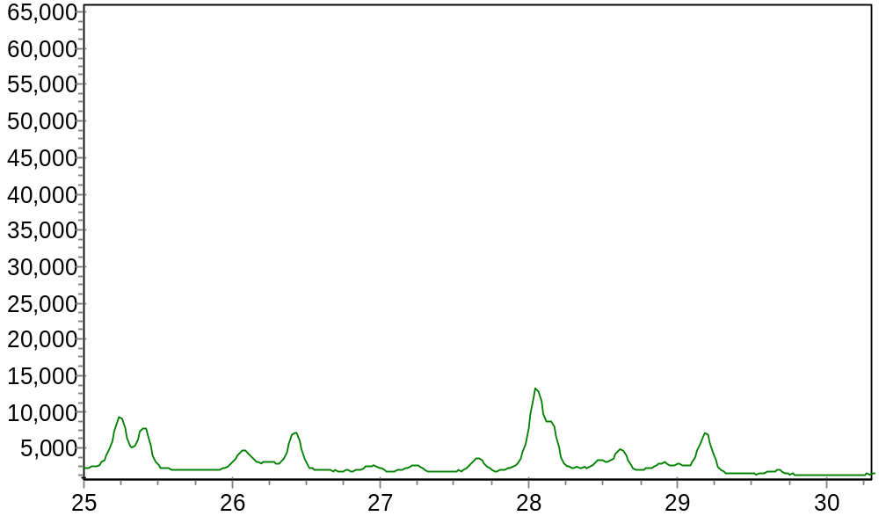

second data set

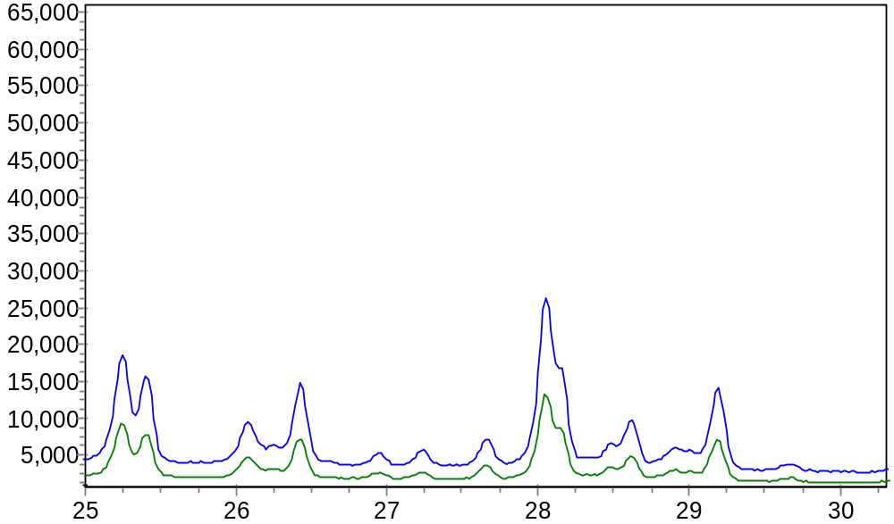

both data sets

